Software Architecture Document
My Family Health Portrait

Last Revised: | 5/13/2010
Produced By: | MFHP Development Team
Version: | 2.0

Document Approvals
The list contains the name and contact information for the core project team and any key stakeholders who have an interest in the success of the project. An “S” identifies persons responsible for approval from the stakeholder groups. Sign off of the document would be required when a decision is made not to take action for defined gaps.

S | Name | Role
 | Terry Cullen | Indian Health Service
 | Greg Downing | Program Director, Personalized Health Care, Office of the Secretary, HHS
 | Greg Feero | National Human Genome Research Institute (NHGRI)
 | George Komatsoulis | National Cancer Institute
 | Kathie Kendrick | Agency for Healthcare Research and Quality
 | Vish Sankaran | Program Director, Federal Health Architecture, ONC
 | Mollie Ullman | Harvard Partners
 | Grant Wood | Intermountain Health

Revision History
When you make a change to a document, you must add an entry to this Revision History table and you must manually type the Last Revised Date on the front cover.

Date | Version | Description | Revised by
09/04/2008 | 0.1 | Initial version | Leslie Power
09/12/2008 | 0.2 | Updated with latest model | L. Power
9/16/2008 | 1.0 | Initial inception baseline | L. Power
11/10/2009 | 2.0 | Initial inception baseline | Brian Humphrey
Copyrights and Trademarks
© Copyright 2010 by United States Department of Health and Human Services. All rights reserved.

Table of Contents
1. Introduction 3
1.1. Purpose 3
1.2. Scope 3
1.3. Definitions, Acronyms, and Abbreviations 3
1.4. References 3
2. Architectural Representation 4
3. Architectural Goals and Constraints 5
3.1. Standards-Based 5
3.2. Open Source 5
3.3. Privacy Ensured 5
3.4. Microsoft HealthVault Integration 5
4. Use-Case View 6
4.1. Create or Edit Family Health History 6
4.2. View Pedigree Chart 7
4.3. Re-Index Profile 8
4.4. Get File 8
4.5. Process File 8
4.6. Export to HealthVault 8
4.7. Import From HealthVault 9
5. Logical View 10
5.1. Overview 10
5.2. Architecturally Significant Design Elements 10
5.2.1. User Interface Layer 10
5.2.2. Remote Java API/web service 10
5.2.3. MFHP Domain Classes 10
5.2.4. HealthVault Domain Model 11
5.2.5. Export to Microsoft HealthVault 12
5.2.6. Import from Microsoft HealthVault 13
6. Implementation View 14
6.1. Overview 14
6.2. HL7 Family History (Pedigree) Model 14
6.3. HL7 Family History (Pedigree) Schema 15
7. Please see Appendix 15
7.1. Codes 15
8. Deployment View 17
9. Appendix 18
9.1. HL7 Family History (Pedigree) XSD 18

Introduction

Purpose
This document provides a comprehensive architectural overview of the My Family Health Portrait (MFHP) system, using a number of different architectural views to depict different aspects of the system. It is intended to capture and convey the significant architectural decisions which have been made on the system.

Scope
This document describes the aspects of the MFHP’s design that are considered to be architecturally significant; that is, those elements and behaviors that are most fundamental for guiding the construction of MFHP and for understanding how its users and clients (external applications interested in making use of the standards-based XML file the system can export) interact with the system. Stakeholders who require a technical understanding of MFHP are encouraged to start by reading this document, then review the MFHP UML model. Please note that all diagrams represented in this document are taken from the MFHP UML model; for more detail about the elements in these diagrams, please consult the source model.

Definitions, Acronyms, and Abbreviations
- EJB – Enterprise JavaBeans
- JEE – Java Enterprise Edition
- Java SE – Java Standard Edition
- JDK – Java Development Kit
- JSP – JavaServer Pages
- POJO – Plain Old Java Object
- RUP – Rational Unified Process
- UML – Unified Modeling Language

References
- MFHP UML Model
- MFHP Use Case Summary
- MFHP Requirements Documents (TK)
- Philippe Kruchten 1995, "The 4+1 view model of architecture," IEEE Software. 12(6), November 1995.
- [RUP] The Rational Unified Process, Version 2003.06.13

Architectural Representation
The MFHP architecture is represented in this document and in the UML design models as a set of views of the system from different but complementary perspectives. These views are:
- The Use-Case View – Describes the functional requirements of the system.
- The Logical View – Describes the organization of the system design into subsystems, interfaces, and classes and how these elements collaborate to provide the functionality described in the use-case view.
- The Process View - Illustrates the process decomposition of the system, including the mapping of classes and subsystems on to processes and threads.
- The Deployment View – Describes how the processes are allocated to hardware and execution environments and the communication paths between hardware nodes.
- The Implementation View – Describes the software components that realize the elements from the logical view and the dependencies between these components.
This style of describing software architecture is the approach recommended by the Rational Unified Process and is based on Philippe Kruchten’s work, “The 4+1 view model of architecture” and is refined in the Rational Unified Process.

Architectural Goals and Constraints
The following factors are key considerations beyond the functional requirements that are guiding the design of MFHP.

Standards-Based
MFHP must be capable of exporting a machine-readable (presumably xml) file containing the family health history entered by users of the system. The expected transport mechanism is the HL7 Family History model (www.hl7.org). The expected coding standard to be employed is SNOMED_CT (www.snomed.org).

Open Source
MFHP is expected to be written using open source tools and precepts, and upon release its source code will be deployed using open source tenets, being freely available to be downloaded, built, and deployed by any user. The exact open source license terms were defined by HHS’s Office of General Counsel.

Privacy Ensured
To ensure that MFHP users’ privacy and health information is protected, the system will not store user data locally. User data may be stored as a downloadable file to the user’s personal storage device, or to Microsoft HealthVault, a third-party Personal Health Record (PHR)

Microsoft HealthVault Integration
MFHP will allow users to connect to Microsoft HealthVault and export/import family health history information.

Use-Case View
The use cases represented in Figure 1 below contain the primary functionality of MFHP. Brief descriptions of each of these use cases are provided below (as extracted from the model). (For information on the complete use-case model, see the MFHP Use-Case Summary).
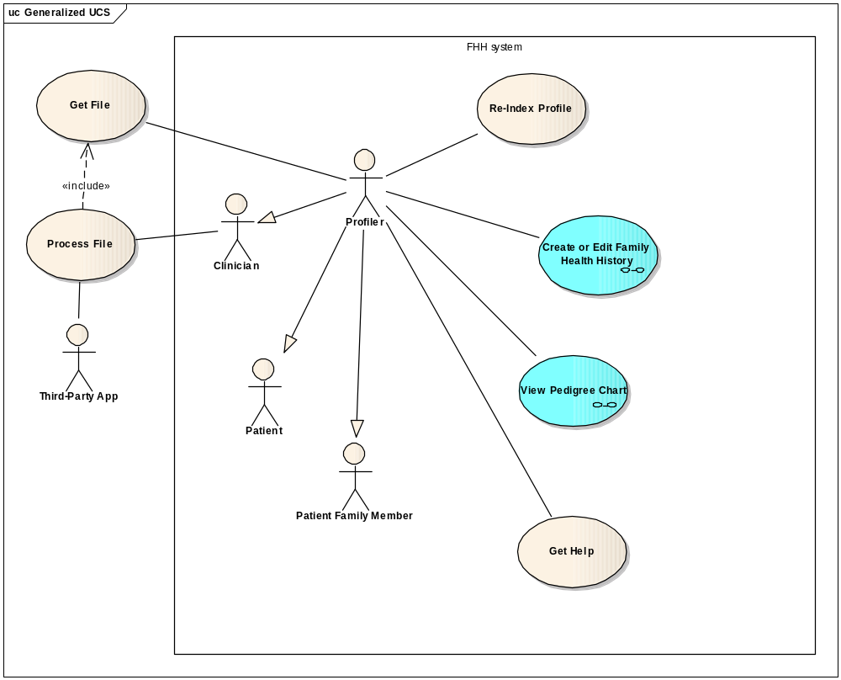
Figure 1 – MFHP Use Cases

Create or Edit Family Health History
This use case enables a user to create a new MFHP profile by entering medical health history for his- or herself and relevant family members. A user may also edit an existing profile by first uploading an existing profile that was created by the application back into the application
Once completed, the Patient can extend this use case to view a pedigree diagram of the health history, download a graphical representation of the model, or download an XML version of the profile to local media.
It should be noted that the system does not store or persist any data, all data is downloaded and stored in the user's environment.
This use case is composed of several user stories as outlined in Figure 2. User Stories comprising Create or Edit Family Health History, below
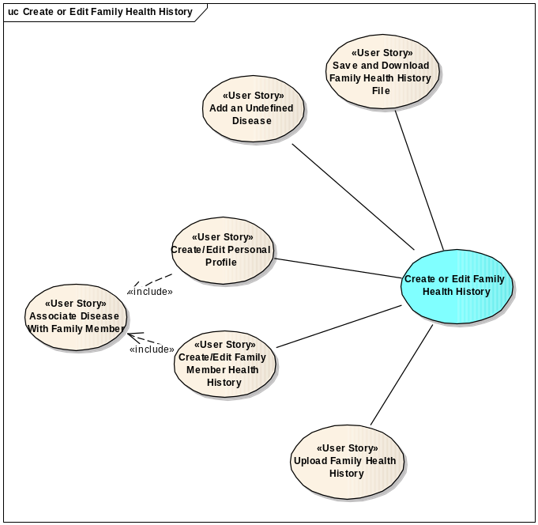
Figure 2. User Stories comprising Create or Edit Family Health History

View Pedigree Chart
This is a system use case which creates a pedigree chart of the family health history based on the selected profile. The user can select to limit the profile to select disease(s), or view all. The chart includes a diagram (pedigree chart) and information in tabular format.
This use case is composed of several user stories as outlined in Figure 3. User Stories comprising View Pedigree Chart, below.
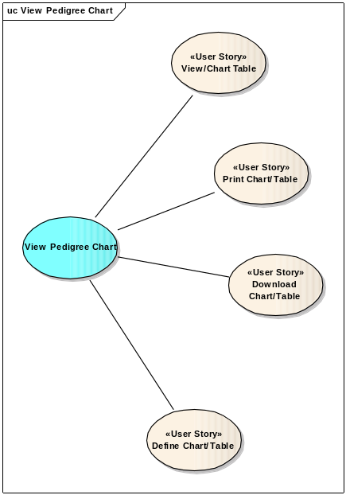
Figure 3. User Stories comprising View Pedigree Chart

Re-Index Profile
This use case allows a family member to take a previously created health profile record and change it so that they become the primary patient.

Get File
This is an external use case that deals with the physical movement of the XML file so that it can be accessed and processed by third party applications.

Process File
This is an external use case which allows a clinician to import and process the generated XML from the MFHP system through any third party application (Risk assessment, EHR, etc).

Export to HealthVault
This use case enables a user to export their medical health history information to Microsoft HealthVault.

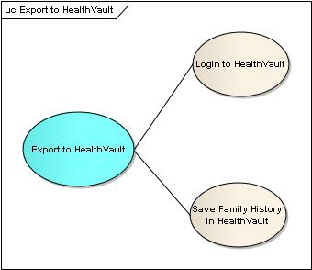

Import From HealthVault
This use case enables a user to import their medical health history information from Microsoft HealthVault.

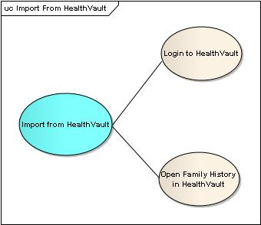

Logical View

Overview
The design model describes the structural hierarchy of the system in layers, packages, and subsystems.
MFHP will be implemented as a JEE 5 application built on top of Java SE 5 (JDK version 1.5.0_10) employing the following core JEE technologies:
- JSP 2.0
- Servlet 2.4
- Struts 2.0

Architecturally Significant Design Elements

User Interface Layer
The MFHP user interface is accessed as a standard web application via HTTPS. It is implemented as a JEE web application employing Struts 2 as the Model-View-Controller implementation. This layer provides presentation, navigation and validation functionality only. Validation logic at this level is limited to standard form based validation (e.g. checking for appropriate field formats) and is implemented using Strut2 2 validation. The pages presented to the web client use HTML and JavaScript only; no applets or other client-side component technologies are used.

Remote Java API/web service
The MFHP component that translates MFHP domain objects to the HL7 Family History XSD will be a “service-ready” class. Under the expectation that MFHP may in the future support output files in other flavors than HL7 (for example, CCD), the system will be flexible enough to support translation to other output formats, using web service or remote Java API. The service-ready interfaces and their exposed operations will be more fully developed and expressed during the elaboration phase.

MFHP Domain Classes
This section will describe the classes used to model the person and organization information provided by MFHP.
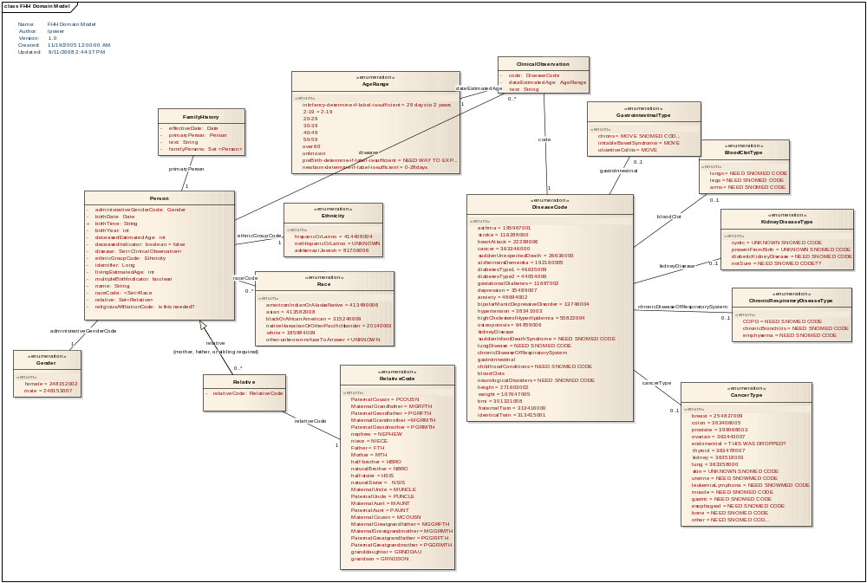
Figure 4. MFHP Domain Classes

HealthVault Domain Model
The HealthVault is a condition-centric approach to tracking family health history, where the focus is on the conditions in the family rather than the structure. This is clearly shown in the domain model.
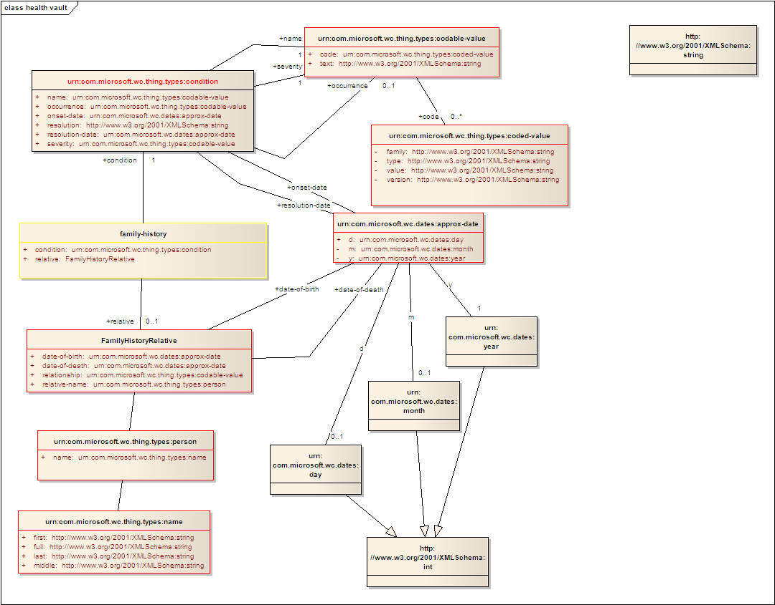
Figure 5 HealthVault Domain Model

Export to Microsoft HealthVault
The user Login process is handled entirely within HealthVault. Control is passed to HealthVault, where the user is prompted to enter their credential or create a new HealthVault account. Once authorized, HealthVault returns control to MFHP along with a user token for subsequent HealthVault access in the session.

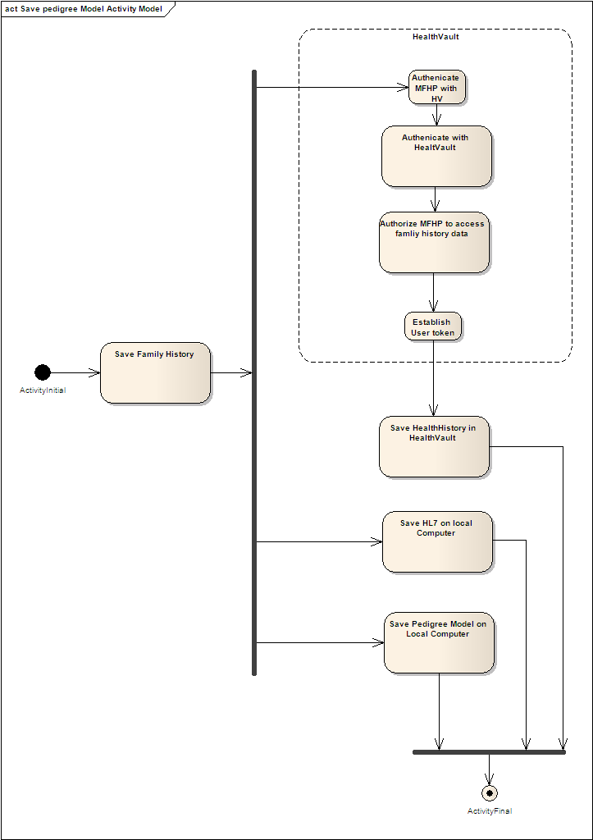
Figure 6 Export to HealthVault Activity Model

Import from Microsoft HealthVault
As with Export, the user Login process is handled entirely within HealthVault and once authorized, HealthVault returns control to MFHP along with a user token for subsequent HealthVault access in the session.

Implementation View

HL7 Family History (Pedigree) Model
The MFHP tool will export information in conformance with the HL7 Family History (Pedigree) model.
The rich HL7 Family History model includes information outside the scope of the MFHP tool; therefore, MFHP will use only certain components of the HL7 Family History model (those that are relevant to the information collected by the MFHP tool). The diagram below indicates the components of the HL7 Family History tool that MFHP will use. This diagram was provided to the MFHP team from members of the HL7 Family History Model team; the original model is property of HL7 and is used below only to indicate which components of it will be used by MFHP.
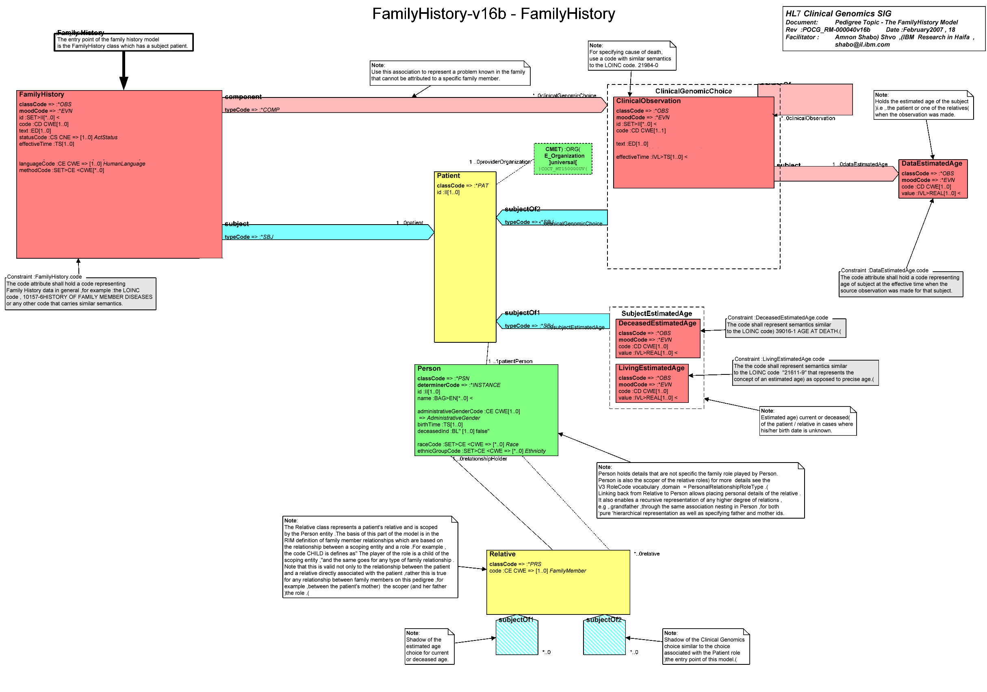
Figure 7. Classes of HL7 Family History model used by MFHP.

HL7 Family History (Pedigree) Schema
Please see Appendix , below for details on the HL7 Family History schema and a copy of the XSD.

Codes
See the gForge repository for an updated table of the various coded values used by the application.
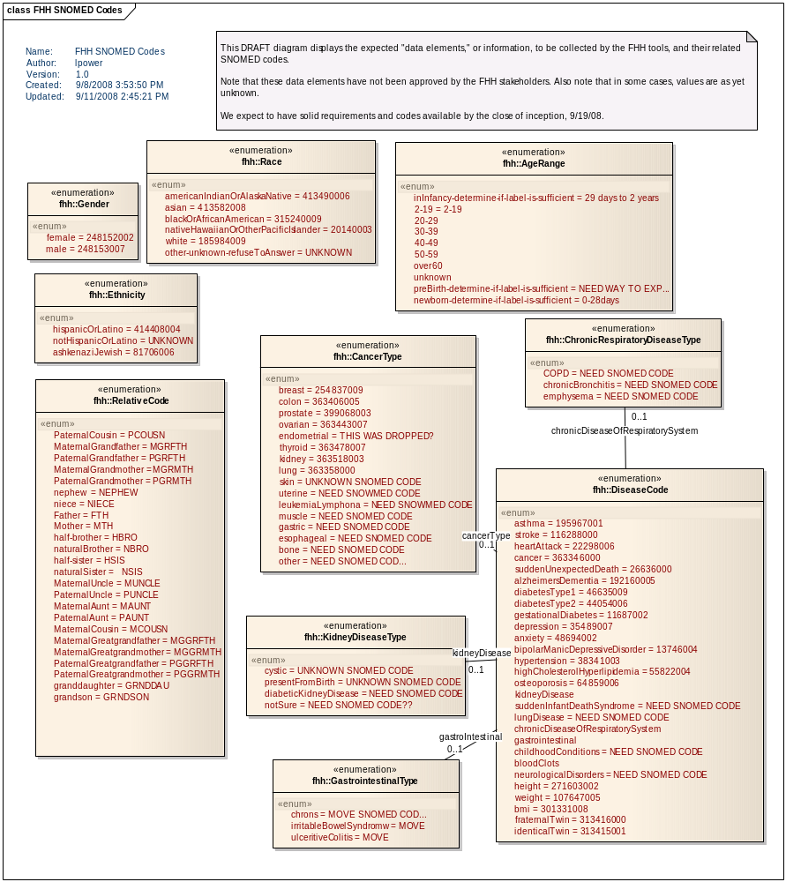
Figure 7. Information to be captured by MFHP, and related SNOMED and HL7 codes.

Deployment View
The MFHP web application is deployed such that the configuration for the authentication to health is a local file system change and there is a clear separation. This allows for either system to change with out requiring a reintegration of the other.
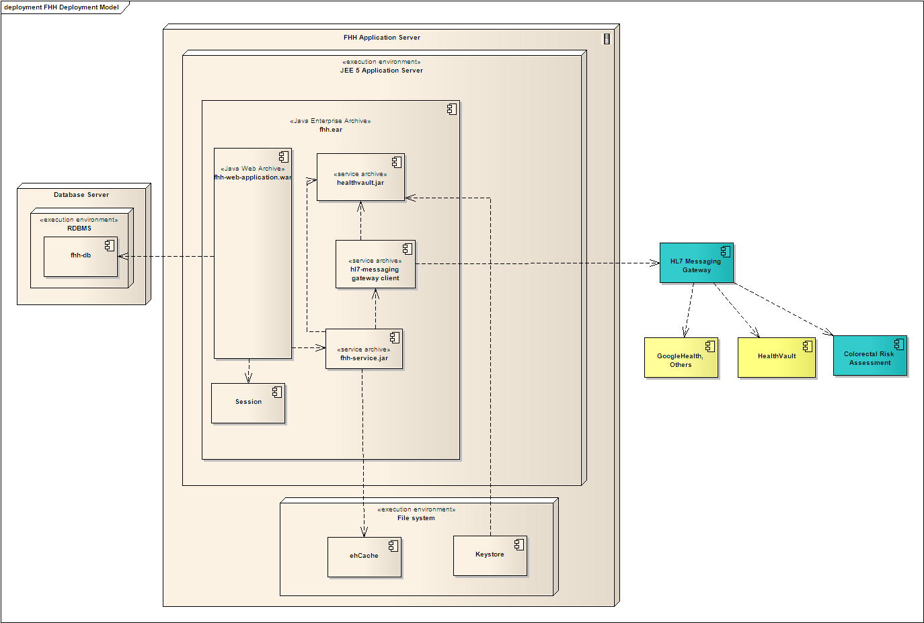
Figure 8. MFHP Deployment Model

Appendix

HL7 Family History (Pedigree) XSD
The table below shows the HL7 Family History (Pedigree) Model XSD. MFHP will export information in conformance with this XSD. Because MFHP does not concern itself with all of the information covered by the model, its files will represent a conformant subset.
POCG_MT000040.xsd

<?xml version="1.0" encoding="UTF-8" standalone="no"?>
<xs:schema xmlns:xs="http://www.w3.org/2001/XMLSchema" xmlns="urn:hl7-org:v3" xmlns:mif="urn:hl7-org:v3/mif" targetNamespace="urn:hl7-org:v3" elementFormDefault="qualified">
<!--
*****************************************************************************************************************
* XML schema for message type POCG_MT000040.
* Source information:
* Rendered by: RoseTree 4.0.2
* Rendered on:
* HMD was rendered into XML using software provided to HL7 by Beeler Consulting LLC.
HMD to MIF Transform: $Id: RoseTreeHmdToMIFStaticModel.xsl,v 1.12 2005/07/19 04:27:26 lmckenzi Exp $
Base transform: $Id: ConvertBase.xsl,v 1.2 2005/04/17 03:20:15 lmckenzi Exp $
Package Id Conversion: $Id: TransformPackageIds.xsl,v 1.3 2005/07/31 05:19:52 lmckenzi Exp $
HTML To MIF markup: $Id: HtmlToMIFMarkup.xsl,v 1.2 2005/04/17 03:20:15 lmckenzi Exp $
Flat to Serialization Transform: $Id: MIFStaticModelFlatToSerialization.xsl,v 1.3 2005/04/17 03:20:15 lmckenzi Exp $
Fix Names Transform: $Id: FixMifNames.xsl,v 1.6 2005/04/17 03:20:15 lmckenzi Exp $
Base transform: $Id: ConvertBase.xsl,v 1.2 2005/04/17 03:20:15 lmckenzi Exp $
Package Id Conversion: $Id: TransformPackageIds.xsl,v 1.3 2005/07/31 05:19:52 lmckenzi Exp $
*
* Generated by XMLITS version 2.0
* MIF to XSD Transform $Id: StaticMifToXsd.xsl,v 1.25 2005/07/09 20:20:15 lmckenzi Exp $
* Package Id Conversion: $Id: TransformPackageIds.xsl,v 1.3 2005/07/31 05:19:52 lmckenzi Exp $
*
* Copyright (c) 2002, 2003, 2004, 2005 Health Level Seven. All rights reserved.
* Redistribution and use in source and binary forms, with or without
* modification, are permitted provided that the following conditions
* are met:
* 1. Redistributions of source code must retain the above copyright
* notice, this list of conditions and the following disclaimer.
* 2. Redistributions in binary form must reproduce the above copyright
* notice, this list of conditions and the following disclaimer in the
* documentation and/or other materials provided with the distribution.
* 3. All advertising materials mentioning features or use of this software
* must display the following acknowledgement:
* This product includes software developed by Health Level Seven.
* THIS SOFTWARE IS PROVIDED BY HEALTH LEVEL SEVEN, INC. AND CONTRIBUTORS "AS IS" AND
* ANY EXPRESS OR IMPLIED WARRANTIES, INCLUDING, BUT NOT LIMITED TO, THE
* IMPLIED WARRANTIES OF MERCHANTABILITY AND FITNESS FOR A PARTICULAR PURPOSE
* ARE DISCLAIMED. IN NO EVENT SHALL THE REGENTS OR CONTRIBUTORS BE LIABLE
* FOR ANY DIRECT, INDIRECT, INCIDENTAL, SPECIAL, EXEMPLARY, OR CONSEQUENTIAL
* DAMAGES (INCLUDING, BUT NOT LIMITED TO, PROCUREMENT OF SUBSTITUTE GOODS
* OR SERVICES; LOSS OF USE, DATA, OR PROFITS; OR BUSINESS INTERRUPTION)
* HOWEVER CAUSED AND ON ANY THEORY OF LIABILITY, WHETHER IN CONTRACT, STRICT
* LIABILITY, OR TORT (INCLUDING NEGLIGENCE OR OTHERWISE) ARISING IN ANY WAY
* OUT OF THE USE OF THIS SOFTWARE, EVEN IF ADVISED OF THE POSSIBILITY OF
* SUCH DAMAGE.
*
********************************************************************************************************************
-->
<xs:annotation>
<xs:documentation>Generated using schema builder version 2.0. Stylesheets:was rendered into XML using software provided to HL7 by Beeler Consulting LLC.
HMD to MIF Transform: $Id: RoseTreeHmdToMIFStaticModel.xsl,v 1.12 2005/07/19 04:27:26 lmckenzi Exp $
Base transform: $Id: ConvertBase.xsl,v 1.2 2005/04/17 03:20:15 lmckenzi Exp $
Package Id Conversion: $Id: TransformPackageIds.xsl,v 1.3 2005/07/31 05:19:52 lmckenzi Exp $
HTML To MIF markup: $Id: HtmlToMIFMarkup.xsl,v 1.2 2005/04/17 03:20:15 lmckenzi Exp $
Flat to Serialization Transform: $Id: MIFStaticModelFlatToSerialization.xsl,v 1.3 2005/04/17 03:20:15 lmckenzi Exp $
Fix Names Transform: $Id: FixMifNames.xsl,v 1.6 2005/04/17 03:20:15 lmckenzi Exp $
Base transform: $Id: ConvertBase.xsl,v 1.2 2005/04/17 03:20:15 lmckenzi Exp $
Package Id Conversion: $Id: TransformPackageIds.xsl,v 1.3 2005/07/31 05:19:52 lmckenzi Exp $.xsl version 2.0</xs:documentation>
</xs:annotation>
<xs:include schemaLocation="../coreschemas/infrastructureRoot.xsd"/>
<xs:include schemaLocation="../coreschemas/NarrativeBlock.xsd"/>
<xs:include schemaLocation="COCT_MT930000.xsd"/>
<xs:complexType name="POCG_MT000040.Age">
<xs:sequence>
<xs:group ref="InfrastructureRootElements"/>
<xs:element name="code" type="CD" minOccurs="0"/>
<xs:element name="value" type="IVL_PQ" minOccurs="0"/>
<xs:element name="pertinentInformation" type="POCG_MT000040.PertinentInformation" nillable="true"/>
</xs:sequence>
<xs:attributeGroup ref="InfrastructureRootAttributes"/>
<xs:attribute name="classCode" type="ActClassObservation" use="optional" default="OBS"/>
<xs:attribute name="moodCode" type="ActMood" use="optional" fixed="EVN"/>
</xs:complexType>
<xs:complexType name="POCG_MT000040.AnalysisResult">
<xs:sequence>
<xs:group ref="InfrastructureRootElements"/>
<xs:element name="code" type="CD" minOccurs="0"/>
<xs:element name="value" type="ANY" minOccurs="0"/>
</xs:sequence>
<xs:attributeGroup ref="InfrastructureRootAttributes"/>
<xs:attribute name="classCode" type="ActClassObservation" use="optional" default="OBS"/>
<xs:attribute name="moodCode" type="ActMood" use="optional" fixed="EVN"/>
</xs:complexType>
<xs:complexType name="POCG_MT000040.ClinicalObservation">
<xs:sequence>
<xs:group ref="InfrastructureRootElements"/>
<xs:element name="code" type="CD"/>
<xs:element name="text" type="ED" minOccurs="0"/>
<xs:element name="effectiveTime" type="IVL_TS" minOccurs="0"/>
<xs:element name="confidentialityCode" type="CE" minOccurs="0" maxOccurs="unbounded"/>
<xs:element name="uncertaintyCode" type="CE" minOccurs="0"/>
<xs:element name="value" type="ANY" minOccurs="0"/>
<xs:element name="methodCode" type="CE" minOccurs="0" maxOccurs="unbounded"/>
<xs:element name="subject" type="POCG_MT000040.Subject4" nillable="true" minOccurs="0"/>
<xs:element name="sourceOf" type="POCG_MT000040.SourceOf" nillable="true" minOccurs="0" maxOccurs="unbounded"/>
</xs:sequence>
<xs:attributeGroup ref="InfrastructureRootAttributes"/>
<xs:attribute name="classCode" type="ActClassObservation" use="optional" default="OBS"/>
<xs:attribute name="moodCode" type="ActMood" use="optional" fixed="EVN"/>
<xs:attribute name="negationInd" type="bl" use="optional"/>
</xs:complexType>
<xs:complexType name="POCG_MT000040.Component">
<xs:sequence>
<xs:group ref="InfrastructureRootElements"/>
<xs:choice>
<xs:element name="age" type="POCG_MT000040.Age" nillable="true"/>
<xs:element name="analysisResult" type="POCG_MT000040.AnalysisResult" nillable="true"/>
<xs:element name="percentageRisk" type="POCG_MT000040.PercentageRisk" nillable="true"/>
<xs:element name="probability" type="POCG_MT000040.Probability" nillable="true"/>
<xs:element name="relativeRisk" type="POCG_MT000040.RelativeRisk" nillable="true"/>
</xs:choice>
</xs:sequence>
<xs:attributeGroup ref="InfrastructureRootAttributes"/>
<xs:attribute name="typeCode" type="ActRelationshipHasComponent" use="optional" default="COMP"/>
</xs:complexType>
<xs:complexType name="POCG_MT000040.Component2">
<xs:sequence>
<xs:group ref="InfrastructureRootElements"/>
<xs:choice>
<xs:element name="geneticLocus" type="COCT_MT930000.GeneticLocus" nillable="true"/>
<xs:element name="clinicalObservation" type="POCG_MT000040.ClinicalObservation" nillable="true"/>
</xs:choice>
</xs:sequence>
<xs:attributeGroup ref="InfrastructureRootAttributes"/>
<xs:attribute name="typeCode" type="ActRelationshipHasComponent" use="optional" default="COMP"/>
</xs:complexType>
<xs:complexType name="POCG_MT000040.Component3">
<xs:sequence>
<xs:group ref="InfrastructureRootElements"/>
<xs:element name="pedigreeAnalysisResults" type="POCG_MT000040.PedigreeAnalysisResults" nillable="true"/>
</xs:sequence>
<xs:attributeGroup ref="InfrastructureRootAttributes"/>
<xs:attribute name="typeCode" type="ActRelationshipHasComponent" use="optional" default="COMP"/>
</xs:complexType>
<xs:complexType name="POCG_MT000040.ControlVariable">
<xs:sequence>
<xs:group ref="InfrastructureRootElements"/>
<xs:element name="inputParameters" type="POCG_MT000040.InputParameters" nillable="true"/>
</xs:sequence>
<xs:attributeGroup ref="InfrastructureRootAttributes"/>
<xs:attribute name="typeCode" type="ActRelationshipType" use="optional" fixed="CTRLV"/>
</xs:complexType>
<xs:complexType name="POCG_MT000040.DataEstimatedAge">
<xs:sequence>
<xs:group ref="InfrastructureRootElements"/>
<xs:element name="code" type="CD" minOccurs="0"/>
<xs:element name="value" type="IVL_PQ" minOccurs="0"/>
</xs:sequence>
<xs:attributeGroup ref="InfrastructureRootAttributes"/>
<xs:attribute name="classCode" type="ActClassObservation" use="optional" default="OBS"/>
<xs:attribute name="moodCode" type="ActMood" use="optional" fixed="EVN"/>
</xs:complexType>
<xs:complexType name="POCG_MT000040.DeceasedEstimatedAge">
<xs:sequence>
<xs:group ref="InfrastructureRootElements"/>
<xs:element name="code" type="CD" minOccurs="0"/>
<xs:element name="value" type="IVL_PQ" minOccurs="0"/>
</xs:sequence>
<xs:attributeGroup ref="InfrastructureRootAttributes"/>
<xs:attribute name="classCode" type="ActClassObservation" use="optional" default="OBS"/>
<xs:attribute name="moodCode" type="ActMood" use="optional" fixed="EVN"/>
</xs:complexType>
<xs:complexType name="POCG_MT000040.FamilyHistory">
<xs:sequence>
<xs:group ref="InfrastructureRootElements"/>
<xs:element name="id" type="II" minOccurs="0" maxOccurs="unbounded"/>
<xs:element name="code" type="CD" minOccurs="0"/>
<xs:element name="text" type="ED" minOccurs="0"/>
<xs:element name="effectiveTime" type="TS" minOccurs="0"/>
<xs:element name="confidentialityCode" type="CE" minOccurs="0" maxOccurs="unbounded"/>
<xs:element name="uncertaintyCode" type="CE" minOccurs="0"/>
<xs:element name="languageCode" type="CE" minOccurs="0"/>
<xs:element name="methodCode" type="CE" minOccurs="0" maxOccurs="unbounded"/>
<xs:element name="subject" type="POCG_MT000040.Subject5" nillable="true" minOccurs="0"/>
<xs:element name="component1" type="POCG_MT000040.Component2" nillable="true" minOccurs="0" maxOccurs="unbounded"/>
<xs:element name="component2" type="POCG_MT000040.Component3" nillable="true" minOccurs="0" maxOccurs="unbounded"/>
</xs:sequence>
<xs:attributeGroup ref="InfrastructureRootAttributes"/>
<xs:attribute name="classCode" type="ActClassObservation" use="optional" default="OBS"/>
<xs:attribute name="moodCode" type="ActMood" use="optional" fixed="EVN"/>
</xs:complexType>
<xs:complexType name="POCG_MT000040.InputParameters">
<xs:sequence>
<xs:group ref="InfrastructureRootElements"/>
<xs:element name="code" type="CD" minOccurs="0"/>
<xs:element name="text" type="ED" minOccurs="0"/>
<xs:element name="value" type="ANY" minOccurs="0"/>
</xs:sequence>
<xs:attributeGroup ref="InfrastructureRootAttributes"/>
<xs:attribute name="classCode" type="ActClassObservation" use="optional" default="OBS"/>
<xs:attribute name="moodCode" type="ActMood" use="optional" fixed="EVN.CRT"/>
</xs:complexType>
<xs:complexType name="POCG_MT000040.LivingEstimatedAge">
<xs:sequence>
<xs:group ref="InfrastructureRootElements"/>
<xs:element name="code" type="CD" minOccurs="0"/>
<xs:element name="value" type="IVL_PQ" minOccurs="0"/>
</xs:sequence>
<xs:attributeGroup ref="InfrastructureRootAttributes"/>
<xs:attribute name="classCode" type="ActClassObservation" use="optional" default="OBS"/>
<xs:attribute name="moodCode" type="ActMood" use="optional" fixed="EVN"/>
</xs:complexType>
<xs:complexType name="POCG_MT000040.Patient">
<xs:sequence>
<xs:group ref="InfrastructureRootElements"/>
<xs:element name="id" type="II" minOccurs="0"/>
<xs:element name="patientPerson" type="POCG_MT000040.Person" nillable="true"/>
<xs:element name="provider" type="POCG_MT000040.Provider" nillable="true" minOccurs="0"/>
<xs:element name="subjectOf1" type="POCG_MT000040.Subject3" nillable="true" minOccurs="0" maxOccurs="unbounded"/>
<xs:element name="subjectOf2" type="POCG_MT000040.Subject" nillable="true" minOccurs="0" maxOccurs="unbounded"/>
</xs:sequence>
<xs:attributeGroup ref="InfrastructureRootAttributes"/>
<xs:attribute name="classCode" type="RoleClass" use="optional" fixed="PAT"/>
</xs:complexType>
<xs:complexType name="POCG_MT000040.PedigreeAnalysisResults">
<xs:sequence>
<xs:group ref="InfrastructureRootElements"/>
<xs:element name="id" type="II" minOccurs="0" maxOccurs="unbounded"/>
<xs:element name="code" type="CD" minOccurs="0"/>
<xs:element name="derivationExpr" type="ST" minOccurs="0"/>
<xs:element name="text" type="ED" minOccurs="0"/>
<xs:element name="effectiveTime" type="IVL_TS" minOccurs="0"/>
<xs:element name="methodCode" type="CE" minOccurs="0" maxOccurs="unbounded"/>
<xs:element name="component" type="POCG_MT000040.Component" nillable="true" minOccurs="0" maxOccurs="unbounded"/>
<xs:element name="controlVariable" type="POCG_MT000040.ControlVariable" nillable="true" minOccurs="0" maxOccurs="unbounded"/>
</xs:sequence>
<xs:attributeGroup ref="InfrastructureRootAttributes"/>
<xs:attribute name="classCode" type="ActClassObservation" use="optional" default="OBS"/>
<xs:attribute name="moodCode" type="ActMood" use="optional" fixed="EVN"/>
<xs:attribute name="negationInd" type="bl" use="optional"/>
</xs:complexType>
<xs:complexType name="POCG_MT000040.PercentageRisk">
<xs:sequence>
<xs:group ref="InfrastructureRootElements"/>
<xs:element name="code" type="CD" minOccurs="0"/>
<xs:element name="value" type="INT" minOccurs="0"/>
</xs:sequence>
<xs:attributeGroup ref="InfrastructureRootAttributes"/>
<xs:attribute name="classCode" type="ActClassObservation" use="optional" default="OBS"/>
<xs:attribute name="moodCode" type="ActMood" use="optional" fixed="EVN"/>
</xs:complexType>
<xs:complexType name="POCG_MT000040.Person">
<xs:sequence>
<xs:group ref="InfrastructureRootElements"/>
<xs:element name="id" type="II" minOccurs="0"/>
<xs:element name="name" type="EN" minOccurs="0" maxOccurs="unbounded"/>
<xs:element name="telecom" type="TEL" minOccurs="0" maxOccurs="unbounded"/>
<xs:element name="administrativeGenderCode" type="CE" minOccurs="0"/>
<xs:element name="birthTime" type="TS" minOccurs="0"/>
<xs:element name="deceasedInd" type="BL" minOccurs="0"/>
<xs:element name="deceasedTime" type="TS" minOccurs="0"/>
<xs:element name="raceCode" type="CE" minOccurs="0" maxOccurs="unbounded"/>
<xs:element name="ethnicGroupCode" type="CE" minOccurs="0" maxOccurs="unbounded"/>
<xs:element name="relative" type="POCG_MT000040.Relative" nillable="true" minOccurs="0" maxOccurs="unbounded"/>
</xs:sequence>
<xs:attributeGroup ref="InfrastructureRootAttributes"/>
<xs:attribute name="classCode" type="EntityClass" use="optional" fixed="PSN"/>
<xs:attribute name="determinerCode" type="EntityDeterminer" use="optional" fixed="INSTANCE"/>
</xs:complexType>
<xs:complexType name="POCG_MT000040.PertinentInformation">
<xs:sequence>
<xs:group ref="InfrastructureRootElements"/>
<xs:element name="probability" type="POCG_MT000040.Probability" nillable="true"/>
</xs:sequence>
<xs:attributeGroup ref="InfrastructureRootAttributes"/>
<xs:attribute name="typeCode" type="ActRelationshipPertains" use="optional" default="PERT"/>
</xs:complexType>
<xs:complexType name="POCG_MT000040.Probability">
<xs:sequence>
<xs:group ref="InfrastructureRootElements"/>
<xs:element name="code" type="CD" minOccurs="0"/>
<xs:element name="value" type="PQ" minOccurs="0"/>
</xs:sequence>
<xs:attributeGroup ref="InfrastructureRootAttributes"/>
<xs:attribute name="classCode" type="ActClassObservation" use="optional" default="OBS"/>
<xs:attribute name="moodCode" type="ActMood" use="optional" fixed="EVN"/>
</xs:complexType>
<xs:complexType name="POCG_MT000040.Provider">
<xs:sequence>
<xs:group ref="InfrastructureRootElements"/>
<xs:element name="id" type="II" minOccurs="0" maxOccurs="unbounded"/>
<xs:element name="name" type="EN" minOccurs="0" maxOccurs="unbounded"/>
</xs:sequence>
<xs:attributeGroup ref="InfrastructureRootAttributes"/>
<xs:attribute name="classCode" type="EntityClassOrganization" use="optional" default="ORG"/>
<xs:attribute name="determinerCode" type="EntityDeterminer" use="optional" fixed="INSTANCE"/>
</xs:complexType>
<xs:complexType name="POCG_MT000040.Relative">
<xs:sequence>
<xs:group ref="InfrastructureRootElements"/>
<xs:element name="code" type="CE" minOccurs="0"/>
<xs:element name="relationshipHolder" type="POCG_MT000040.Person" nillable="true" minOccurs="0"/>
<xs:element name="subjectOf1" type="POCG_MT000040.Subject3" nillable="true" minOccurs="0" maxOccurs="unbounded"/>
<xs:element name="subjectOf2" type="POCG_MT000040.Subject" nillable="true" minOccurs="0" maxOccurs="unbounded"/>
</xs:sequence>
<xs:attributeGroup ref="InfrastructureRootAttributes"/>
<xs:attribute name="classCode" type="RoleClass" use="optional" fixed="PRS"/>
</xs:complexType>
<xs:complexType name="POCG_MT000040.RelativeRisk">
<xs:sequence>
<xs:group ref="InfrastructureRootElements"/>
<xs:element name="code" type="CD" minOccurs="0"/>
<xs:element name="value" type="PQ" minOccurs="0"/>
</xs:sequence>
<xs:attributeGroup ref="InfrastructureRootAttributes"/>
<xs:attribute name="classCode" type="ActClassObservation" use="optional" default="OBS"/>
<xs:attribute name="moodCode" type="ActMood" use="optional" fixed="EVN"/>
</xs:complexType>
<xs:complexType name="POCG_MT000040.SourceOf">
<xs:sequence>
<xs:group ref="InfrastructureRootElements"/>
<xs:element name="clinicalObservation" type="POCG_MT000040.ClinicalObservation" nillable="true"/>
</xs:sequence>
<xs:attributeGroup ref="InfrastructureRootAttributes"/>
<xs:attribute name="typeCode" type="ActRelationshipType" use="required"/>
</xs:complexType>
<xs:complexType name="POCG_MT000040.Subject">
<xs:sequence>
<xs:group ref="InfrastructureRootElements"/>
<xs:choice>
<xs:element name="geneticLocus" type="COCT_MT930000.GeneticLocus" nillable="true"/>
<xs:element name="clinicalObservation" type="POCG_MT000040.ClinicalObservation" nillable="true"/>
</xs:choice>
</xs:sequence>
<xs:attributeGroup ref="InfrastructureRootAttributes"/>
<xs:attribute name="typeCode" type="ParticipationTargetSubject" use="optional" default="SBJ"/>
</xs:complexType>
<xs:complexType name="POCG_MT000040.Subject3">
<xs:sequence>
<xs:group ref="InfrastructureRootElements"/>
<xs:choice>
<xs:element name="deceasedEstimatedAge" type="POCG_MT000040.DeceasedEstimatedAge" nillable="true"/>
<xs:element name="livingEstimatedAge" type="POCG_MT000040.LivingEstimatedAge" nillable="true"/>
</xs:choice>
</xs:sequence>
<xs:attributeGroup ref="InfrastructureRootAttributes"/>
<xs:attribute name="typeCode" type="ParticipationTargetSubject" use="optional" default="SBJ"/>
</xs:complexType>
<xs:complexType name="POCG_MT000040.Subject4">
<xs:sequence>
<xs:group ref="InfrastructureRootElements"/>
<xs:element name="dataEstimatedAge" type="POCG_MT000040.DataEstimatedAge" nillable="true"/>
</xs:sequence>
<xs:attributeGroup ref="InfrastructureRootAttributes"/>
<xs:attribute name="typeCode" type="ActRelationshipType" use="optional" fixed="SUBJ"/>
</xs:complexType>
<xs:complexType name="POCG_MT000040.Subject5">
<xs:sequence>
<xs:group ref="InfrastructureRootElements"/>
<xs:element name="patient" type="POCG_MT000040.Patient" nillable="true"/>
</xs:sequence>
<xs:attributeGroup ref="InfrastructureRootAttributes"/>
<xs:attribute name="typeCode" type="ParticipationTargetSubject" use="optional" default="SBJ"/>
</xs:complexType>
</xs:schema>

Figure 9. HL7 Family History (Pedigree) XSD Format

