Task 1 — Grade Checker
Objective:
Create a Python program that accepts a student's marks and assigns a grade based on the given grading criteria.
Code:
marks = int(input("Enter your marks: "))
if marks >= 90:
grade = 'A'elif marks >= 80:
grade = 'B'
elif marks >= 70:
grade = 'C'
elif marks >= 60:
grade = 'D'
else:
grade = 'F'
print("Your grade is: " + grade)
Command used:
python GradeChecker.py
Explanation:
The program first asks the user to enter their marks using input(). Since input() returns the value as text, int() is used to convert the entered marks into an integer.
The program then uses an if/elif/else structure to determine the grade:
If the marks are 90 or above, the grade is A.
If the marks are 80 or above, the grade is B.
If the marks are 70 or above, the grade is C.
If the marks are 60 or above, the grade is D.
If none of these conditions are true, the grade is F.
Finally, the program displays the calculated grade using print().
Testing:
The program was tested with different marks, including 95, 86, 78, 69, 56, and the boundary values 90, 80, 70, 60, and 50. The program produced the expected grade for each test.

Screenshot
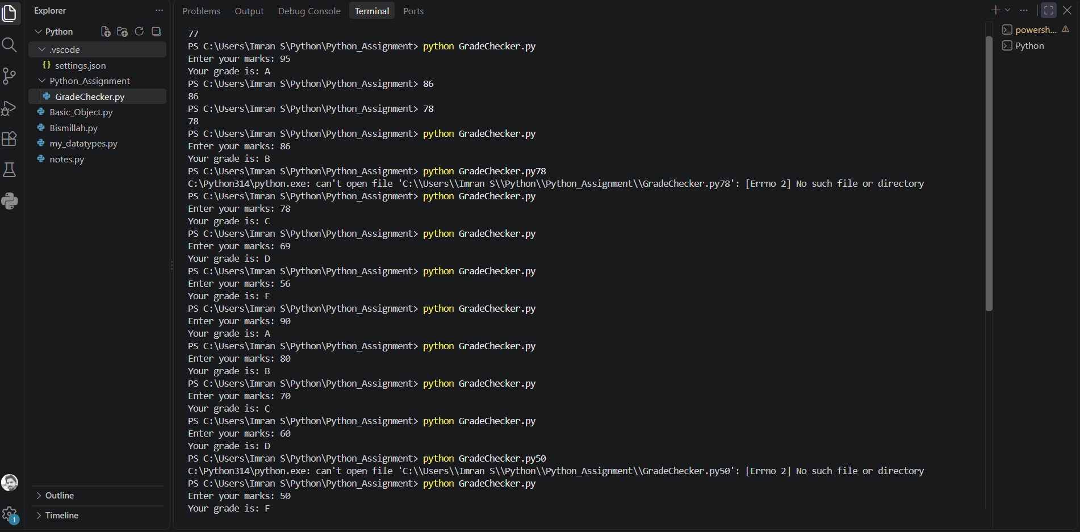
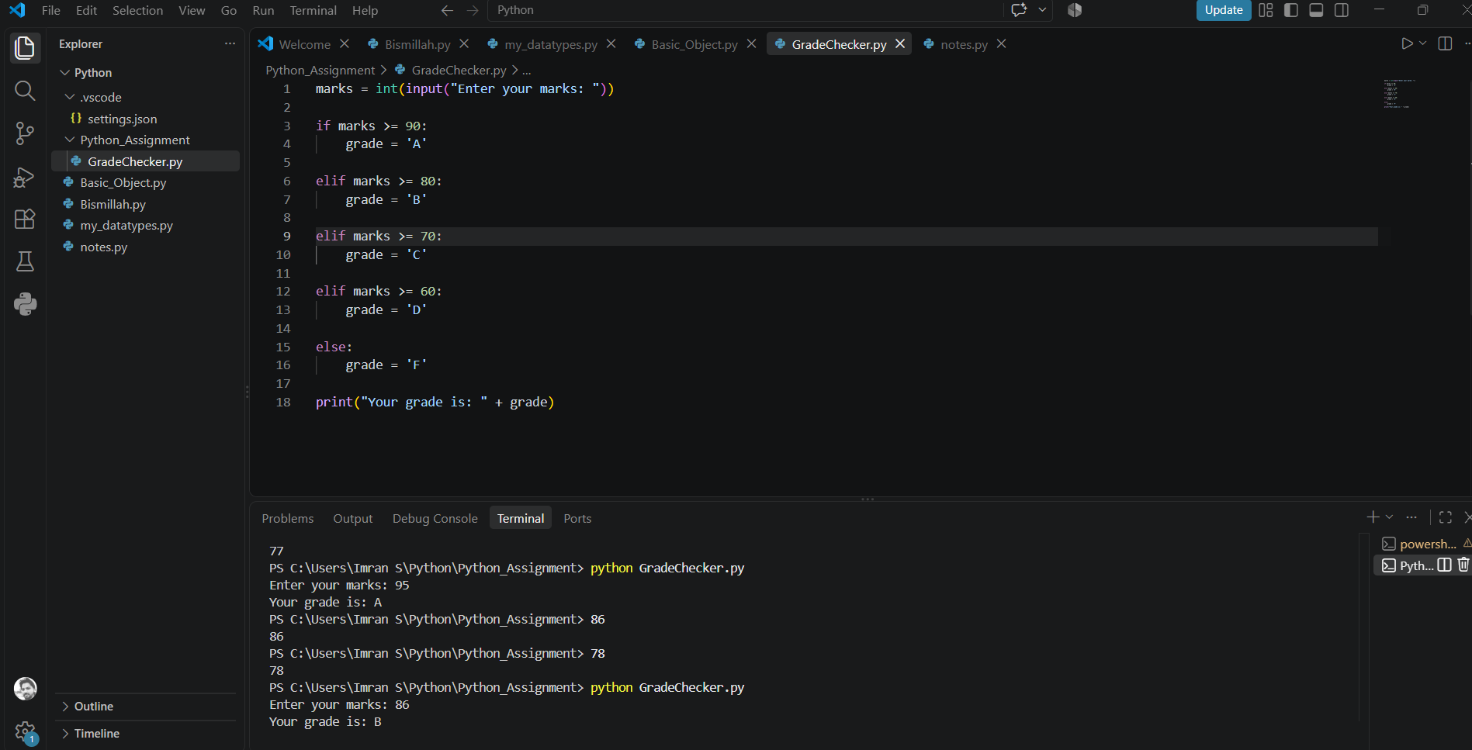

Task 2 — Student Grades
Objective:
Create a Python program using a dictionary to store student names and their grades. The program should allow the user to enter a student name and grade, update the grade if the student already exists, or add the student if they are new. Finally, it should display all student grades.
Code:
students = {
"Ali": 95,
"Rahul": 86,
"Ahmed": 78,
"Omkar": 69,
"Sameer": 56,
}
student = input("Enter student name: ")
if student in students:
print("Student exists")
else:
print("Student does not exist")
grade = int(input("Enter grade: "))
students[student] = grade
print("Student Grades:")
for student, grade in students.items():
print(f"{student}: {grade}")
Explanation:
The program first creates a dictionary named students, where each student's name is stored as a key and their grade is stored as the corresponding value.
The input() function is used to ask the user to enter a student name. The in operator with an if/else statement checks whether the entered student already exists in the dictionary.
The program then asks the user to enter the student's grade. The int() function converts the entered grade from text into an integer.
The statement: students[student] = grade
is used to store the student's grade in the dictionary. If the student already exists, their previous grade is updated. If the student does not exist, a new student is added to the dictionary.
Finally, the for loop with .items() goes through the dictionary and displays all the students along with their grades.
Testing:
1. Updating an Existing Student: The program was tested with the existing student Ali. His original grade was 95, and a new grade of 90 was entered. The output showed:
Ali: 90
This confirms that the existing student's grade was successfully updated.
2. Adding a New Student: The program was then tested with Imran, who was not present in the initial dictionary. A grade of 80 was entered.
The output showed:
Imran: 80
This confirms that a new student was successfully added to the dictionary.
Commands Used:
python StudentGrades.py
Screenshot:
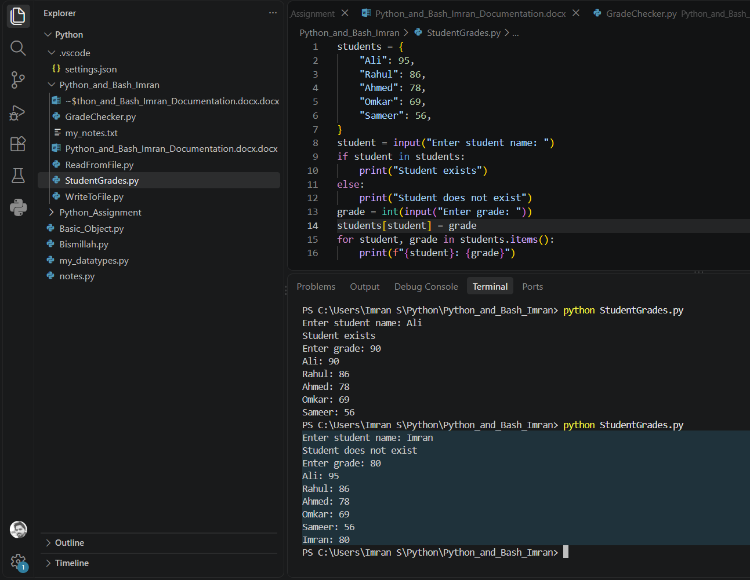

Task 3 — Write to File
Objective: Create a text file using Python and write content into it using open() and write().
Code:
with open("my_notes.txt", "w") as file:
file.write("This is my first Python file.")
Explanation:
The program uses the open() function with "w" mode to create and open a text file named my_notes.txt.
The "w" mode stands for write mode. It allows the program to write content into the file.
The file.write() method writes the following text into the file:
This is my first Python file.
The program uses the with statement to work with the file. Once the with block finishes, Python automatically closes the file.
Command Used:
The program was executed using:
python WriteToFile.py
The dir command was then used to verify that my_notes.txt was created.
Finally, the following command was used to verify the contents of the file:
type my_notes.txt
Result: The file was successfully created and contained:
This is my first Python file.
Screenshot:
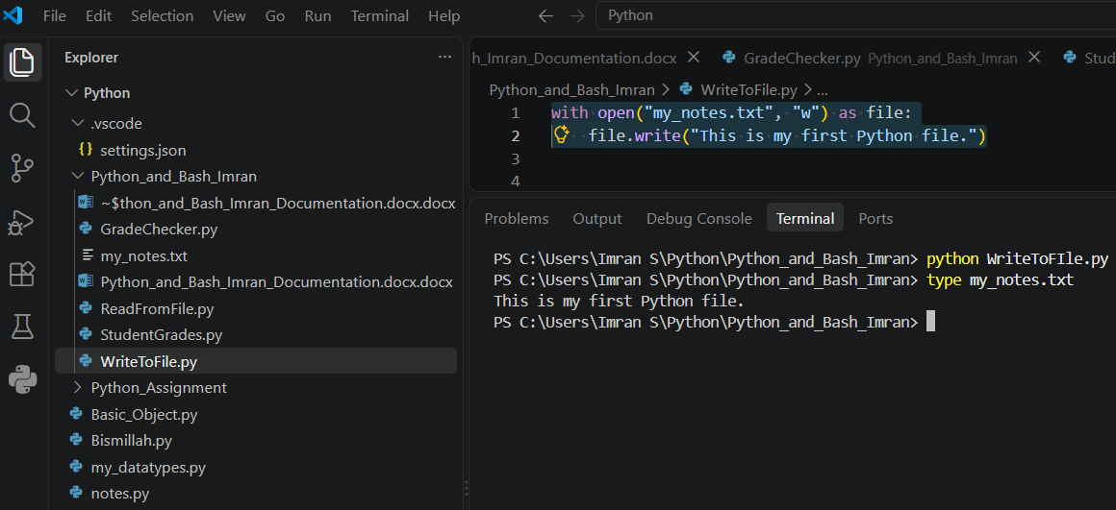

Task 4 — Read from File
Objective:
Read the contents of an existing text file using Python's open() function and the file.read() method.
Code:
with open("my_notes.txt", "r") as file:
content = file.read()
print(content)
Explanation: The program opens the existing my_notes.txt file using the open() function.
The "r" mode specifies that the file is being opened in read mode.
The file.read() method reads the complete contents of the file and stores the result in the content variable.
The print() function then displays the contents on the terminal.
The with statement manages the file properly and automatically closes it after the operation is completed.
Command Used:
The program was executed using:
python ReadFromFile.py
Result:
The program successfully read and displayed the contents of my_notes.txt:
This is my first Python file.
Screenshot:
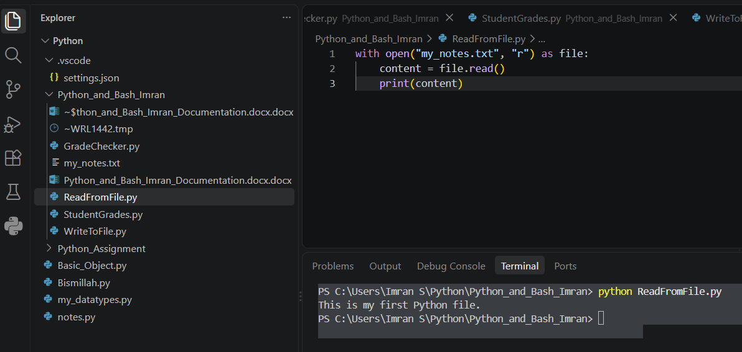

GitHub Repository Link: https://github.com/informimran-netizen/Python_and_Bash_Imran

