Packet totals

source="C:\\aaaeve\\eve.json" host="DESKTOP-D52LDB1" index="bot_scanning" | eval S_Packets=src_ip + dest_ip | eval packet_month=case(date_month=="january","01", date_month=="february","02", date_month=="march","03", date_month=="april","04", date_month=="may","05", date_month=="june","06", date_month=="july","07", date_month=="august","08", date_month=="september","09", date_month=="october","10", date_month=="november","11", date_month=="december","12") | eval packet_day=printf("%02d",date_mday) | eval Pcap_Date = (date_year + "-" + packet_month + "-" + packet_day) | where date_year in (2016, 2017) AND event_type == "alert" | chart sum(linecount) AS Total_Packets, distinct_count(S_Packets) AS SYN_Packets by Pcap_Date | eval Retran_Packets = Total_Packets - SYN_Packets

<http://localhost:8000/en-US/app/search/search?sid=1542062320.10222>

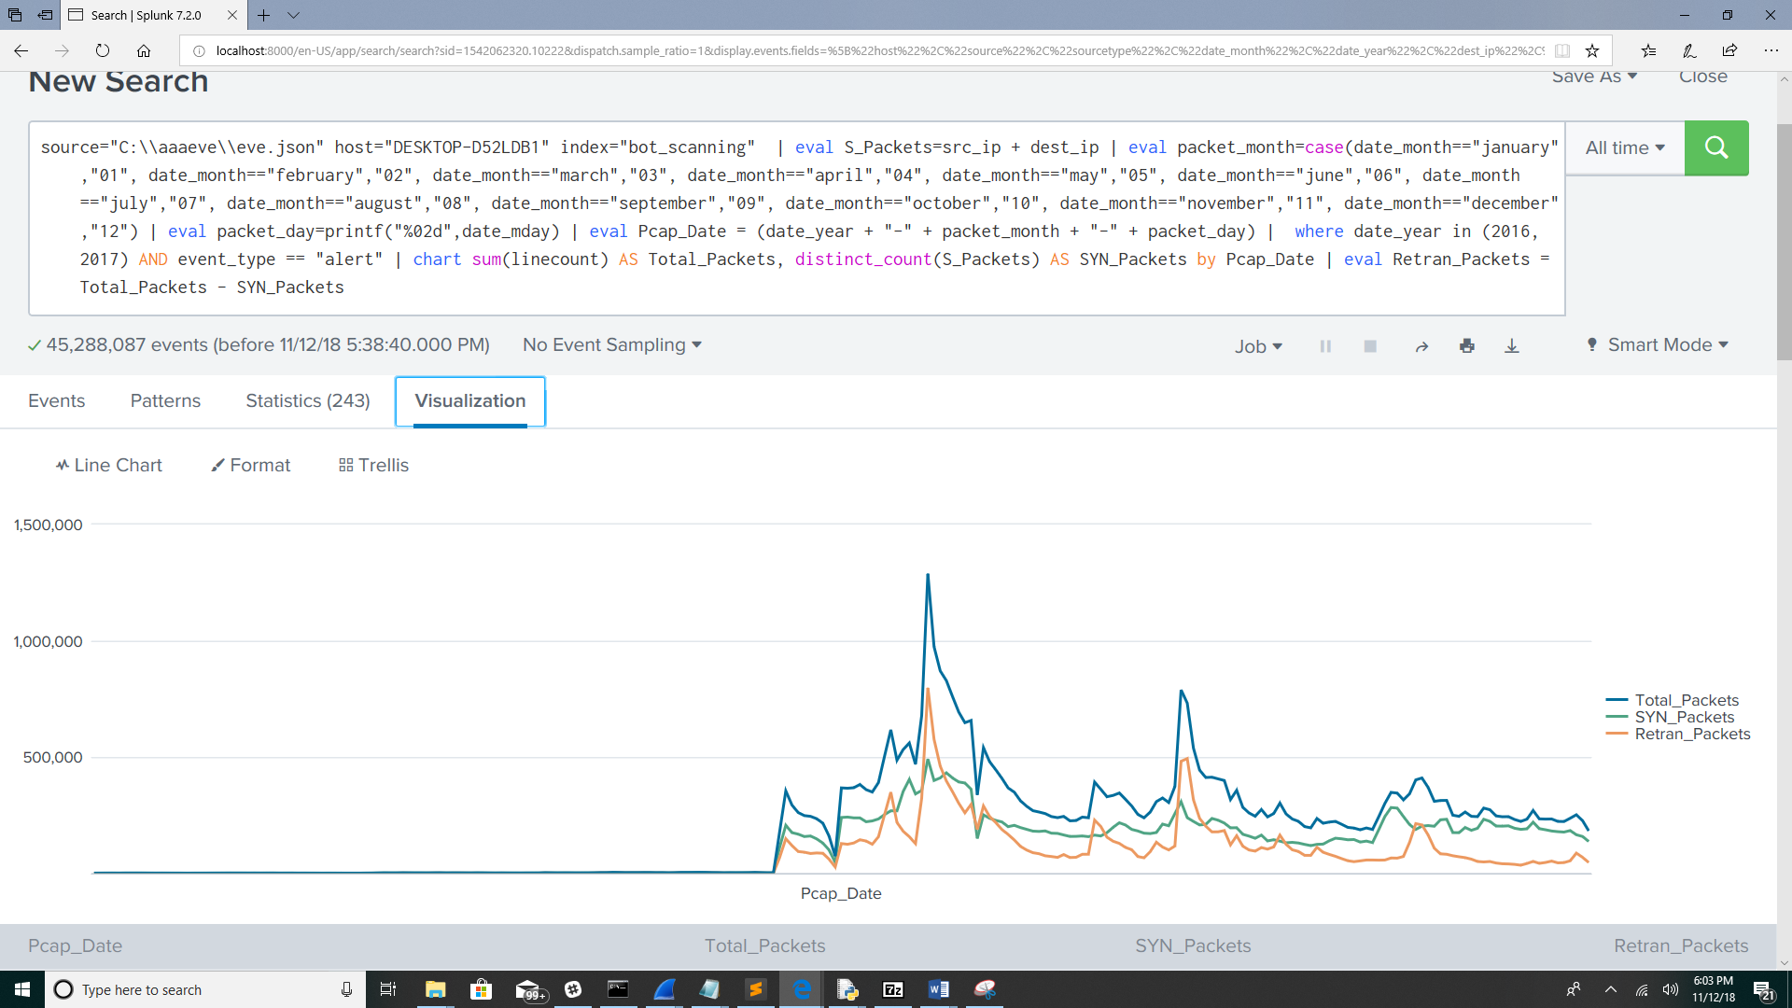

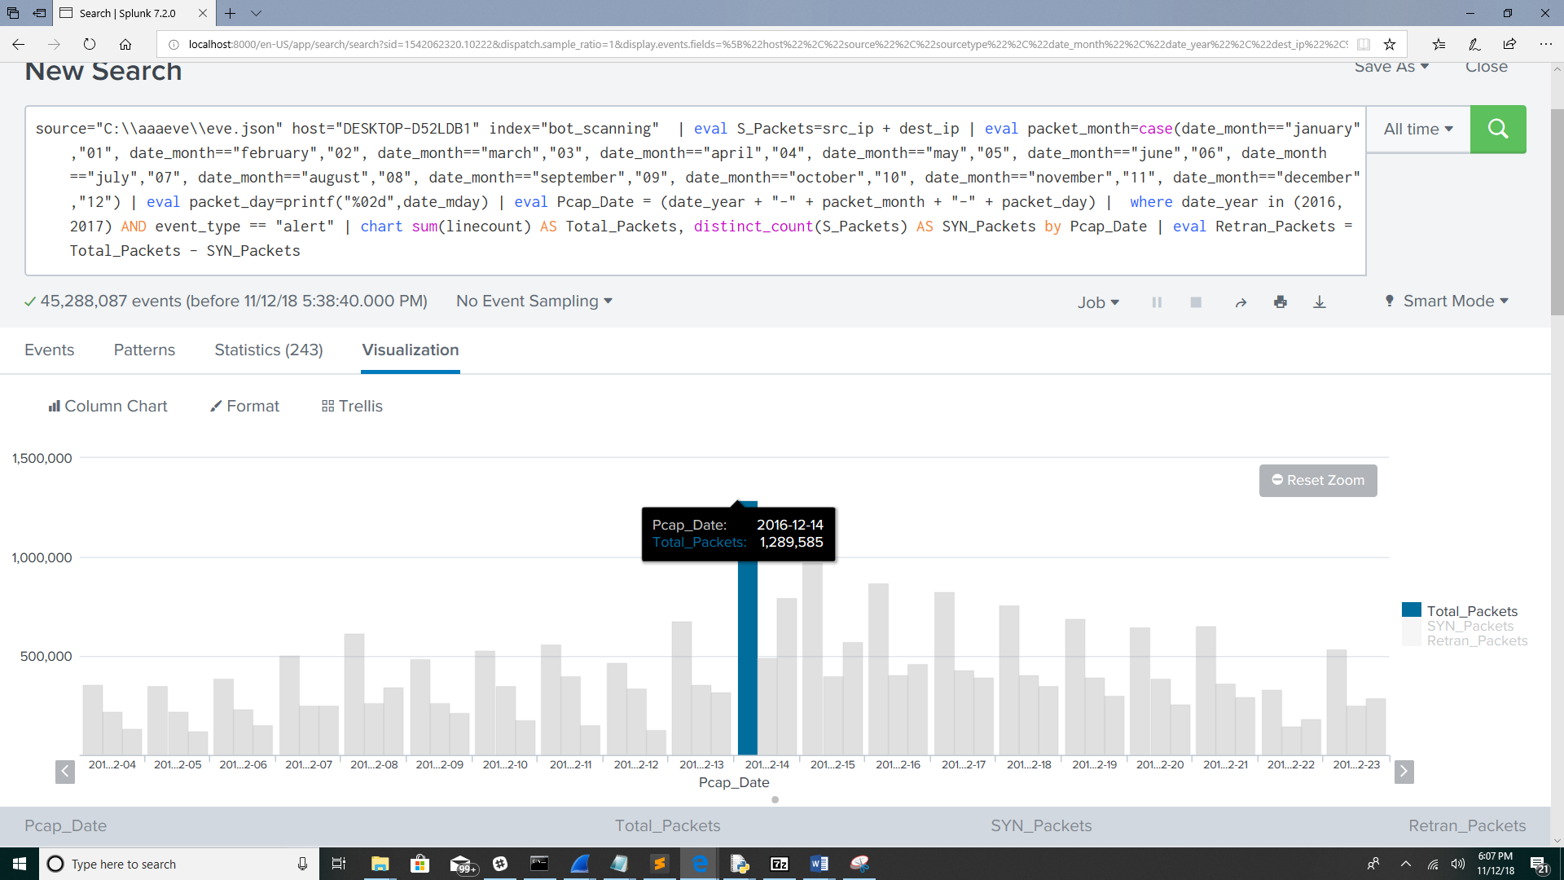

Bot Totals

source="C:\\aaaeve\\eve.json" host="DESKTOP-D52LDB1" index="bot_scanning" | eval packet_month=case(date_month=="january","01", date_month=="february","02", date_month=="march","03", date_month=="april","04", date_month=="may","05", date_month=="june","06", date_month=="july","07", date_month=="august","08", date_month=="september","09", date_month=="october","10", date_month=="november","11", date_month=="december","12") | eval packet_day=printf("%02d",date_mday) | eval Pcap_Date = (date_year + "-" + packet_month + "-" + packet_day) | where date_year in (2016, 2017) AND event_type == "alert" | chart distinct_count(src_ip) AS Bots, distinct_count(dest_ip) AS Pot_Bot_Victims by Pcap_Date

<http://desktop-d52ldb1:8000/en-US/app/search/search?sid=1541973888.3171>

