A data frame with 32 observations on 11 variables.

|  |  |  |
| --- | --- | --- |
| [, 1] | mpg | Miles/(US) gallon |
| [, 2] | cyl | Number of cylinders |
| [, 3] | disp | Displacement (cu.in.) |
| [, 4] | hp | Gross horsepower |
| [, 5] | drat | Rear axle ratio |
| [, 6] | wt | Weight (1000 lbs) |
| [, 7] | qsec | 1/4 mile time |
| [, 8] | vs | V/S |
| [, 9] | am | Transmission (0 = automatic, 1 = manual) |
| [,10] | gear | Number of forward gears |
| [,11] | carb | Number of carburetors |

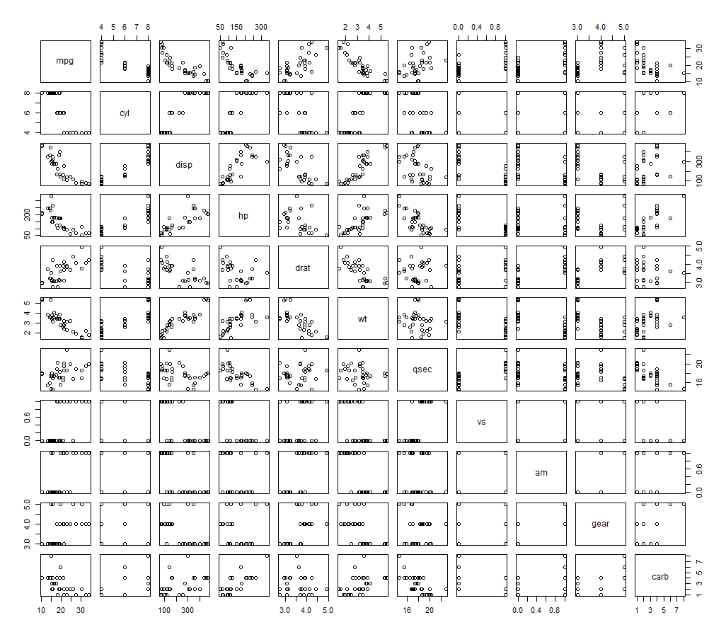

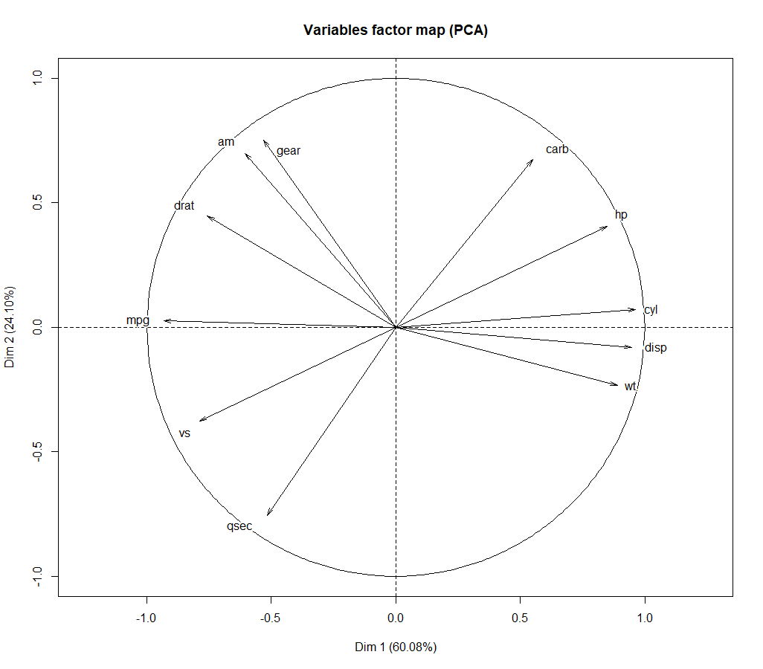

kPCA