
(U) Switchblade
April 30, 2014

(U) Table of Changes
Date | Change Description | Authority
04/30/14 | Created. | EDG/AED/EDB

(U) Table of Contents
1 Overview 1
2 System Architecture 2
3 Switchblade Configuration 3
3.1 Nginx Configuration 3
3.2 Network Routing 3
4 Configuration of Peer Components 4
4.1 Beacon Routers 4
4.2 Honeycomb Tool-handler 4
4.3 Cover Server 4

Overview
Switchblade is an authenticating proxy for operational use with with other proxy services such as Hive and Madison. Switchblade employs self-signed public key certificates in conjunction with open-source web server Nginx and Linux IP policy routing to pass authenticated data to a tool handler and unauthenticated data on to a cover server.

System Architecture
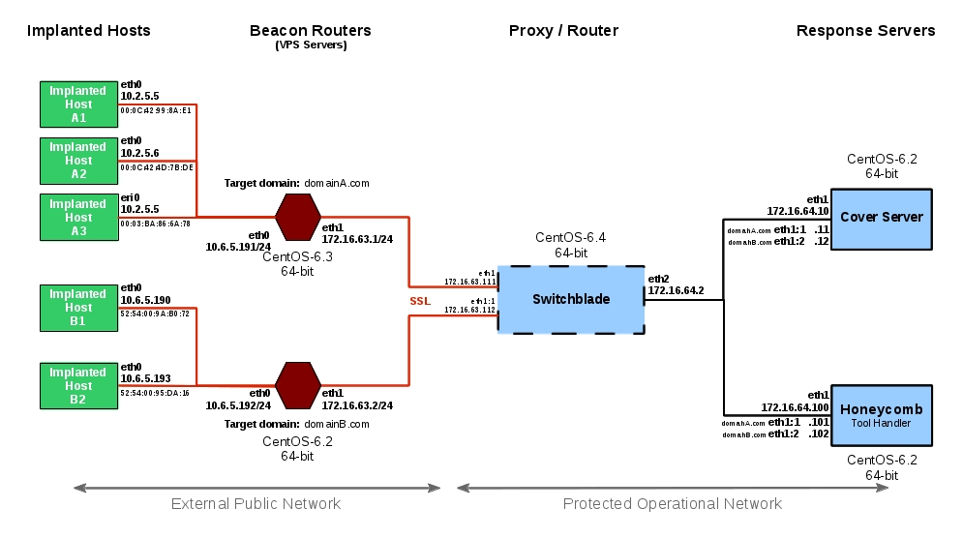
The following diagram shows a typical Switchblade networking environment.
Beacons from implanted hosts are assigned a beacon router having a cover domain name. Beacon routers are connected to the Switchblade proxy through VPN tunnels to provide security and privacy. Each beacon router / domain has its own dedicated interface and address on the Switchblade. A beacon arriving at a beacon router is routed to the Switchblade which authenticates the implant client's certificate. Authenticated beacon packets are then routed on to the Honeycomb tool-handler; all others are routed to a cover server corresponding to the domain of the beacon router. The configuration of Switchblade and its peer components allows the egress source address of beacon to be maintained through to the tool-handler or cover server for logging purposes.

Switchblade Configuration

Nginx Configuration
A configuration file named ssl.conf is installed in the /etc/nginx/conf.d directory and contains a server configuration section for each redirection domain.
The key configuration parameters are as follows:
# HTTPS server

server {
listen 172.16.63.113:443 ssl; ➊
server_name nginx.edb.devlan.net;

ssl_certificate /etc/nginx/certs/domainA/server.crt;
➋ ssl_certificate_key /etc/nginx/certs/domainA/server.key;
ssl_client_certificate /etc/nginx/certs/domainA/ca.crt;
ssl_verify_client optional;
ssl_verify_depth 2;
ssl_protocols TLSv1 TLSv1.1 TLSv1.2;
ssl_prefer_server_ciphers on;

proxy_set_header Host $host:$proxy_port;

➌ location / {
if ($ssl_client_verify = SUCCESS) {
proxy_pass http://172.16.64.100:4098;
}
proxy_pass http://172.16.64.12:44302;
}
}
➊ Listen address and port
➋ SSL certificate locations (and SSL configuration parameters)
➌ Redirection logic
The redirection logic checks the SSL client's certificate and, if valid, redirects the packets to the Honeycomb tool-handler at the specified address and port number (172.16.64.100, port 4098). All other traffic is sent to a corresponding cover server (address 172.16.64.12, port 44302).

Network Routing
Linux policy routing is used to sort routed packets and keep the implant beacon's source address intact.
#!/bin/bash
# Script to configure policy routing

echo -en “101\thiveA >> /etc/iproute2/rt_tables
echo -en “102\thiveB >> /etc/iproute2/rt_tables
ip route add default via 172.16.63.1 table hiveA
ip route add default via 172.16.63.2 table hiveB
ip rule add from 172.16.63.111 table hiveA prio 1
ip rule add from 172.16.63.112 table hiveB prio 1

Configuration of Peer Components

Beacon Routers

Honeycomb Tool-handler

Cover Server

