Our best of the best Zamboanga Tour Package just for you!



1. Travel Planning and Booking:

Tailored travel experiences with personalized itineraries, accommodation booking, and seamless transportation services. Let our experts craft a unique journey based on your preferences, interests, and budget.

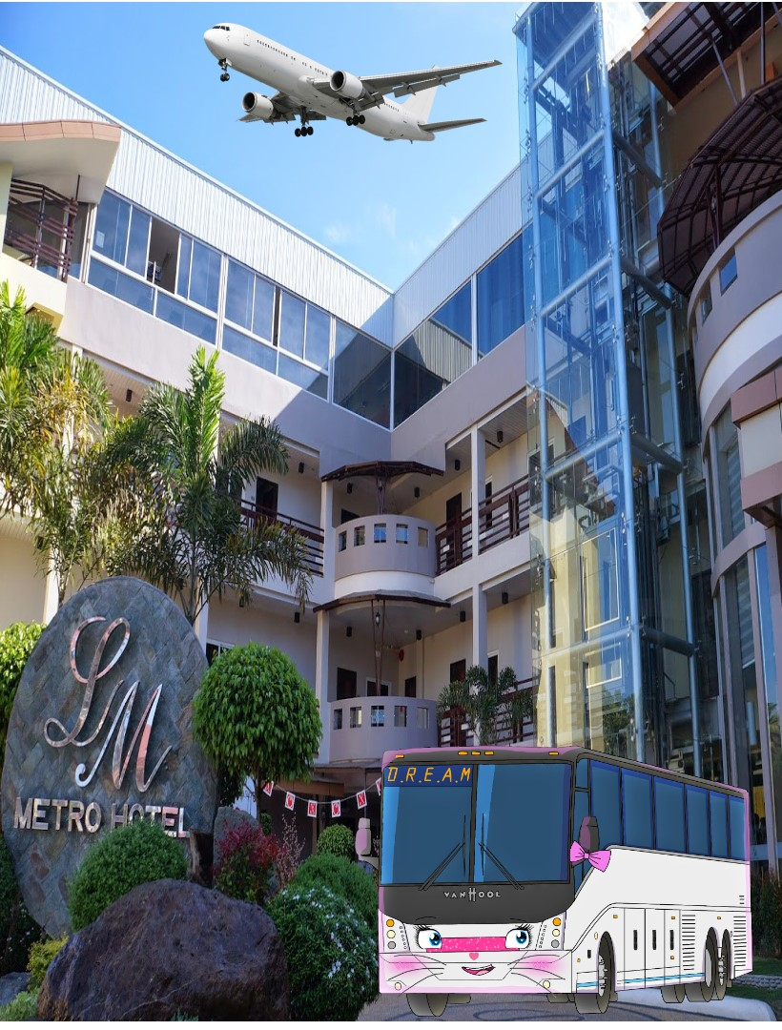



2. Tours and Excursions:

Local Guides: Elevate your travel with passionate local guides for deeper insights into culture, history, and attractions.

Group Tours: Enjoy well-organized group tours with scheduled activities for a fulfilling travel experience.

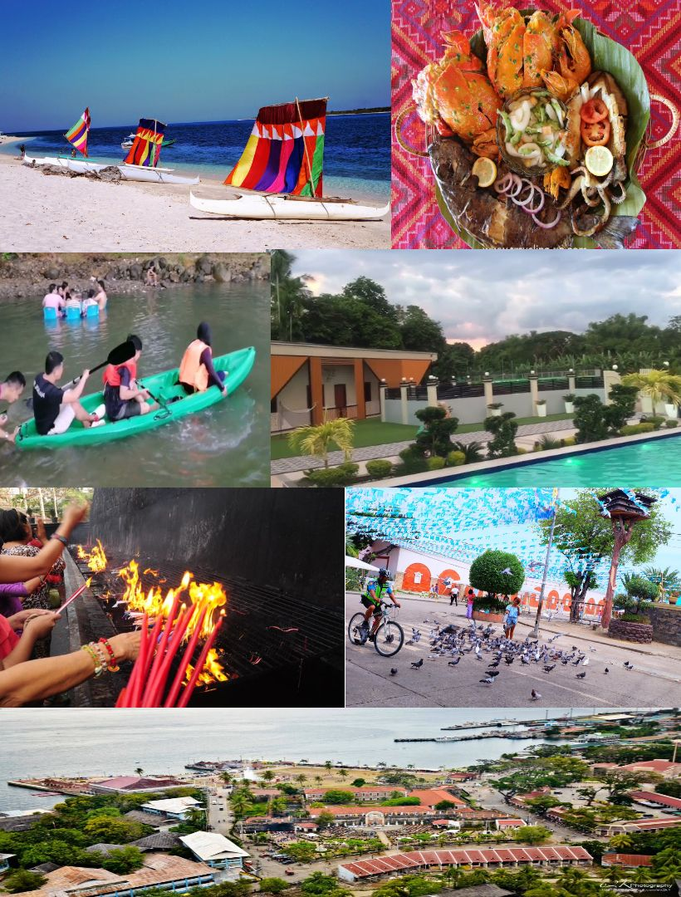Themed Tours: Explore your interests, from culinary delights to adventure, history, or cultural immersion, with our specialized tours.

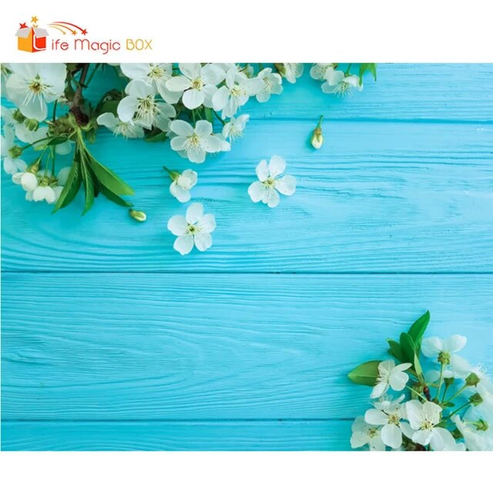

3. Travel Insurance and Assistance:

Travel with confidence using our insurance packages, covering trip cancellations, medical emergencies, and lost luggage. Benefit from 24/7 support for emergencies and dedicated assistance for issues like lost documents. Prioritize your well-being with our detailed safety

and health guidelines, offering essential information on precautions, local customs, and travel advisories.





PRICE!

Philippine Airlines-₱18,005

Bus-₱500(All destinations)

Food Budget-₱2,000(For the whole tour)

Hotel-₱3,000

Activities (Free)

Total= -₱23,005