Image to text conversion – Execution guidance

Type : 01

* Execution using **python code** and **command** **prompt**
* Before executing this command you need to navigate to the directory using the other commands

**Navigate to directory:**

1. Enter the drive identification ( C:/D:/E:)
2. Enter the full path : (full path where the python file is located)

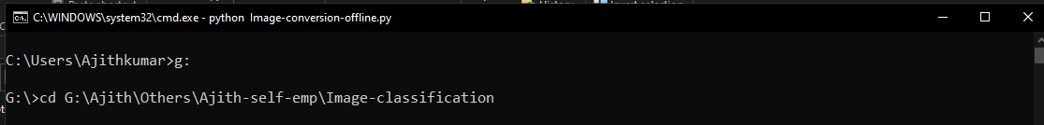

**Command to execute :** python Image-conversion-offline.py

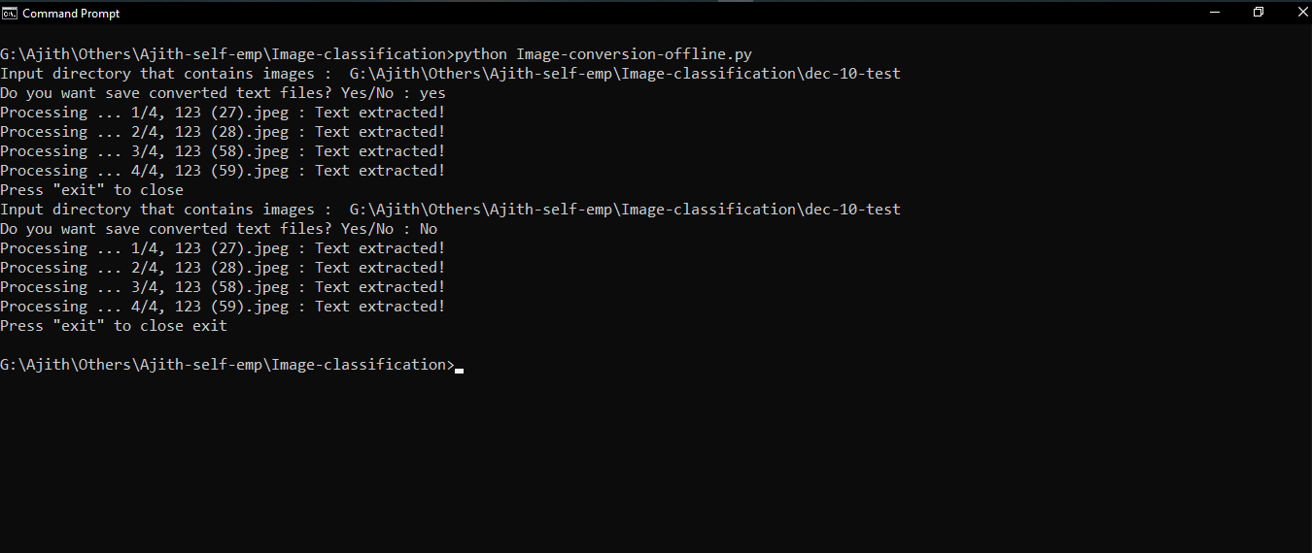

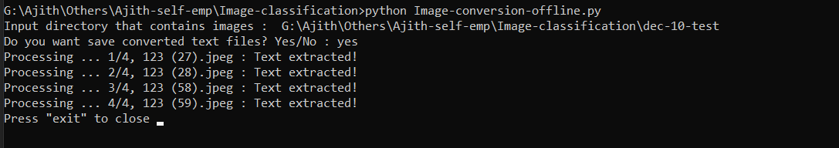

If you want to continue execution press “**Enter**”

If you want to stop execution type “**exit**”

Type : 02

**Using .bat file**

1. Type the commands like this in notepad++

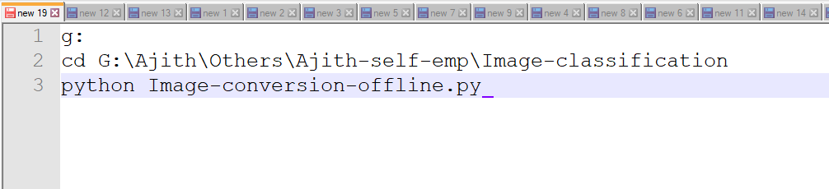

1. Save the file ends with “**.bat**” in any directory.

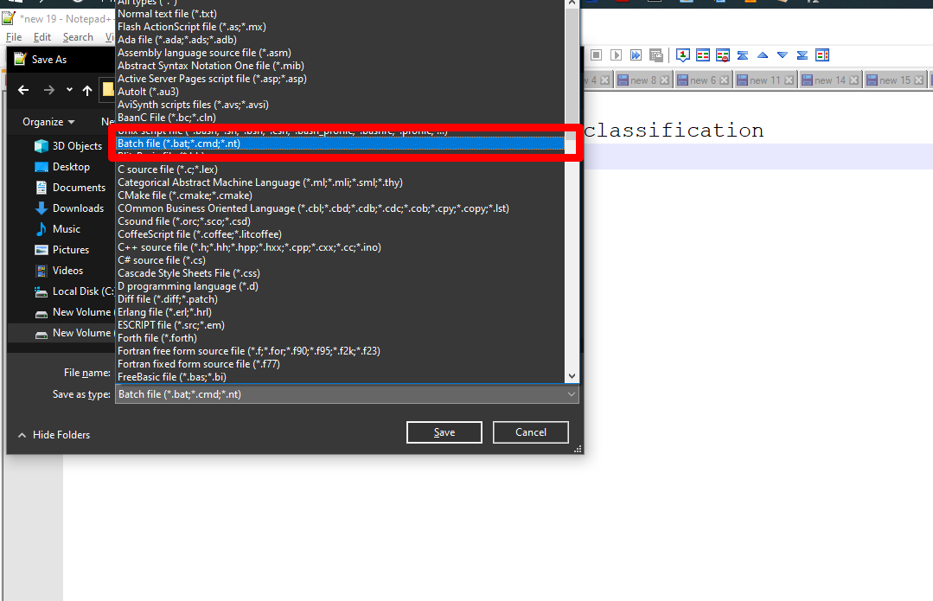

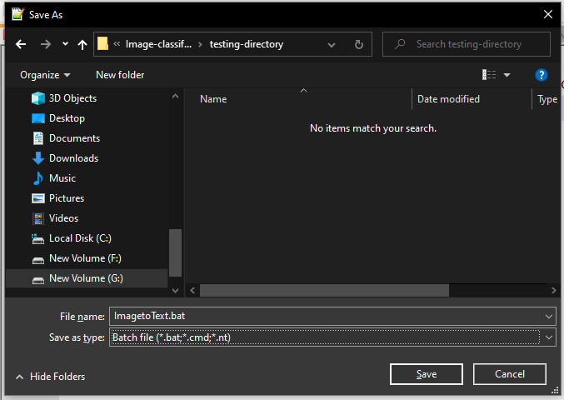

1. **Double click** on it or choose “**Run as administrator**” to execute the application

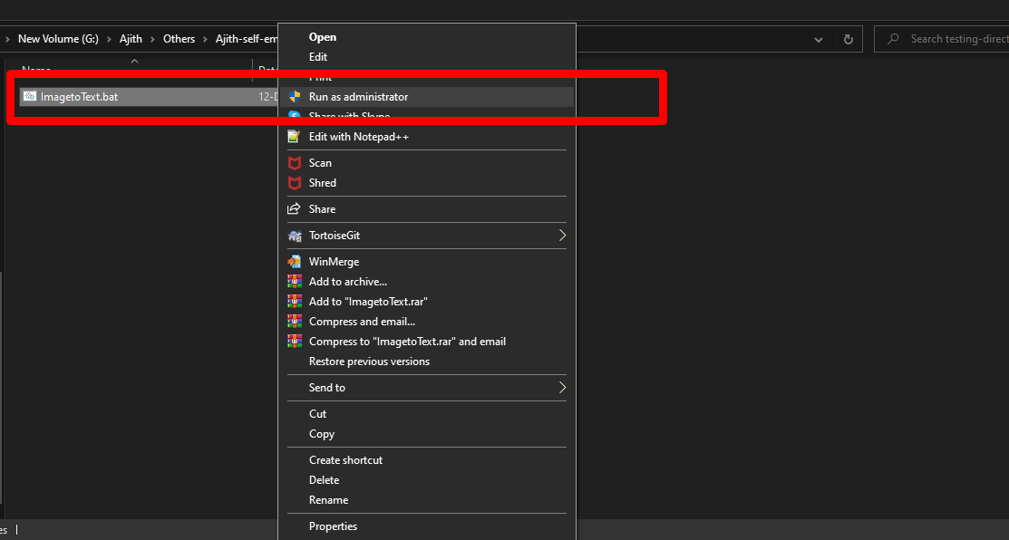

-----------------------------------------------------------------------------------------------------------------------------------

**Type: 03**

Run the exe file by double click on it

