**Image to text conversation: Installation guidelines Version:1.0**

**Step-01 :**

**Installation – One time process:**

The below requirements need to be installed before running the application.

1. **Python version 3+ -** 
   * **Source link :** <https://www.python.org/downloads/>
   * **Download**  the any of the links based on your system configuration

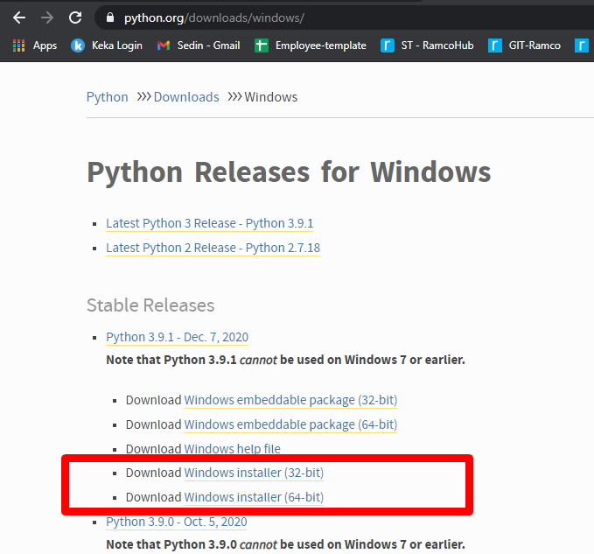

1. **Tesseract -**

* **Source link :** <https://github.com/UB-Mannheim/tesseract/wiki>
* **Download** any one of the links based upon your system configuration as shown in the image.

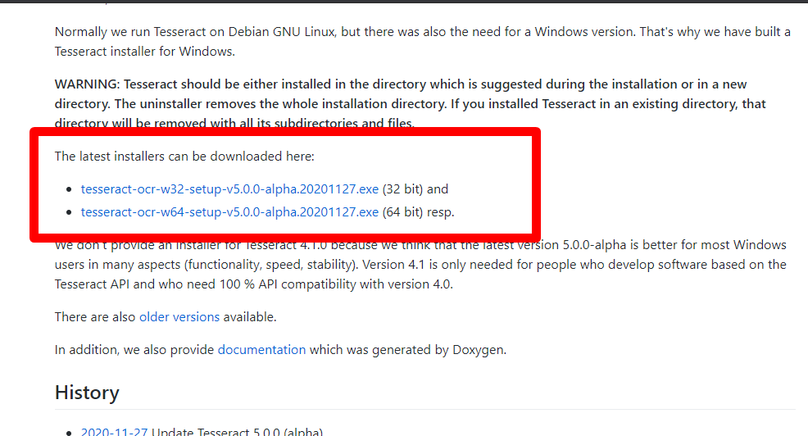

**Checking of correct installation:**

1. **Python** – type python and hit enter in a command prompt as shown in the image.

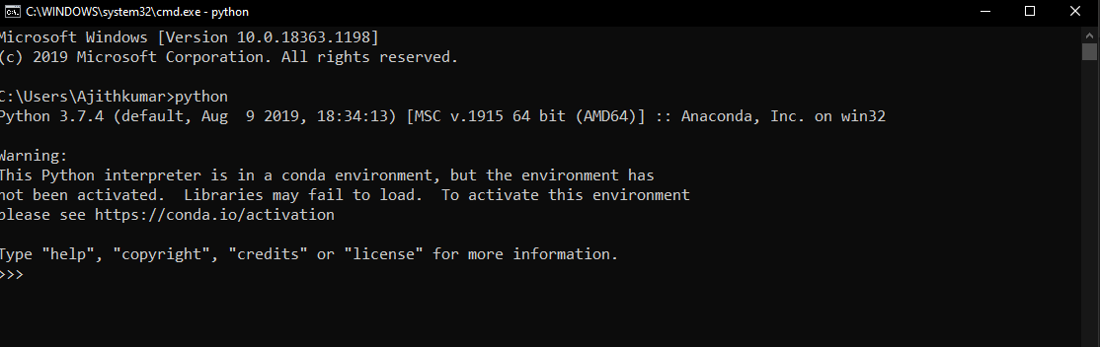

1. **Tesseract –** Check the installed directory in C drive.

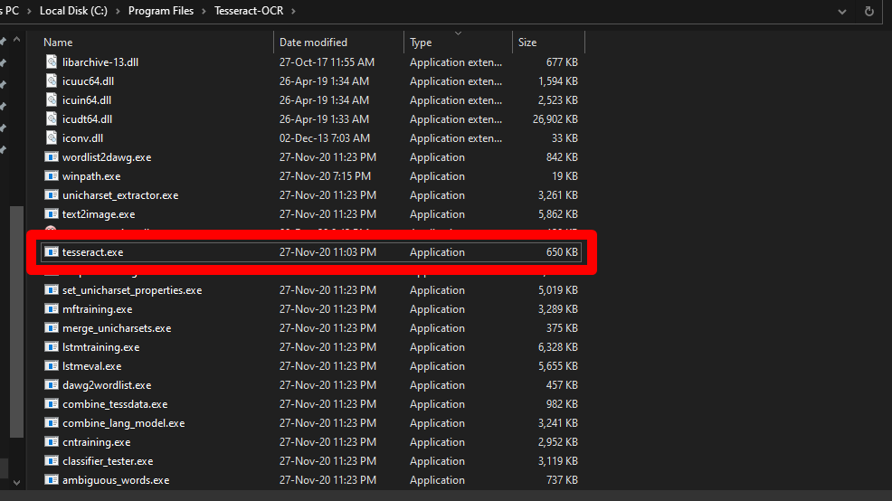

* Copy the above c drive path to the file “**CONFIG.py**”

**Note:** use double slash for the path

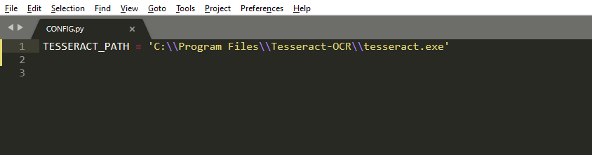

*We have successfully installed the requirements*

**--------------------------------------------------------------------------------------------**

**Step-02:**

**Python package installation – one time process after software installation:**

Run the below commands one after another ( if you get any error based on you network connectivity , please re run the command )

* Pip install openpyxl
* Pip install pyinstaller
* Pip install pytesseract

As shown in the below image , run the 3 commands one after another

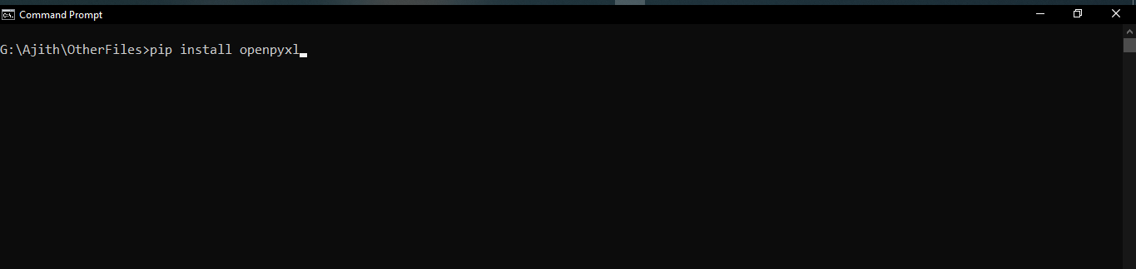

Now we have installed all the necessary items for this software !