A Universal Plant RNA Isolation Method Utilizing Double Grinding and Hot CTAB

Short Title: A Universal Plant RNA Isolation

Subject Category: Nucleic Acids

Corresponding Author:
Evan H. DeLucia, Department of Plant Biology, 1404 Institute for Genomic Biology, MC-195, University of Illinois, Urbana – Champaign, IL 61820. (217) 333-6177. delucia@life.uiuc.edu.

Title: A Universal Plant RNA Isolation Method Utilizing Double Grinding and Hot CTAB

Lauren M. Segal¹, Clare L. Casteel^{1,2}, and Evan H. DeLucia^{1,2}

¹Institute of Genomic Biology, ²Department of Plant Biology, University of Illinois, Urbana – Champaign
ABSTRACT
Understanding regulation of gene expression is the foundation for much of modern biology and often begins with extracting pure, high quality RNA. The extraction protocol described here (Double Grind Hot CTAB; DGHC) can be applied to a wide variety of tissues rich in secondary compounds and results in high-quality RNA, free of contamination, while using a minimal amount of tissue. This method requires no secondary cleanup or re-extractions minimizing time and subsequent yield loss. The extraction normally yields between 30µg and 180µg RNA from 800mg of tissue. This method has been utilized with 11 different species, including grape (Vitis vinifera), loblolly pine (Pinus taeda), poplar (Populus tremuloides), elm (Ulmus Americana), maple (Acer rubrum), cherry (Prunus avium), corn (Zea mays), wheat (Triticum awaestivum), tobacco (Nicotiana tabacum), tomato (Solanum lycopersicum), and arabidopsis (Arabidopsis thaliana). This protocol for RNA isolation is an ideal choice for plant tissue rich in secondary compounds.

Keywords: Carbohydrates; RNA; CTAB
INTRODUCTION
Isolation of high-quality ribonucleic acid (RNA) from loblolly pine (Pinus taeda L.) and other tree species is difficult because of the presence of secondary metabolites that co-precipitate with RNA. These contaminants result in impure RNA and inhibit downstream applications such as northern blot and microarrays by binding nucleic acids and proteins^{1,2,3}. Woody plant tissue and other plants with excessive amounts of secondary metabolites have high levels of polysaccharides, polyphenols and other phenolics⁴. In addition, viscous sap in woody plants, such as elm (Ulmus Americana) and pine interfere with the separation of solvent phases during the extraction process⁵ producing low yields and poor quality RNA.
Phytohormone signaling transcripts were previously demonstrated to be down-regulated in soybean (Glycine max) grown under elevated CO₂^{6,7,8}. We wanted to examine the impact of elevated CO₂ on phytohormone signaling transcripts across eleven different plant species, including several trees. This research required use of a minimum amount of tissue while still recovering high quality RNA in amounts suitable for qRT-PCR analysis. Although there are many protocols and kits (e.g. Chomczynski and Sacchi single step, UltraClean Plant RNA Isolation kit (MoBio), Qiagen RNeasy Plant kit, Agilent Plant RNA Isolation kit, Plant/Fungi RNA Purification kit) that have been used to extract RNA, these methods have failed to reliably extract RNA from our tree tissues.
Methods have been developed for isolation of total RNA from individual plant tissues, but they are often species specific and utilize phenol. Extraction reagents are commercially available for extracting RNA specifically from plant tissue (TRIzol (Sigma) and Concert Plant RNA reagent (Invitrogen)). However, attempts to use these reagents to extract RNA from our tree species have failed to produce an adequate quality or quantity of RNA necessary for downstream applications across species examined. Phenol based RNA extraction methods, such as the DB protocol⁹, are not suitable for plant species with excessive amounts of secondary compounds and polysaccharides, such as trees. Phenol causes oxidation of the secondary compounds resulting in brown extracts, poor quality RNA and low yields when used on tissue with excessive levels of these contaminates. Protocols that utilize Cetyl trimethylammonium bromide (CTAB) specifically target tissue rich in secondary metabolites ^{3,9,11}. These methods often require large amounts of tissue, are time consuming and often species-specific, forcing us to utilize more than four protocols when working with many different species, increasing overall cost. We developed a CTAB-based method, the Double Grind Hot CTAB (DGHC) protocol which reliably produced adequate amounts of high quality RNA for all 11 of our species examined (Fig. 1). The main limitation of our method is human error, thus, all steps must be followed carefully to prevent yield loss and contamination. Critical steps where human error is more likely are highlighted in the protocol.
The DGHC method for RNA isolation permits extraction of large quantities of pure RNA from a wide-range of species including the loblolly pine and other trees using minimal amounts of tissue. We have been able to extract clean RNA with high yields from grape (Vitis vinifera), loblolly pine (Pinus taeda), poplar (Populus tremuloides), elm (Ulmus Americana), maple (Acer rubrum), cherry (Prunus avium), corn (Zea mays), wheat (Triticum aestivum), tobacco (Nicotiana tabacum), tomato (Solanum lycopersicum), and arabidopsis (Arabidopsis thaliana), and we believe this method can be applied to an even wider variety of tissues (Table 1). This protocol has also been used for both small and large-scale extractions, with clean results for both. RNA isolated with the DGHC method is suitable for all downstream applications, like qRT-PCR, microarrays, northern blots analysis, and many others which require RNA to be very clean with A₂₆₀/A₂₃₀ ratios of 1.8 or higher¹².
The DGHC protocol is consistent and simple and can be reliably applied to a variety of plant tissue, including those rich in polysaccharides and waxes (i.e. grape leaves, loblolly pine, elm, red maple). The extraction takes two days including an overnight precipitation which yields higher and purer RNA concentrations in comparison with a one-day extraction, usually with A₂₆₀/A₂₈₀ and A₂₆₀/A₂₃₀ ratios from1.8-2.3 (Fig. 1). The protocol requires small quantities of tissue (~200 mg), however many precautions must be made to avoid RNA contamination. The DGHC method is consistent which is ideal when tissue and financial sources are limited, compared to previous methods⁹ that require multiple cleanings and extra tissue, for extractions which are not always successful. While the steps in this method are not difficult, they are time consuming and attention to detail is critical, however one is rewarded with excellent quality of RNA even from the most difficult plant tissue.

MATERIALS

REAGENTS
Agarose (molecular biology grade; Fisher Scientific, Pittsburgh, PA, cat. no. PI-17850)
Bromophenol blue (sodium salt; Sigma Aldrich, St. Louis, MO; cat. no. B8026)
Chloroform Isoamyl Alcohol 24:1 (Sigma Aldrich, St. Louis, MO; cat no. C0549-1QT)
Ethanol (Fisher Scientific, Pittsburgh, PA; cat. no. AC61509-0020)
Ethidium bromide (Sigma Aldrich, St Louis, MO; cat. no. E1385
CAUTION! Extremely harmful, avoid contact with eyes and skin.
Cetyltrimethylammonium bromide [CTAB] (Sigma Aldrich, St. Louis, MO; cat. no. H9151)
Lithium Chloride (Sigma Aldrich, St. Louis, MO; cat no. L9650)
2-Mercaptoethanol (Sigma Aldrich, St. Louis, MO, cat no. M6250)
CAUTION! Toxic should be used in fume hood.
Polyvinylpyrrolidone (Sigma Aldrich, St. Louis, MO; cat. no. PVP360)
RNaseZap® (Ambion, Inc., Austin, TX; cat. no. AM9780)
Seal-Rite 2-ml microcentrifuge tube, natural, sterile rnase free (USA Scientific, Ocala, FL; cat. no. 1620-2700)
Seal-Rite 1.5-ml microcentrifuge tube, natural, sterile rnase free (USA Scientific, Ocala, FL; cat. no. 1615-5510)
Sodium Chloride (Ambion, Inc., Austin, TX; cat. no. AM9759)
Spermidine (molecular biology grade) (Sigma Aldrich, St. Louis, MO; cat. no. S0266)
Tris borate EDTA (Ambion Inc., Austin, TX; cat. no. AM9260G)
Tris Hydrochloride 1M pH (Fisher Scientific, Pittsburgh, PA; cat. no. BP1758-100)
Water Nuclease free* (Ambion, Inc., Austin, TX. cat. no. AM9932)
* not DEPC treated

EQUIPMENT
Bioanalyzer (Agilent, Santa Clara, CA; Model 2100)
Eppendorf Centrifuge (Fisher Scientific, Pittsburgh, PA; Eppendorf Model 5810R)
Eppendorf Microcentrifuge (Fisher Scientific, Pittsburgh, PA; Eppendorf Model 5430)
Nanodrop ND-1000 spectrophotometer (NanoDrop Technologies, Wilmington, DE)
Electrophoresis system (Bio-Rad, Hercules, CA, Sub Cell GT)
GT Power Pac 300, power supply (Bio-Rad, Hercules, CA)
Gel Doc XR system (Bio-Rad, Hercules, CA)

REAGENT SETUP - TIMING - 30 min
Note: Instructions for 100-ml of Pine extraction buffer (can be prepared ahead of time and stored at room temperature)
1 Mix 10-mL of 1M Tris Hcl, 2 g Ctab, 6-mL of 0.5M EDTA, 40-mL 5M NaCL, 0.05 g Spermadine and complete to 100-mL with Millipore water that has been autoclaved.
2 Heat and stir mixture until chemicals are completely dissolved (~20 min)

EQUIPMENT SETUP - TIMING - 1 hr prior to extraction
PREPARING WATER BATH AND STERILIZATION - DAY 1
1 Set water bath to 65 ºC and wait 20 min until temperature is correct.
CAUTION: Water bath is hot. Do not touch the metal surface.
2 Wash mortars and pestles with soap and rinse twice with tap water and then once under de-ionized water.
3 Wrap mortars and pestles in aluminum foil and autoclave with a 20 min solid sterilization and a 20 min cool down period.
Note: Step 2 and 3 can be performed in advance if mortars and pestles are stored in a sterile environment.
4 Cool down centrifuge to 4 ºC.

PROCEDURE
1st HOMOGENIZATION OF TISSUE - TIMING - 1 hr for eight samples
1 Take tissue samples from -80ºC freezer and keep in liquid nitrogen until ready to be ground to prevent thawing.
CRITICAL STEP: Tissue from experiments needs to be collected immediately into liquid nitrogen, then stored in -80ºC freezer until step 1 to prevent degradation. Insuring the tissue does not thaw after freezing is critical.
2 Pre-cool pre-sterilized mortars and pestles by pouring liquid nitrogen into them.
3 Quickly pour tissue sample into cold mortars and grind until tissue is a powder.
CRITICAL STEP: Do not let tissue thaw. Slowly pour more liquid nitrogen into mortars if necessary to prevent thawing. Slow pour is critical to avoid losing tissue through nitrogen splashing.
4 Once tissue is ground pour tissue back into frozen original tube.
CRITICAL STEP: Keep tube frozen; never add tissue into a warmed tube.

EXTRACTION
COMPLETE PREPARATION OF PINE EXTRACTION BUFFER - TIMING - 25 min
5 Decide how much extraction buffer is needed: for every 400 mg of tissue prepare 2 ml of final extraction buffer see Table 2.
6 Warm extraction buffer stock for 10 min in 65°C water bath and then complete extraction buffer by adding 2% (w/v) PVP and 2% (v/v) β-mercaptoethanol see Table 2 for example.
CAUTION! β-mercaptoethanol must be used under a fume hood to avoid toxic fumes.
7 Incubate completed extraction buffer for 10 min at 65°C and keep warm until extraction.

HOMOGENIZATION - TIMING - 1 hr for eight samples
8 Take pre-ground tissue samples from -80°C freezer and keep in liquid nitrogen until ready to re grind to prevent thawing.
9 Pre-cool pre-sterilized mortars and pestles by pouring liquid nitrogen into them.
10 Quickly take about 800 mg (4 scoops, for large extraction) of pre ground tissue using a spatula pre-cooled in liquid nitrogen and add it to cold mortars and pestles.
CRITICAL STEP: Do not let tissue thaw. Using spatula that has been cooled in nitrogen is critical. Pour more liquid nitrogen into mortars if necessary to prevent thawing and add slowly to avoid liquid nitrogen from splashing up.
11 Regrind tissue until a very fine powder.
CRITICAL STEP: Do not let tissue thaw until extraction buffer is added, second grinding period is critical, finely grind tissue until no structure is recognized to obtain high RNA yields.
12 After tissue is finely ground add 3 mL of extraction buffer to thoroughly cover tissue, mix in buffer by grinding. If necessary quickly add an additional 1 mL of buffer to cover tissue.
13 Let buffer-tissue mixture thaw, grinding to mix thoroughly and shorten thaw period. Then pour well-mixed tissue solution into pre-labeled 15-mL RNAse free tube, marking each with the name and the letter A.

EXTRACTION AND PRECIPITATION - TIMING - 1.5 hr
14 Incubate samples at 65°C for 20 min in water bath.
CRITICAL STEP: Samples must be fully covered in the water bath.
15 Centrifuge samples at 18,000 g for 10 min at 4°C.
16 While samples are centrifuging, Warm 5% (w/v) CTAB solution to 65°C prior to use and label 2 empty 15 mL Rnase-free tube for each sample, marking one with the name and the letter B and the second with the name and the letter C .
17 Transfer supernatant (top layer) into the new B labeled tube for each sample separately, and determine the volume.
CRITCAL STEP: Avoid taking and touching the middle layer. Increase the centrifuge speed if layers fail to separate.
18 Add one-fifth volume of pre-warmed 5% (w/v) CTAB to new tubes with the supernatant and incubate at 65°C for 10 min and mix by inversion.
19 Extract samples by adding 1 vol chloroform-isoamyl alcohol (24:1 [v/v]). Mix by inversion and centrifuge samples at 18,000 g for 10 min at 4°C.
CAUTION!: Always use chloroform under a fume hood.
Note: A white layer should form between the supernatant and the bottom layer.
20 Label a 1.5 ml tube for each sample
21 Transfer supernatant (top layer) into new C labled 15 mL tube.
CRITICAL STEP: Be careful not to contact or transfer any of the white layer into new tube.
22 Repeat steps 19 and 21 two more times labeling two more sets of tubes with the sample name and the letter D for the first set then E for the second set.
23 Transfer supernatant (top layer) to a new 1.5-ml tube and measure amount recovered. Add ½ vol of 10 M LiCl and let precipitate overnight at -20°C.
PAUSE POINT! The samples can be stored at -20°C up to 1 week.
CRITICAL STEP: The last transfer of supernatant needs to be into a 1.5 mL tube.

RNA RECOVERY AND WASHING - TIMING - 45min
24 Cool down centrifuge to 4°C before beginning RNA recovery.
25 Centrifuge at 18,000g for 25 min at 4°C.
26 Locate pellet in tube if possible and mark outside of tube if necessary. Discard supernatant and add 1 mL 80% ethanol to tube.
CRITICAL STEP: Be careful not to lose or touch pellet.
27 Centrifuge samples at 18,000g for 10 min at 4°C.
28 Repeat steps 25-26, then discard supernatant.

RESUSPENDING PELLET - TIMING - 20 min
29 Air dry pellets with open tubes for ~10 min on clean surface. Remove any excess ethanol with Kimwipe© but avoid contact with pellet.
CRITICAL STEP: All ethanol must evaporate or RNA quality will be poor, in addition the pellet may become clear so mark or note location of pellet prior to drying. Avoid over drying pellet or re-suspension will be difficult.
30 Dissolve the pellet in 10-50 µl Nuclease-free water, adding water directing to pellet area.
PAUSE POINT! The samples can now be stored in the -80°C freezer. Avoid multiple freeze thaw cycles that may lead to degradation.

MEASURE RNA CONCENTRATION – TIMING - 10 min
31 Determine the RNA concentration and purity by measuring the absorbance at 230, 260, and 280 nm using a Nanodrop spectrophotometer. The purity is estimated by the A₂₆₀/A₂₈₀ and A₂₆₀/A₂₃₀ ratios, in which pure RNA would have a ratio of 1.8 or higher.

CHECKING RNA QUALITY BY ELECTROPHORESIS – TIMING - 30 min - 1 hr
32 Check the RNA quality using either (A) Bioanalyzer microfluidic electrophoresis chips or (B) an agarose RNA gel, previously described in detail by DB protocol⁹.

TIMING
Steps 1-4: Tissue collection and homogenization, 1 hr for eight samples
Steps 5-7: Completion of extraction buffer, 25 min
Steps 8-13: Homogenization, 1 hr for eight samples
Steps 14-23: Extraction and precipitation, 1.5 hr plus over night precipitation
Steps 24-28: Washing RNA, 45 min
Steps 29-30: Resuspending RNA, 20 min
Step 31: Measuring RNA concentration, 10 min for eight samples
Step 32: Confirm RNA quality

TROUBLESHOOTING?
See Table 3 for troubleshooting

ANTICIPATED RESULTS
The DGHC method described here yields high concentrations of pure RNA from herbaceous plant and tree tissues rich in secondary metabolites and polysaccharides (Table 1, Fig. 2, 3). The total RNA should be free of contaminants and with the A₂₆₀/A₂₈₀ ratio of isolated RNA above 1.8. The typical yield for 800 mg of tissue yields 30.1µg to 180.2µg, but extractions can be scaled down (200mg of tissue was successfully utilized for all species, data not shown). The bioanalyzer and electrophoretic bands for RNA represent the quality of RNA extracted from various species (Fig. 2, 3). Pure samples will have A₂₆₀/A₂₈₀ and A₂₆₀/A₂₃₀ values greater than 1.8, which can be seen in Table 1. The electrophoretic and bioanalyzer patterns for RNA depict the low 26S to 18S ribosomal bands of the agarose gel and electrophoresis chips for each sample. If extraction procedures yield low quality RNA as seen in Figure 4, Table 3 contains suggested trouble shooting procedures.
This improved CTAB-based method, the DGHC protocol, developed for RNA extraction of woody plants, was utilized for 11 different plant species to extract high quality RNA (Table 1). CTAB has previously been used for the extraction of RNA from several woody plants such as young pine and poplar^{10, 13}, however these methods did not successfully extract RNA for all our mature tree species. With the aim of reducing the time and cost of the extraction and increasing flexibility of the protocol without reducing quality and yield of RNA, we improved on previously described CTAB protocols. The DGHC protocol worked reliably for RNA extractions for a variety of plant species (Table 1), reducing overall time and cost, while increasing flexibility. Overall, the protocol described here is simple, cost-efficient, and reliable.
ACKNOWLEDGEMENTS: This research was supported by the Office of Science (BER), U.S. Department of Energy, Grant no. DE-FG02-04ER63489.

AUTHOR CONTRIUBTION STATEMENTS: L.M.S. and C.L.C. designed and preformed the experiments and L.M.S., C.L.C. and E.H.D wrote the paper.

COMPETING FINANCIAL INTERESTS: The authors declare no competing financial interests.
FIGURE CAPTIONS:

Figure 1. Flow chart of each step in total RNA isolation with CTAB protocol described in full detail in the PROCEDURE section.

Figure 2. Bioanalyzer patterns for RNA of each sample extracted using DGHC method. (A) The sample lanes contain samples of isolated RNA for the following species: 1) Pine, 2) Elm, 3) Cherry, 4) Maple, 5) Tobacco, 6) Arabidopsis, 7) Corn, 8) Wheat. (B) The electropherogram represents the same figure as before but instead represents the intensity of the 18S and 26S bands.

Figure 3. The RNA isolated from the following species: (A) 1) Tobacco, 2) Wheat, 3) Corn, 4) Arabidopsis, 5) Pine, 6) Maple 7) Cherry, 8) Elm, 9) Grape, (B) 10) Tomato, (C) 11) Poplar using DGHC method was run on an agarose gel.

Figure 4. Nanodrop spectrophotometric measurements of RNA purified with the CTAB protocol with a good result (A) and a bad result (B) for tomato (Solanum lycopersicum).
TABLES AND FIGURES

TABLE 1. RNA yields and quality from 800 mg of leaf tissue for 11 different plant species

Common Name Scientific Name Yield (µgrams) A260/280 A230/280
grape (Vitis vinifera) 180.2 1.99 2.34
loblolly pine (Pinus taeda) 30.1 2.21 2.36
poplar (Populus tremuloides) 138.3 2.09 2.28
elm (Ulmus Americana) 53.1 2.20 2.31
maple (Acer rubrum) 127.7 2.12 2.25
cherry (Prunus avium) 48.3 2.19 2.20
corn (Zea mays) 41.1 2.14 1.81
wheat (Triticum aestivum) 165.7 2.12 1.82
tobacco (Nicotiana tabacum) 46.1 2.21 2.27
tomato (Solanum lycopersicum) 137.9 2.10 2.15
arabidopsis (Arabidopsis thaliana) 124.9 2.13 2.10
TABLE 2. Example of buffer completion from original buffer; 2%(w/v) PVP and 2% (v/v) β-mercaptoethanol are added to complete the pine extraction buffer (Final pine extraction buffer amounts shown are examples and may be adjusted accordingly to desired volume).

Amount Desired of Completed Pine Extraction Buffer | 10ml | 20ml
Β-Mercaptoethanol | 200ul | 400ul
PVP | 0.2g | 0.4g

TABLE 3. Troubleshooting
Step 14 | No tissue separation during extraction process | Samples not evenly heated or centrifuge speed needs to be increased | Incubate samples evenly in water bath, making sure tubes are completely covered, and/or centrifuge at a higher speed (suggested: 18,000 g for 3 min)
Steps 20 and 27 | Insoluble RNA pellet | Sample dried too long  Secondary metabolites are present | Only dry sample until EtOH is evaporated, check that EtOH smell is gone (~10 to 15 min), then immediately dissolve  Make sure middle layer in steps 17, 18, and 21 are not transferred during any of the extraction processes
Steps 11, 20, and 27 | Low RNA yield | Secondary metabolites are present  Homogenization was not adequate | Make sure middle layer in steps 17, 18, and 21 are not transferred during any of the extraction processes  Make sure to grind tissue a second time (Step 11) until it is a fine powder and then quickly add extraction buffer
Problem Possible Reason Possible Solution

FIGURES
Figure 1
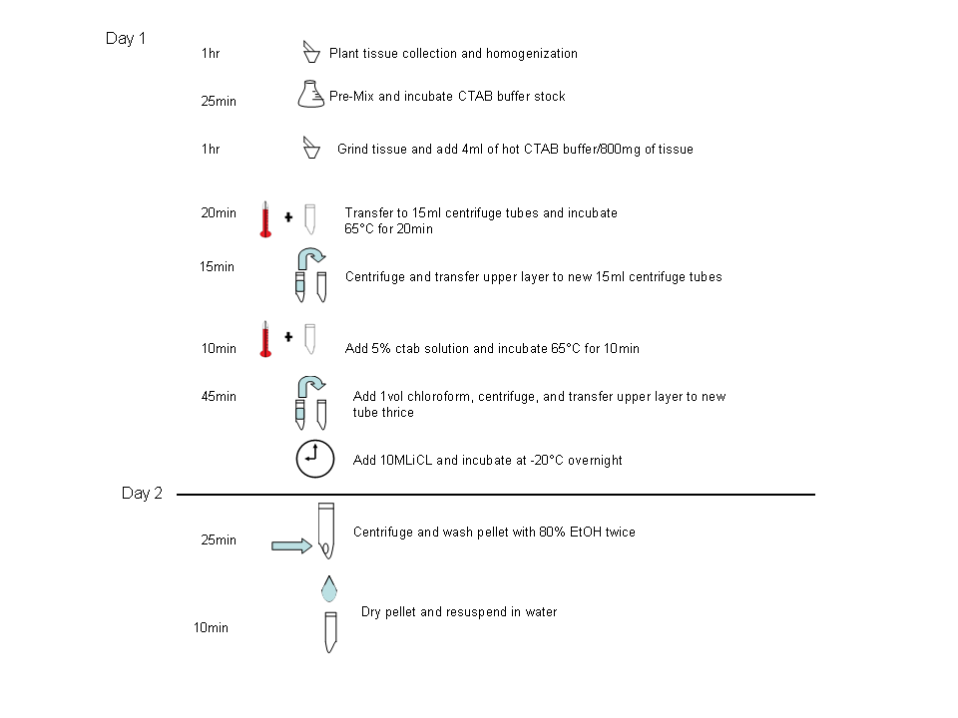
Figure 2

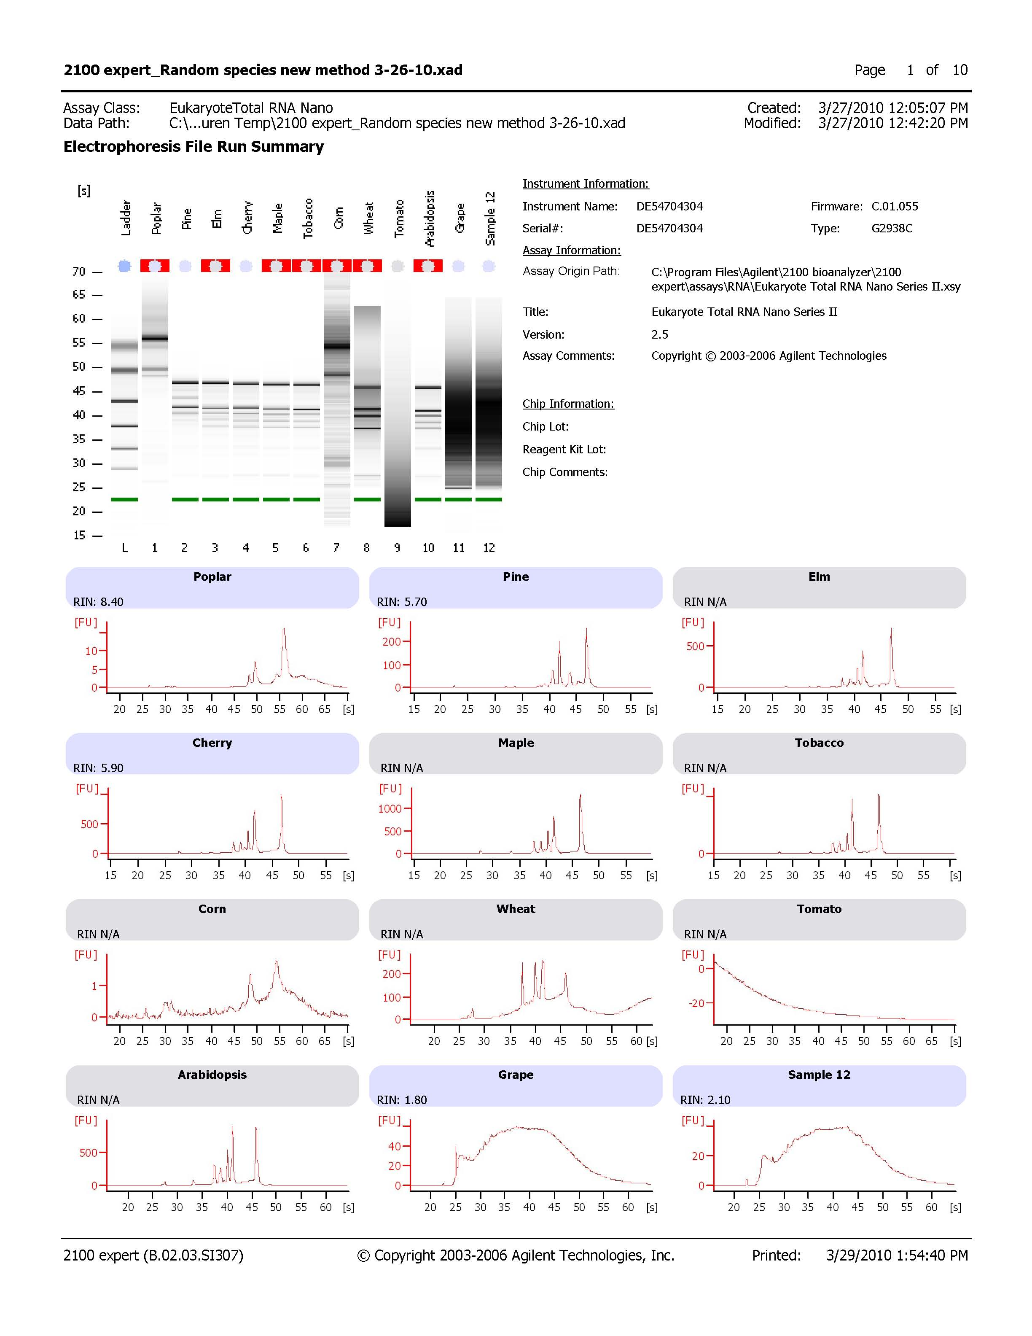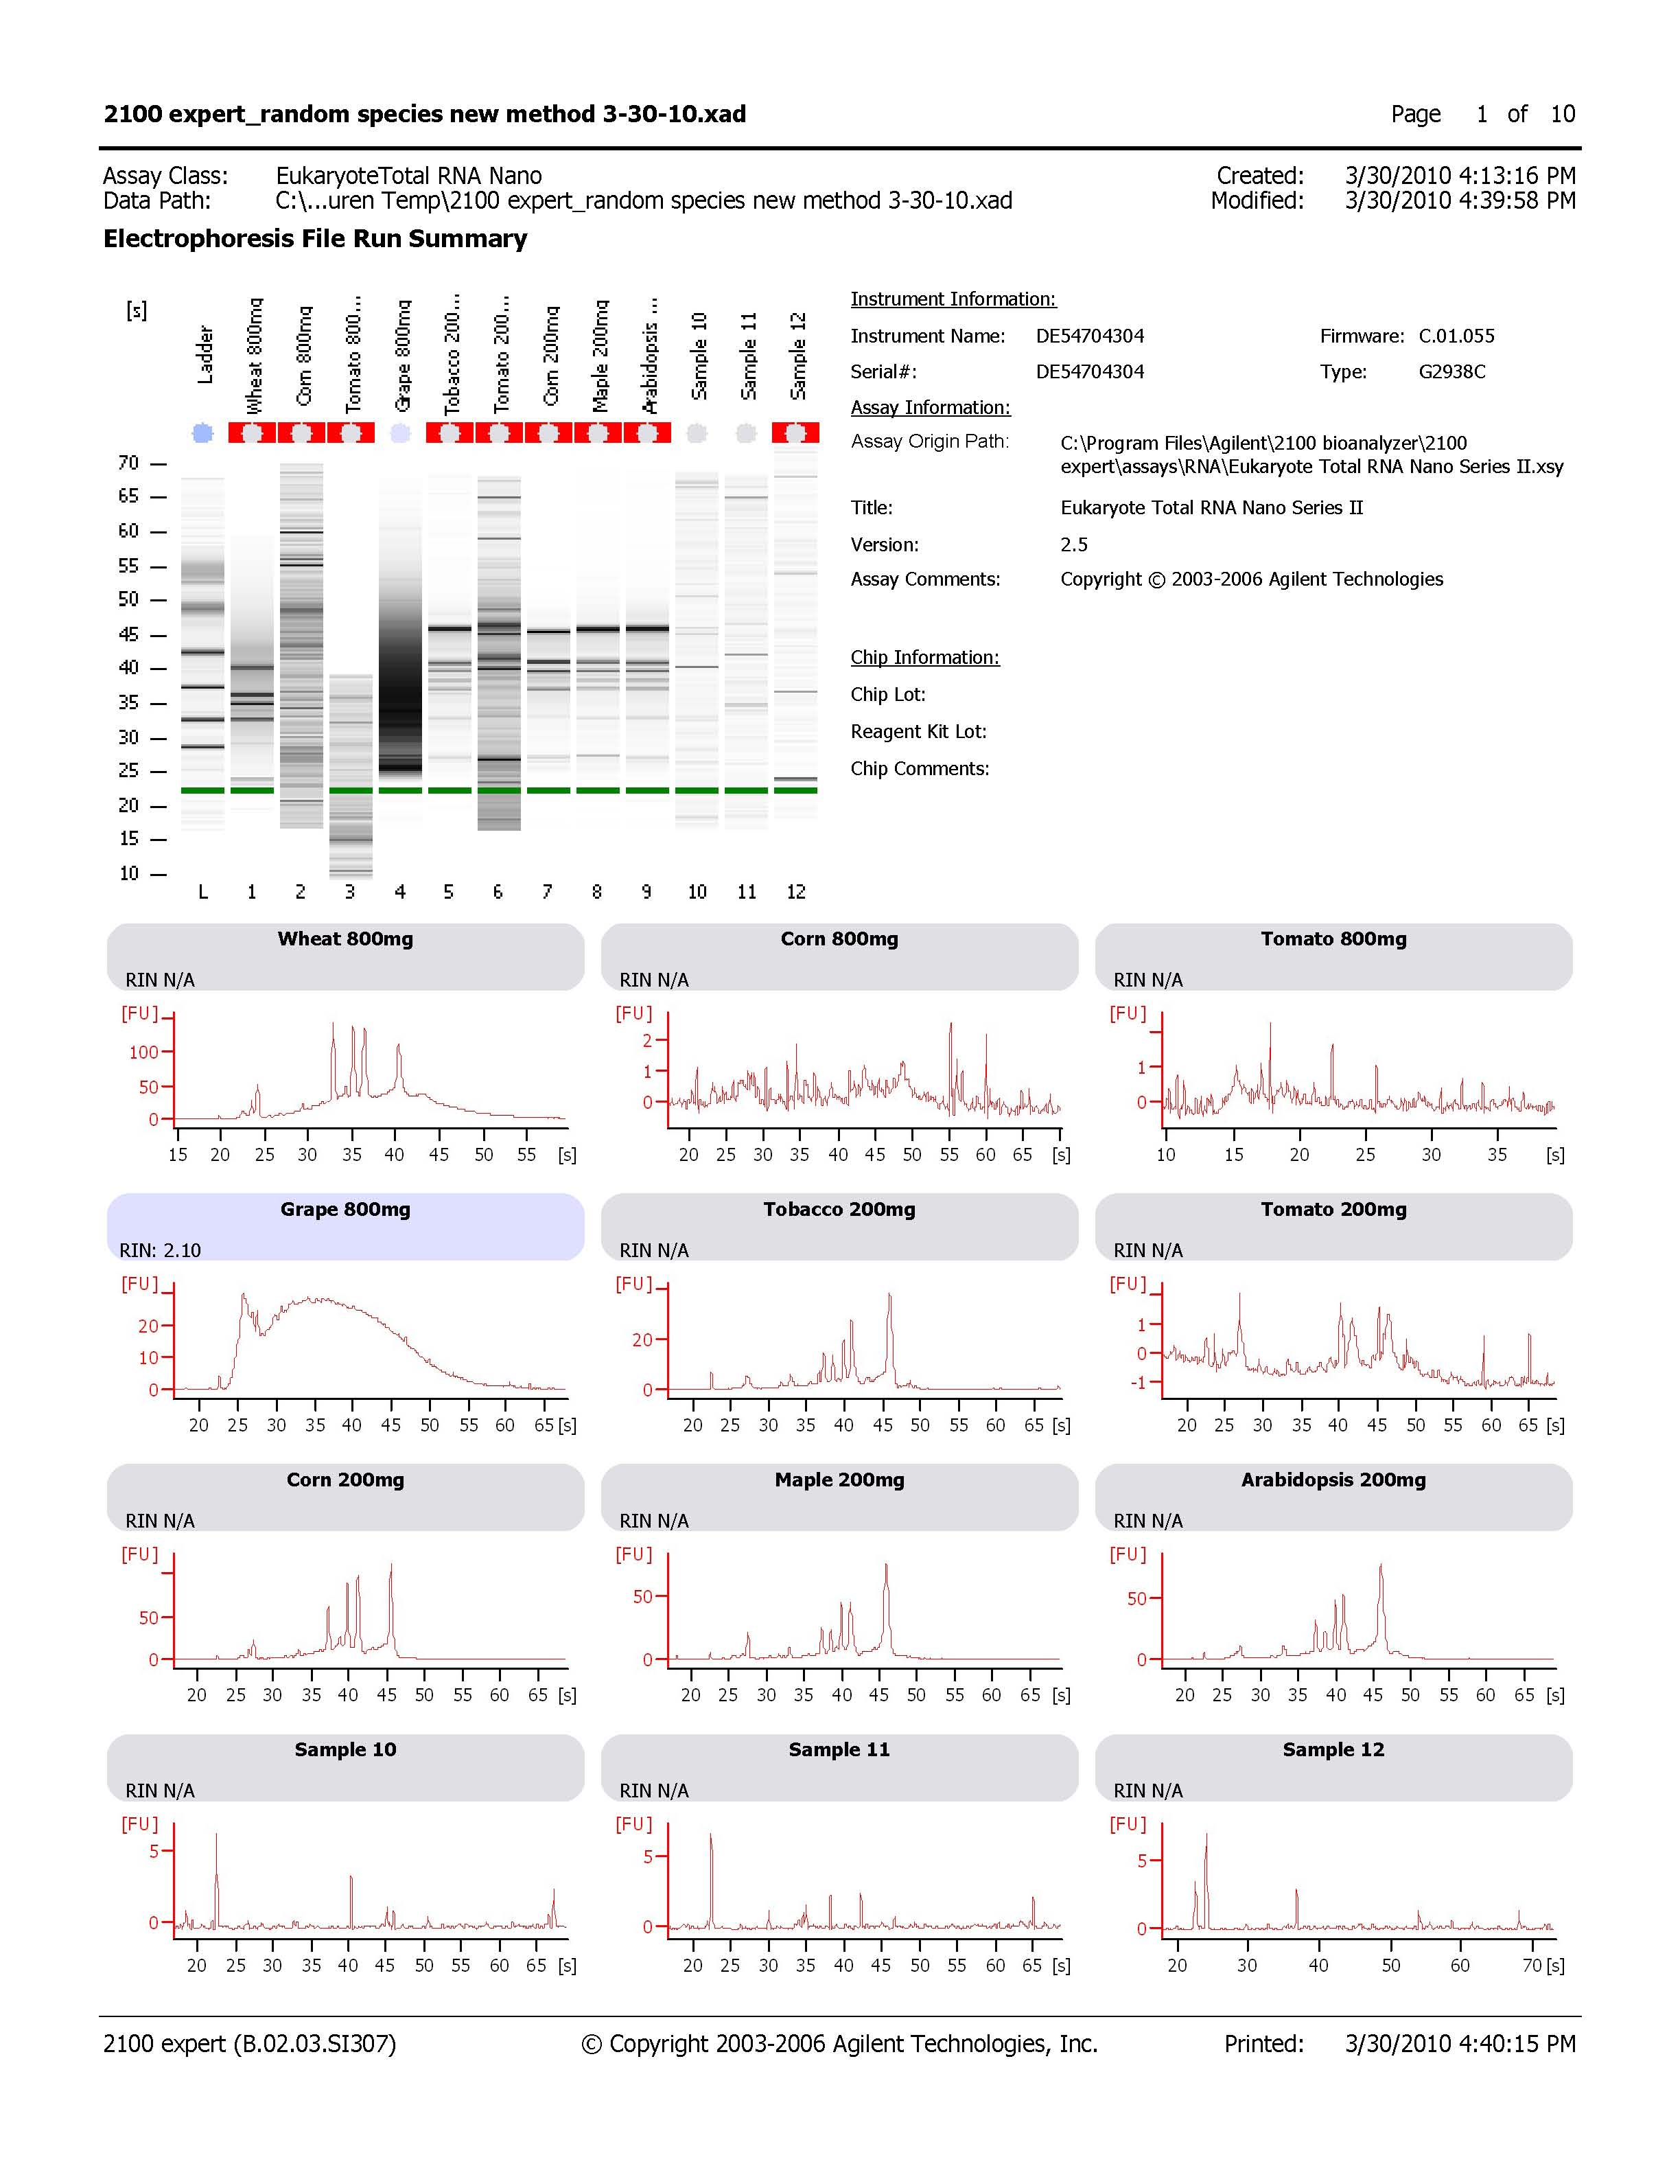
1 2 3 4 5 6 7 8
1
2
3
5
6
7
8
(A)
(B)
4
Figure 3
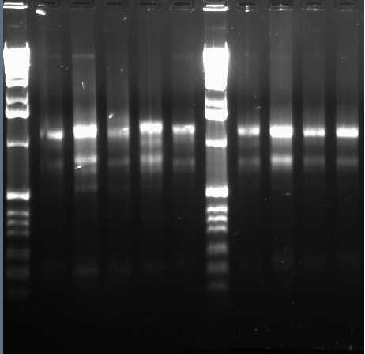
A.

L₁ 1 2 3 4 5 L₂ 6 7 8 9

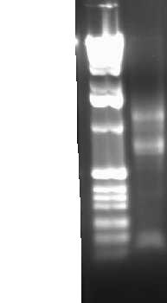
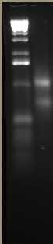
B. C.

L₃ 10
L₄ 11
Figure 4
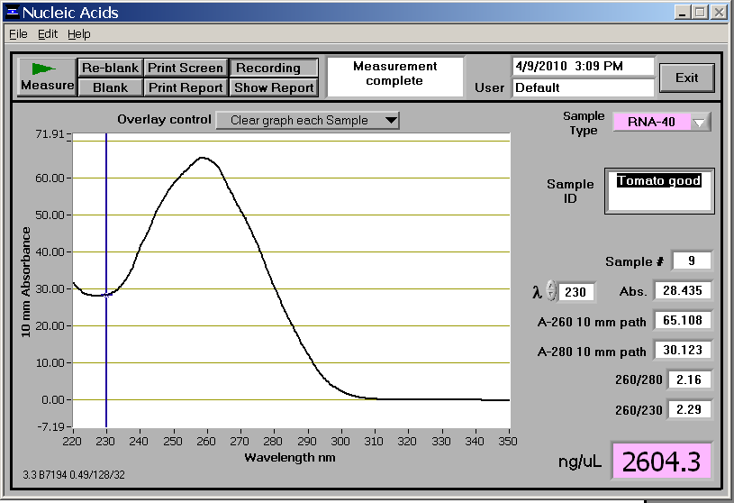
A.

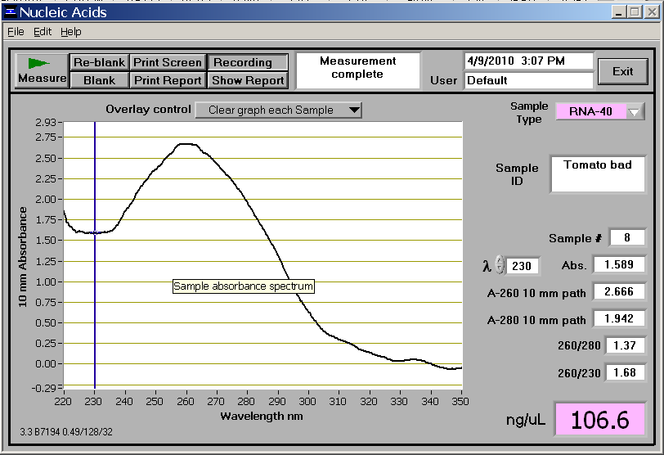
B.

REFERENCES
1. C. Dellacorte, Isolation of nucleic acids from the sea anemone Condylactis gigantea (Cnidaria: anthozoa), Tissue Cell 26 (1994) 613–619.
2. R.A. Salzman, T. Fujita, K. Zhu-Salzman, P.M. Hasegawa, R.A. Bressan, An improved RNA isolation method for plant tissues containing high levels of phenolic compounds or carbohydrates, Plant Molecular Biology Reporter 17 (1999) 11–17.
3. G. Gambino, I. Perrone, I.A. Gribaudo, Rapid and effective method for RNA extraction from different tissues of grapevine and other woody plants, Phytochemical Analysis 19 (2008) 520-525.
4. A. Schneiderbauer, H. Sandermann Jr., D. Ernst, Isolation of functional RNA from plant tissue rich in phenolic compounds, Anal. Biochemistry 197 (1991) 91-95.
5. Y. Zeng, T. Yang, RNA isolation from highly viscous samples rich in polyphenols and polysaccharides, Plant Molecular Biology Reporter 20 (2002) 417a–417e.
6. C.L. Casteel, B.F. O’Neil, J.A. Zavala, Transcriptional profiling reveals elevated CO₂ and elevated O₃ alter resistance of soybean (Glycine max) to Japanese beetles (Popillia japonica), Plant Cell and Environment 31 (2008) 419-434.

7. J. Zavala, C.L. Casteel, E.H. DeLucia, M.R. Berenbaum, Anthropogenic increase in carbon dioxide compromises plant defense against invasive insects, PNAS. 105 (2008) 5129-5133.
8. J. Zavala, C.L. Casteel, P.D. Nabity, M.R. Berenbaum, E.H. DeLucia, Role of cysteine proteinase inhibitors in preference of Japanese beetles (Popillia japonica) for soybean (Glycine max) leaves of different ages and grown under elevated CO₂, Oecologia 161(2009) 35-41.
9. D. Bilgin, E. DeLucia, S.J. Clough, Robust plant RNA isolation method suitable for Affymetrix GeneChip analysis and quantitative real-time RT-PCR, Nature Protocols 4 (2009) 333-339.
10. S. Chang, J. Puryear, J. Cairney, A simple and efficient method
for isolating RNA from pine trees, Plant Mol. Biol. Rep. 11 (1993) 113–116.
11. N. Rusic, O. Hoegh-Guldberg, A method for extracting a high-quality RNA from Symbiodinium sp., Journal of Applied Phycology 22 (2009) 139-146.
12. S. Fleige, M.W. Pfaffl, RNA integrity and the effect on the real-time qRT-PCR performance, Molecular Aspects of Medicine 27 (2006) 126-139.
13. N. Kolosova, B. Miller, S. Ralph, B.E. Ellis, C. Douglas, K. Ritland, J. Bohlmann, Isolation of high-quality RNA from gymnosperm and angiosperm trees, Biotechniques 36 (2004) 821–824.

