# Chapter 2

# Elevated CO2 and temperature increase soil C losses from a soybean-maize ecosystem

## 

## Abstract

Warming temperatures and increasing CO2 are likely to have large effects on the amount of carbon stored in soil, but predictions of these effects are poorly constrained. We elevated temperature (canopy: +2.8 °C; soil growing season: +1.8 °C; soil fallow: +2.3 °C) for three years within the 9th-11th years of an elevated CO2 (+200 ppm) experiment on a maize-soybean agroecosystem, measured respiration by roots and soil microbes, then used a process-based ecosystem model (DayCent) to simulate the decadal effects of warming and CO2 enrichment on soil C. Both heating and elevated CO2 increased respiration from soil microbes by ~20%, but heating reduced respiration from roots and rhizosphere by ~25%. The effects were additive, with no heat x CO2 interactions. Particulate organic matter and total soil C declined over time in all treatments and were lower in elevated CO2 plots than in ambient plots, but did not differ between heat treatments. We speculate that these declines indicate a priming effect, with increased C inputs under elevated CO2 fueling a loss of old soil carbon. Model simulations of heated plots agreed with our observations and predicted loss of ~15% of soil organic C after 100 years of heating, but simulations of elevated CO2 failed to predict the observed C losses and instead predicted a ~4% gain in soil organic C under any heating conditions. Despite model uncertainty, our empirical results suggest that combined, elevated CO2 and temperature will lead to long term declines in the amount of carbon stored in agricultural soils.

## Introduction

Human activity, primarily fossil fuel burning, is increasing atmospheric [CO2] and raising global mean temperature (Hartmann et al. 2013). These changes are likely to have direct and indirect effects on storage of soil organic carbon (SOC), but estimates of the direction and magnitude of these effects are poorly constrained (Dieleman et al. 2012, Lu et al. 2013). Soils worldwide store over two orders of magnitude more C than annual anthropogenic emissions ( 1500 Pg C in the top 1 m; Eswaran et al. 1993), so even small changes in soil C storage in response to climate change could produce large feedbacks to the global C cycle. This may be especially true of the SOC-rich former prairie soils of the agriculturally managed Midwestern United States, where annual tillage, infrequent water limitation, regular fertilization, and frequent pulses of highly labile C from crop residues provide ideal conditions for temperature-controlled microbial activity (Tisdall and Oades 1980).

Changes in soil C are difficult to detect on short timescales because some pools turn over slowly, with mean residence times of hundreds of years. Although it is conceptually useful to identify the faster-cycling subpools of soil C, we lack experimental methods to measure them directly (Schmidt et al. 2011). Instead, changes in the rate of CO2 fluxes from soil can be used as a proxy for changes in the soil C cycle by partitioning total CO2 flux (Rtot) into components attributed to “autotrophic” respiration (Raut) from plant roots and rhizosphere organisms, or to “heterotrophic” respiration (Rhet) from soil microbes in the process of breaking down soil organic matter (SOM). Because Rhet is the primary avenue for loss of soil C, any change in Rhet indicates a change in the rate of soil C loss. Rhet is strongly controlled by soil temperature and moisture and therefore expected to shift under future climate conditions (Davidson and Janssens 2006, Subke and Bahn 2010, Conant et al. 2011, Bradford 2013). In contrast, changes in Raut are indirectly linked to the rate of C *input* from roots, so a unit change in Rtot could indicate either increasing or decreasing soil C. Therefore correct partitioning of fluxes is essential to their use as a proxy for changes in pool size (Kuzyakov and Larionova 2005).

Previous soil heating experiments have generally shown short-term increases in Rtot (Rustad et al. 2001, Wu et al. 2011), except when heating exacerbated soil water limitations (Schindlbacher et al. 2012, Wall et al. 2013, Suseela and Dukes 2013, Pendall et al. 2013, Wang et al. 2014). This heating effect often diminishes after a few years of treatment. Whether these responses will persist over the long term under climate change depends on whether a particular soil’s Rhet response is modulated by availability of nutrients or C substrates (Luo et al. 2001, Chevallier et al. 2015) or by physiological adaptation of the microbial community (Allison et al. 2010, Bradford 2013). In addition, few of these studies were able to separate soil respiration into its autotrophic and heterotrophic components. Since Rhet is strongly controlled by thermal kinetics while Raut responds to a wide variety of non-thermal factors, it has been widely assumed that temperature-associated increases in Rtot are driven by increasing Rhet, but support for this assumption is equivocal (Hartley et al. 2007, Bond-Lamberty and Thomson 2010, Suseela and Dukes 2013, Wang et al. 2014).

Previous CO2 enrichment experiments have generally shown sustained increases in Rtot (King et al. 2004, Bernhardt et al. 2006, Pregitzer et al. 2006, Peralta and Wander 2008, Carrillo et al. 2011, Drake et al. 2011, Adair et al. 2011, Keidel et al. 2015), but there are few reported results from field experiments that manipulate both heat and CO2 simultaneously. Of those that are reported (Carrillo et al. 2011, Pendall et al. 2011, 2013, Selsted et al. 2012), the observed responses seem to be mostly mediated by water availability, with heat increasing Rtot when moisture is available and reducing it when heating produces drier soil. Elevated CO2 mediates these effects by ameliorating soil water stress through increased plant water use efficiency, but the strength and predictability of this effect seems to vary widely both within and between experiments.

The objective of this study was to measure the root- and SOM-derived components of soil respiration in an intact maize-soybean ecosystem subjected to mid-21st century temperature (+3.5 °C) and CO2 (585 ppm) conditions under fully open-air conditions at SoyFACE (Urbana IL, USA). We then used a process-based biogeochemical model (DayCent; Parton et al. 1998) to predict the long-term effects of these respiratory responses on soil C storage. We predicted that elevated temperature would increase the activity of soil heterotrophs, leading to increased respiration in root-free soil and long-term losses of C from the most labile pools of SOM. We further predicted that elevated CO2 would increase plant biomass above and belowground, leading to higher C inputs that would at least partially ameliorate the long-term effect of heat on soil C, and therefore that the long-term fate of soil C at our site would depend on the strength of the interaction between heat and CO2 effects.

## 

## Materials and methods

### Site description

Measurements were made at the *Soy*bean *F*ree-*A*ir *C*oncentration *E*nrichment (SoyFACE) experiment (40.04N, 88.23W; elev. 215 m; soyface.igb.illinois.edu), a 32-Ha experimental site near Urbana IL, USA. The site is flat, tile-drained, and has been cultivated for over 100 years. Soils are deep and highly productive, mapped as Flanagan silt loam (fine, smectitic, mesic Aquic Argiudoll) and Drummer silty clay loam (fine-silty, mixed, superactive, mesic Typic Endoaquoll). The mean annual temperature is 11 °C, with monthly mean temperatures ranging from -3 °C in January to 24 °C in July, and annual precipitation is ~1 m, with approximately half falling during the May-September growing season (Angel 2010a).

The site was managed in a two-year rotation, with maize (*Zea mays* cv 34B43) and soybean (*Glycine max* cv 93B15) alternating between the eastern and western halves of the site. Maize was fertilized with 202 kg N Ha-1 yr-1 and soybean was not fertilized. The soil was typically chisel plowed each spring before planting, and in the fall after maize harvest but not after soybean. Measurements were taken from 2009-2011 in the west half of the site, where the crop rotation cycle for these years was soybean-maize-soybean. Management of these crops was consistent with previously reported practices at the site (Leakey et al. 2004, Morgan et al. 2005), with the exception that no fall tillage was done after the 2010 maize crop so that the heating equipment could be kept in operation overwinter.

### Elevated CO2 and temperature treatments

The field was divided into four experimental blocks, each containing two 20-m octagonal rings spaced 100 m apart to avoid cross-contamination by fumigation gases. One ring in each block was maintained at ambient atmospheric conditions (approximately 390 ppm CO2), while the other was fumigated to a target of 585 ppm CO2 using *F*ree *A*ir *C*oncentration *E*nrichment (FACE) technology (Miglietta et al. 2001). Elevated CO2 was maintained from dawn until dusk throughout the growing season. The high-CO2 rings in the study area have been fumigated every growing season since 2001.

Starting in 2009, each ring was further split by imposing an elevated temperature treatment. One 3-m hexagonal subplot of each ring was equipped with overhead infrared heaters as in Kimball (2005). The heaters were adjusted throughout the growing season to stay 1.4 m above the canopy and were controlled by infrared radiometers to maintain a difference of 3.5 °C between the canopy-top temperature of heated and unheated plots. When rain was falling and when soil temperature was 5 °C, heating was ineffective and heater output was therefore reduced to a minimum. The heating system operated continuously between June 2009 and September 2011 except during planting when all equipment was removed to allow field tillage, during harvest when power cables were removed to allow harvester traffic, and during a two-week period in January 2010 when the equipment was rebuilt to repair damage from rodents. Further details on the heating treatment are reported in (Ruiz-Vera et al. 2013, 2015, Rosenthal et al. 2014).

### Measurement of soil properties and CO2 efflux

CO2 efflux from soil was measured at three locations in each plot using 20-cm diameter collars made from PVC pipe. At each location, one collar was inserted 3 cm into the soil to capture total soil respiration (Rtot), and a second collar was inserted 25 cm to capture respiration by soil heterotrophs (Rhet) by excluding roots and rhizosphere: The top 30 cm of soil contain at least 70% of soybean and 60% of maize root mass (Mayaki et al. 1976, Anderson-Teixeira et al. 2013), so this root-exclusion collar acts as a small trenched plot (Vogel and Valentine 2005). Collars were installed at crop emergence time each spring and left in place all year, then removed for field tillage just before the next year’s planting. This annual reinstallation also eliminated several major limitations that apply to root-exclusion methods in untilled systems: it removed any accumulated difference in C or nutrient availability from previous years of root exclusion, and there was no need to correct for decomposition of roots severed during installation (Hanson et al. 2000) because root biomass at installation was near zero. Respiration by roots and rhizosphere (Raut) was calculated for each location as the difference between Rtot and Rhet.

CO2 efflux rates were measured using an infrared gas analyzer (LI-8100; Li-Cor, Lincoln NE USA) fitted with a 20-cm static chamber (Li-Cor 8100-103) that rested on top of the soil collar. For each observation, the chamber was closed for two minutes while [CO2] was logged every second. Linear regressions on static-chamber observations underestimate the initial flux rate (Healy et al. 1996), so flux rates were computed in software by the LI-8100, which fit a saturating exponential curve of the form:

where is [CO2] at the moment the chamber closed, is time, and and are fitted parameters representing curvature and [CO2] at the asymptote, respectively. Evaluating the derivative of at then gives the instantaneous initial slope , which was scaled by the volume of the soil chamber to give CO2 flux rate at the moment the chamber closed.

Using exponential rather than linear fits is especially important in a FACE setting, because it allows a further correction for initial chamber conditions: Respiration was measured while fumigation was active. Pure CO2 is released from the upwind side of the ring and mixes to the target concentration as it is blown across the plot (Miglietta et al. 2001), meaning that in elevated-CO2 plots the flux chamber would sometimes close on a transient high-[CO2] air mass (up to 2000 ppm). In these cases the CO2 concentration gradient from soil to chamber air, and thus the rate of diffusion across the soil surface, was small. This meant that for these readings the fitted flux rate ‘at the moment the chamber closed’ was much smaller than the true equilibrium rate. We corrected this bias using a method recommended by Li-Cor Inc. that re-evaluates the previously fit [CO2] curve to find the equilibrium flux , where and are taken from the previous curve fit and is the daily average [CO2] in that ring (585 PPM for fumigated rings, 370-400 PPM for unfumigated rings).

Soil temperatures were measured simultaneously with each respiration measurement using a thermocouple probe inserted to 5 cm depth. Soil volumetric water content was measured from 5 to 105 cm depth 2-3 times each week using a capacitance probe and is reported elsewhere (Rosenthal et al. 2014, Ruiz-Vera et al. 2015).

Particulate organic matter (POM), which consists of fragmented but undecomposed plant matter and is used as a proxy for the abundance of labile soil C, was measured using a procedure modified from Marriott & Wander (2006). Briefly, air-dried soil was sieved to 2 mm and a 10-g sample was weighed into a 30-mL plastic bottle. The mouth of the bottle was covered with a 53-µm nylon mesh to retain POM and sand while allowing silt and clay particles to escape. The bottle was submerged in 5% sodium hexametaphosphate (HMP) and shaken for one hour, then the HMP and suspended fines <53 µm were removed, replaced with deionized water, and shaking was repeated until no further fine material was extracted. The remaining POM + sand was transferred to a pouch of 53-µm mesh, rinsed with DI water, dried at 30 °C, and weighed. Samples were then ground in a ball mill (Geno Grinder 2010; BT&C, Lebanon New Jersey, USA) and combusted to determine C content using an elemental analyzer (Costech ECS4010; Costech Analytical Technologies, Valencia, California, USA).

### Statistical analysis

Analysis of variance for soil respiration was performed in a complete-block design using CO2 as a whole-plot fixed effect and heat as a split-plot fixed effect nested within CO2. Blocks were treated as random, and autocorrelation within plots from repeated measurement through the season was estimated as a first-order autoregressive function. Rtot, Rhet, and Raut fluxes for each season were analyzed separately as mixed-effects linear models with repeated measures using the nlme and lsmeans packages in R 3.2.4 (Lenth 2016, Pinheiro et al. 2016, R Core Team 2016). The date of each survey event was included as a categorical variable to account for within-season changes. Although most of the temporal variation is likely to be driven by weather and crop growth phase, the Day effect was treated as a catchall term and no explicit temperature or moisture covariates were included in the model. Because repeated measurements within the same plot are pseudo-replicates, the three flux measurements from each plot were averaged, giving n=4 observations per treatment in each day. Because experiments with few replicates have low power to detect small differences, we set a significance threshold of p 0.1 to minimize the chance of false negative conclusions (Filion et al. 2000). Full statistical output and data-processing scripts are available in the data package for this manuscript (Black et al. 2016).

### Modeling of soil respiration and soil organic carbon

Because a three-year heating experiment is likely too short to detect changes in SOC, we performed an *in silico* experiment using a process-based ecosystem model (DayCent; Parton et al. 1998) to simulate the effects of a 100-year global change manipulation and better understand the long-term effects of elevated CO2 and temperature on soil carbon dynamics. DayCent has been widely used to model soil C, N, P and S dynamics and trace gas fluxes. It has been particularly well-validated for crop and grassland systems, and is straightforward to modify for predicted future conditions, making it ideal for simulations of the future ecosystem effects of climate and/or land-use changes (Davis et al. 2010, 2012, Hartman et al. 2011). DayCent model development has been closely tied to previous global change experiments and its input parameters are designed for easy calibration against experimentally measured responses (Parton et al. 2007, Frey et al. 2013).

To predict the medium- and long-term effects of ongoing ecosystem warming and elevated CO2 on soil carbon cycling, we performed a three-part set of DayCent simulations to simulate the historic development of the SoyFACE site from native prairie into a maize-soy rotation, extended this simulation through the 21st century, then ran the model four times using all factorial combinations of elevated CO2 and heat.

To calibrate the size and turnover rates of soil C pools, the model was first run to equilibrium by simulating a native tallgrass prairie at pre-industrial [CO2] of 294 PPM. Each simulation lasted 3867 years and looped over a weather file made by randomly ordering the years of an 1889-2009 temperature and precipitation record for Urbana, Illinois (Angel 2010b). Vegetation for the spin-up period used prairie grass parameters provided by Hudiburg et al. (2015), with autumn burning every 5th year and low-intensity grazing by bison (10% of foliage removed 3 times per growing season). Soil parameters were based on bulk densities and organic matter contents of undisturbed Illinois prairie remnants (David et al. 2009), and on physical properties of the Flanagan and Drummer soil series (NRCS 2012). To match the high-moisture conditions predominant in Central Illinois before the introduction of artificial drainage, a standing water table was simulated from January through May. Soil organic matter turnover times were adjusted to produce steady-state (<1% change per decade in last 100 yr) SOM C and N of 10450 and 760 g m-2, respectively, in the top 20 cm (Figure 2.S1). These totals are comparable to those measured in tallgrass prairie remnants on deep, mesic soils throughout the Midwest (Aref and Wander 1998, Kucharik et al. 2006, Matamala et al. 2008, David et al. 2009, Jelinski and Kucharik 2009, Brye and Riley 2009) and were achieved using turnover rates for the active, intermediate, and slow soil C pools of 11, 0.1, and 0.002 yr-1, giving residence times of 33 days, 10 years and 500 years, respectively.

Annual rows crops were simulated beginning in 1868, the year our site was first recorded as occupied by European settlers. To simulate the change from an untilled, seasonally wet prairie to a tile-drained, annually-tilled crop system, we ceased simulating a standing water table, increased the maximum decomposition rate of intermediate- and slow-turnover organic matter, and reduced leaching rates for N and OM (Table 2.S1). Additionally, we reduced the rate of nonsymbiotic soil N fixation and the fraction of mineralized N lost to nitrification to better match conditions observed in row crop systems (Table 2.S1). Site-specific parameters were based on soil conditions measured at the site (Peralta and Wander 2008, C. Black, unpublished data; J. Jastrow, unpublished data; Moran and Jastrow 2010), soil moisture measured at the site (S. B. Gray, unpublished data; Rosenthal et al. 2014, Ruiz-Vera et al. 2015), and historical weather data from the Illinois State Water Survey (Angel 2010b). Atmospheric [CO2] was increased linearly to match the rise in industrial fossil fuel burning, from 294 ppm in 1868 to 370 ppm in 2000. Crop-specific parameters for maize and soybeans were developed by Hudiburg et al. (2015) to match the rate and physiological mechanisms of 20th-century crop genetic improvements: maize yield gains have come mostly from increases in planting density and photosynthetic capacity (Duvick 2005), so we simulated an increase in the maximum daily biomass production rate, with minor adjustments to other parameters (Table 2.S3). In contrast, soybean yield increases have come mostly from improved yield partitioning at constant plant size (Koester et al. 2014), so our soybean parameters were constant except that we increased the maximum harvest index in 1950 and 1980.

The management history of the site before 1980 was inferred from records of crop acreage and fertilizer usage for Champaign County retrieved from the National Agricultural Statistics Service (NASS 2011). Site management since 1980 is well described (Moran and Jastrow 2010) and was simulated accordingly (Table 2.S2). Briefly, management progressed from low-yielding mixed maize/oat/pasture in 1869 through increasingly intensive cropping and fertilization to a maize-soybean-oat rotation by 1935 and a maize-soybean rotation by 1950, with fertilization rates and cultivar parameters adjusted each decade to match NASS records. Beginning in 1970 we changed cultivation from moldboard plow every spring and fall to chisel plowing each spring and in fall after maize only, and fertilization rates were held steady at 157 kg N Ha-1. This management schedule was continued though 1999, then concluded in 2000 with one year of winter wheat (Moran and Jastrow 2010).

To simulate the SoyFACE climate change manipulations, we extended the 20th-century simulation for the years 2001-2109 using the actual 2001-2011 planting and harvest dates of the SoyFACE experimental field. Weather data for 2001-2011 was retrieved from DAYMET (Thornton et al. 2014) and the model was run four times: a control run with actual weather conditions and [CO2] set to 370 ppm (ambient conditions at the initiation of the SoyFACE experiment), a CO2-only run with [CO2] increased by 200 ppm to 570 ppm as a step change in 2001, a heat-only run with daily maximum and minimum temperatures increased 3.5 °C as a step change in 2009, and a heat+CO2 run with both temperature and CO2 increased. Note that we did not simulate any further increase in [CO2] after the step change, so for all model-data comparisons we treated values modeled at 370 or 570 ppm as equivalent to field values observed in 2009-2011 at ~390 or 585 ppm.

Our model calibration strategy was to use the performance of our spin-up and historic hindcast scenarios as indicators of correct parameter calibration, then run the climate change scenarios with no further changes in model tuning. To the extent that model hindcasts do match known conditions, we gain confidence that model predictions for the future are reasonable. To evaluate model performance in more detail, we compared modeled soil temperature, moisture, and respiration rates against our 2009-2011 field observations. We also compared modeled aboveground biomass and grain yields for 2001-2008 against detailed phenological measurements from SoyFACE, using a database compiled by Twine et al (2013). All model parameters and analysis scripts are available online (Supplement 2.S1; Black et al. 2016).

## 

## Results

### Temperature and CO2 manipulation

Infrared heating produced a mean temperature increase of approximately 3.1, 2.7, and 2.6 °C at the top of the canopy in 2009, 2010, and 2011, respectively, and CO2 fumigation consistently maintained ~585 ppm CO2 during daylight hours (Ruiz-Vera et al. 2013, 2015). Soil temperature at 5-cm depth was increased by 1.8 0.2 °C (mean standard error of daily differences) during the growing seasons (Figure 2.1). During fallow seasons, heater output was intermittently reduced during extreme cold snaps (less than 16% of total time) but soil temperature for the whole season was still increased by 2.3 0.1 °C (Figure 2.1). There was no consistent difference in soil temperature between eCO2 and unfumigated plots given the same heat treatment.

### Soil respiration

Overall, heating caused a consistent and large increase in Rhet but reduced Raut by a similar degree, producing no appreciable net effect of heating on Rtot, while eCO2 increased Rhet and affected Raut differently each year, with the net effect of a small stimulation in Rtot from eCO2. Averaged across the entire experiment, Rhet was higher than control by 16, 12, and 48% in the eCO2, heat, and heat+CO2 treatments, respectively. Raut was slightly (3%) higher in eCO2 and lower in heated plots by 21% (heat) and 31% (heat+eCO2). Rtot was higher in eCO2 treatments by 11% (unheated eCO2) and 13% (heated eCO2) but 3% lower in the heated ambient CO2 treatment (Figure 2.2).

Separate mixed-model analyses of respiration from each season (Table 2.1) showed that under soybeans in 2009, Rtot was unchanged while Rhet increased and Raut decreased in both heat and eCO2 treatments. Under maize in 2010, CO2 increased Rtot, heat increased Rhet, and there were no differences in Raut between treatments. Under soybeans in 2011, there were no differences in Rtot between treatments while Rhet was higher and Raut was lower in heated plots. Rhet also showed a three-way interaction between Heat, CO2, and Day, with higher Rhet from heated eCO2 plots on June 24 and July 18 but no statistical difference between treatments on the other days of the season (Figure 2.3). During the fallow period following soybeans (winter 2009-2010), Raut and Rtot did not differ between treatments while Rhet was higher in eCO2 plots and had an interactive effect with heat and day, with a trend (p < 0.12) for higher Rhet from heated plots on October 7 and December 31, lower Rhet from heated plots on December 10, and no statistical difference on the other days. During the fallow period following maize (winter 2010-2011), no component of soil respiration (Rtot, Rhet, Raut) differed between treatments. The main effect of Day was significant in all treatments every season, while the heat by CO2 and CO2 by Day interactions were never significant.

### Particulate organic matter

POM-C declined from the beginning to the end of the experiment (2009 > all other harvests; Tukey HSD p < 0.01; Figure 2.4) and was approximately 14% lower in eCO2 plots than in ambient plots (ANOVA F=7.69, p < 0.01; Figure 2.4), but showed no statistically resolvable difference between heated and unheated plots (ANOVA F=0.29, p > 0.5). Averaged across all treatments, the top 30 cm of soil contained 588 ± 41 g POM C m-2 (mean ± SE) in Spring 2009, 439 ± 21 in Spring 2010, 444 ± 25 in Spring 2011, and 457 ± 22 in Fall 2011.

### DayCent model

DayCent simulations of 20th-century grain yields of maize and soybeans agreed well with historic crop yields from Champaign County and captured about half of the observed year-to-year variation in yield (Figure 2.S2 & Figure 2.S3; root-mean-square error = 82.6 g C m-2, RMSE/mean = 0.53). Modeled total C and N in soil organic matter at the end of the historic agriculture scenario were both very near the values measured at SoyFACE (Figure 2.S1). During the 2001-2008 CO2 simulation, the temporal dynamics of modeled aboveground biomass within each season matched well with values observed at SoyFACE in those years (Figure 2.S4). Observed soybean grain yields at the site averaged 191 ± 30 g C m-2 in ambient plots and 212 ± 39 in eCO2 plots (Twine et al. 2013); modeled yields for the same years were 194 ± 65 and 254 ± 75 g C m-2, respectively. Observed maize yields averaged 423 ± 15 g C m-2 in ambient plots and 412 ± 44 in eCO2 plots (Leakey et al. 2006, Markelz et al. 2011, Ruiz-Vera et al. 2015); modeled yields for the same years were 432 ± 38 and 460 ± 22 g C m-2, respectively.

Modeled effects on soil temperatures were somewhat higher than the observed differences, with heated model runs 4.1 ± 0.6 °C (mean ± sd) warmer than unheated runs at 5-cm depth during the growing season, while observed differences were less than 2 °C. Additionally, modeled soil temperature differences dropped to 3.5 °C before planting and after harvest, while observed differences were larger then than during the growing season (~2.5 °C; Figure 2.1). Modeled temperatures in elevated CO2 model runs were 0.5 ± 0.4 °C lower than those in ambient runs, but no consistent differences were observed in the field (Figure 2.1).

Compared to the values observed in the field, DayCent captured the seasonal variation and relative timing in all components of soil respiration, matched its magnitude well for Rhet, and consistently underpredicted Raut, producing a smaller overall under prediction of Rtot (Figure 2.S5).

When the simulation was extended to 100 years of heating and elevated [CO2], DayCent predicted that CO2 would increase all soil C pools, producing an increase of about ~4% in total SOM C (Figure 2.5). In contrast, heating was predicted to produce a rapid drop in all pools that overwhelmed the increased C inputs from eCO2, producing a loss from heated runs, relative to the control scenario, of 15% of total soil C in the top 20 cm by 2109 (Figure 2.5).

## 

## Discussion

Experimental manipulation of CO2 and temperature conditions similar to those expected for the mid-21st century increased respiration from soil microbes, likely indicating a drawdown of both labile and protected soil C. This effect would not have been detectable without partitioning respiration into its root and microbial components, and it was not offset by the observed positive effect of CO2 on plant productivity. Instead, CO2 increased respiration and reduced POM C, and we saw no evidence of interactions between heat and CO2 responses, leading us to speculate that eCO2 primed long-term losses of SOC. Our model results adequately captured the effects of temperature and the additive effect of the temperature and CO2 responses, but did not reproduce a CO2 priming effect, so actual soil C losses may exceed our model-predicted value of 15% in 100 years.

Our results support the prediction that elevated temperature would increase the activity of soil heterotrophs and that this increased respiration would lead to long-term losses of soil C. Three years of heating produced strong and persistent increases in Rhet (Figure 2.2; Table 2.1) and our model results are consistent with these increases leading to losses of C from all soil pools (Figure 2.5). Because heating reduced Raut simultaneously with increasing Rhet, there was no change in total soil respiration with heat (Figure 2.2; Table 2.1). This result contrasts with many previous studies (reviewed in Rustad et al. 2001, Wang et al. 2014) where Rtot increased under heating except under water limitation, but this discrepancy is explained by partitioning fluxes into their autotrophic and heterotrophic components.

Consistent with recent meta-analyses (Dieleman et al. 2012, Wang et al. 2014), we found that Rhet responded reliably to increased temperature even when opposing changes in Raut masked its effect on Rtot. This highlights the importance of separating soil CO2 fluxes in global change experiments into their root and microbial components. We speculate that this masking may also occur at other sites where Rtot was measured without partitioning and found unresponsive to heat, especially those in grasslands and crops where root activity seems less responsive to eCO2 than in forest systems (Wang et al. 2014).

Our results did not support the prediction that elevated CO2 would increase plant biomass above and belowground, leading to higher C inputs that would at least partially ameliorate the long-term effect of heat on soil C. Although aboveground plant biomass was higher in eCO2 plots during soybean years, heating largely negated this difference (Ruiz-Vera et al. 2013) and there was little difference in root mass (S. B. Gray, in prep). Rhet increased more in heat+eCO2 plots than in plots given heat alone, indicating increased respiratory losses. Meanwhile Raut, a probable correlate of C inputs from root exudation and turnover, was lower in eCO2 plots in 2009 and showed no detectable change in other years, and the change in Raut between heat and heat+eCO2 plots was similar to that between unheated control and eCO2 plots. One possible explanation for these findings is that the extra C inputs from eCO2 were priming the breakdown of existing soil C, as seen previously at this and other FACE sites across widely differing ecosystem types (Peralta and Wander 2008, Moran and Jastrow 2010, Carrillo et al. 2011, Drake et al. 2011, Hopkins et al. 2014, Fang et al. 2015), rather than offsetting the effect of heat.

The priming hypothesis also is consistent with our observation that POM-C declined from 2009 to 2011 and was lower in eCO2 plots than in unfumigated plots (Figure 2.4). The lack of an increase in POM-C with eCO2 at this site was noted previously and attributed to priming by Peralta *et al.* (2008) after 3 years of fumigation, but it is worth noting that in year 3 the difference in POM-C between treatments was not yet significant. Given that the CO2 priming effect required most of a decade to become statistically resolvable, it is perhaps not surprising that 3 years of heating did not produce a detectable change in POM-C.

Compared to other experiments that have examined the simultaneous effects of heating and eCO2 on soil C dynamics, SoyFACE is notable for showing no obvious heat CO2 interactions. Although unheated FACE experiments have commonly showed direct effects of eCO2 on soil respiration (Pendall et al. 2003, Pregitzer et al. 2008, Drake et al. 2011, Adair et al. 2011, Lam et al. 2014), many heat CO2 experiments are dominated by indirect effects (Dieleman et al. 2012), which seem to be mediated by the joint effects of CO2 and heating on soil water availability (Wan et al. 2007, Pendall et al. 2011, 2013, Selsted et al. 2012). Our site, by contrast, showed no significant heat CO2 interactions, perhaps because the site is only rarely dry enough to limit respiration. Water content was consistently higher in eCO2 plots and was lower in heated plots in 2009 and on some days in 2010, but volumetric water content never dropped below 20% and the differences in soil water were not significant in 2011, the driest summer of the study (Rosenthal et al. 2014, Ruiz-Vera et al. 2015). Thus the effects of water availability on Rhet appear to be additive to the heat effect, not a driving mechanism.

The observed changes in Raut may be caused by differences in root distribution. We have no evidence of changes in total root biomass, however minirhizotron observations from maize in 2010 suggest that elevated CO2 affected the depth distribution of roots, with greater root length in shallow soils and lower root length in deeper soils, but the effects depended on temperature treatment (S. B. Gray, in prep). In 2009 soybeans in heated plots appeared to use deeper soil water (Rosenthal et al. 2014), possibly indicating a shift of roots toward deeper soil that would have reduced the amount of root-respired C reaching the surface, thus contributing to the reduction in Raut from soybeans we observed that year.

The empirical results from this study are reinforced by forward extrapolations from a process based model which indicates that heat, either singly or combined with increased CO2, will drive long-term losses in SOC from agricultural soils, adding to losses in SOC caused by aggressive tillage practices. This result is consistent with previous models of CO2 warming experiments in predicting a net loss of soil C under global warming (Parton et al. 2007).

Given the difficulty of inferring SOC changes from short-term direct measurements and the number of known processes that DayCent integrates, we posit that these model results provide our best available prediction of the *direction* of future SOC trajectories in a warming climate, and that that they place a lower bound on the *magnitude* of future losses as CO2 increases. However, our modelling approach was unable to test the hypothesis of a priming effect of eCO2 on soil C breakdown, because DayCent’s SOC model has an explicitly specified turnover time for each pool. Turnover can be manually increased to simulate priming (Cheng et al. 2013), but this requires a known degree of increase. Our observation that POM-C declined under elevated CO2 gives an indirect indication that turnover rates have increased, but is not sufficient to constrain the magnitude of the increase, especially in slower-cycling C pools. Instead, increasing model C inputs through CO2 fertilization lead to an increase in modeled SOM with no decrease in fast C pools that would match our observed drop in POM-C. Therefore our model results probably understate the extent of soil C losses under elevated CO2. To produce more accurate long-term predictions of SOC dynamics under systems with active priming, models with explicit microbial processes may be needed (Wieder et al. 2013).

Elevated CO2 and temperature, both singly and in combination, appear to accelerate the loss of soil C from agricultural ecosystems, through probably distinct and potentially additive pathways. Simple measurements of whole-soil respiration were not sufficient to detect these changes, so future experimental work should routinely include partitioning of soil respiration into plant-derived and SOM-derived components. Robust predictions of CO2 priming effects will require updated ecosystem models that contain explicit microbial dynamics.

## 

## Acknowledgements

Thank you to Michael Masters, Nicholas DeLucia, Ahbisheik Pal, and Micah Sweeney for assistance with data collection; Michael Masters and Corey Mitchell for soil C analyses; David Drag and Kannan Puthuval for maintaining the experimental site; Sharon Gray, Matthew Siebers, Andrew Leakey, and Eva Joo for sharing calibration data; and Robert Paul, Benjamin Duval, and Cindy Keogh for valuable advice about DayCent.  
Portions of this research were funded by the US Department of Energy’s National Institute for Climatic Change Research.

## References

Adair, E. C., P. B. Reich, J. J. Trost, and S. E. Hobbie. 2011. Elevated CO2 stimulates grassland soil respiration by increasing carbon inputs rather than by enhancing soil moisture. Global Change Biology 17:3546–3563.

Allison, S. D., M. D. Wallenstein, and M. A. Bradford. 2010. Soil-carbon response to warming dependent on microbial physiology. Nature Geoscience 3:336–340.

Anderson-Teixeira, K. J., M. D. Masters, C. K. Black, M. Zeri, M. Z. Hussain, C. J. Bernacchi, and E. H. DeLucia. 2013. Altered belowground carbon cycling following land-use change to perennial bioenergy crops. Ecosystems 16:508–520.

Angel, J. 2010a. Official 1981-2010 Climate Normals. Illinois State Climatologist Office, Illinois State Water Survey. <http://www.isws.illinois.edu/atmos/statecli/newnormals/normals.USC00118740.txt>.

Angel, J. 2010b. Climate Observations for Champaign-Urbana, IL. Illinois State Climatologist Office, Illinois State Water Survey. <http://www.isws.illinois.edu/atmos/statecli/cuweather/index.htm>.

Aref, S., and M. Wander. 1998. Long-term trends of corn yield and soil organic matter in different crop sequences and soil fertility treatments on the morrow plots. Advances in Agronomy 62:153–197.

Bernhardt, E. S., J. J. Barber, J. S. Pippen, L. Taneva, J. A. Andrews, and W. H. Schlesinger. 2006. Long-term effects of free air CO2 enrichment (FACE) on soil respiration. Biogeochemistry 77:91–116.

Black, C. K., S. C. Davis, T. W. Hudiburg, C. J. Bernacchi, and E. H. DeLucia. 2016. Data from: Elevated CO2 and temperature increase soil C losses from a soybean-maize ecosystem. Dryad Digital Repository. [http://dx.doi.org/10.5061/dryad.bn7j3](http://dx.doi.org/10.5061/dryad.bn7j3%20).

Bond-Lamberty, B., and A. Thomson. 2010. Temperature-associated increases in the global soil respiration record. Nature 464:579–582.

Bradford, M. A. 2013. Thermal adaptation of decomposer communities in warming soils. Frontiers in Microbiology 4:1–16.

Brye, K. R., and T. L. Riley. 2009. Soil and plant property differences across a chronosequence of humid-temperate tallgrass prairie restorations. Soil Science 174:346–357.

Carrillo, Y., E. G. Pendall, F. A. Dijkstra, J. A. Morgan, and J. M. Newcomb. 2011. Response of soil organic matter pools to elevated CO2 and warming in a semi-arid grassland. Plant and Soil 347:339–350.

Cheng, W. X., W. J. Parton, M. A. Gonzalez-Meler, R. P. Phillips, S. Asao, G. G. McNickle, E. Brzostek, and J. D. Jastrow. 2013. Synthesis and modeling perspectives of rhizosphere priming. New Phytologist 201:31–44.

Chevallier, T., K. Hmaidi, E. Kouakoua, M. Bernoux, T. Gallali, J. Toucet, C. Jolivet, P. Deleporte, and B. G. Barthès. 2015. Physical protection of soil carbon in macroaggregates does not reduce the temperature dependence of soil CO2 emissions. Journal of Plant Nutrition and Soil Science 178:592–600.

Conant, R. T., M. G. Ryan, G. I. Ågren, H. E. Birge, E. A. Davidson, P. E. Eliasson, S. E. Evans, S. D. Frey, C. P. Giardina, F. M. Hopkins, R. Hyvönen, M. U. F. Kirschbaum, J. M. Lavallee, J. Leifeld, W. J. Parton, J. Megan Steinweg, M. D. Wallenstein, J. Å. Martin Wetterstedt, and M. A. Bradford. 2011. Temperature and soil organic matter decomposition rates – synthesis of current knowledge and a way forward. Global Change Biology 17:3392–3404.

David, M. B., G. F. McIsaac, R. G. Darmody, and R. A. Omonode. 2009. Long-term changes in mollisol organic carbon and nitrogen. Journal of Environment Quality 38:200–211.

Davidson, E. A., and I. A. Janssens. 2006. Temperature sensitivity of soil carbon decomposition and feedbacks to climate change. Nature 440:165–173.

Davis, S. C., W. J. Parton, S. J. Del Grosso, C. Keough, E. Marx, P. R. Adler, and E. H. DeLucia. 2012. Impact of second-generation biofuel agriculture on greenhouse-gas emissions in the corn-growing regions of the US. Frontiers in Ecology and the Environment 10:69–74.

Davis, S. C., W. J. Parton, F. G. Dohleman, C. M. Smith, S. J. Del Grosso, A. D. Kent, and E. H. DeLucia. 2010. Comparative biogeochemical cycles of bioenergy crops reveal nitrogen-fixation and low greenhouse gas emissions in a *Miscanthus × giganteus* agro-ecosystem. Ecosystems 13:144–156.

Dieleman, W. I. J., S. Vicca, F. A. Dijkstra, F. Hagedorn, M. J. Hovenden, K. S. Larsen, J. A. Morgan, A. Volder, C. Beier, J. S. Dukes, J. King, S. Leuzinger, S. Linder, Y. Luo, R. Oren, P. De Angelis, D. T. Tingey, M. R. Hoosbeek, and I. A. Janssens. 2012. Simple additive effects are rare: a quantitative review of plant biomass and soil process responses to combined manipulations of CO2 and temperature. Global Change Biology 18:2681–2693.

Drake, J. E., A. Gallet-Budynek, K. S. Hofmockel, E. S. Bernhardt, S. A. Billings, R. B. Jackson, K. S. Johnsen, J. Lichter, H. R. McCarthy, M. L. McCormack, D. J. P. Moore, R. Oren, S. Palmroth, R. P. Phillips, J. S. Pippen, S. G. Pritchard, K. K. Treseder, W. H. Schlesinger, E. H. DeLucia, and A. C. Finzi. 2011. Increases in the flux of carbon belowground stimulate nitrogen uptake and sustain the long-term enhancement of forest productivity under elevated CO2. Ecology Letters 14:349–357.

Duvick, D. N. 2005. The contribution of breeding to yield advances in maize (*Zea mays* L.). Advances in Agronomy 86:83–145.

Eswaran, H., E. Van Den Berg, and P. Reich. 1993. Organic carbon in soils of the world. Soil Science Society Of America Journal 57:192–194.

Fang, H., S. Cheng, E. Lin, G. Yu, S. Niu, Y. Wang, M. Xu, X. Dang, L. Li, and L. Wang. 2015. Elevated atmospheric carbon dioxide concentration stimulates soil microbial activity and impacts water-extractable organic carbon in an agricultural soil. Biogeochemistry 122:253–267.

Filion, M., P. Dutilleul, and C. Potvin. 2000. Optimum experimental design for Free-Air Carbon dioxide Enrichment (FACE) studies. Global Change Biology 6:843–854.

Frey, S. D., J. Lee, J. M. Melillo, and J. Six. 2013. The temperature response of soil microbial efficiency and its feedback to climate. Nature Climate Change 3:395–398.

Hanson, P. J., N. T. Edwards, C. T. Garten, and J. A. Andrews. 2000. Separating root and soil microbial contributions to soil respiration: A review of methods and observations. Biogeochemistry 48:115–146.

Hartley, I. P., A. Heinemeyer, S. P. Evans, and P. Ineson. 2007. The effect of soil warming on bulk soil vs. rhizosphere respiration. Global Change Biology 13:2654–2667.

Hartman, M. D., E. R. Merchant, W. J. Parton, M. P. Gutmann, S. M. Lutz, and S. A. Williams. 2011. Impact of historical land-use changes on greenhouse gas exchange in the U.S. Great Plains, 1883–2003. Ecological Applications 21:1105–1119.

Hartmann, D., A. M. G. Klein Tank, M. Rusticucci, L. V. Alexander, S. Brönnimann, Y. A.-R. Charabi, F. J. Dentener, E. J. Dlugokencky, D. R. Easterling, A. Kaplan, B. J. Soden, P. W. Thorne, M. Wild, and P. Zhai. 2013. Observations: Atmosphere and Surface. Pages 159–254 *in* Intergovernmental Panel on Climate Change, editor. Climate change 2013 : The physical science basis : Working group I contribution to the fifth assessment report of the intergovernmental panel on climate change. Cambridge University Press, Cambridge.

Healy, R. W., R. G. Striegl, T. F. Russell, G. L. Hutchinson, and G. P. Livingston. 1996. Numerical evaluation of static-chamber measurements of soil—atmosphere gas exchange: identification of physical processes. Soil Science Society Of America Journal 60:740–747.

Hopkins, F. M., T. R. Filley, G. Gleixner, M. Lange, S. M. Top, and S. E. Trumbore. 2014. Increased belowground carbon inputs and warming promote loss of soil organic carbon through complementary microbial responses. Soil Biology and Biochemistry 76:57–69.

Hudiburg, T. W., S. C. Davis, W. J. Parton, and E. H. DeLucia. 2015. Bioenergy crop greenhouse gas mitigation potential under a range of management practices. Global Change Biology Bioenergy 7:366–374.

Jelinski, N. A., and C. J. Kucharik. 2009. Land-use effects on soil carbon and nitrogen on a U.S. Midwestern floodplain. Soil Science Society Of America Journal 73:217–225.

Keidel, L., C. Kammann, L. Grünhage, G. Moser, and C. Müller. 2015. Positive feedback of elevated CO2 on soil respiration in late autumn and winter. Biogeosciences 12:1257–1269.

Kimball, B. A. 2005. Theory and performance of an infrared heater for warming ecosystems. Global Change Biology 11:2041–2056.

King, J. S., P. J. Hanson, E. Bernhardt, P. deAngelis, R. J. Norby, and K. S. Pregitzer. 2004. A multiyear synthesis of soil respiration responses to elevated atmospheric CO2 from four forest FACE experiments. Global Change Biology 10:1027–1042.

Koester, R. P., J. A. Skoneczka, T. R. Cary, B. W. Diers, and E. A. Ainsworth. 2014. Historical gains in soybean (*Glycine max* Merr.) seed yield are driven by linear increases in light interception, energy conversion, and partitioning efficiencies. Journal of Experimental Botany 65:3311–3321.

Kucharik, C. J., N. J. Fayram, and K. N. Cahill. 2006. A paired study of prairie carbon stocks, fluxes, and phenology: comparing the world’s oldest prairie restoration with an adjacent remnant. Global Change Biology 12:122–139.

Kuzyakov, Y., and A. A. Larionova. 2005. Root and rhizomicrobial respiration: A review of approaches to estimate respiration by autotrophic and heterotrophic organisms in soil. Journal of Plant Nutrition and Soil Science 168:503–520.

Lam, S. K., R. Norton, R. Armstrong, and D. Chen. 2014. Increased microbial activity under elevated [CO2] does not enhance residue decomposition in a semi-arid cropping system in Australia. Soil Biology and Biochemistry 72:97–99.

Leakey, A. D. B., C. J. Bernacchi, F. G. Dohleman, D. Ort, and S. P. Long. 2004. Will photosynthesis of maize (*Zea mays*) in the US Corn Belt increase in future [CO2] rich atmospheres? An analysis of diurnal courses of CO2 uptake under free-air concentration enrichment (FACE). Global Change Biology 10:951–962.

Leakey, A. D. B., M. Uribelarrea, E. A. Ainsworth, S. L. Naidu, A. Rogers, D. R. Ort, and S. P. Long. 2006. Photosynthesis, productivity, and yield of maize are not affected by open-air elevation of CO2 concentration in the absence of drought. Plant Physiology 140:779–790.

Lenth, R. V. 2016. Least-squares means: The R package lsmeans. Journal of Statistical Software 69:1–33.

Lu, M., X. Zhou, Q. Yang, H. Li, Y. Luo, C. Fang, J. Chen, X. Yang, and B. Li. 2013. Responses of ecosystem carbon cycle to experimental warming: a meta-analysis. Ecology 94:726–738.

Luo, Y., S. Wan, D. Hui, and L. L. Wallace. 2001. Acclimatization of soil respiration to warming in a tall grass prairie. Nature 413:622–625.

Markelz, R. J. C., R. S. Strellner, and A. D. B. Leakey. 2011. Impairment of C4 photosynthesis by drought is exacerbated by limiting nitrogen and ameliorated by elevated [CO2] in maize. Journal of Experimental Botany 62:3235–3246.

Marriott, E. E., and M. M. Wander. 2006. Total and labile soil organic matter in organic and conventional farming systems. Soil Science Society Of America Journal 70:950–959.

Matamala, R. R., J. D. Jastrow, R. M. Miller, and C. T. Garten. 2008. Temporal changes in C and N stocks of restored prairie: implications for C sequestration strategies. Ecological Applications 18:1470–1488.

Mayaki, J., I. Teare, and L. Stone. 1976. Top and root growth of irrigated and nonirrigated soybeans. Crop Science 16:92–94.

Miglietta, F., A. Peressotti, F. P. Vaccari, A. Zaldei, P. deAngelis, and G. Scarascia-Mugnozza. 2001. Free-air CO2 enrichment (FACE) of a poplar plantation: the POPFACE fumigation system. New Phytologist 150:465–476.

Moran, K. K., and J. D. Jastrow. 2010. Elevated carbon dioxide does not offset loss of soil carbon from a corn-soybean agroecosystem. Environmental Pollution 158:1088–1094.

Morgan, P. B., G. A. Bollero, R. L. Nelson, F. G. Dohleman, and S. P. Long. 2005. Smaller than predicted increase in aboveground net primary production and yield of field-grown soybean under fully open-air [CO2] elevation. Global Change Biology 11:1856–1865.

NASS. 2011. Census of Agriculture Quick Stats 2.0. National Agricultural Statistics Service, United States Department of Agriculture. <http://www.nass.usda.gov/Quick_Stats/>.

NRCS. 2012. Web Soil Survey. Soil Survey Staff, Natural Resources Conservation Service, United States Department of Agriculture. <http://websoilsurvey.nrcs.usda.gov/>.

Parton, W. J., M. D. Hartman, D. S. Ojima, and D. S. Schimel. 1998. DAYCENT and its land surface submodel: description and testing. Global and Planetary Change 19:35–48.

Parton, W. J., J. A. Morgan, G. Wang, and S. J. Del Grosso. 2007. Projected ecosystem impact of the Prairie Heating and CO2 Enrichment experiment. New Phytologist 174:823–834.

Pendall, E. G., S. J. Del Grosso, J. King, D. R. LeCain, D. Milchunas, J. A. Morgan, A. Mosier, D. S. Ojima, W. J. Parton, P. Tans, and J. White. 2003. Elevated atmospheric CO2 effects and soil water feedbacks on soil respiration components in a Colorado grassland. Global Biogeochemical Cycles 17:1046.

Pendall, E. G., J. L. Heisler-White, D. G. Williams, F. A. Dijkstra, Y. Carrillo, J. A. Morgan, and D. R. LeCain. 2013. Warming reduces carbon losses from grassland exposed to elevated atmospheric carbon dioxide. Plos One 8:e71921.

Pendall, E. G., Y. Osanai, A. L. Williams, and M. J. Hovenden. 2011. Soil carbon storage under simulated climate change is mediated by plant functional type. Global Change Biology 17:505–514.

Peralta, A. L., and M. M. Wander. 2008. Soil organic matter dynamics under soybean exposed to elevated [CO2]. Plant and Soil 303:69–81.

Pinheiro, J., D. Bates, S. DebRoy, D. Sarkar, and R Core Team. 2016. nlme: Linear and nonlinear mixed effects models. R package version 3.1-127. <http://CRAN.R-project.org/package=nlme>.

Pregitzer, K. S., A. J. Burton, J. S. King, and D. R. Zak. 2008. Soil respiration, root biomass, and root turnover following long-term exposure of northern forests to elevated atmospheric CO2 and tropospheric O3. New Phytologist 180:153–161.

Pregitzer, K., W. Loya, M. Kubiske, and D. Zak. 2006. Soil respiration in northern forests exposed to elevated atmospheric carbon dioxide and ozone. Oecologia 148:503–516.

R Core Team. 2016. R: A language and environment for statistical computing. Version 3.2.4. R Foundation for Statistical Computing, Vienna, Austria. <https://www.R-project.org/>.

Rosenthal, D. M., U. M. Ruiz-Vera, M. H. Siebers, S. B. Gray, C. J. Bernacchi, and D. R. Ort. 2014. Biochemical acclimation, stomatal limitation and precipitation patterns underlie decreases in photosynthetic stimulation of soybean (*Glycine max*) at elevated [CO2] and temperatures under fully open air field conditions. Plant Science 226:136–146.

Ruiz-Vera, U. M., M. H. Siebers, D. W. Drag, D. R. Ort, and C. J. Bernacchi. 2015. Canopy warming caused photosynthetic acclimation and reduced seed yield in maize grown at ambient and elevated [CO2]. Global Change Biology 21:4237–4249.

Ruiz-Vera, U. M., M. Siebers, S. B. Gray, D. W. Drag, D. M. Rosenthal, B. A. Kimball, D. R. Ort, and C. Bernacchi. 2013. Global warming can negate the expected CO2 stimulation in photosynthesis and productivity for soybean grown in the Midwest United States. Plant Physiology 162:410–423.

Rustad, L., J. L. Campbell, G. M. Marion, R. J. Norby, M. J. Mitchell, A. E. Hartley, J. H. C. Cornelissen, and J. Gurevitch. 2001. A meta-analysis of the response of soil respiration, net nitrogen mineralization, and aboveground plant growth to experimental ecosystem warming. Oecologia 126:543–562.

Schindlbacher, A., S. Wunderlich, W. Borken, B. Kitzler, S. Zechmeister-Boltenstern, and R. Jandl. 2012. Soil respiration under climate change: prolonged summer drought offsets soil warming effects. Global Change Biology 18:2270–2279.

Schmidt, M. W. I., M. S. Torn, S. Abiven, T. Dittmar, G. Guggenberger, I. A. Janssens, M. Kleber, I. Kögel-Knabner, J. Lehmann, D. A. C. Manning, P. Nannipieri, D. P. Rasse, S. Weiner, and S. E. Trumbore. 2011. Persistence of soil organic matter as an ecosystem property. Nature 478:49–56.

Selsted, M. B., L. Linden, A. Ibrom, A. Michelsen, K. S. Larsen, J. K. Pedersen, T. N. Mikkelsen, K. Pilegaard, C. Beier, and P. Ambus. 2012. Soil respiration is stimulated by elevated CO2 and reduced by summer drought: three years of measurements in a multifactor ecosystem manipulation experiment in a temperate heathland (CLIMAITE). Global Change Biology 18:1216–1230.

Subke, J.-A., and M. Bahn. 2010. On the ’temperature sensitivity’ of soil respiration: Can we use the immeasurable to predict the unknown? Soil Biology and Biochemistry 42:1653–1656.

Suseela, V., and J. S. Dukes. 2013. The responses of soil and rhizosphere respiration to simulated climatic changes vary by season. Ecology 94:403–413.

Thornton, P. E., M. M. Thornton, B. W. Mayer, N. Wilhelmi, Y. Wei, R. Devarakonda, and R. B. Cook. 2014. Daymet: Daily Surface Weather Data on a 1-km Grid for North America, Version 2. ORNL DAAC, Oak Ridge, Tennessee, USA. <http://daac.ornl.gov/>.

Tisdall, J. M., and J. M. Oades. 1980. The effect of crop rotation on aggregation in a red-brown earth. Australian Journal of Soil Research 18:423–433.

Twine, T. E., J. J. Bryant, K. Richter, C. J. Bernacchi, K. D. McConnaughay, S. J. Morris, and A. D. B. Leakey. 2013. Impacts of elevated CO2 concentration on the productivity and surface energy budget of the soybean and maize agroecosystem in the Midwest USA. Global Change Biology 19:2838–2852.

Vogel, J., and D. Valentine. 2005. Small root exclusion collars provide reasonable estimates of root respiration when measured during the growing season of installation. Canadian Journal of Forest Research 35:2112–2117.

Wall, G. W., J. E. T. McLain, B. A. Kimball, J. W. White, M. J. Ottman, and R. L. Garcia. 2013. Infrared warming affects intrarow soil carbon dioxide efflux during vegetative growth of spring wheat. Agronomy Journal 105:607–618.

Wan, S., R. J. Norby, J. Ledford, and J. F. Weltzin. 2007. Responses of soil respiration to elevated CO2, air warming, and changing soil water availability in a model old-field grassland. Global Change Biology 13:2411–2424.

Wang, X., L. Liu, S. Piao, I. A. Janssens, J. Tang, W. Liu, Y. Chi, J. Wang, and S. Xu. 2014. Soil respiration under climate warming: differential response of heterotrophic and autotrophic respiration. Global Change Biology 20:3229–3237.

Wieder, W. R., G. B. Bonan, and S. D. Allison. 2013. Global soil carbon projections are improved by modelling microbial processes. Nature Climate Change 3:909–912.

Wu, Z., P. Dijkstra, G. W. Koch, J. Peñuelas, and B. A. Hungate. 2011. Responses of terrestrial ecosystems to temperature and precipitation change: a meta-analysis of experimental manipulation. Global Change Biology 17:927–942.

## Tables and Figures

Table 2.1: Mixed effects model results for rates of soil CO2 efflux attributed to soil heterotrophs (Rhet), plant roots and rhizosphere organisms (Raut), and whole soil (Rtot). The first six columns show P values for each effect. Boldface values are significant at a preselected threshold of 0.1. The main Day effect was always significant (all P < 0.02) and is not shown here to save space. The last two columns show percent change from control for each treatment, presented as the estimated differences ± 1 standard error of whole-season LS means.

|  |  |  |  |  |  |  |  |  |
| --- | --- | --- | --- | --- | --- | --- | --- | --- |
| Component | Heat | CO2 | Heat CO2 | Heat Day | CO2 Day | Heat CO2 Day | Heat % change | CO2 % change |
| Soy 2009 | |
| Raut | **0.014** | **0.089** | 0.552 | 0.737 | 0.717 | 0.988 | -53 ± 15 | -41 ± 17 |
| Rhet | **0.035** | **0.068** | 0.271 | 0.790 | 0.495 | 0.724 | 32 ± 11 | 31 ± 11 |
| Rtot | 0.475 | 0.920 | 0.636 | 0.859 | 0.389 | 0.932 | -6 ± 7 | 0 ± 8 |
| Fallow 2009-20101 | |
| Raut | 0.465 | 0.915 | 0.845 | 0.909 | 0.922 | 0.899 | 26 ± 50 | -6 ± 43 |
| Rhet | 0.875 | **0.097** | 0.879 | **0.053** | 0.775 | 0.934 | 5 ± 7 | 14 ± 7 |
| Rtot | 0.315 | 0.424 | 0.776 | 0.869 | 0.915 | 0.901 | 12 ± 12 | 8 ± 12 |
| Maize 2010 | |
| Raut | 0.716 | 0.806 | 0.917 | 0.561 | 0.317 | 0.277 | -8 ± 19 | 6 ± 20 |
| Rhet | **0.053** | 0.137 | 0.181 | 0.704 | 0.632 | 0.931 | 20 ± 8 | 28 ± 15 |
| Rtot | 0.263 | **0.059** | 0.226 | 0.687 | 0.642 | 0.605 | 8 ± 7 | 20 ± 7 |
| Fallow 2010-2011 | |
| Raut | 0.532 | 0.796 | 0.216 | 0.940 | 0.339 | 0.231 | -17 ± 30 | 1 ± 43 |
| Rhet | 0.740 | 0.800 | 0.687 | 0.636 | 0.310 | 0.752 | 6 ± 12 | 1 ± 12 |
| Rtot | 0.771 | 0.953 | 0.381 | 0.977 | 0.204 | 0.117 | -2 ± 11 | 2 ± 17 |
| Soy 2011 | |
| Raut | **0.018** | 0.190 | 0.864 | 0.690 | 0.794 | 0.381 | -48 ± 15 | 57 ± 33 |
| Rhet | **0.047** | 0.224 | 0.700 | 0.801 | 0.739 | **0.091** | 27 ± 11 | 18 ± 12 |
| Rtot | 0.131 | 0.252 | 0.824 | 0.906 | 0.822 | 0.997 | -11 ± 6 | 29 ± 21 |

1Data from March 1, 2010 were excluded from the model because they contained no usable observations from heated plots.

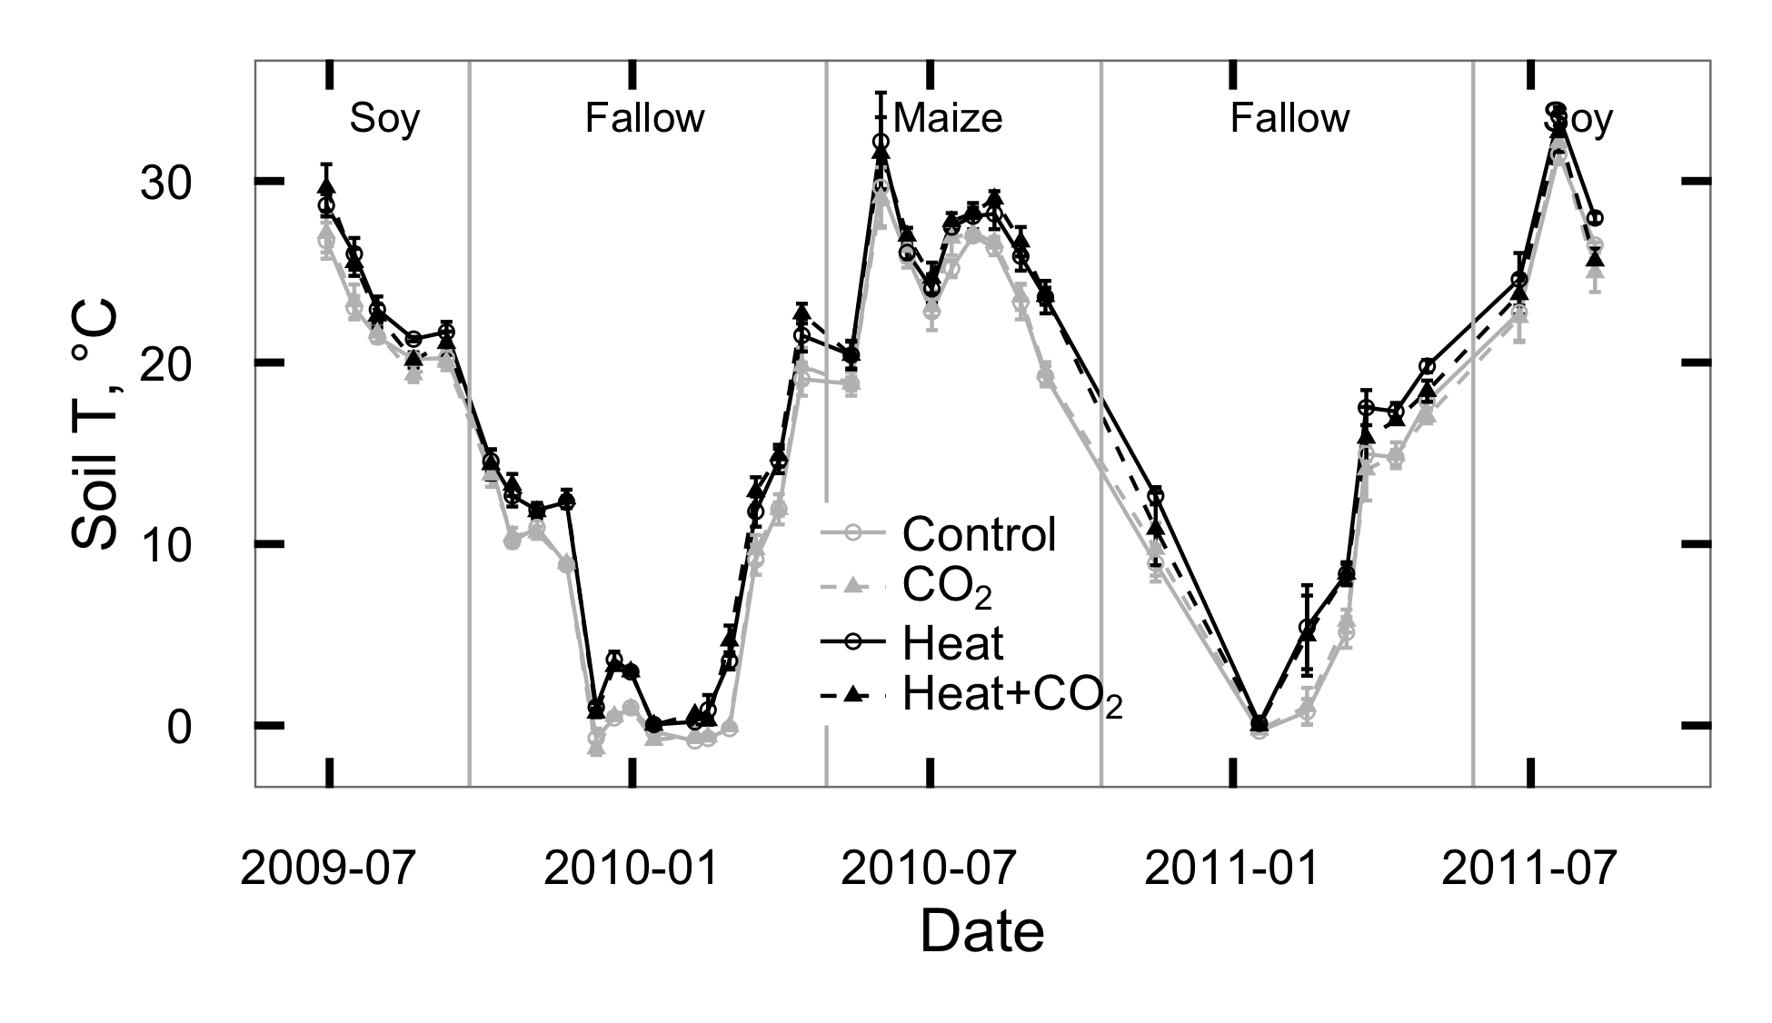

Figure 2.1: Temperature measured 5 cm below the soil surface at SoyFACE between June 2009 and October 2011. Error bars show treatment means 1 standard error for each day.

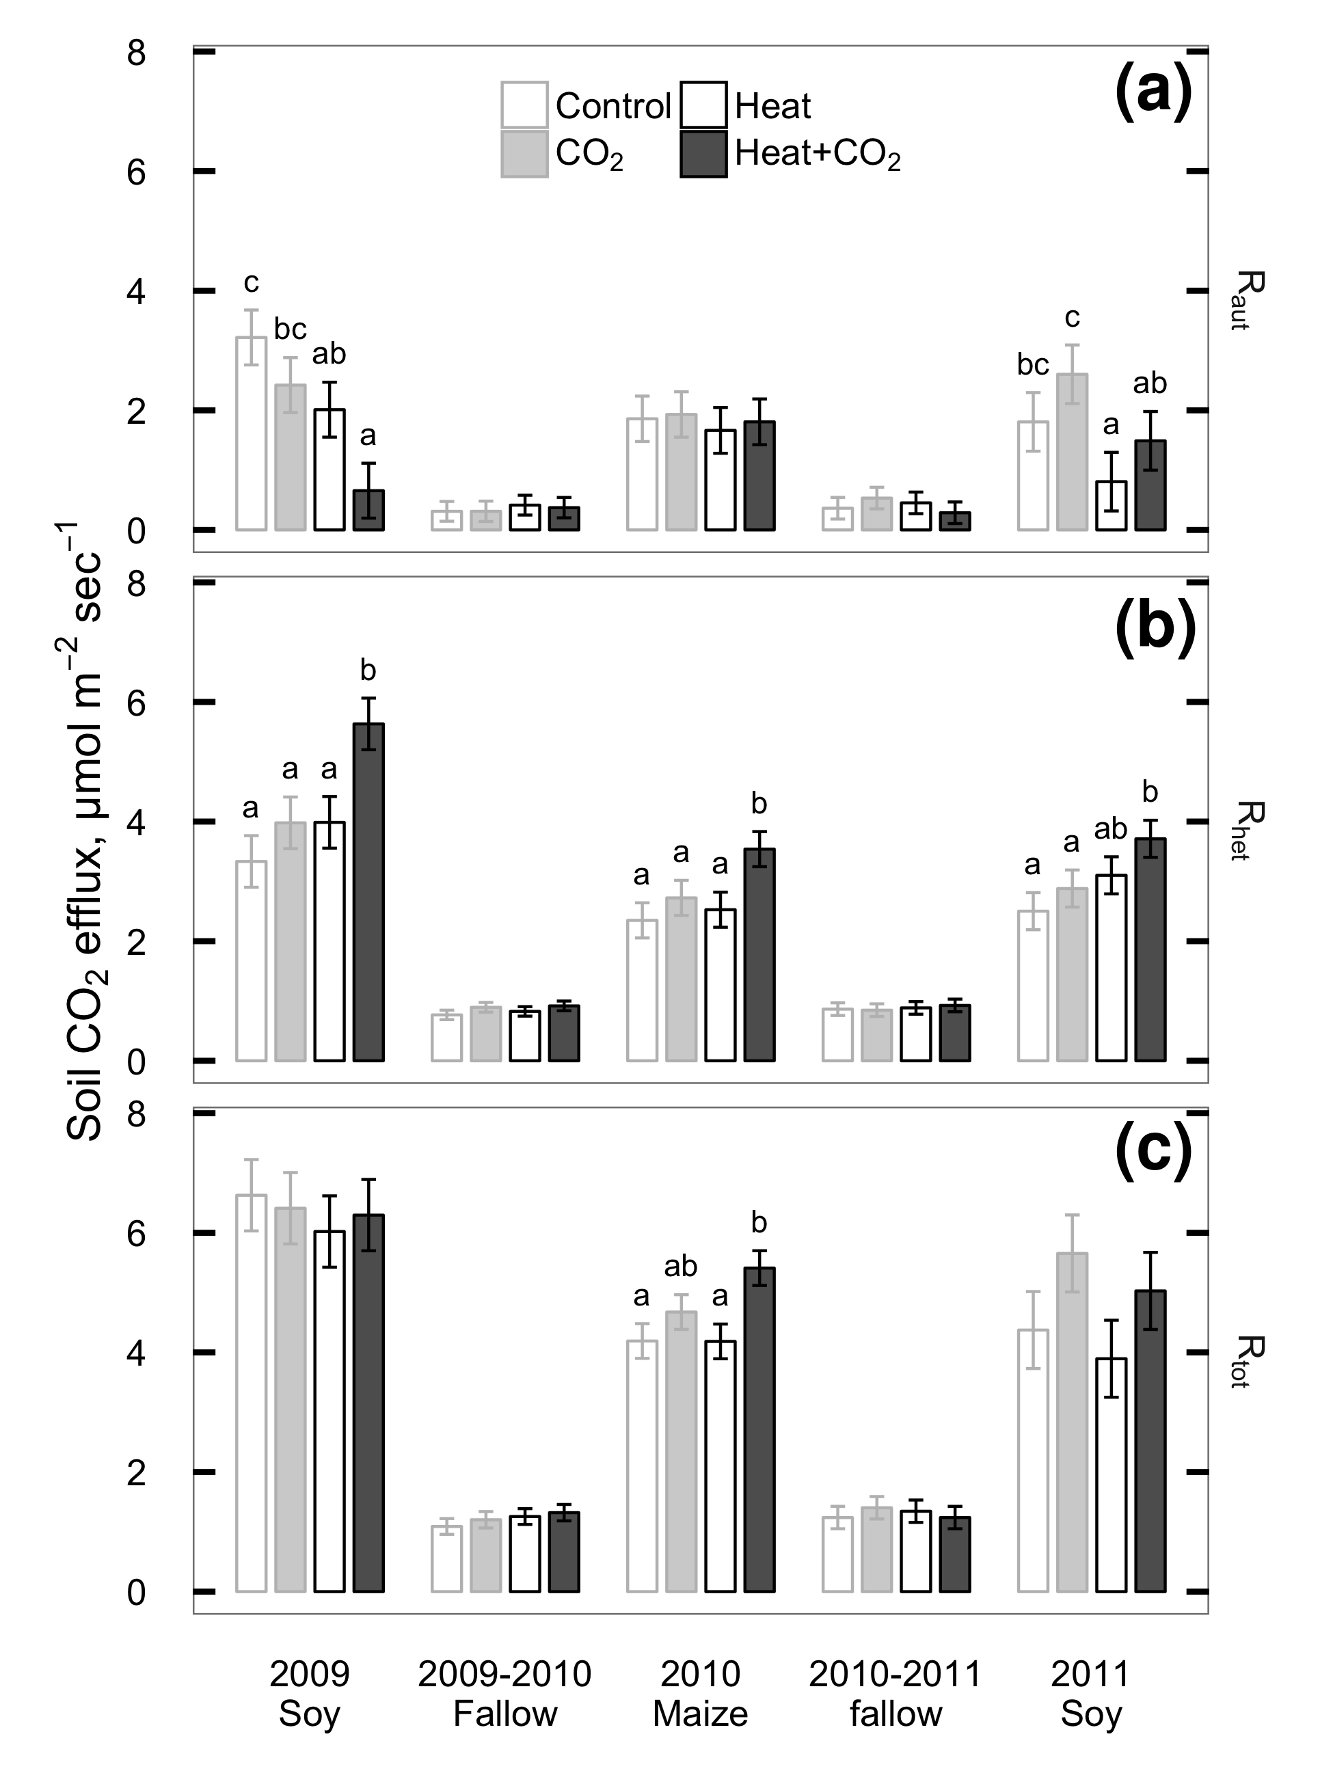

Figure 2.2: Seasonal means of CO2 flux measured from plant roots and rhizosphere (Raut; a), soil heterotrophs (Rhet; b), and whole soil (Rtot; c) at SoyFACE between June 2009 and October 2011. Error bars show treatment LS means 1 standard error for each season. Within each season, treatments that share a letter are not statistically different (P > 0.1).

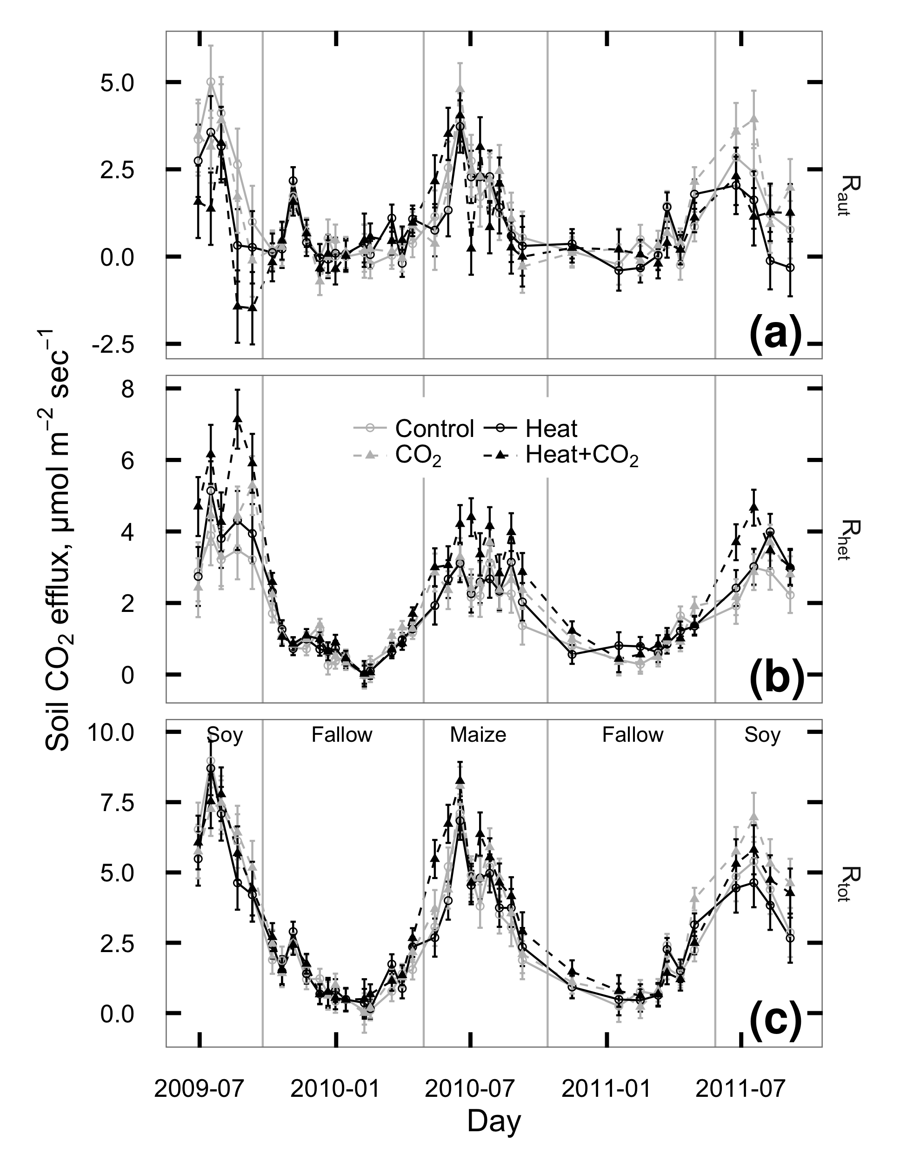

Figure 2.3: CO2 flux measured from plant roots and rhizosphere (Raut; a), soil heterotrophs (Rhet; b), and whole soil (Rtot; c) at SoyFACE between June 2009 and October 2011. Each season was analyzed separately; vertical grey lines indicate cutoffs between seasons. Error bars show treatment LS means 1 standard error for each day.

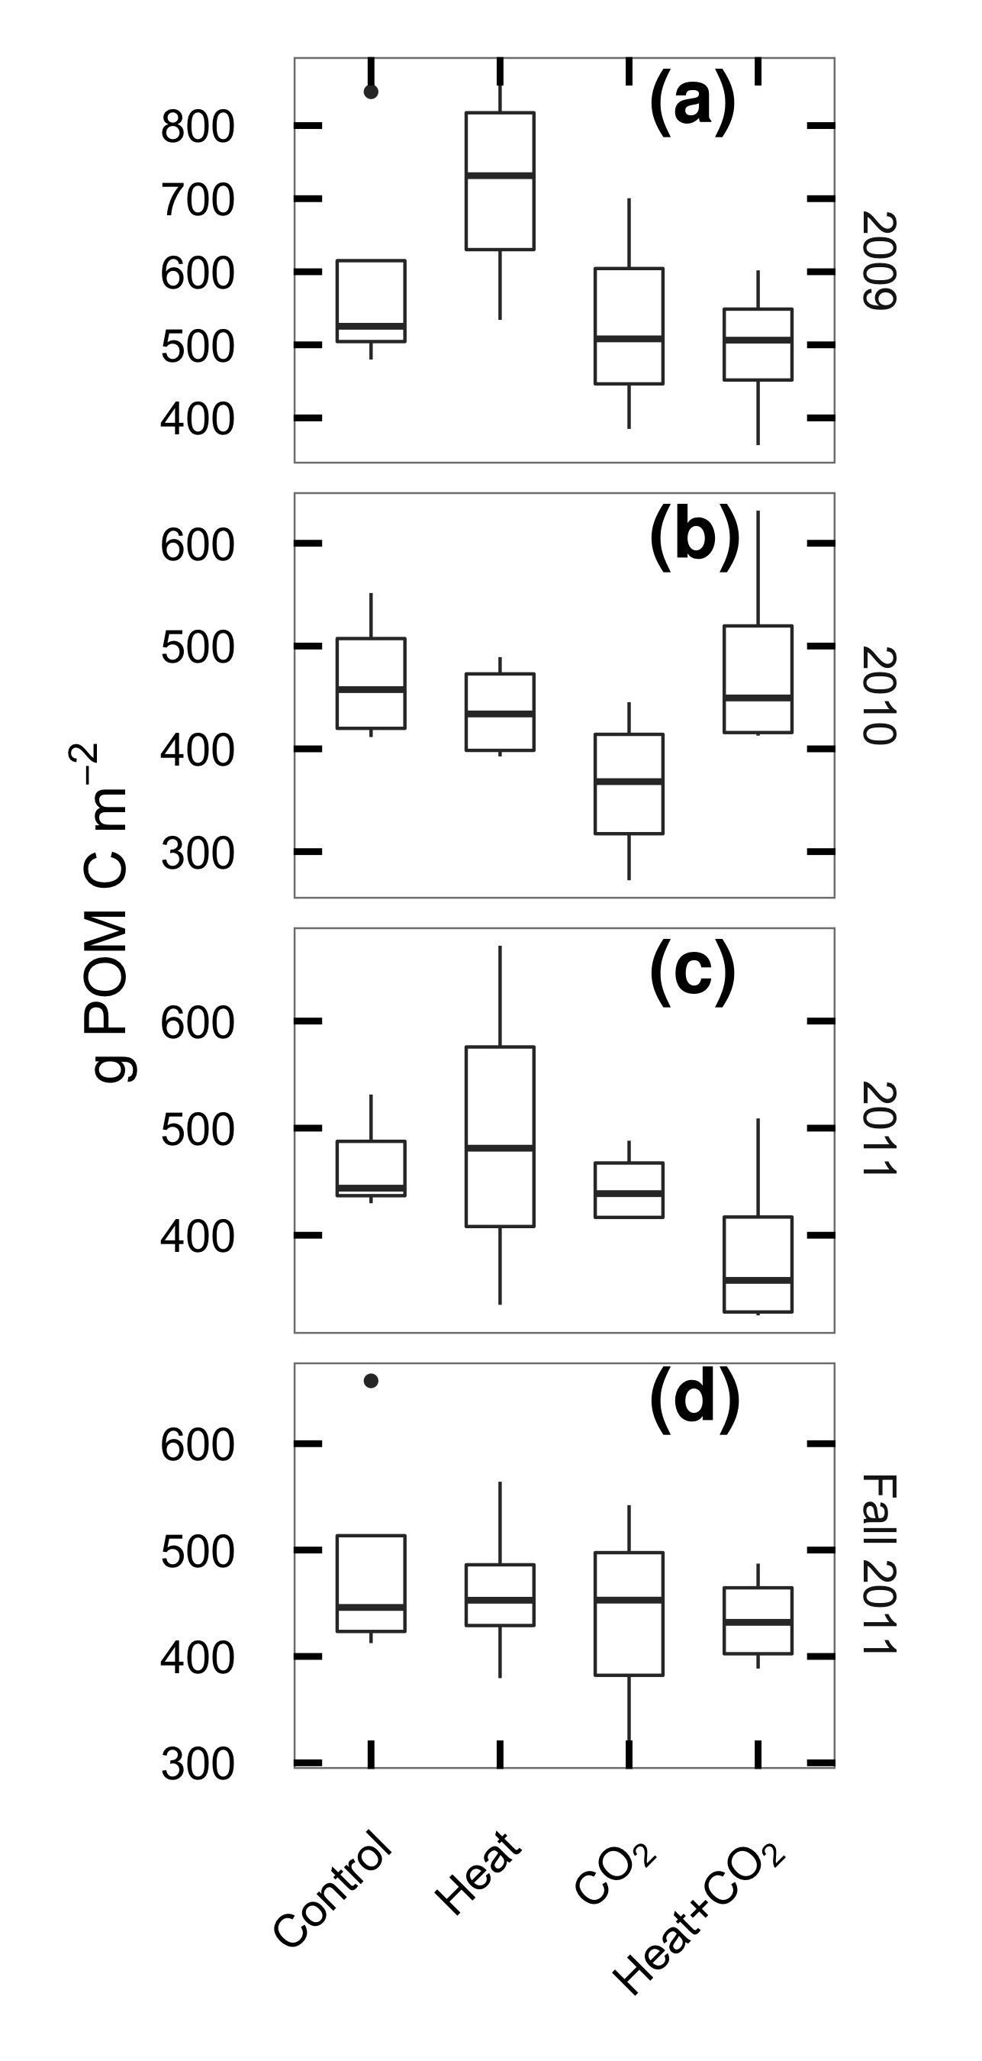

Figure 2.4: Particulate organic matter carbon (POM-C) in the top 30 cm of soil at SoyFACE, sampled in spring of 2009 (a), 2010 (b), 2011 (c) and at the end of the experiment in fall 2011 (d). Boxes cover the estimated interquartile range of each group, whiskers extend to the smaller of max/min or 1.5 IQR.

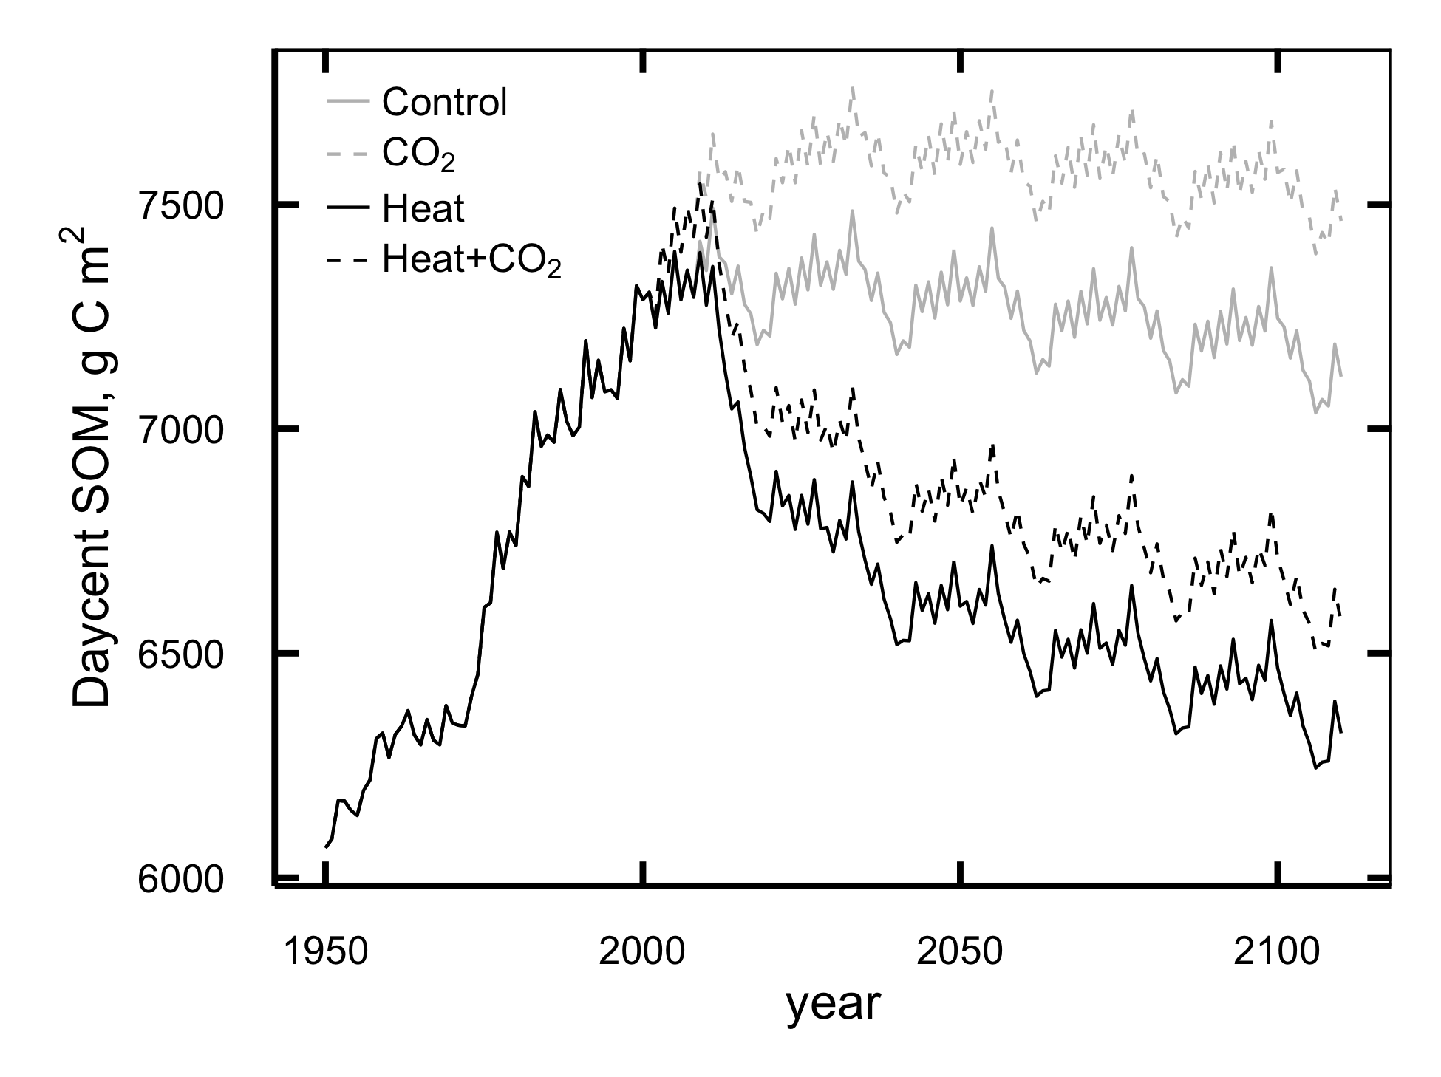

Figure 2.5: Mean annual values for total soil organic matter (g C m-2) predicted by DayCent in the top 20 cm of SoyFACE soil.

# 

## Supplement 2.S1: DayCent model fit evaluation

### Data availability

All the data for this paper, including raw files, data-processing scripts, and DayCent simulation files, is permanantly archived in Dryad (http://datadryad.org) and is freely available online: http://dx.doi.org/10.5061/dryad.bn7j3.

Additionally, the DayCent model files, raw output, run management scripts and the majority of the model calibration data are available online at https://github.com/infotroph/soyface_daycent. Some validation was performed against unpublished datasets that were shared by collaborators in advance of publication; these are not available in this project’s archive, but we intend to update the Github repository with links to those datasets at such time as their authors make them available.

Table 2.S1: Summary of model parameters changed between phases of the DayCent model run.

|  |  |  |  |  |  |  |  |
| --- | --- | --- | --- | --- | --- | --- | --- |
| File | Parameter | Spin-up value | | | Ag value | FACE value | Remarks |
| sitepar.in | watertable[1-5] | | 1 | 0 | | 0 | Tile drainage lowers Jan-May water table |
| sitepar.in | netm_to_no3 | | 0.05 | 0.8 | | 0.8 | Nitrification much lower in undisturbed grassland |
| fix.100 | CO2PPM(1) | | 294 | 294 | | 370 | Starting [CO2] |
| fix.100 | CO2PPM(2) | | 294 | 370 | | 570 | Ending [CO2] |
| fix.100 | CO2RMP | | 1 | 1 | | 0 | 0=step change in given year, 1=ramp |
| fix.100 | DEC4 | | 0.002 | 0.0025 | | 0.0025 | Slow-turnover OM decomposes faster in tilled, drained soil |
| fix.100 | DEC5(1) | | 0.08 | 0.2 | | 0.2 | Intermediate-turnover OM at surface decomposes faster in tilled, drained soil |
| fix.100 | DEC5(2) | | 0.1 | 0.25 | | 0.25 | Intermediate-turnover OM below surface decomposes faster in tilled, drained soil |
| fix.100 | FLEACH(1) | | 0.7 | 0.4 | | 0.4 | Intercept for mineral leaching as a function of sand content |
| fix.100 | FLEACH(2) | | 0.9 | 0.4 | | 0.4 | Slope for mineral leaching as a function of sand content |
| fix.100 | FLEACH(3) | | 0.95 | 0.2 | | 0.2 | Leaching fraction multiplier for leached mineral N |
| fix.100 | MINLCH | | 1.5 | 1.0 | | 1.0 | Minimum cm water flow to activate mineral leaching |
| fix.100 | OMLECH(1) | | 0.03 | 0.05 | | 0.05 | Intercept for organic matter leaching as a function of sand content |
| fix.100 | OMLECH(2) | | 0.12 | 0.15 | | 0.15 | Slope for organic matter leaching as a function of sand content |
| fix.100 | OMLECH(3) | | 1.9 | 0.1 | | 0.1 | Minimum cm water flow to activate organic leaching |
| soyface.100 | EPNFS(2) | | 0.017 | 0.005 | | 0.005 | Slope for nonsymbiotic N fixation as a function of annual precipitation |

Table 2.S2: Summary of management schedule for DayCent simulations.

|  |  |  |  |  |
| --- | --- | --- | --- | --- |
| Years | Crop | Weather1 | Tillage2 | N management3 |
| -2000–1868 | Prairie | R | Fire every 5th year | Graze May–July |
| 1869–1888 | 2 yr maize 1, oat, 2 yr pasture | R | Spring MD before maize & oat, fall M | Graze May–Oct after oats and during pasture |
| 1889–1934 | 2 yr maize 1, oat, 2 yr pasture | H | Spring MD before maize & oat, fall M | Graze May–Oct after oats and during pasture |
| 1935–1949 | Maize 3, oat, low yield soy | H | Spring MD, fall M | Fert 40.4, graze after oats |
| 1950–1959 | Maize 5, medium yield soy | H | Spring MD, fall M | Fert 56 |
| 1960–1969 | Maize 7, medium yield soy | H | Spring MD, fall M | Fert 100 |
| 1970–1979 | Maize 9, medium yield soy | H | Spring CD, fall C after maize | Fert 157 |
| 1980–1998 | Maize 10, high yield soy | H | Spring CD, fall C after maize | Fert 157 |
| 1999–2000 | High yield soy, winter wheat | H | Spring CD, fall C after wheat | Fert 116.4 |
| 2001-2109 | Maize 10, high yield soy | D | Spring CD, fall C after maize | Fert 157 |

1R = randomized weather; H = historic weather from Illinois Water Survey (4.7 km from site); D = Gridded weather for site retrieved from DAYMET.

2M = Moldboard plow; D = disk; C = Chisel plow.

3Fertilization rates are in kg N ha-1. Fertilizer is applied before planting of maize and wheat only; other crops are never fertilized.

Table 2.S3: Summary of DayCent parameters changed between simulated maize cultivars. All parameters not shown here are identical between cultivars; see CROP.100 in the model files for details.

|  |  |  |  |  |  |  |
| --- | --- | --- | --- | --- | --- | --- |
| Parameter | C11 | C3 | C5 | C7 | C9 | C10 |
| PRDX(1) | 0.30 | 0.45 | 0.70 | 0.75 | 1.00 | 1.50 |
| FRTC(5) | 0.10 | 0.10 | 0.10 | 0.20 | 0.20 | 0.20 |
| CFRTCN(1)2 | 0.40 | 0.40 | 0.40 | 0.30 | 0.30 | 0.30 |
| PRAMN(1,1) | 20 | 20 | 10 | 10 | 10 | 10 |
| PRAMX(1,1) | 40 | 40 | 20 | 20 | 20 | 20 |
| HIMAX | 0.35 | 0.40 | 0.50 | 0.60 | 0.60 | 0.60 |
| EFRGRN(1) | 0.50 | 0.75 | 0.75 | 0.75 | 0.75 | 0.75 |
| FALLRT | 0.10 | 0.10 | 0.10 | 0.10 | 0.20 | 0.20 |
| TMPGERM2 | 10 | 10 | 10 | 15 | 15 | 15 |
| DDBASE2 | 1500 | 1500 | 1700 | 1450 | 1450 | 1450 |
| TMPKILL2 | 7 | 7 | 12 | 14 | 14 | 14 |

1These cultivar names come from a set of 11 developed by Hudiburg et al. (2015); C2, C4, C6, C8, C11 are not shown here because they were not used in the current simulations.

2These parameters are ignored by DayCent when FRTINDX==2, as it is for all of these cultivars, and are included here only for completeness.

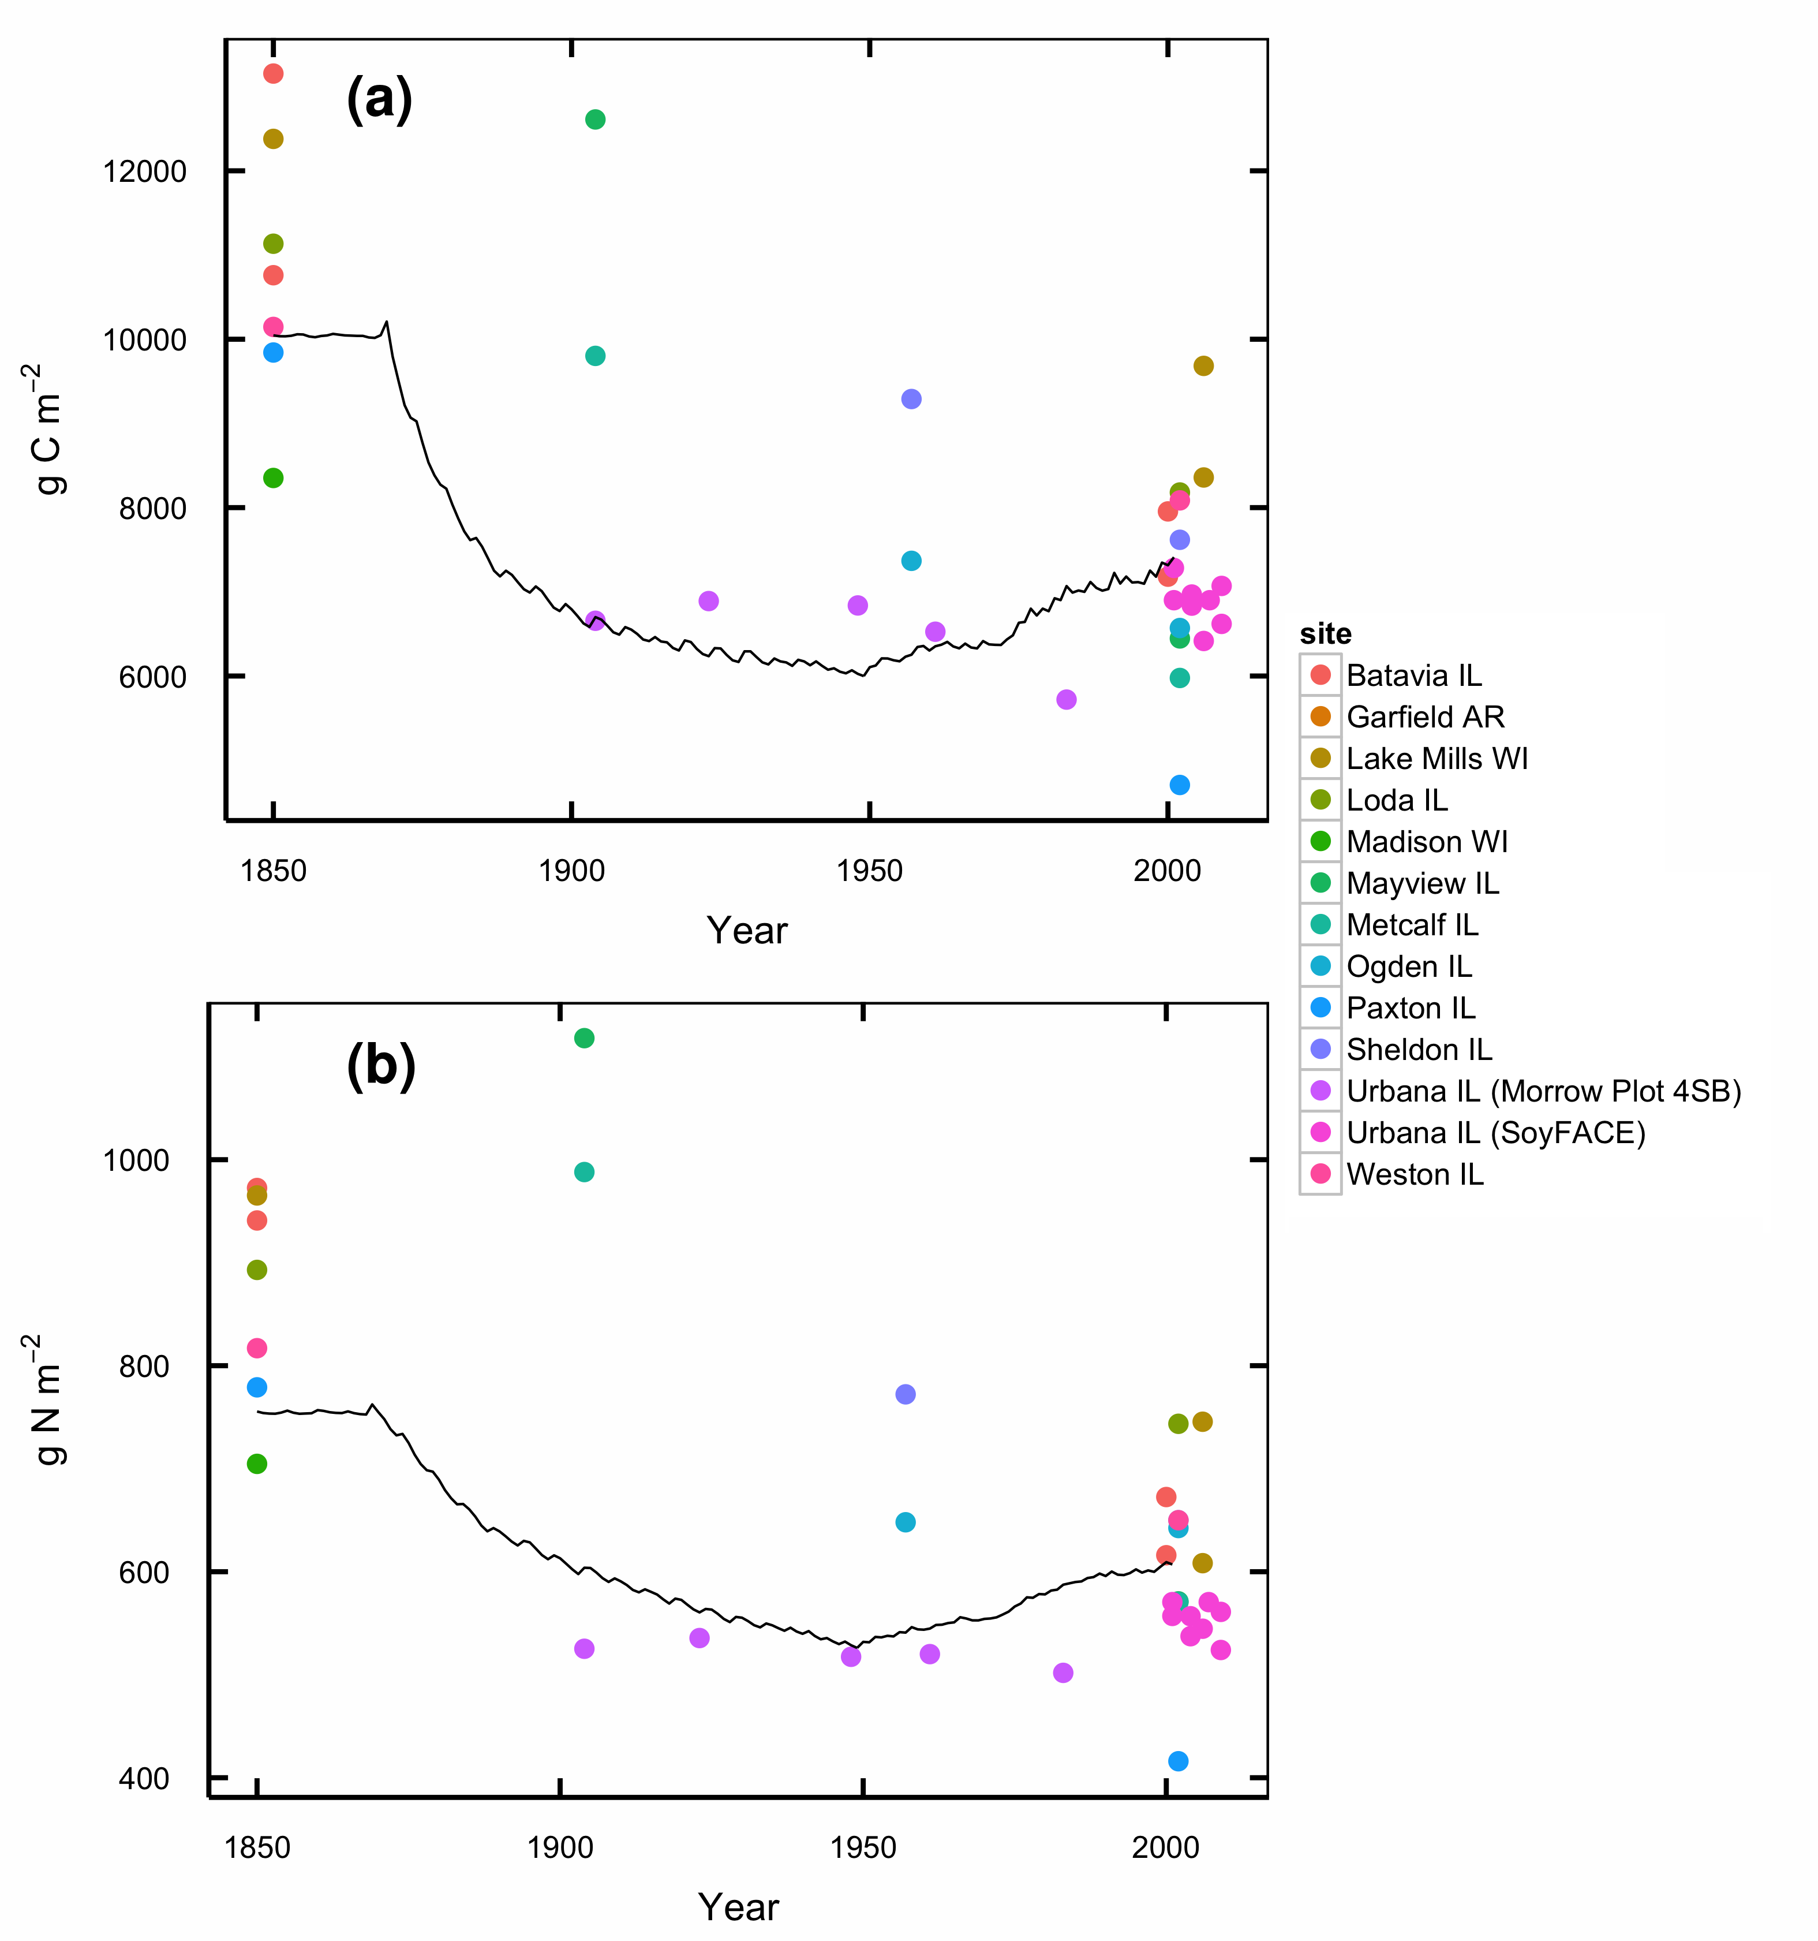

Figure 2.S1: Total organic C (a) and N (b) in soils under conversion from tallgrass prairie to agriculture. Lines show DayCent modeled soil C for the spin-up and historical agriculture phases of the model run. Points are observed SOC contents of prairie soils at comparable stages of similar management histories.

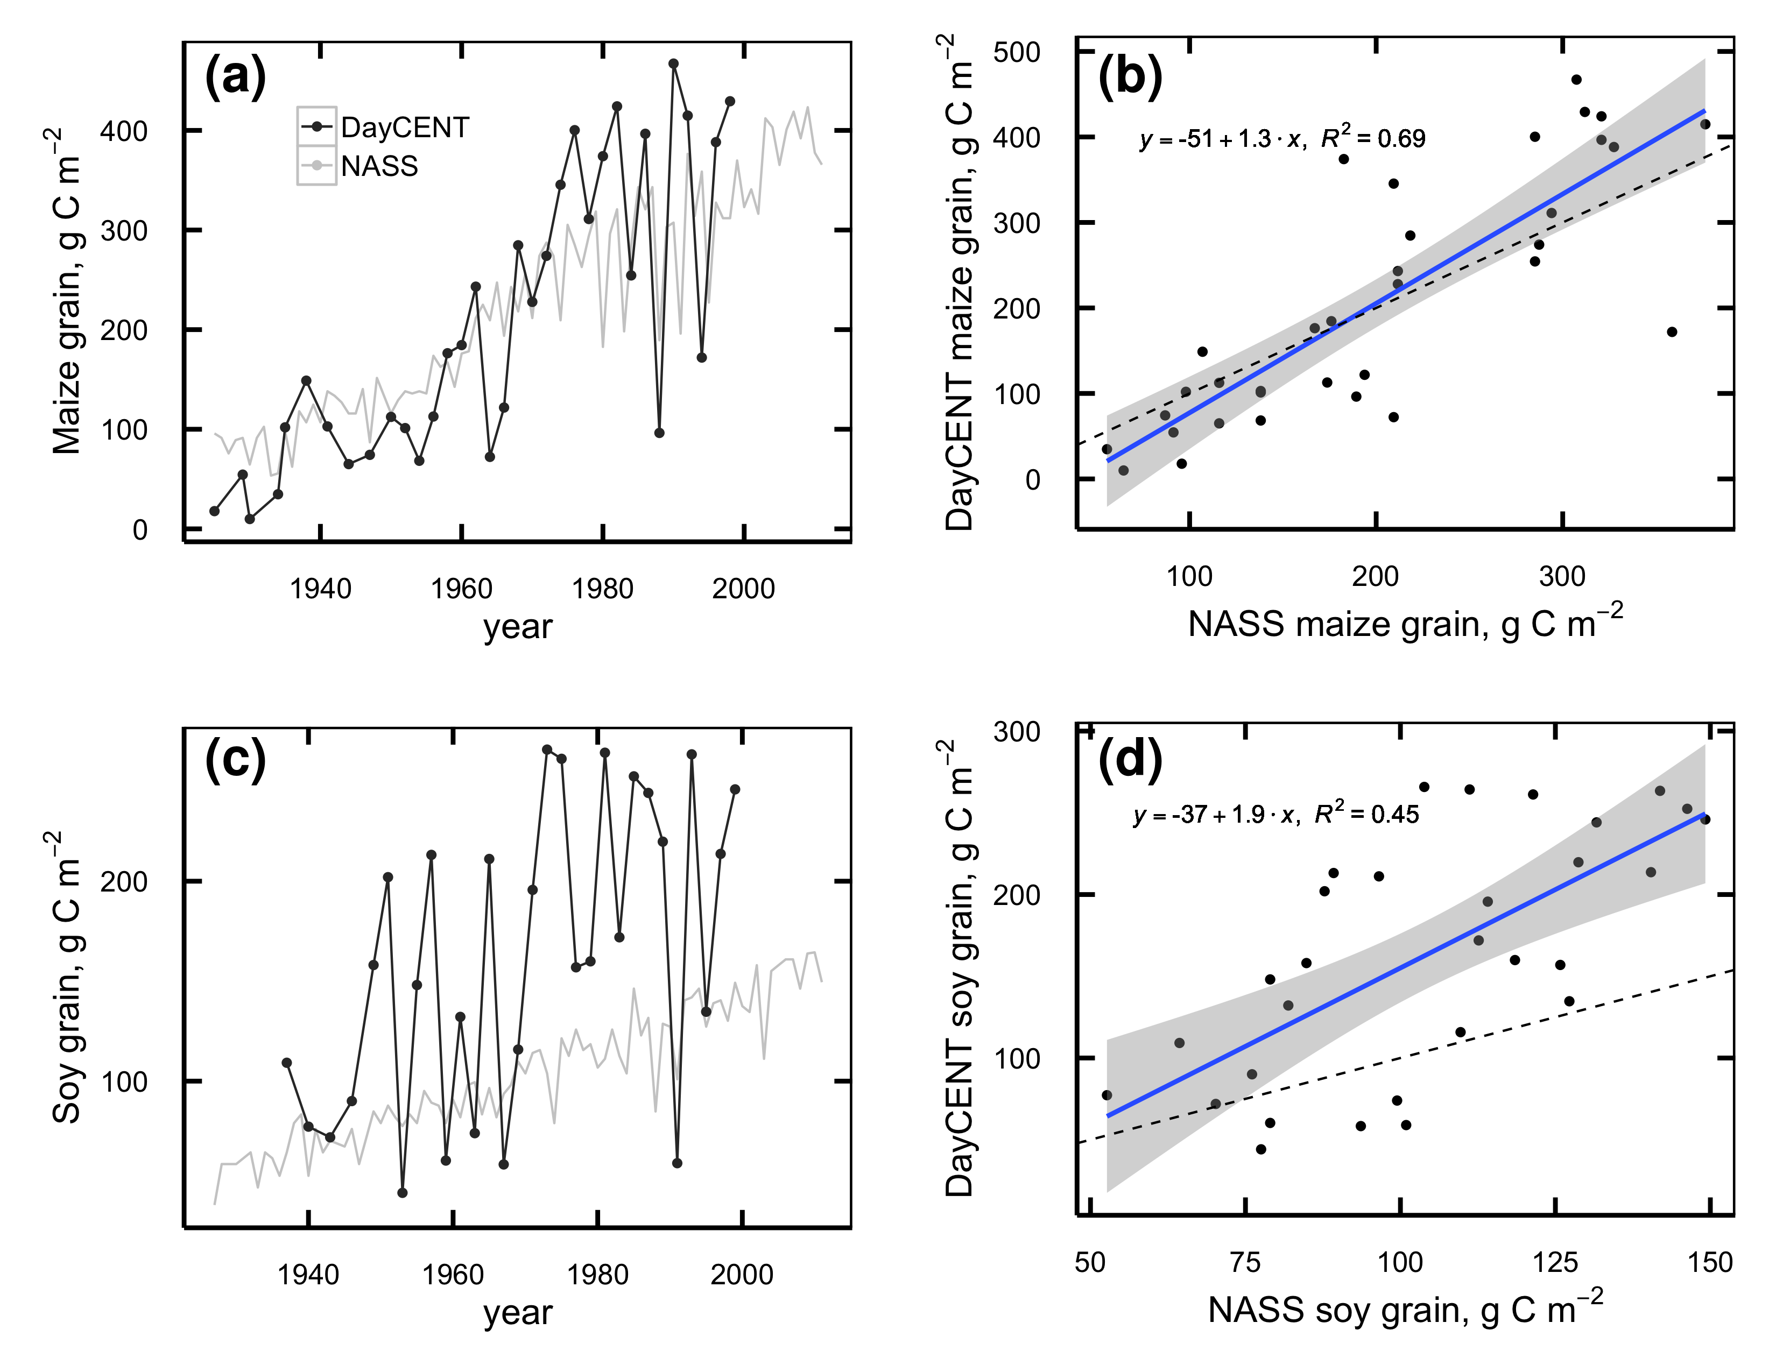

Figure 2.S2: a,c: Maize (a) and soybean (c) grain production simulated by DayCent (black lines) and Champaign County averages from NASS (grey lines). b,d, linear regression of DayCent vs. NASS maize (b) and soybean (d) yields.

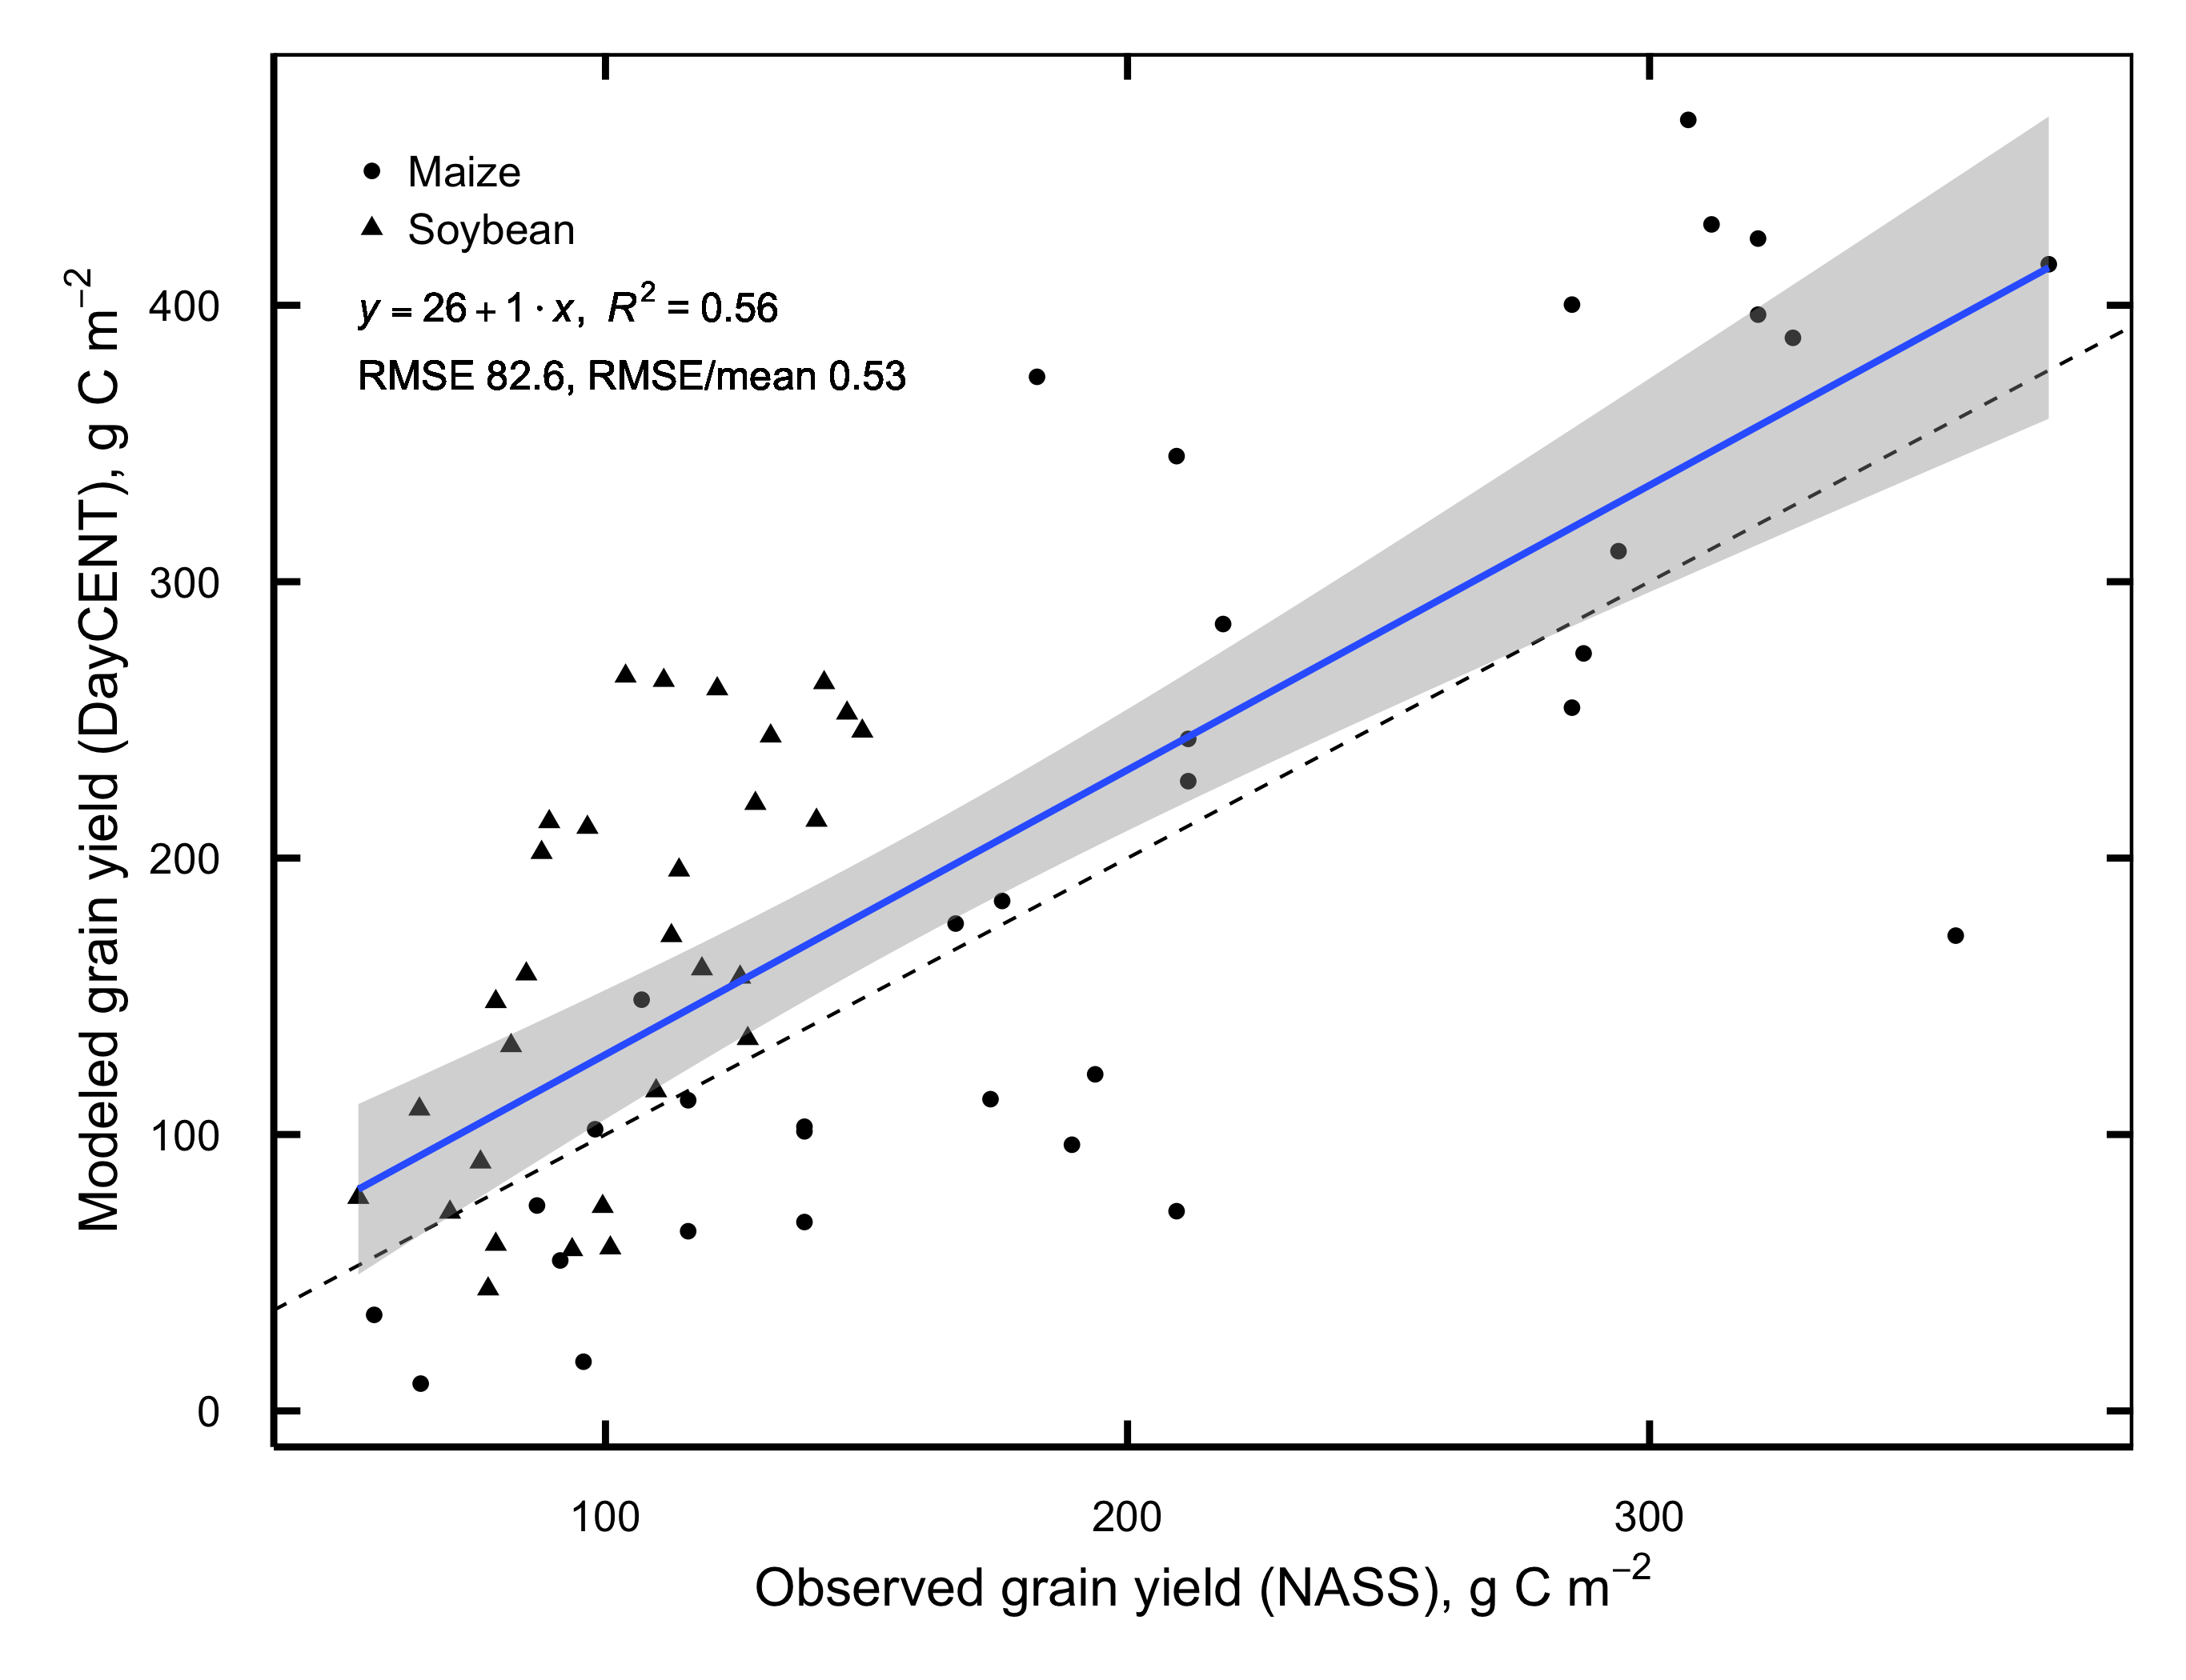

Figure 2.S3: Linear regression of DayCent vs. NASS grain yields for all years combined.

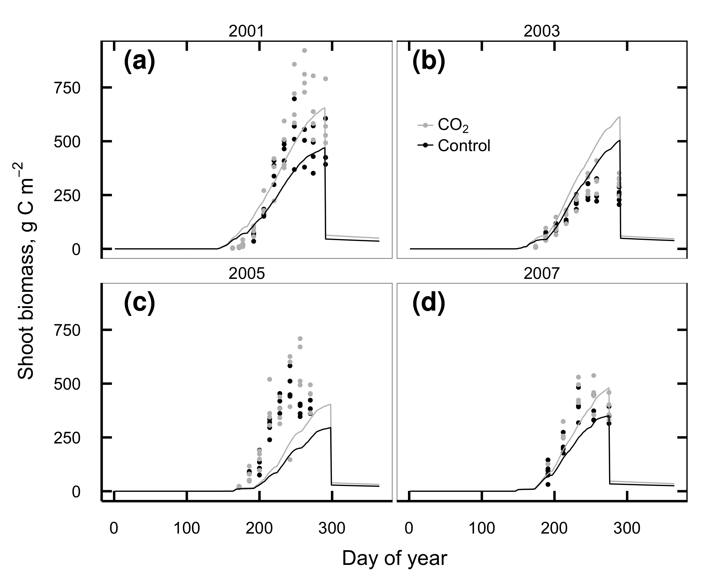

Figure 2.S4: Aboveground soybean biomass C observed at SoyFACE (dots) and simulated by DayCent in 2001 (a), 2003 (b), 2005 (c), and 2007 (d). Observations from 2003 include effects from a defoliating hailstorm on DOY 198 that is not simulated in the model.

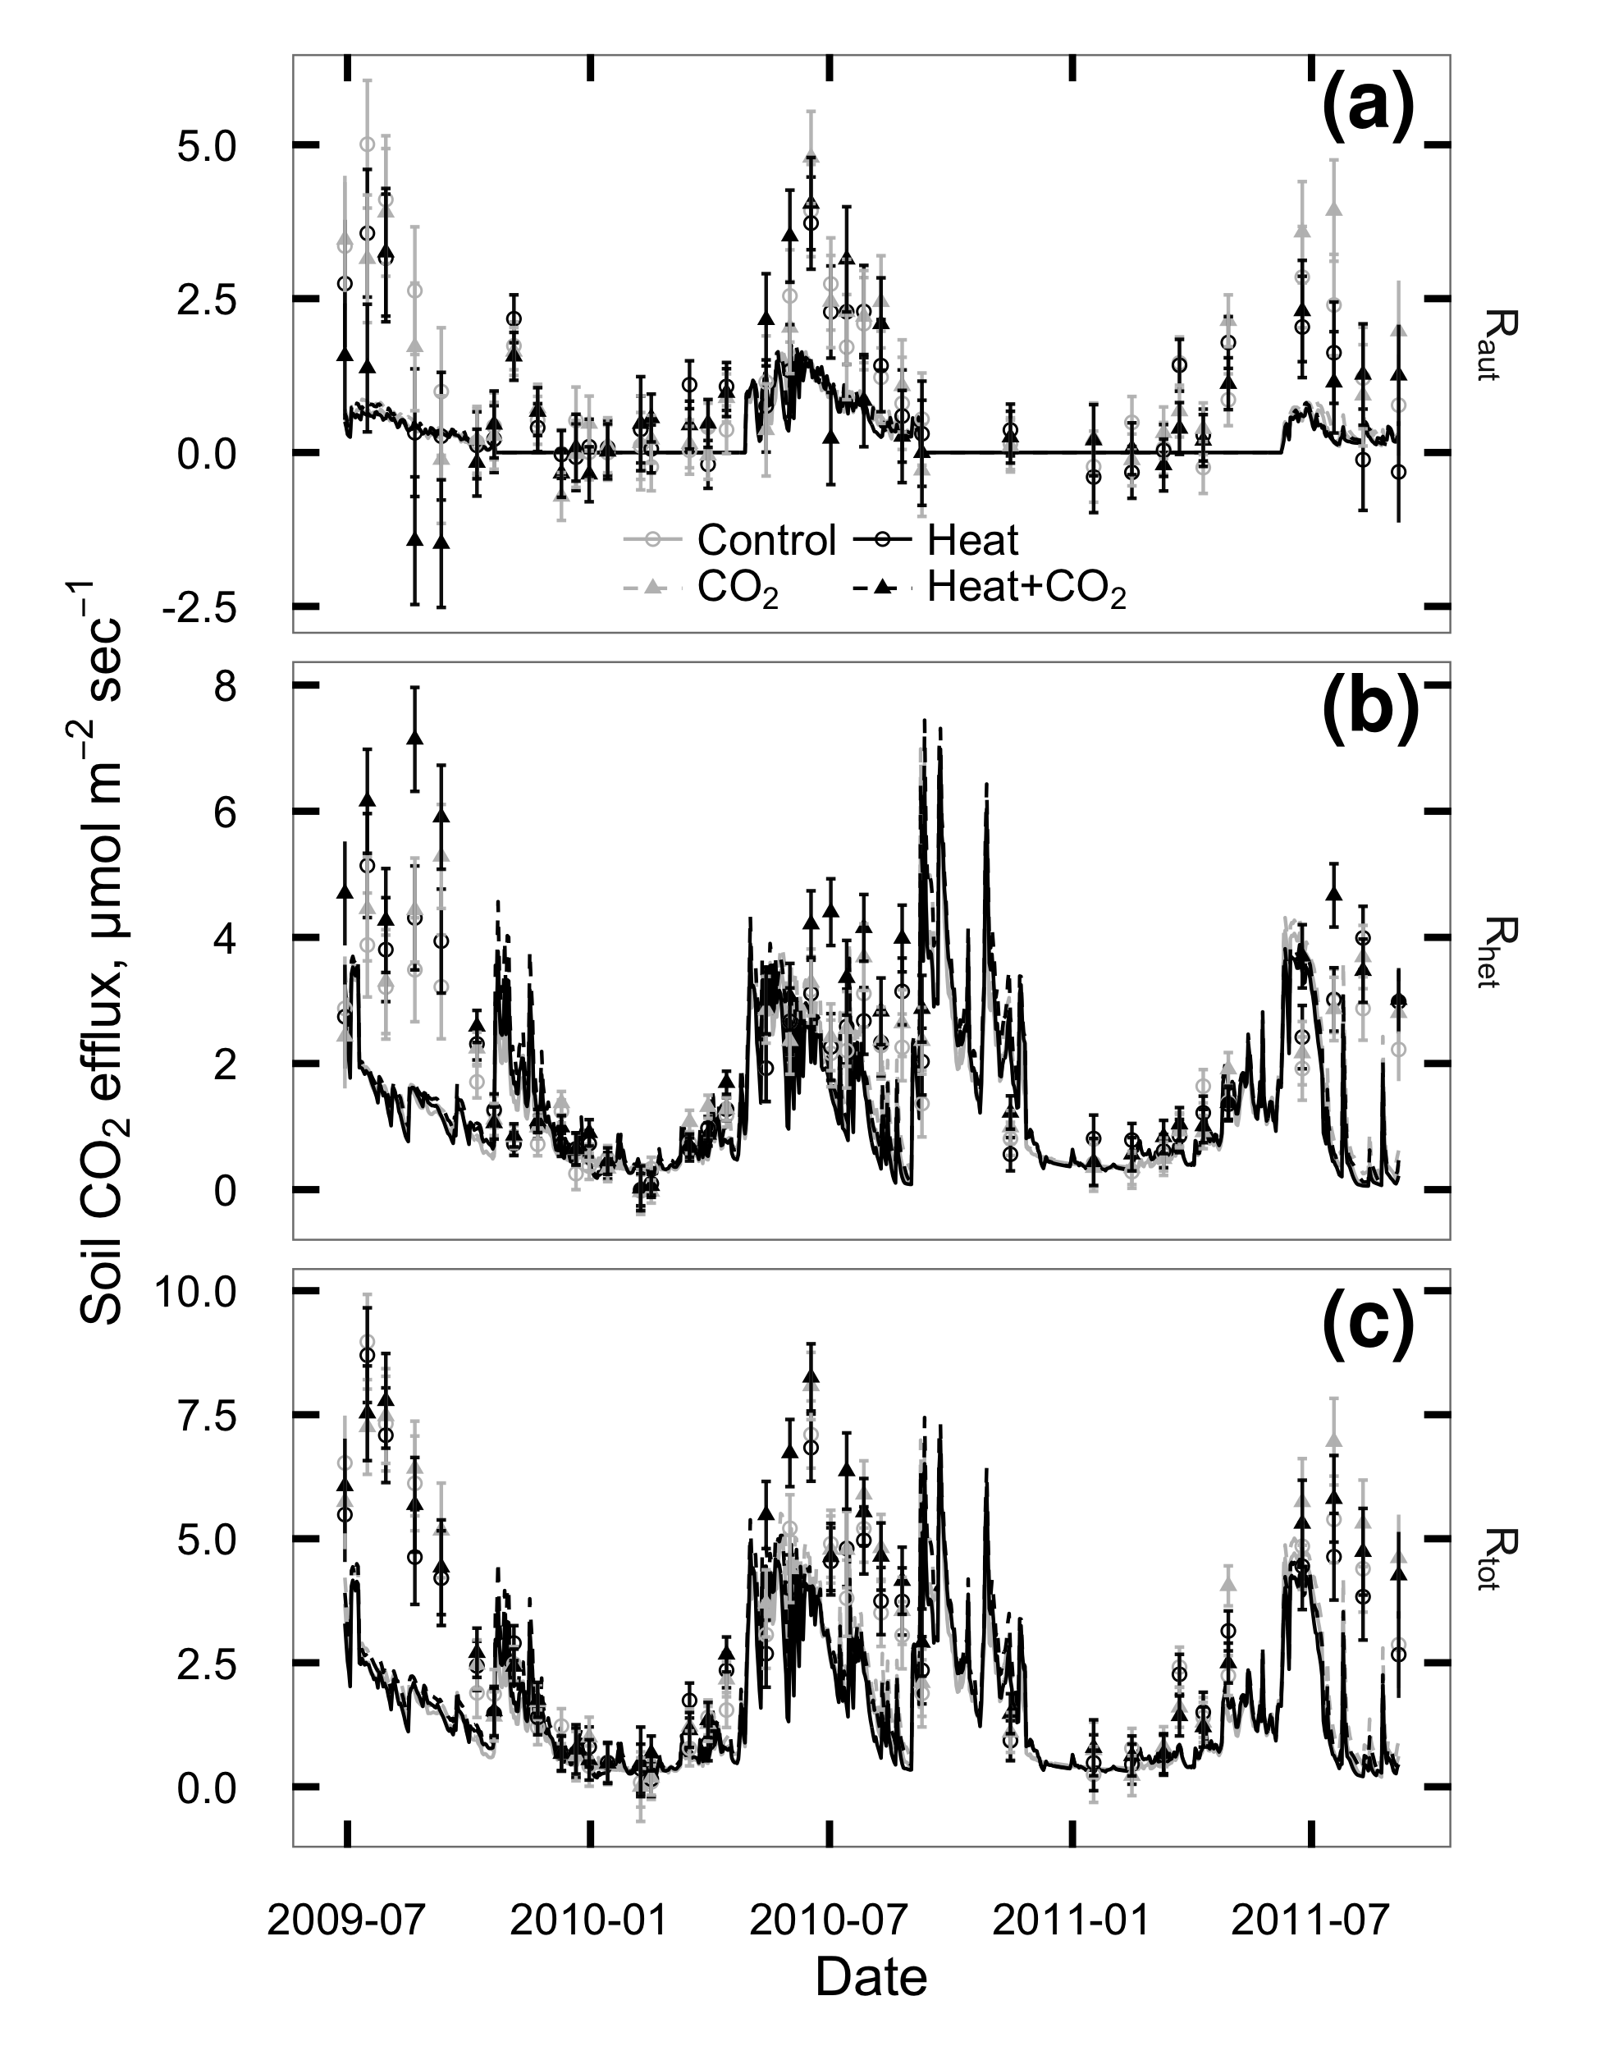

Figure 2.S5: CO2 flux from plant roots and rhizosphere (Raut; a), soil heterotrophs (Rhet; b), and whole soil (Rtot; c) at SoyFACE between June 2009 and October 2011. Symbols with error bars show observed treatment means 1 standard error for each day. Lines show values predicted by DayCent. Grey = unheated; Black = heated; Solid lines & unfilled circles = ambient CO2; dashed lines & filled triangles = elevated CO2.