PLANT ROOT CONTRIBUTIONS TO THE CARBON BALANCE OF A CHANGING AGRICULTURAL MIDWEST

BY

CHRISTOPHER KYLE BLACK

DISSERTATION

Submitted in partial fulfillment of the requirements

for the degree of Doctor of Philosophy in Plant Biology

in the Graduate College of the

University of Illinois at Urbana-Champaign, 2016

Urbana, Illinois

Doctoral Committee:

Professor Evan H. DeLucia, Chair

Associate Professor Carl J. Bernacchi

Assistant Professor Sarah C. Davis, Ohio University

Associate Professor Andrew D. B. Leakey

# Chapter 1

# Introduction

Earth’s climate is changing because of increases in atmospheric CO2 caused by human fossil fuel use. In the Midwestern United States, temperatures are forecast to increase 2-4 °C from 20th-century averages and [CO2] to exceed 500 ppm by the mid-21st century (Romero-Lankao et al. 2014, Mellilo et al. 2016). These changes will have profound effects on the ecology and biogeochemistry of all ecosystems, and therefore on the policies and land use decisions needed to manage them effectively. Land use decisions in turn change ecosystem C storage and will therefore feed back to global climate in ways either stabilizing if a new land use stores more C or destabilizing if a new land use releases C (Anderson-Teixeira and DeLucia 2011). Therefore, quantifying the C storage potential of potential land-use scenarios is fundamental to predicting climate responses and an essential step toward choosing policies that promote climate-positive outcomes.

The dominant ecosystems of the Midwest are agricultural, and are currently managed almost exclusively for the production of maize and soybean, generally grown in rotation. In 2016 a total of 71.3 million Ha were planted to maize and soybean (NASS 2011), making it the largest ecosystem type in the continental US by area. Since their aboveground biomass is removed or tilled in each year, C storage in these ecosystems consists exclusively of the soil C pool. A large proportion of new C inputs come from root and root-exudate C and the overall annual ecosystem C balance depends greatly on tillage decisions (Allmaras et al. 2004, Bernacchi et al. 2005). Therefore, understanding the C storage potential of agroecosystems is primarily a question of understanding root and soil C cycling.

The largest current use for US-produced maize (~40% of total production; NASS 2011) is as a feedstock for the production of ethanol. It has been suggested that changing some of this acreage to produce cellulosic fuel crops could potentialy have climate and economic benefits. In general, cellulosic crops that take a “land sparing” approach by maximizing ethanol production on a small number of acres appear most likely to be successful in current economic conditions (Heaton et al. 2008, Davis et al. 2012, Hudiburg et al. 2016), while lower-productivity but lower-input systems such as prairie restorations may still have considerable benefits if other ecosystem services, such as biodiversity and resilience to unpredictable climates, are considered (Fornara and Tilman 2009, Gelfand et al. 2013). However, considerable uncertainty remains about the accumulation rate and turnover time of soil C in both high- and low-input biofuel crops (Anderson-Teixeira et al. 2013, Agostini et al. 2015, Bach and Hofmockel 2016).

The central aim of my dissertation research was to quantify how the mass, placement, and chemical & taxonomic makeup of roots will affect the trajectory of belowground C storage in the warmer, higher CO2 Midwest of the coming decades. Within this overarching framework, I focus on three land-use scenarios that can be characterized as conventional tillage, high-yield perennial grasses, and low-input restored prairie. Because these scenarios differ widely in the amount of previous work available to build from, the outstanding questions about belowground C cycling differ in each system. This means that in each system I collected very different measurements, not all of which can immediately be converted into units of carbon. But in each case I attempt to assess what it means for the long-term C status of the system.

## Scenario 1: Maize-soybean rotation

I begin with a business-as-usual scenario, where the Midwestern United States continues to be mostly managed as a conventional maize-soybean rotation and farmers do their best to maintain maximum yields in an increasingly warm and high-CO2 environment. In this scenario the responses of crop roots are relatively well-studied: Elevated CO2 increases soybean plant size, including the root system (Ainsworth and Long 2005, Ruiz-Vera et al. 2013, Gray et al. 2016), and appears to have little effect on maize plant size (Leakey et al. 2006, Ruiz-Vera et al. 2015). It is important to note that from an agronomic perspective, these increases in biomass appear unlikely to translate into reliable yield increases (Ruiz-Vera et al. 2013, 2015, Gray et al. 2016), but from a carbon cycling perspective it is likely that maize-soybean ecosystems will have higher C inputs to the soil in the future. Therefore in this chapter I focused on the question of outputs: How do elevated temperature and CO2 affect the rate of C *loss* from the soil? By measuring soil CO2 flux for three years, partitioning it into root-derived and microbe-derived components, and comparing the results against the predictions of a 100-year in silico experiment using an ecosystem biogeochemistry model (Parton et al. 1998), I found that elevated temperature increases the microbial breakdown of soil organic matter and that increases in biomass input from elevated CO2 appear to prime additional increases in respiration, suggesting that the long-term result of the business as usual scenario will be substantial losses of soil C.

## Scenario 2: High-yield biofuels

Next, I ask whether some of the predicted soil C losses can be avoided by changing management strategies. High-yielding perennial grasses have large root systems and reduced disturbance cycles and have been proposed as a promising biofuel feedstock that may also increase soil C storage (Agostini et al. 2015). However, the stability of this C may depend greatly on the timing of its arrival and its physical placement in the soil profile (De Deyn et al. 2008). To explore root C inputs in more depth, improved nondestructive methods of root monitoring are needed (Rewald et al. 2012, Topp et al. 2016). I develop and calibrate a Bayesian statistical model written in Stan (Carpenter et al. 2016) to estimate the root volume of a full soil profile from minirhizotron images, and combine it with results from direct sampling to show that perennial monocultures of switchgrass and *Miscanthus* can have root systems comparable in size to native prairies, and importantly that they store much of this mass in the deepest and probably most stable soil layers. This raises hope that these root carbon inputs can be maintained as soil carbon for longer than if they were sent to shallower soil.

## Scenario 3: Low-input high-diversity biofuels

Finally, I turn to a multispecies grassland more like the native vegetation of our region of the Midwest. As an ethanol crop, restored prairies produce far less biomass per acre than high-yielding monocultures, and therefore they would require substantially more land diverted from food production (Heaton et al. 2008), making their widespread adoption seem unlikely at present. However, as the biome that literally created the fertility of the Corn Belt, the ability of prairies to store soil C over the long term is indisputable (David et al. 2009), and their adoption may accelerate if climate policy shifts to increase attention to other management goals such as yield stability in extreme conditions, supporting trophic diversity, and preserving locally adapted species (Fargione et al. 2009). Compared to the monocultures of the other two scenarios, my challenge in quantifying root inputs to this complex community mixture is very basic: “Here are some roots, but which species grew them?” I use DNA metabarcoding to disentangle the species in the root mixture and ask whther there is any spatial structure to the root stand: How do the species partition the niche space, and how does that affect the potential for C storage? I find that grasses increase in prevalence deeper in the soil profile, implying that the deep-soil inputs, with the highest chance of long-term C storage, are likely also enriched in grass roots, which tend to have lower turnover, i.e. longer C residence time, than forb roots.

## Scaling up: Exploiting computation to match small samples to big questions

In addition to their linked interest in soil C, these projects also share a common methodological thread: I each case I am asking questions for which the scale of the available measurement methods is poorly matched to the scale of inference. Quantifying soil C contents or root mass is easy for any given sample, but obtaining each sample is laborious and usually destructive, and belowground systems are characterized by extreme heterogeneity on all scales. This means that questions about changes in belowground C across time or space are inherently difficult, often to the point of impracticality, to answer by direct measurement alone. Therefore each of the following chapters includes a substantial computational component. My approach is to collect what direct measurements are available, then use models to synthesize the available infomation to match the scale of the question.

The model is different for each question: In chapter 2 I scale root and microbial respiration from instantaneous flux rates to century-scale changes in pool size using a well-tested and and mechanistically validated simulation of ecosystem biogeochemical processes. In chapter 3 I use a novel Bayesian statistical model to correct biases in image-based estimates of root distribution, therefore bringing an indirect measurement method into closer agreement with more laborious direct observations. Finally, in chapter 4 I apply bioinformatic tools from the rapidly emerging field of environmental metagenomics to filter noisy, mixed-sample DNA sequences into estimates of root identity and to attribute spatially partitioned niches to their taxonomic groups.

All of these computational analyses use different sets of programming tools, but a critical common theme is that the assumptions I made while programming them are *at least* as important for the quality of my inferences as are the methods I used for my direct measurements. However, unlike collecting soil cores, it is easy to redo computations! To that end, all of the code and data for these chapters are freely available online at my public code repository at https://github.com/infotroph/ and also at locations listed in each chapter. I encourage anyone to reproduce my analyses, test my assumptions for themselves, or alter the code for their own pruposes. If you find errors, please tell me.

## References

Agostini, F., A. S. Gregory, and G. M. Richter. 2015. Carbon Sequestration by Perennial Energy Crops: Is the Jury Still Out? BioEnergy Research 8:1057–1080.

Ainsworth, E. A., and S. P. Long. 2005. What have we learned from 15 years of free-air CO2 enrichment (FACE)? A meta-analytic review of the responses of photosynthesis, canopy properties and plant production to rising CO2. New Phytologist 165:351–371.

Allmaras, R. R., D. R. Linden, and C. E. Clapp. 2004. Corn-Residue Transformations into Root and Soil Carbon as Related to Nitrogen, Tillage, and Stover Management. Soil Science Society Of America Journal 68:1366.

Anderson-Teixeira, K. J., and E. H. DeLucia. 2011. The greenhouse gas value of ecosystems. Global Change Biology 17:425–438.

Anderson-Teixeira, K. J., M. D. Masters, C. K. Black, M. Zeri, M. Z. Hussain, C. J. Bernacchi, and E. H. DeLucia. 2013. Altered Belowground Carbon Cycling Following Land-Use Change to Perennial Bioenergy Crops. Ecosystems 16:508–520.

Bach, E. M., and K. S. Hofmockel. 2016. A time for every season: soil aggregate turnover stimulates decomposition and reduces carbon loss in grasslands managed for bioenergy. Global Change Biology Bioenergy 8:588–599.

Bernacchi, C. J., S. E. Hollinger, and T. Meyers. 2005. The conversion of the corn/soybean ecosystem to no-till agriculture may result in a carbon sink. Global Change Biology 11:1867–1872.

Carpenter, B., A. Gelman, M. Hoffman, D. Lee, B. Goodrich, M. Betancourt, M. A. Brubaker, J. Guo, P. Li, and A. and Riddell. 2016. Stan: A Probabilistic Programming Language. Journal of Statistical Software.

David, M. B., G. F. McIsaac, R. G. Darmody, and R. A. Omonode. 2009. Long-term changes in mollisol organic carbon and nitrogen. Journal of Environment Quality 38:200–211.

Davis, S. C., W. J. Parton, S. J. Del Grosso, C. Keough, E. Marx, P. R. Adler, and E. H. DeLucia. 2012. Impact of second-generation biofuel agriculture on greenhouse-gas emissions in the corn-growing regions of the US. Frontiers in Ecology and the Environment 10:69–74.

De Deyn, G. B., J. H. C. Cornelissen, and R. D. Bardgett. 2008. Plant functional traits and soil carbon sequestration in contrasting biomes. Ecology Letters 11:516–531.

Fargione, J. E., T. R. Cooper, D. J. Flaspohler, J. Hill, C. Lehman, T. McCoy, S. McLeod, E. J. Nelson, K. S. Oberhauser, and D. Tilman. 2009. Bioenergy and Wildlife: Threats and Opportunities for Grassland Conservation. BioScience 59:767–777.

Fornara, D. A., and D. Tilman. 2009. Ecological mechanisms associated with the positive diversity-productivity relationship in an N-limited grassland. Ecology 90:408–418.

Gelfand, I., R. Sahajpal, X. Zhang, R. C. Izaurralde, K. L. Gross, and G. P. Robertson. 2013. Sustainable bioenergy production from marginal lands in the US Midwest. Nature 493:514–517.

Gray, S. B., O. Dermody, S. P. Klein, A. M. Locke, J. M. McGrath, R. E. Paul, D. M. Rosenthal, U. M. Ruiz-Vera, M. H. Siebers, R. Strellner, E. A. Ainsworth, C. J. Bernacchi, S. P. Long, D. R. Ort, and A. D. B. Leakey. 2016. Intensifying drought eliminates the expected benefits of elevated carbon dioxide for soybean. Nature Plants 2:16132.

Heaton, E. A., F. G. Dohleman, and S. P. Long. 2008. Meeting US biofuel goals with less land: the potential of Miscanthus. Global Change Biology 14:2000–2014.

Hudiburg, T. W., W. Wang, M. Khanna, S. P. Long, P. Dwivedi, W. J. Parton, M. Hartman, and E. H. DeLucia. 2016. Impacts of a 32-billion-gallon bioenergy landscape on land and fossil fuel use in the US. Nature Energy 1:15005.

Leakey, A. D. B., M. Uribelarrea, E. A. Ainsworth, S. L. Naidu, A. Rogers, D. R. Ort, and S. P. Long. 2006. Photosynthesis, productivity, and yield of maize are not affected by open-air elevation of CO2 concentration in the absence of drought. Plant Physiology 140:779–790.

Mellilo, J. M., T. Richmond, and G. W. Yohe, editors. 2016. Climate Change Impacts in the United States. U.S. Global Change Research Program; U.S. Government Printng Office.

NASS. 2011. Census of Agriculture Quick Stats 2.0.

Parton, W. J., M. D. Hartman, D. S. Ojima, and D. S. Schimel. 1998. DAYCENT and its land surface submodel: description and testing. Global and Planetary Change 19:35–48.

Rewald, B., C. Meinen, M. Trockenbrodt, J. E. Ephrath, and S. Rachmilevitch. 2012. Root taxa identification in plant mixtures – current techniques and future challenges. Plant and Soil 359:165–182.

Romero-Lankao, P., J. B. Smith, D. J. Davidson, N. S. Diffenbaugh, P. L. Kinney, P. Kirshen, P. Kovacs, and L. Villers-Ruiz. 2014. North America. Pages 1439–1498 *in* V. R. Barros, C. B. Field, D. J. Dokken, M. D. Mastrandrea, K. J. Mach, T. E. Bilir, M. Chatterjee, K. L. Ebi, Y. O. Estrada, R. C. Genova, B. Girma, E. S. Kissel, A. N. Levy, S. MacCracken, P. R. Mastrandrea, and L. L. White, editors. Climate change 2014: Impacts, adaptation, and vulnerability. part b: Regional aspects. contribution of working group ii to the fifth assessment report of the intergovernmental panel of climate change. Cambridge University Press, Cambridge, United Kingdom; New York, NY, USA.

Ruiz-Vera, U. M., M. H. Siebers, D. W. Drag, D. R. Ort, and C. J. Bernacchi. 2015. Canopy warming caused photosynthetic acclimation and reduced seed yield in maize grown at ambient and elevated [CO2]. Global Change Biology 21:4237–4249.

Ruiz-Vera, U. M., M. Siebers, S. B. Gray, D. W. Drag, D. M. Rosenthal, B. A. Kimball, D. R. Ort, and C. J. Bernacchi. 2013. Global warming can negate the expected CO2 stimulation in photosynthesis and productivity for soybean grown in the Midwest United States. Plant Physiology 162:410–423.

Topp, C. N., A. L. Bray, N. A. Ellis, and Z. Liu. 2016. How can we harness quantitative genetic variation in crop root systems for agricultural improvement? Journal Of Integrative Plant Biology 58:213–225.

# Chapter 2

# Elevated CO2 and temperature increase soil C losses from a soybean-maize ecosystem

## Abstract

Warming temperatures and increasing CO2 are likely to have large effects on the amount of carbon stored in soil, but predictions of these effects are poorly constrained. We elevated temperature (canopy: +2.8 °C; soil growing season: +1.8 °C; soil fallow: +2.3 °C) for three years within the 9th-11th years of an elevated CO2 (+200 ppm) experiment on a maize-soybean agroecosystem, measured respiration by roots and soil microbes, then used a process-based ecosystem model (DayCent) to simulate the decadal effects of warming and CO2 enrichment on soil C. Both heating and elevated CO2 increased respiration from soil microbes by ~20%, but heating reduced respiration from roots and rhizosphere by ~25%. The effects were additive, with no heat x CO2 interactions. Particulate organic matter and total soil C declined over time in all treatments and were lower in elevated CO2 plots than in ambient plots, but did not differ between heat treatments. We speculate that these declines indicate a priming effect, with increased C inputs under elevated CO2 fueling a loss of old soil carbon. Model simulations of heated plots agreed with our observations and predicted loss of ~15% of soil organic C after 100 years of heating, but simulations of elevated CO2 failed to predict the observed C losses and instead predicted a ~4% gain in soil organic C under any heating conditions. Despite model uncertainty, our empirical results suggest that combined, elevated CO2 and temperature will lead to long term declines in the amount of carbon stored in agricultural soils.

## Introduction

Human activity, primarily fossil fuel burning, is increasing atmospheric [CO2] and raising global mean temperature (Hartmann *et al.*, 2013). These changes are likely to have direct and indirect effects on storage of soil organic carbon (SOC), but estimates of the direction and magnitude of these effects are poorly constrained (Dieleman *et al.*, 2012; Lu *et al.*, 2013). Soils worldwide store over two orders of magnitude more C than annual anthropogenic emissions ( 1500 Pg C in the top 1 m; Eswaran *et al.*, 1993), so even small changes in soil C storage in response to climate change could produce large feedbacks to the global C cycle. This may be especially true of the SOC-rich former prairie soils of the agriculturally managed Midwestern United States, where annual tillage, infrequent water limitation, regular fertilization, and frequent pulses of highly labile C from crop residues provide ideal conditions for temperature-controlled microbial activity (Tisdall & Oades, 1980).

Changes in soil C are difficult to detect on short timescales because some pools turn over slowly, with mean residence times of hundreds of years. Although it is conceptually useful to identify the faster-cycling subpools of soil C, we lack experimental methods to measure them directly (Schmidt *et al.*, 2011). Instead, changes in the rate of CO2 fluxes from soil can be used as a proxy for changes in the soil C cycle by partitioning total CO2 flux (Rtot) into components attributed to “autotrophic” respiration (Raut) from plant roots and rhizosphere organisms, or to “heterotrophic” respiration (Rhet) from soil microbes in the process of breaking down soil organic matter (SOM). Because Rhet is the primary avenue for loss of soil C, any change in Rhet indicates a change in the rate of soil C loss. Rhet is strongly controlled by soil temperature and moisture and therefore expected to shift under future climate conditions (Davidson & Janssens, 2006; Subke & Bahn, 2010; Conant *et al.*, 2011; Bradford, 2013). In contrast, changes in Raut are indirectly linked to the rate of C *input* from roots, so a unit change in Rtot could indicate either increasing or decreasing soil C. Therefore correct partitioning of fluxes is essential to their use as a proxy for changes in pool size (Kuzyakov & Larionova, 2005).

Previous soil heating experiments have generally shown short-term increases in Rtot (Rustad *et al.*, 2001; Wu *et al.*, 2011), except when heating exacerbated soil water limitations (Schindlbacher *et al.*, 2012; Pendall *et al.*, 2013; Suseela & Dukes, 2013; Wall *et al.*, 2013; Wang *et al.*, 2014). This heating effect often diminishes after a few years of treatment. Whether these responses will persist over the long term under climate change depends on whether a particular soil’s Rhet response is modulated by availability of nutrients or C substrates (Luo *et al.*, 2001; Chevallier *et al.*, 2015) or by physiological adaptation of the microbial community (Allison *et al.*, 2010; Bradford, 2013). In addition, few of these studies were able to separate soil respiration into its autotrophic and heterotrophic components. Since Rhet is strongly controlled by thermal kinetics while Raut responds to a wide variety of non-thermal factors, it has been widely assumed that temperature-associated increases in Rtot are driven by increasing Rhet, but support for this assumption is equivocal (Hartley *et al.*, 2007; Bond-Lamberty & Thomson, 2010; Suseela & Dukes, 2013; Wang *et al.*, 2014).

Previous CO2 enrichment experiments have generally shown sustained increases in Rtot (King *et al.*, 2004; Bernhardt *et al.*, 2006; Pregitzer *et al.*, 2006; Peralta & Wander, 2008; Adair *et al.*, 2011; Carrillo *et al.*, 2011; Drake *et al.*, 2011; Keidel *et al.*, 2015), but there are few reported results from field experiments that manipulate both heat and CO2 simultaneously. Of those that are reported (Carrillo *et al.*, 2011; Pendall *et al.*, 2011, 2013; Selsted *et al.*, 2012), the observed responses seem to be mostly mediated by water availability, with heat increasing Rtot when moisture is available and reducing it when heating produces drier soil. Elevated CO2 mediates these effects by ameliorating soil water stress through increased plant water use efficiency, but the strength and predictability of this effect seems to vary widely both within and between experiments.

The objective of this study was to measure the root- and SOM-derived components of soil respiration in an intact maize-soybean ecosystem subjected to mid-21st century temperature (+3.5 °C) and CO2 (585 ppm) conditions under fully open-air conditions at SoyFACE (Urbana IL, USA). We then used a process-based biogeochemical model (DayCent; Parton *et al.*, 1998) to predict the long-term effects of these respiratory responses on soil C storage. We predicted that elevated temperature would increase the activity of soil heterotrophs, leading to increased respiration in root-free soil and long-term losses of C from the most labile pools of SOM. We further predicted that elevated CO2 would increase plant biomass above and belowground, leading to higher C inputs that would at least partially ameliorate the long-term effect of heat on soil C, and therefore that the long-term fate of soil C at our site would depend on the strength of the interaction between heat and CO2 effects.

## Materials and methods

### Site description

Measurements were made at the *Soy*bean *F*ree-*A*ir *C*oncentration *E*nrichment (SoyFACE) experiment (40.04N, 88.23W; elev. 215 m; soyface.igb.illinois.edu), a 32-Ha experimental site near Urbana IL, USA. The site is flat, tile-drained, and has been cultivated for over 100 years. Soils are deep and highly productive, mapped as Flanagan silt loam (fine, smectitic, mesic Aquic Argiudoll) and Drummer silty clay loam (fine-silty, mixed, superactive, mesic Typic Endoaquoll). The mean annual temperature is 11 °C, with monthly mean temperatures ranging from -3 °C in January to 24 °C in July, and annual precipitation is ~1 m, with approximately half falling during the May-September growing season (Angel, 2010a).

The site was managed in a two-year rotation, with maize (*Zea mays* cv 34B43) and soybean (*Glycine max* cv 93B15) alternating between the eastern and western halves of the site. Maize was fertilized with 202 kg N Ha-1 yr-1 and soybean was not fertilized. The soil was typically chisel plowed each spring before planting, and in the fall after maize harvest but not after soybean. Measurements were taken from 2009-2011 in the west half of the site, where the crop rotation cycle for these years was soybean-maize-soybean. Management of these crops was consistent with previously reported practices at the site (Leakey *et al.*, 2004; Morgan *et al.*, 2005), with the exception that no fall tillage was done after the 2010 maize crop so that the heating equipment could be kept in operation overwinter.

### Elevated CO2 and temperature treatments

The field was divided into four experimental blocks, each containing two 20-m octagonal rings spaced 100 m apart to avoid cross-contamination by fumigation gases. One ring in each block was maintained at ambient atmospheric conditions (approximately 390 ppm CO2), while the other was fumigated to a target of 585 ppm CO2 using *F*ree *A*ir *C*oncentration *E*nrichment (FACE) technology (Miglietta *et al.*, 2001). Elevated CO2 was maintained from dawn until dusk throughout the growing season. The high-CO2 rings in the study area have been fumigated every growing season since 2001.

Starting in 2009, each ring was further split by imposing an elevated temperature treatment. One 3-m hexagonal subplot of each ring was equipped with overhead infrared heaters as in Kimball (2005). The heaters were adjusted throughout the growing season to stay 1.4 m above the canopy and were controlled by infrared radiometers to maintain a difference of 3.5 °C between the canopy-top temperature of heated and unheated plots. When rain was falling and when soil temperature was 5 °C, heating was ineffective and heater output was therefore reduced to a minimum. The heating system operated continuously between June 2009 and September 2011 except during planting when all equipment was removed to allow field tillage, during harvest when power cables were removed to allow harvester traffic, and during a two-week period in January 2010 when the equipment was rebuilt to repair damage from rodents. Further details on the heating treatment are reported in (Ruiz-Vera *et al.*, 2013, 2015; Rosenthal *et al.*, 2014).

### Measurement of soil properties and CO2 efflux

CO2 efflux from soil was measured at three locations in each plot using 20-cm diameter collars made from PVC pipe. At each location, one collar was inserted 3 cm into the soil to capture total soil respiration (Rtot), and a second collar was inserted 25 cm to capture respiration by soil heterotrophs (Rhet) by excluding roots and rhizosphere: The top 30 cm of soil contain at least 70% of soybean and 60% of maize root mass (Mayaki *et al.*, 1976; Anderson-Teixeira *et al.*, 2013), so this root-exclusion collar acts as a small trenched plot (Vogel & Valentine, 2005). Collars were installed at crop emergence time each spring and left in place all year, then removed for field tillage just before the next year’s planting. This annual reinstallation also eliminated several major limitations that apply to root-exclusion methods in untilled systems: it removed any accumulated difference in C or nutrient availability from previous years of root exclusion, and there was no need to correct for decomposition of roots severed during installation (Hanson *et al.*, 2000) because root biomass at installation was near zero. Respiration by roots and rhizosphere (Raut) was calculated for each location as the difference between Rtot and Rhet.

CO2 efflux rates were measured using an infrared gas analyzer (LI-8100; Li-Cor, Lincoln NE USA) fitted with a 20-cm static chamber (Li-Cor 8100-103) that rested on top of the soil collar. For each observation, the chamber was closed for two minutes while [CO2] was logged every second. Linear regressions on static-chamber observations underestimate the initial flux rate (Healy *et al.*, 1996), so flux rates were computed in software by the LI-8100, which fit a saturating exponential curve of the form:

where is [CO2] at the moment the chamber closed, is time, and and are fitted parameters representing curvature and [CO2] at the asymptote, respectively. Evaluating the derivative of at then gives the instantaneous initial slope , which was scaled by the volume of the soil chamber to give CO2 flux rate at the moment the chamber closed.

Using exponential rather than linear fits is especially important in a FACE setting, because it allows a further correction for initial chamber conditions: Respiration was measured while fumigation was active. Pure CO2 is released from the upwind side of the ring and mixes to the target concentration as it is blown across the plot (Miglietta *et al.*, 2001), meaning that in elevated-CO2 plots the flux chamber would sometimes close on a transient high-[CO2] air mass (up to 2000 ppm). In these cases the CO2 concentration gradient from soil to chamber air, and thus the rate of diffusion across the soil surface, was small. This meant that for these readings the fitted flux rate ‘at the moment the chamber closed’ was much smaller than the true equilibrium rate. We corrected this bias using a method recommended by Li-Cor Inc. that re-evaluates the previously fit [CO2] curve to find the equilibrium flux , where and are taken from the previous curve fit and is the daily average [CO2] in that ring (585 PPM for fumigated rings, 370-400 PPM for unfumigated rings).

Soil temperatures were measured simultaneously with each respiration measurement using a thermocouple probe inserted to 5 cm depth. Soil volumetric water content was measured from 5 to 105 cm depth 2-3 times each week using a capacitance probe and is reported elsewhere (Rosenthal *et al.*, 2014; Ruiz-Vera *et al.*, 2015).

Particulate organic matter (POM), which consists of fragmented but undecomposed plant matter and is used as a proxy for the abundance of labile soil C, was measured using a procedure modified from Marriott & Wander (2006). Briefly, air-dried soil was sieved to 2 mm and a 10-g sample was weighed into a 30-mL plastic bottle. The mouth of the bottle was covered with a 53-µm nylon mesh to retain POM and sand while allowing silt and clay particles to escape. The bottle was submerged in 5% sodium hexametaphosphate (HMP) and shaken for one hour, then the HMP and suspended fines <53 µm were removed, replaced with deionized water, and shaking was repeated until no further fine material was extracted. The remaining POM + sand was transferred to a pouch of 53-µm mesh, rinsed with DI water, dried at 30 °C, and weighed. Samples were then ground in a ball mill (Geno Grinder 2010; BT&C, Lebanon New Jersey, USA) and combusted to determine C content using an elemental analyzer (Costech ECS4010; Costech Analytical Technologies, Valencia, California, USA).

### Statistical analysis

Analysis of variance for soil respiration was performed in a complete-block design using CO2 as a whole-plot fixed effect and heat as a split-plot fixed effect nested within CO2. Blocks were treated as random, and autocorrelation within plots from repeated measurement through the season was estimated as a first-order autoregressive function. Rtot, Rhet, and Raut fluxes for each season were analyzed separately as mixed-effects linear models with repeated measures using the nlme and lsmeans packages in R 3.2.4 (Lenth, 2016; Pinheiro *et al.*, 2016; R Core Team, 2016). The date of each survey event was included as a categorical variable to account for within-season changes. Although most of the temporal variation is likely to be driven by weather and crop growth phase, the Day effect was treated as a catchall term and no explicit temperature or moisture covariates were included in the model. Because repeated measurements within the same plot are pseudo-replicates, the three flux measurements from each plot were averaged, giving n=4 observations per treatment in each day. Because experiments with few replicates have low power to detect small differences, we set a significance threshold of p 0.1 to minimize the chance of false negative conclusions (Filion *et al.*, 2000). Full statistical output and data-processing scripts are available in the data package for this manuscript (Black *et al.*, 2016).

### Modeling of soil respiration and soil organic carbon

Because a three-year heating experiment is likely too short to detect changes in SOC, we performed an *in silico* experiment using a process-based ecosystem model (DayCent; Parton *et al.*, 1998) to simulate the effects of a 100-year global change manipulation and better understand the long-term effects of elevated CO2 and temperature on soil carbon dynamics. DayCent has been widely used to model soil C, N, P and S dynamics and trace gas fluxes. It has been particularly well-validated for crop and grassland systems, and is straightforward to modify for predicted future conditions, making it ideal for simulations of the future ecosystem effects of climate and/or land-use changes (Davis *et al.*, 2010, 2012; Hartman *et al.*, 2011). DayCent model development has been closely tied to previous global change experiments and its input parameters are designed for easy calibration against experimentally measured responses (Parton *et al.*, 2007; Frey *et al.*, 2013).

To predict the medium- and long-term effects of ongoing ecosystem warming and elevated CO2 on soil carbon cycling, we performed a three-part set of DayCent simulations to simulate the historic development of the SoyFACE site from native prairie into a maize-soy rotation, extended this simulation through the 21st century, then ran the model four times using all factorial combinations of elevated CO2 and heat.

To calibrate the size and turnover rates of soil C pools, the model was first run to equilibrium by simulating a native tallgrass prairie at pre-industrial [CO2] of 294 PPM. Each simulation lasted 3867 years and looped over a weather file made by randomly ordering the years of an 1889-2009 temperature and precipitation record for Urbana, Illinois (Angel, 2010b). Vegetation for the spin-up period used prairie grass parameters provided by Hudiburg et al. (2015), with autumn burning every 5th year and low-intensity grazing by bison (10% of foliage removed 3 times per growing season). Soil parameters were based on bulk densities and organic matter contents of undisturbed Illinois prairie remnants (David *et al.*, 2009), and on physical properties of the Flanagan and Drummer soil series (NRCS, 2012). To match the high-moisture conditions predominant in Central Illinois before the introduction of artificial drainage, a standing water table was simulated from January through May. Soil organic matter turnover times were adjusted to produce steady-state (<1% change per decade in last 100 yr) SOM C and N of 10450 and 760 g m-2, respectively, in the top 20 cm ((**???**)). These totals are comparable to those measured in tallgrass prairie remnants on deep, mesic soils throughout the Midwest (Aref & Wander, 1998; Kucharik *et al.*, 2006; Matamala *et al.*, 2008; Brye & Riley, 2009; David *et al.*, 2009; Jelinski & Kucharik, 2009) and were achieved using turnover rates for the active, intermediate, and slow soil C pools of 11, 0.1, and 0.002 yr-1, giving residence times of 33 days, 10 years and 500 years, respectively.

Annual rows crops were simulated beginning in 1868, the year our site was first recorded as occupied by European settlers. To simulate the change from an untilled, seasonally wet prairie to a tile-drained, annually-tilled crop system, we ceased simulating a standing water table, increased the maximum decomposition rate of intermediate- and slow-turnover organic matter, and reduced leaching rates for N and OM (Table S1). Additionally, we reduced the rate of nonsymbiotic soil N fixation and the fraction of mineralized N lost to nitrification to better match conditions observed in row crop systems (Table S1). Site-specific parameters were based on soil conditions measured at the site (Peralta & Wander, 2008; C. Black, unpublished data; J. Jastrow, unpublished data; Moran & Jastrow, 2010), soil moisture measured at the site (S. B. Gray, unpublished data; Rosenthal *et al.*, 2014; Ruiz-Vera *et al.*, 2015), and historical weather data from the Illinois State Water Survey (Angel, 2010b). Atmospheric [CO2] was increased linearly to match the rise in industrial fossil fuel burning, from 294 ppm in 1868 to 370 ppm in 2000. Crop-specific parameters for maize and soybeans were developed by Hudiburg et al. (2015) to match the rate and physiological mechanisms of 20th-century crop genetic improvements: maize yield gains have come mostly from increases in planting density and photosynthetic capacity (Duvick, 2005), so we simulated an increase in the maximum daily biomass production rate, with minor adjustments to other parameters (Table S3). In contrast, soybean yield increases have come mostly from improved yield partitioning at constant plant size (Koester *et al.*, 2014), so our soybean parameters were constant except that we increased the maximum harvest index in 1950 and 1980.

The management history of the site before 1980 was inferred from records of crop acreage and fertilizer usage for Champaign County retrieved from the National Agricultural Statistics Service (NASS, 2011). Site management since 1980 is well described (Moran & Jastrow, 2010) and was simulated accordingly (Table S2). Briefly, management progressed from low-yielding mixed maize/oat/pasture in 1869 through increasingly intensive cropping and fertilization to a maize-soybean-oat rotation by 1935 and a maize-soybean rotation by 1950, with fertilization rates and cultivar parameters adjusted each decade to match NASS records. Beginning in 1970 we changed cultivation from moldboard plow every spring and fall to chisel plowing each spring and in fall after maize only, and fertilization rates were held steady at 157 kg N Ha-1. This management schedule was continued though 1999, then concluded in 2000 with one year of winter wheat (Moran & Jastrow, 2010).

To simulate the SoyFACE climate change manipulations, we extended the 20th-century simulation for the years 2001-2109 using the actual 2001-2011 planting and harvest dates of the SoyFACE experimental field. Weather data for 2001-2011 was retrieved from DAYMET (Thornton *et al.*, 2014) and the model was run four times: a control run with actual weather conditions and [CO2] set to 370 ppm (ambient conditions at the initiation of the SoyFACE experiment), a CO2-only run with [CO2] increased by 200 ppm to 570 ppm as a step change in 2001, a heat-only run with daily maximum and minimum temperatures increased 3.5 °C as a step change in 2009, and a heat+CO2 run with both temperature and CO2 increased. Note that we did not simulate any further increase in [CO2] after the step change, so for all model-data comparisons we treated values modeled at 370 or 570 ppm as equivalent to field values observed in 2009-2011 at ~390 or 585 ppm.

Our model calibration strategy was to use the performance of our spin-up and historic hindcast scenarios as indicators of correct parameter calibration, then run the climate change scenarios with no further changes in model tuning. To the extent that model hindcasts do match known conditions, we gain confidence that model predictions for the future are reasonable. To evaluate model performance in more detail, we compared modeled soil temperature, moisture, and respiration rates against our 2009-2011 field observations. We also compared modeled aboveground biomass and grain yields for 2001-2008 against detailed phenological measurements from SoyFACE, using a database compiled by Twine et al (2013). All model parameters and analysis scripts are available online (Appendix 1; Black *et al.*, 2016).

## Results

### Temperature and CO2 manipulation

Infrared heating produced a mean temperature increase of approximately 3.1, 2.7, and 2.6 °C at the top of the canopy in 2009, 2010, and 2011, respectively, and CO2 fumigation consistently maintained ~585 ppm CO2 during daylight hours (Ruiz-Vera *et al.*, 2013, 2015). Soil temperature at 5-cm depth was increased by 1.8 0.2 °C (mean standard error of daily differences) during the growing seasons (Figure 1). During fallow seasons, heater output was intermittently reduced during extreme cold snaps (less than 16% of total time) but soil temperature for the whole season was still increased by 2.3 0.1 °C (Figure 1). There was no consistent difference in soil temperature between eCO2 and unfumigated plots given the same heat treatment.

### Soil respiration

Overall, heating caused a consistent and large increase in Rhet but reduced Raut by a similar degree, producing no appreciable net effect of heating on Rtot, while eCO2 increased Rhet and affected Raut differently each year, with the net effect of a small stimulation in Rtot from eCO2. Averaged across the entire experiment, Rhet was higher than control by 16, 12, and 48% in the eCO2, heat, and heat+CO2 treatments, respectively. Raut was slightly (3%) higher in eCO2 and lower in heated plots by 21% (heat) and 31% (heat+eCO2). Rtot was higher in eCO2 treatments by 11% (unheated eCO2) and 13% (heated eCO2) but 3% lower in the heated ambient CO2 treatment (Figure 2).

Separate mixed-model analyses of respiration from each season (Table 1) showed that under soybeans in 2009, Rtot was unchanged while Rhet increased and Raut decreased in both heat and eCO2 treatments. Under maize in 2010, CO2 increased Rtot, heat increased Rhet, and there were no differences in Raut between treatments. Under soybeans in 2011, there were no differences in Rtot between treatments while Rhet was higher and Raut was lower in heated plots. Rhet also showed a three-way interaction between Heat, CO2, and Day, with higher Rhet from heated eCO2 plots on June 24 and July 18 but no statistical difference between treatments on the other days of the season (Figure 3). During the fallow period following soybeans (winter 2009-2010), Raut and Rtot did not differ between treatments while Rhet was higher in eCO2 plots and had an interactive effect with heat and day, with a trend (p < 0.12) for higher Rhet from heated plots on October 7 and December 31, lower Rhet from heated plots on December 10, and no statistical difference on the other days. During the fallow period following maize (winter 2010-2011), no component of soil respiration (Rtot, Rhet, Raut) differed between treatments. The main effect of Day was significant in all treatments every season, while the heat by CO2 and CO2 by Day interactions were never significant.

### Particulate organic matter

POM-C declined from the beginning to the end of the experiment (2009 > all other harvests; Tukey HSD p < 0.01; Figure 4) and was approximately 14% lower in eCO2 plots than in ambient plots (ANOVA F=7.69, p < 0.01; Figure 4), but showed no statistically resolvable difference between heated and unheated plots (ANOVA F=0.29, p > 0.5). Averaged across all treatments, the top 30 cm of soil contained 588 ± 41 g POM C m-2 (mean ± SE) in Spring 2009, 439 ± 21 in Spring 2010, 444 ± 25 in Spring 2011, and 457 ± 22 in Fall 2011.

### DayCent model

DayCent simulations of 20th-century grain yields of maize and soybeans agreed well with historic crop yields from Champaign County and captured about half of the observed year-to-year variation in yield (Figs S2 & S3; root-mean-square error = 82.6 g C m-2, RMSE/mean = 0.53). Modeled total C and N in soil organic matter at the end of the historic agriculture scenario were both very near the values measured at SoyFACE (Fig. S1). During the 2001-2008 CO2 simulation, the temporal dynamics of modeled aboveground biomass within each season matched well with values observed at SoyFACE in those years (Fig. S4). Observed soybean grain yields at the site averaged 191 ± 30 g C m-2 in ambient plots and 212 ± 39 in eCO2 plots (Twine *et al.*, 2013); modeled yields for the same years were 194 ± 65 and 254 ± 75 g C m-2, respectively. Observed maize yields averaged 423 ± 15 g C m-2 in ambient plots and 412 ± 44 in eCO2 plots (Leakey *et al.*, 2006; Markelz *et al.*, 2011; Ruiz-Vera *et al.*, 2015); modeled yields for the same years were 432 ± 38 and 460 ± 22 g C m-2, respectively.

Modeled effects on soil temperatures were somewhat higher than the observed differences, with heated model runs 4.1 ± 0.6 °C (mean ± sd) warmer than unheated runs at 5-cm depth during the growing season, while observed differences were less than 2 °C. Additionally, modeled soil temperature differences dropped to 3.5 °C before planting and after harvest, while observed differences were larger then than during the growing season (~2.5 °C; Figure 1). Modeled temperatures in elevated CO2 model runs were 0.5 ± 0.4 °C lower than those in ambient runs, but no consistent differences were observed in the field (Figure 1).

Compared to the values observed in the field, DayCent captured the seasonal variation and relative timing in all components of soil respiration, matched its magnitude well for Rhet, and consistently underpredicted Raut, producing a smaller overall under prediction of Rtot (Figure S5).

When the simulation was extended to 100 years of heating and elevated [CO2], DayCent predicted that CO2 would increase all soil C pools, producing an increase of about ~4% in total SOM C (Figure 5). In contrast, heating was predicted to produce a rapid drop in all pools that overwhelmed the increased C inputs from eCO2, producing a loss from heated runs, relative to the control scenario, of 15% of total soil C in the top 20 cm by 2109 (Figure 5).

Table 1: Mixed effects model results for rates of soil CO2 efflux attributed to soil heterotrophs (Rhet), plant roots and rhizosphere organisms (Raut), and whole soil (Rtot). The first six columns show P values for each effect. Boldface values are significant at a preselected threshold of 0.1. The main Day effect was always significant (all P < 0.02) and is not shown here to save space. The last two columns show percent change from control for each treatment, presented as the estimated differences ± 1 standard error of whole-season LS means.

|  |  |  |  |  |  |  |  |  |
| --- | --- | --- | --- | --- | --- | --- | --- | --- |
| Component | Heat | CO2 | Heat CO2 | Heat Day | CO2 Day | Heat CO2 Day | Heat % change | CO2 % change |
| Soy 2009 |  |
| Raut | **0.014** | **0.089** | 0.552 | 0.737 | 0.717 | 0.988 | -53 ± 15 | -41 ± 17 |
| Rhet | **0.035** | **0.068** | 0.271 | 0.790 | 0.495 | 0.724 | 32 ± 11 | 31 ± 11 |
| Rtot | 0.475 | 0.920 | 0.636 | 0.859 | 0.389 | 0.932 | -6 ± 7 | 0 ± 8 |
| Fallow 2009-20101 |  |
| Raut | 0.465 | 0.915 | 0.845 | 0.909 | 0.922 | 0.899 | 26 ± 50 | -6 ± 43 |
| Rhet | 0.875 | **0.097** | 0.879 | **0.053** | 0.775 | 0.934 | 5 ± 7 | 14 ± 7 |
| Rtot | 0.315 | 0.424 | 0.776 | 0.869 | 0.915 | 0.901 | 12 ± 12 | 8 ± 12 |
| Maize 2010 |  |
| Raut | 0.716 | 0.806 | 0.917 | 0.561 | 0.317 | 0.277 | -8 ± 19 | 6 ± 20 |
| Rhet | **0.053** | 0.137 | 0.181 | 0.704 | 0.632 | 0.931 | 20 ± 8 | 28 ± 15 |
| Rtot | 0.263 | **0.059** | 0.226 | 0.687 | 0.642 | 0.605 | 8 ± 7 | 20 ± 7 |
| Fallow 2010-2011 |  |
| Raut | 0.532 | 0.796 | 0.216 | 0.940 | 0.339 | 0.231 | -17 ± 30 | 1 ± 43 |
| Rhet | 0.740 | 0.800 | 0.687 | 0.636 | 0.310 | 0.752 | 6 ± 12 | 1 ± 12 |
| Rtot | 0.771 | 0.953 | 0.381 | 0.977 | 0.204 | 0.117 | -2 ± 11 | 2 ± 17 |
| Soy 2011 |  |
| Raut | **0.018** | 0.190 | 0.864 | 0.690 | 0.794 | 0.381 | -48 ± 15 | 57 ± 33 |
| Rhet | **0.047** | 0.224 | 0.700 | 0.801 | 0.739 | **0.091** | 27 ± 11 | 18 ± 12 |
| Rtot | 0.131 | 0.252 | 0.824 | 0.906 | 0.822 | 0.997 | -11 ± 6 | 29 ± 21 |

1Data from March 1, 2010 were excluded from the model because they contained no usable observations from heated plots.

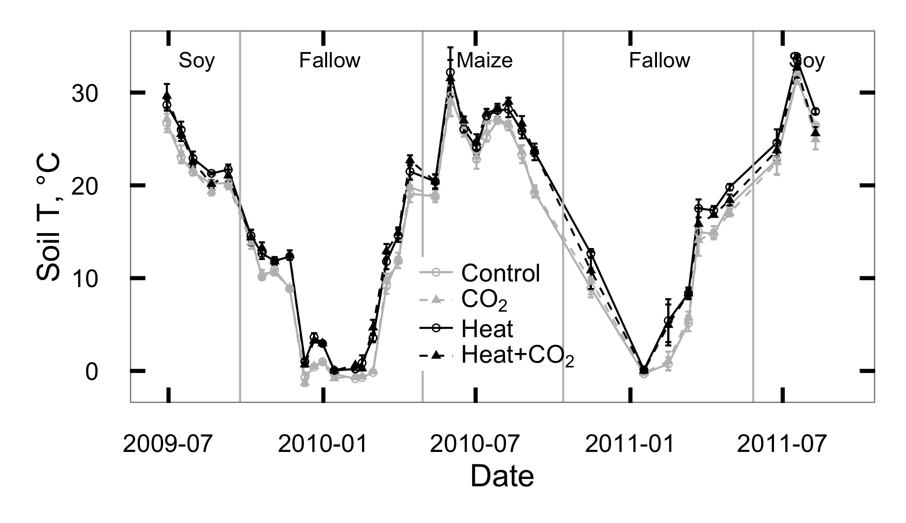

Figure 1: Temperature measured 5 cm below the soil surface at SoyFACE between June 2009 and October 2011. Error bars show treatment means 1 standard error for each day.

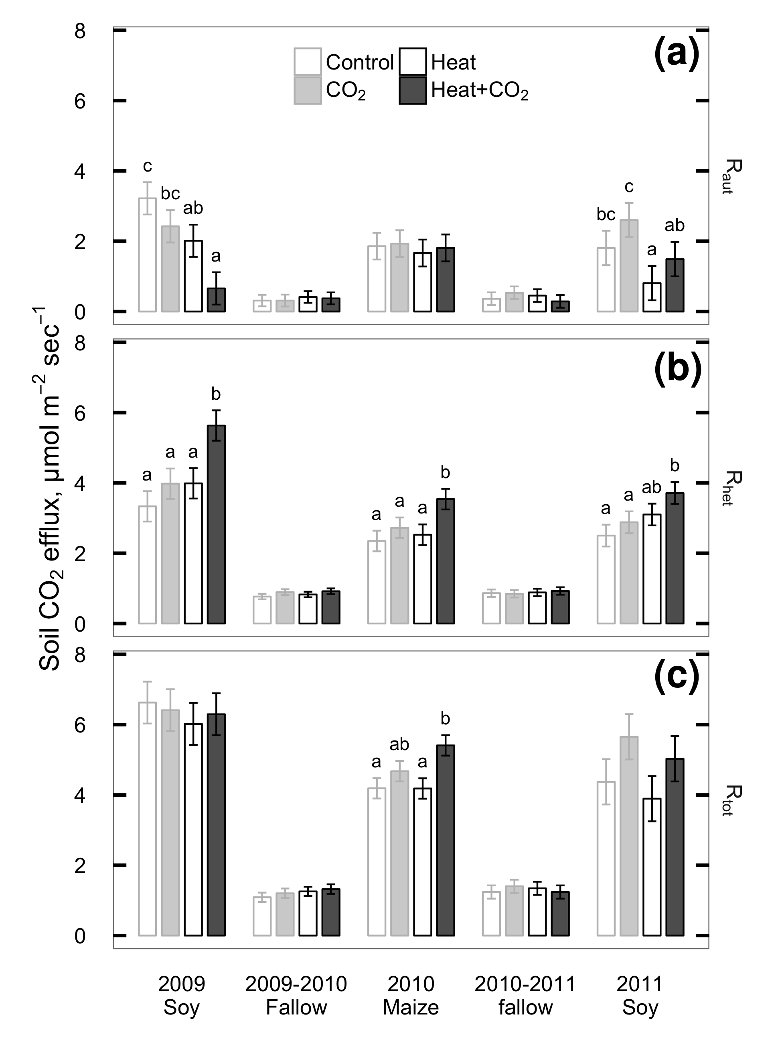

Figure 2: Seasonal means of CO2 flux measured from plant roots and rhizosphere (Raut; a), soil heterotrophs (Rhet; b), and whole soil (Rtot; c) at SoyFACE between June 2009 and October 2011. Error bars show treatment LS means 1 standard error for each season. Within each season, treatments that share a letter are not statistically different (P > 0.1).

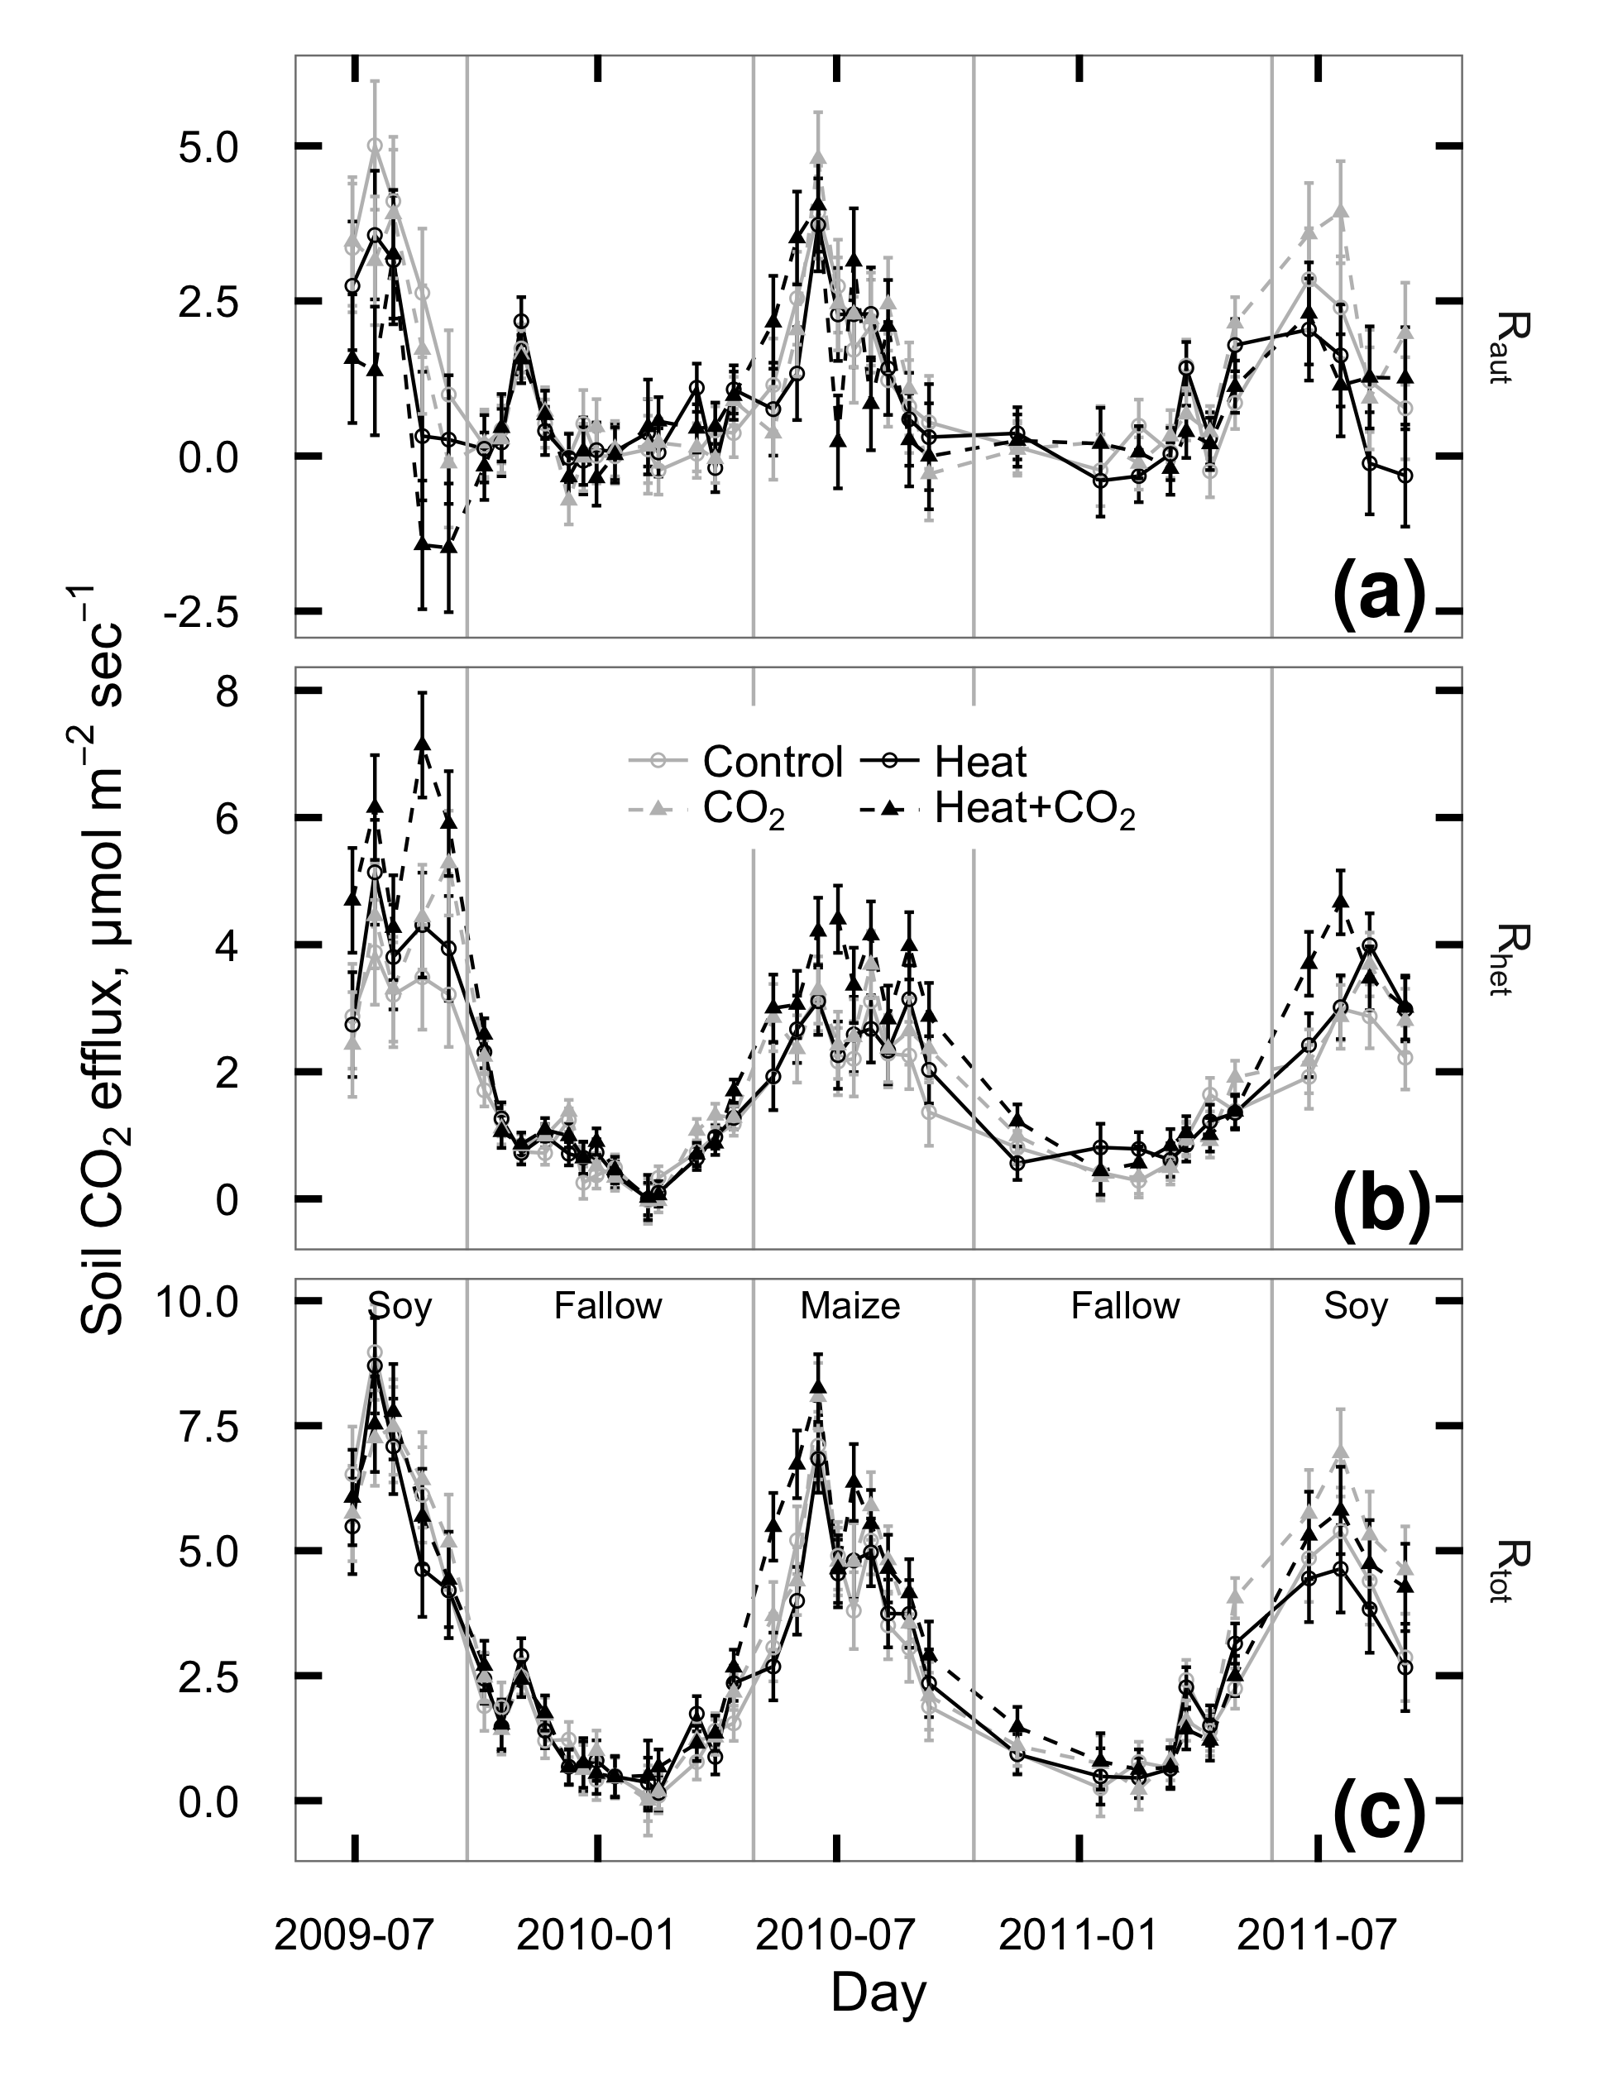

Figure 3: CO2 flux measured from plant roots and rhizosphere (Raut; a), soil heterotrophs (Rhet; b), and whole soil (Rtot; c) at SoyFACE between June 2009 and October 2011. Each season was analyzed separately; vertical grey lines indicate cutoffs between seasons. Error bars show treatment LS means 1 standard error for each day.

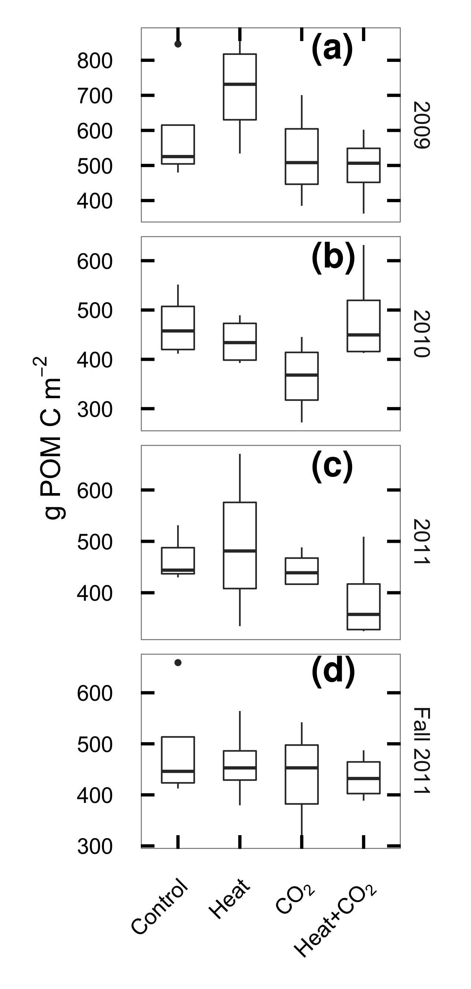

Figure 4: Particulate organic matter carbon (POM-C) in the top 30 cm of soil at SoyFACE, sampled in spring of 2009 (a), 2010 (b), 2011 (c) and at the end of the experiment in fall 2011 (d). Boxes cover the estimated interquartile range of each group, whiskers extend to the smaller of max/min or 1.5 IQR.

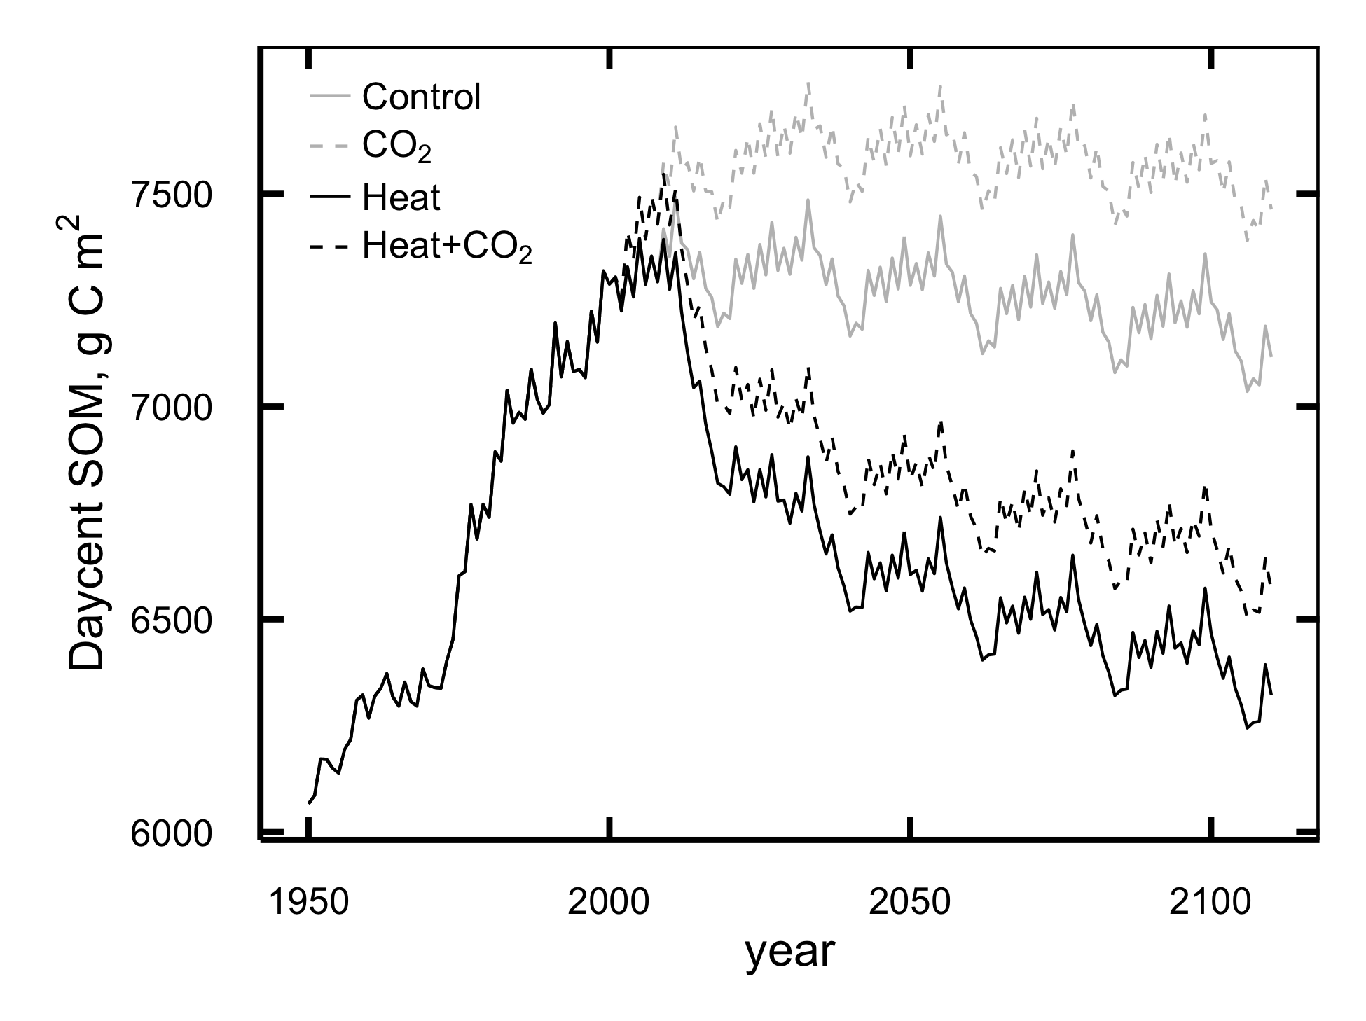

Figure 5: Mean annual values for total soil organic matter (g C m-2) predicted by DayCent in the top 20 cm of SoyFACE soil.

## Discussion

Experimental manipulation of CO2 and temperature conditions similar to those expected for the mid-21st century increased respiration from soil microbes, likely indicating a drawdown of both labile and protected soil C. This effect would not have been detectable without partitioning respiration into its root and microbial components, and it was not offset by the observed positive effect of CO2 on plant productivity. Instead, CO2 increased respiration and reduced POM C, and we saw no evidence of interactions between heat and CO2 responses, leading us to speculate that eCO2 primed long-term losses of SOC. Our model results adequately captured the effects of temperature and the additive effect of the temperature and CO2 responses, but did not reproduce a CO2 priming effect, so actual soil C losses may exceed our model-predicted value of 15% in 100 years.

Our results support the prediction that elevated temperature would increase the activity of soil heterotrophs and that this increased respiration would lead to long-term losses of soil C. Three years of heating produced strong and persistent increases in Rhet (Figure 2; Table 1) and our model results are consistent with these increases leading to losses of C from all soil pools (Figure 5). Because heating reduced Raut simultaneously with increasing Rhet, there was no change in total soil respiration with heat (Figure 2; Table 1). This result contrasts with many previous studies (reviewed in Rustad *et al.*, 2001; Wang *et al.*, 2014) where Rtot increased under heating except under water limitation, but this discrepancy is explained by partitioning fluxes into their autotrophic and heterotrophic components.

Consistent with recent meta-analyses (Dieleman *et al.*, 2012; Wang *et al.*, 2014), we found that Rhet responded reliably to increased temperature even when opposing changes in Raut masked its effect on Rtot. This highlights the importance of separating soil CO2 fluxes in global change experiments into their root and microbial components. We speculate that this masking may also occur at other sites where Rtot was measured without partitioning and found unresponsive to heat, especially those in grasslands and crops where root activity seems less responsive to eCO2 than in forest systems (Wang *et al.*, 2014).

Our results did not support the prediction that elevated CO2 would increase plant biomass above and belowground, leading to higher C inputs that would at least partially ameliorate the long-term effect of heat on soil C. Although aboveground plant biomass was higher in eCO2 plots during soybean years, heating largely negated this difference (Ruiz-Vera *et al.*, 2013) and there was little difference in root mass (S. B. Gray, in prep). Rhet increased more in heat+eCO2 plots than in plots given heat alone, indicating increased respiratory losses. Meanwhile Raut, a probable correlate of C inputs from root exudation and turnover, was lower in eCO2 plots in 2009 and showed no detectable change in other years, and the change in Raut between heat and heat+eCO2 plots was similar to that between unheated control and eCO2 plots. One possible explanation for these findings is that the extra C inputs from eCO2 were priming the breakdown of existing soil C, as seen previously at this and other FACE sites across widely differing ecosystem types (Peralta & Wander, 2008; Moran & Jastrow, 2010; Carrillo *et al.*, 2011; Drake *et al.*, 2011; Hopkins *et al.*, 2014; Fang *et al.*, 2015), rather than offsetting the effect of heat.

The priming hypothesis also is consistent with our observation that POM-C declined from 2009 to 2011 and was lower in eCO2 plots than in unfumigated plots (Figure 4). The lack of an increase in POM-C with eCO2 at this site was noted previously and attributed to priming by Peralta *et al.* (2008) after 3 years of fumigation, but it is worth noting that in year 3 the difference in POM-C between treatments was not yet significant. Given that the CO2 priming effect required most of a decade to become statistically resolvable, it is perhaps not surprising that 3 years of heating did not produce a detectable change in POM-C.

Compared to other experiments that have examined the simultaneous effects of heating and eCO2 on soil C dynamics, SoyFACE is notable for showing no obvious heat CO2 interactions. Although unheated FACE experiments have commonly showed direct effects of eCO2 on soil respiration (Pendall *et al.*, 2003; Pregitzer *et al.*, 2008; Adair *et al.*, 2011; Drake *et al.*, 2011; Lam *et al.*, 2014), many heat CO2 experiments are dominated by indirect effects (Dieleman *et al.*, 2012), which seem to be mediated by the joint effects of CO2 and heating on soil water availability (Wan *et al.*, 2007; Pendall *et al.*, 2011, 2013; Selsted *et al.*, 2012). Our site, by contrast, showed no significant heat CO2 interactions, perhaps because the site is only rarely dry enough to limit respiration. Water content was consistently higher in eCO2 plots and was lower in heated plots in 2009 and on some days in 2010, but volumetric water content never dropped below 20% and the differences in soil water were not significant in 2011, the driest summer of the study (Rosenthal *et al.*, 2014; Ruiz-Vera *et al.*, 2015). Thus the effects of water availability on Rhet appear to be additive to the heat effect, not a driving mechanism.

The observed changes in Raut may be caused by differences in root distribution. We have no evidence of changes in total root biomass, however minirhizotron observations from maize in 2010 suggest that elevated CO2 affected the depth distribution of roots, with greater root length in shallow soils and lower root length in deeper soils, but the effects depended on temperature treatment (S. B. Gray, in prep). In 2009 soybeans in heated plots appeared to use deeper soil water (Rosenthal *et al.*, 2014), possibly indicating a shift of roots toward deeper soil that would have reduced the amount of root-respired C reaching the surface, thus contributing to the reduction in Raut from soybeans we observed that year.

The empirical results from this study are reinforced by forward extrapolations from a process based model which indicates that heat, either singly or combined with increased CO2, will drive long-term losses in SOC from agricultural soils, adding to losses in SOC caused by aggressive tillage practices. This result is consistent with previous models of CO2 warming experiments in predicting a net loss of soil C under global warming (Parton *et al.*, 2007).

Given the difficulty of inferring SOC changes from short-term direct measurements and the number of known processes that DayCent integrates, we posit that these model results provide our best available prediction of the *direction* of future SOC trajectories in a warming climate, and that that they place a lower bound on the *magnitude* of future losses as CO2 increases. However, our modelling approach was unable to test the hypothesis of a priming effect of eCO2 on soil C breakdown, because DayCent’s SOC model has an explicitly specified turnover time for each pool. Turnover can be manually increased to simulate priming (Cheng *et al.*, 2013), but this requires a known degree of increase. Our observation that POM-C declined under elevated CO2 gives an indirect indication that turnover rates have increased, but is not sufficient to constrain the magnitude of the increase, especially in slower-cycling C pools. Instead, increasing model C inputs through CO2 fertilization lead to an increase in modeled SOM with no decrease in fast C pools that would match our observed drop in POM-C. Therefore our model results probably understate the extent of soil C losses under elevated CO2. To produce more accurate long-term predictions of SOC dynamics under systems with active priming, models with explicit microbial processes may be needed (Wieder *et al.*, 2013).

Elevated CO2 and temperature, both singly and in combination, appear to accelerate the loss of soil C from agricultural ecosystems, through probably distinct and potentially additive pathways. Simple measurements of whole-soil respiration were not sufficient to detect these changes, so future experimental work should routinely include partitioning of soil respiration into plant-derived and SOM-derived components. Robust predictions of CO2 priming effects will require updated ecosystem models that contain explicit microbial dynamics.

## Acknowledgements

Thank you to Michael Masters, Nicholas DeLucia, Ahbisheik Pal, and Micah Sweeney for assistance with data collection; Michael Masters and Corey Mitchell for soil C analyses; David Drag and Kannan Puthuval for maintaining the experimental site; Sharon Gray, Matthew Siebers, Andrew Leakey, and Eva Joo for sharing calibration data; and Robert Paul, Benjamin Duval, and Cindy Keogh for valuable advice about DayCent.  
Portions of this research were funded by the US Department of Energy’s National Institute for Climatic Change Research.

## Appendix 1: DayCent model fit evaluation

### Data availability

All the data for this paper, including raw files, data-processing scripts, and DayCent simulation files, is permanantly archived in Dryad (http://datadryad.org) and is freely available online: http://dx.doi.org/10.5061/dryad.bn7j3.

Additionally, the DayCent model files, raw output, run management scripts and the majority of the model calibration data are available online at https://github.com/infotroph/soyface_daycent. Some validation was performed against unpublished datasets that were shared by collaborators in advance of publication; these are not available in this project’s archive, but we intend to update the Github repository with links to those datasets at such time as their authors make them available.

Table S1: Summary of model parameters changed between phases of the DayCent model run.

|  |  |  |  |  |  |
| --- | --- | --- | --- | --- | --- |
| File | Parameter | Spin-up value | Ag value | FACE value | Remarks |
| sitepar.in | watertable[1-5] | 1 | 0 | 0 | Tile drainage lowers Jan-May water table |
| sitepar.in | netm_to_no3 | 0.05 | 0.8 | 0.8 | Nitrification much lower in undisturbed grassland |
| fix.100 | CO2PPM(1) | 294 | 294 | 370 | Starting [CO2] |
| fix.100 | CO2PPM(2) | 294 | 370 | 570 | Ending [CO2] |
| fix.100 | CO2RMP | 1 | 1 | 0 | 0=step change in given year, 1=ramp |
| fix.100 | DEC4 | 0.002 | 0.0025 | 0.0025 | Slow-turnover OM decomposes faster in tilled, drained soil |
| fix.100 | DEC5(1) | 0.08 | 0.2 | 0.2 | Intermediate-turnover OM at surface decomposes faster in tilled, drained soil |
| fix.100 | DEC5(2) | 0.1 | 0.25 | 0.25 | Intermediate-turnover OM below surface decomposes faster in tilled, drained soil |
| fix.100 | FLEACH(1) | 0.7 | 0.4 | 0.4 | Intercept for mineral leaching as a function of sand content |
| fix.100 | FLEACH(2) | 0.9 | 0.4 | 0.4 | Slope for mineral leaching as a function of sand content |
| fix.100 | FLEACH(3) | 0.95 | 0.2 | 0.2 | Leaching fraction multiplier for leached mineral N |
| fix.100 | MINLCH | 1.5 | 1.0 | 1.0 | Minimum cm water flow to activate mineral leaching |
| fix.100 | OMLECH(1) | 0.03 | 0.05 | 0.05 | Intercept for organic matter leaching as a function of sand content |
| fix.100 | OMLECH(2) | 0.12 | 0.15 | 0.15 | Slope for organic matter leaching as a function of sand content |
| fix.100 | OMLECH(3) | 1.9 | 0.1 | 0.1 | Minimum cm water flow to activate organic leaching |
| soyface.100 | EPNFS(2) | 0.017 | 0.005 | 0.005 | Slope for nonsymbiotic N fixation as a function of annual precipitation |

Table S2: Summary of management schedule for DayCent simulations

|  |  |  |  |  |  |
| --- | --- | --- | --- | --- | --- |
| Years | Crop | Weather1 | | Tillage2 | N management3 |
| -2000–1868 | Prairie | | R | Fire every 5th year | Graze May–July |
| 1869–1888 | 2 yr maize 1, oat, 2 yr pasture | | R | Spring MD before maize & oat, fall M | Graze May–Oct after oats and during pasture |
| 1889–1934 | 2 yr maize 1, oat, 2 yr pasture | | H | Spring MD before maize & oat, fall M | Graze May–Oct after oats and during pasture |
| 1935–1949 | Maize 3, oat, low yield soy | | H | Spring MD, fall M | Fert 40.4, graze after oats |
| 1950–1959 | Maize 5, medium yield soy | | H | Spring MD, fall M | Fert 56 |
| 1960–1969 | Maize 7, medium yield soy | | H | Spring MD, fall M | Fert 100 |
| 1970–1979 | Maize 9, medium yield soy | | H | Spring CD, fall C after maize | Fert 157 |
| 1980–1998 | Maize 10, high yield soy | | H | Spring CD, fall C after maize | Fert 157 |
| 1999–2000 | High yield soy, winter wheat | | H | Spring CD, fall C after wheat | Fert 116.4 |
| 2001-2109 | Maize 10, high yield soy | | D | Spring CD, fall C after maize | Fert 157 |

1R = randomized weather; H = historic weather from Illinois Water Survey (4.7 km from site); D = Gridded weather for site retrieved from DAYMET.

2M = Moldboard plow; D = disk; C = Chisel plow.

3Fertilization rates are in kg N ha-1. Fertilizer is applied before planting of maize and wheat only; other crops are never fertilized.

Table S3: Summary of DayCent parameters changed between simulated maize cultivars. All parameters not shown here are identical between cultivars; see CROP.100 in the model files for details.

|  |  |  |  |  |  |  |
| --- | --- | --- | --- | --- | --- | --- |
| Parameter | C11 | C3 | C5 | C7 | C9 | C10 |
| PRDX(1) | 0.30 | 0.45 | 0.70 | 0.75 | 1.00 | 1.50 |
| FRTC(5) | 0.10 | 0.10 | 0.10 | 0.20 | 0.20 | 0.20 |
| CFRTCN(1)2 | 0.40 | 0.40 | 0.40 | 0.30 | 0.30 | 0.30 |
| PRAMN(1,1) | 20 | 20 | 10 | 10 | 10 | 10 |
| PRAMX(1,1) | 40 | 40 | 20 | 20 | 20 | 20 |
| HIMAX | 0.35 | 0.40 | 0.50 | 0.60 | 0.60 | 0.60 |
| EFRGRN(1) | 0.50 | 0.75 | 0.75 | 0.75 | 0.75 | 0.75 |
| FALLRT | 0.10 | 0.10 | 0.10 | 0.10 | 0.20 | 0.20 |
| TMPGERM2 | 10 | 10 | 10 | 15 | 15 | 15 |
| DDBASE2 | 1500 | 1500 | 1700 | 1450 | 1450 | 1450 |
| TMPKILL2 | 7 | 7 | 12 | 14 | 14 | 14 |

1These cultivar names come from a set of 11 developed by Hudiburg et al. (2015); C2, C4, C6, C8, C11 are not shown here because they were not used in the current simulations.

2These parameters are ignored by DayCent when FRTINDX==2, as it is for all of these cultivars, and are included here only for completeness.

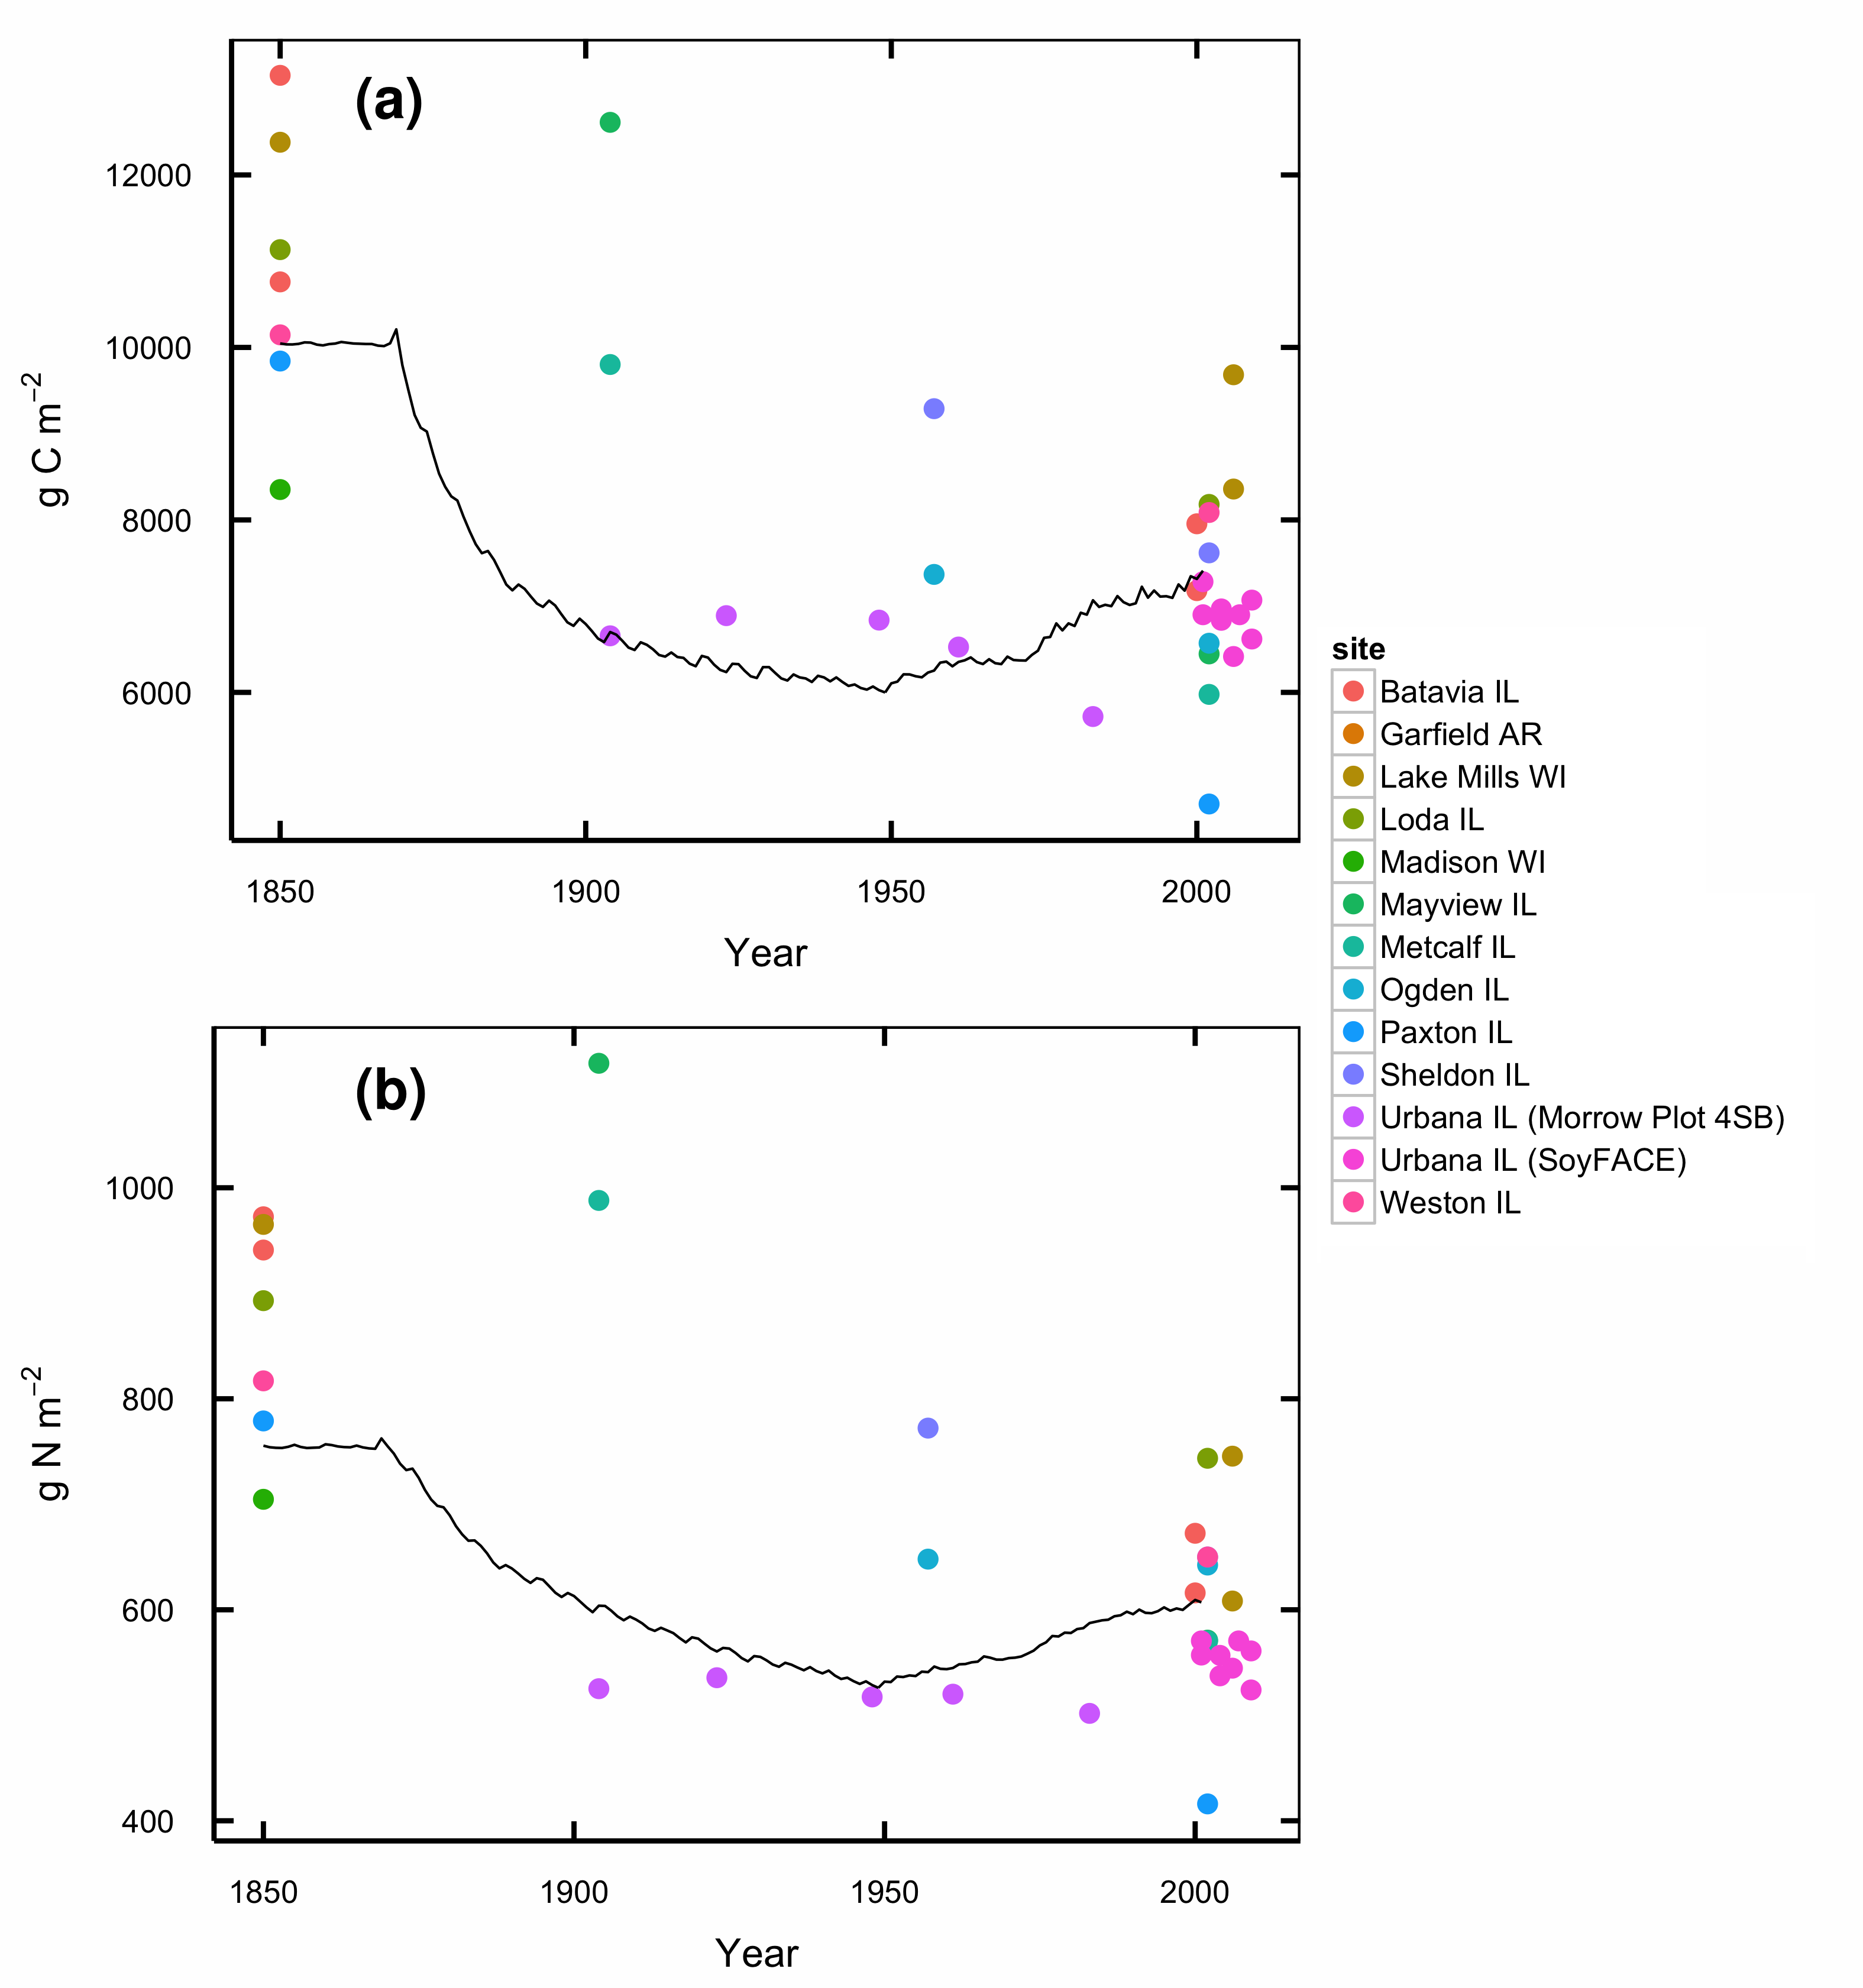

Figure S1: Total organic C (a) and N (b) in soils under conversion from tallgrass prairie to agriculture. Lines show DayCent modeled soil C for the spin-up and historical agriculture phases of the model run. Points are observed SOC contents of prairie soils at comparable stages of similar management histories.

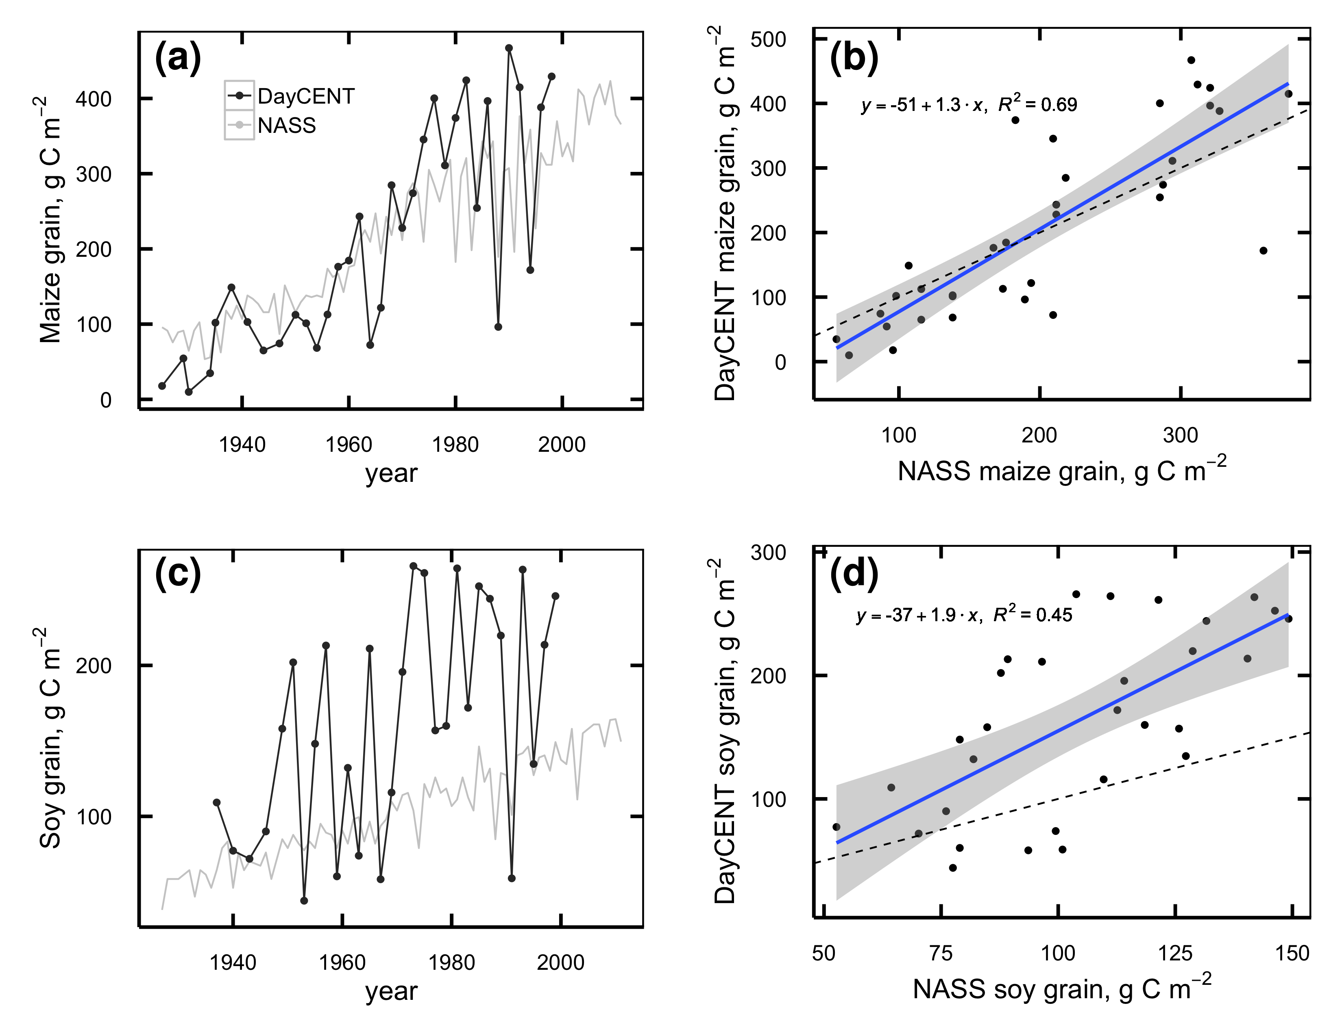

Figure S2: a,c: Maize (a) and soybean (c) grain production simulated by DayCent (black lines) and Champaign County averages from NASS (grey lines). b,d: linear regression of DayCent vs. NASS maize (b) and soybean (d) yields.

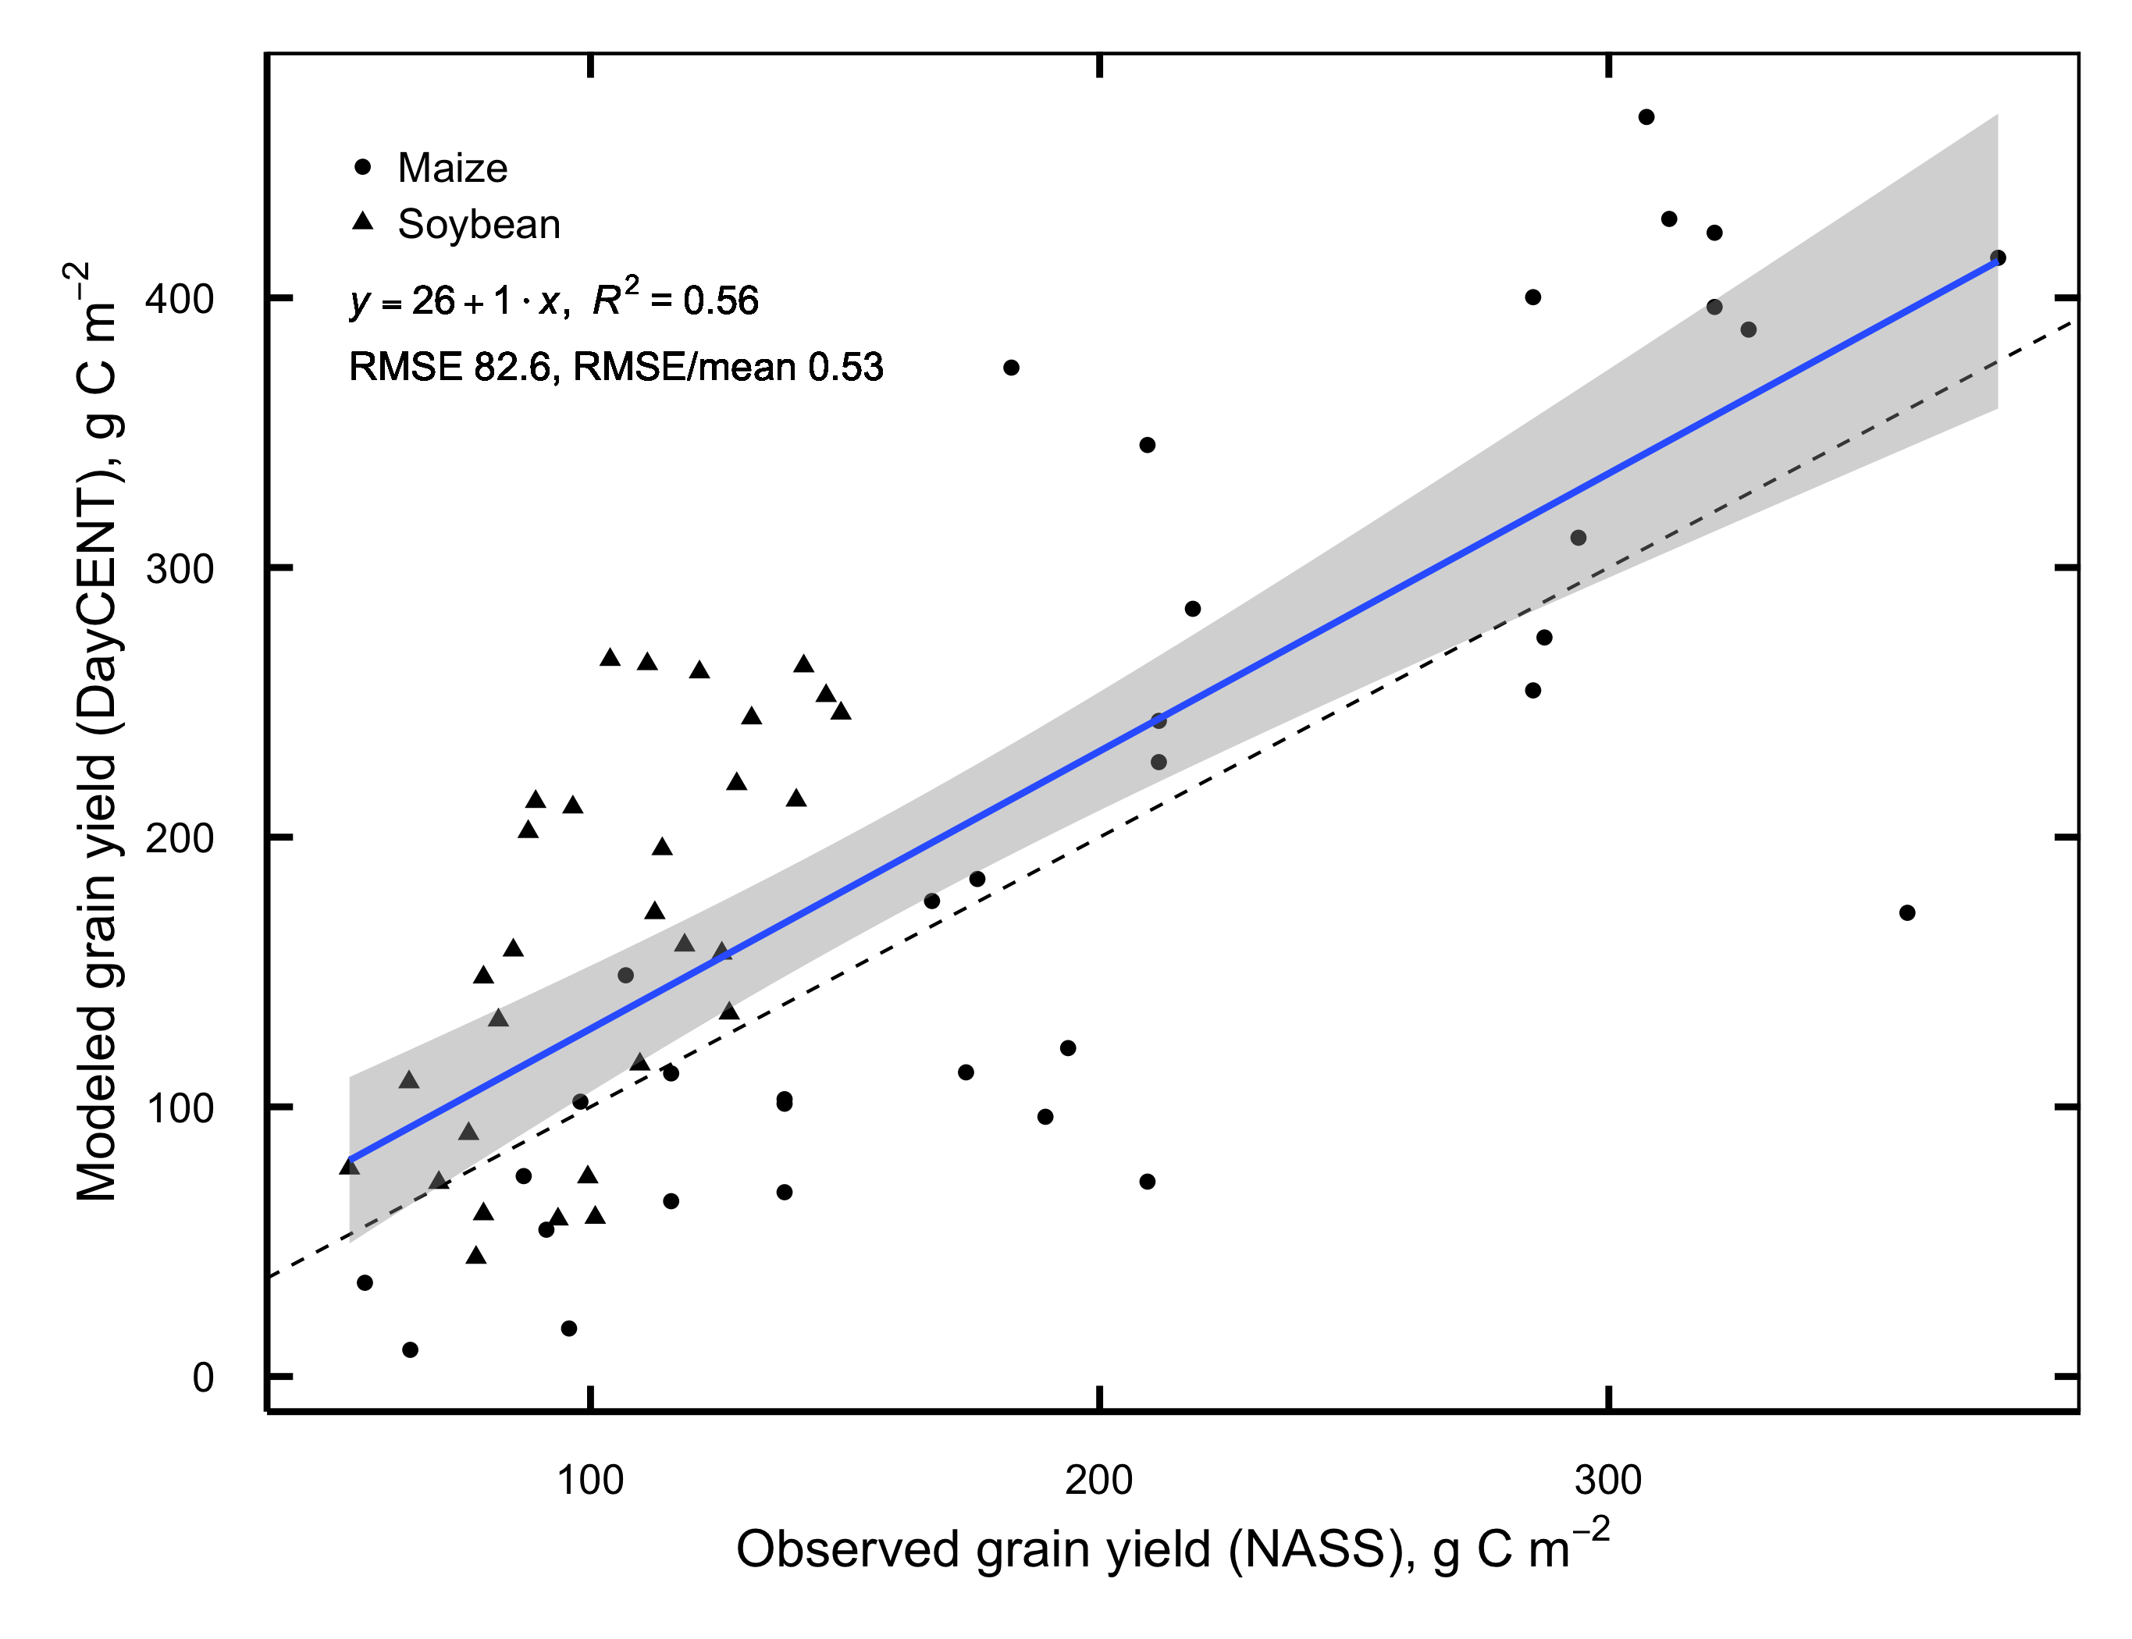

Figure S3: Linear regression of DayCent vs. NASS grain yields for all years combined.

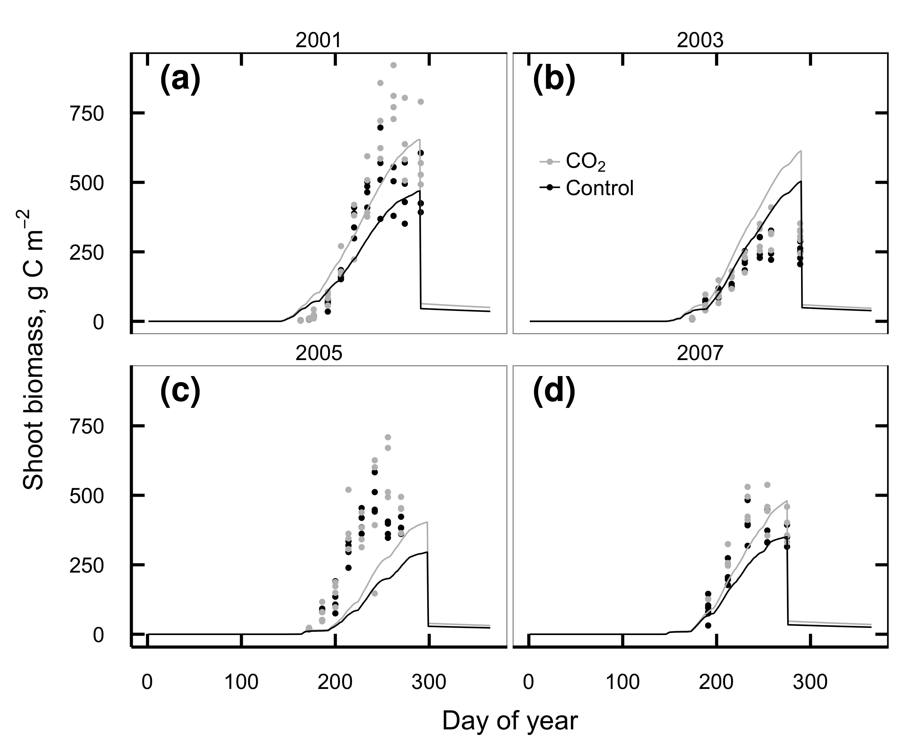

Figure S4: Aboveground soybean biomass C observed at SoyFACE (dots) and simulated by DayCent in 2001 (a), 2003 (b), 2005 (c), and 2007 (d). Observations from 2003 include effects from a defoliating hailstorm on DOY 198 that is not simulated in the model.

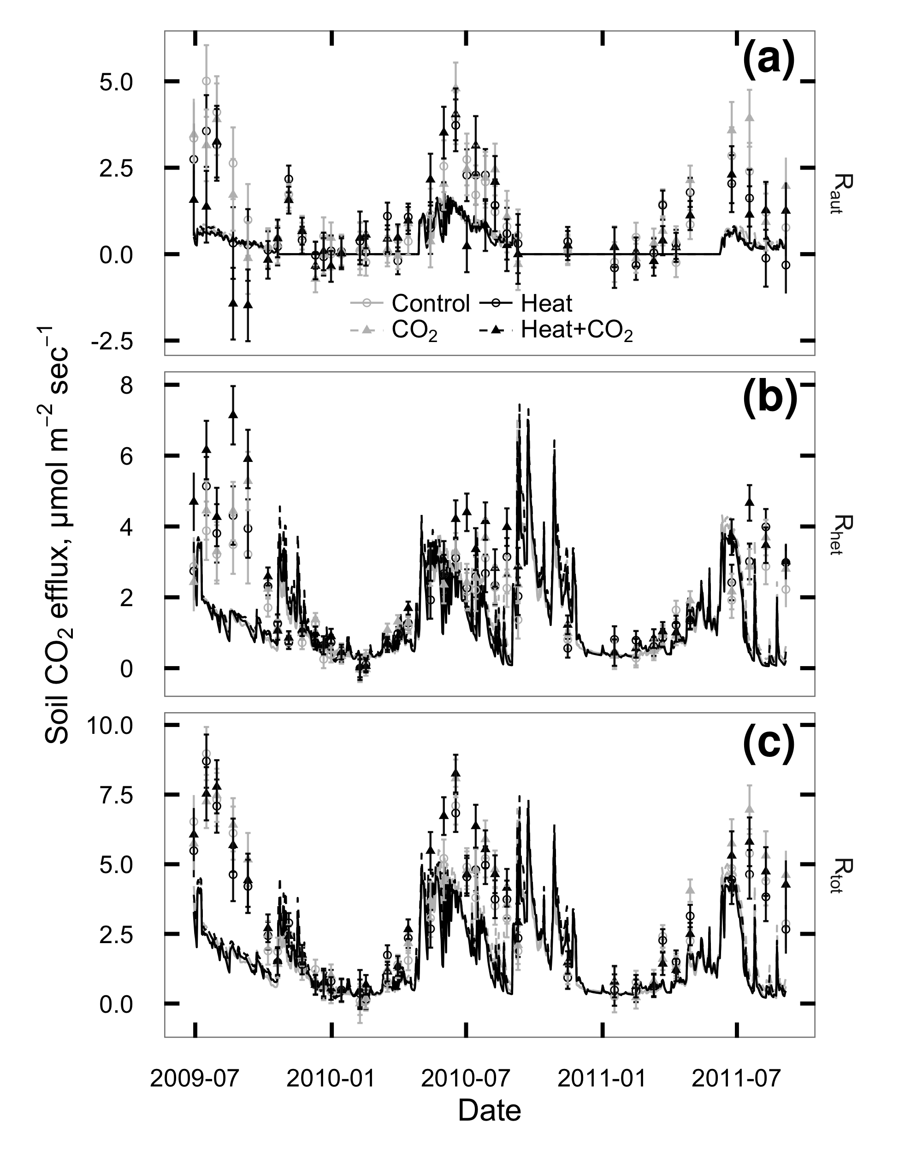

Figure S5: CO2 flux from plant roots and rhizosphere (Raut; a), soil heterotrophs (Rhet; b), and whole soil (Rtot; c) at SoyFACE between June 2009 and October 2011. Symbols with error bars show observed treatment means 1 standard error for each day. Lines show values predicted by DayCent. Grey = unheated; Black = heated; Solid lines & unfilled circles = ambient CO2; dashed lines & filled triangles = elevated CO2.

## References

Adair EC, Reich PB, Trost JJ, Hobbie SE (2011) Elevated CO2 stimulates grassland soil respiration by increasing carbon inputs rather than by enhancing soil moisture. *Global Change Biology*, **17**, 3546–3563.

Allison SD, Wallenstein MD, Bradford MA (2010) Soil-carbon response to warming dependent on microbial physiology. *Nature Geoscience*, **3**, 336–340.

Anderson-Teixeira KJ, Masters MD, Black CK, Zeri M, Hussain MZ, Bernacchi CJ, DeLucia EH (2013) Altered belowground carbon cycling following land-use change to perennial bioenergy crops. *Ecosystems*, **16**, 508–520.

Angel J (2010a) Official 1981-2010 Climate Normals. Illinois State Climatologist Office, Illinois State Water Survey. Available at <http://www.isws.illinois.edu/atmos/statecli/newnormals/normals.USC00118740.txt>. Accessed January 18, 2011.

Angel J (2010b) Climate Observations for Champaign-Urbana, IL. Illinois State Climatologist Office, Illinois State Water Survey. Available at <http://www.isws.illinois.edu/atmos/statecli/cuweather/index.htm>. Accessed January 18, 2011.

Aref S, Wander M (1998) Long-term trends of corn yield and soil organic matter in different crop sequences and soil fertility treatments on the morrow plots. *Advances in Agronomy*, **62**, 153–197.

Bernhardt ES, Barber JJ, Pippen JS, Taneva L, Andrews JA, Schlesinger WH (2006) Long-term effects of free air CO2 enrichment (FACE) on soil respiration. *Biogeochemistry*, **77**, 91–116.

Black CK, Davis SC, Hudiburg TW, Bernacchi CJ, DeLucia EH (2016) Data from: Elevated CO2 and temperature increase soil C losses from a soybean-maize ecosystem. Dryad Digital Repository. Available at [http://dx.doi.org/10.5061/dryad.bn7j3](http://dx.doi.org/10.5061/dryad.bn7j3%20). Accessed May 24, 2016.

Bond-Lamberty B, Thomson A (2010) Temperature-associated increases in the global soil respiration record. *Nature*, **464**, 579–582.

Bradford MA (2013) Thermal adaptation of decomposer communities in warming soils. *Frontiers in Microbiology*, **4**, 1–16.

Brye KR, Riley TL (2009) Soil and plant property differences across a chronosequence of humid-temperate tallgrass prairie restorations. *Soil Science*, **174**, 346–357.

Carrillo Y, Pendall EG, Dijkstra FA, Morgan JA, Newcomb JM (2011) Response of soil organic matter pools to elevated CO2 and warming in a semi-arid grassland. *Plant and Soil*, **347**, 339–350.

Cheng WX, Parton WJ, Gonzalez-Meler MA et al. (2013) Synthesis and modeling perspectives of rhizosphere priming. *New Phytologist*, **201**, 31–44.

Chevallier T, Hmaidi K, Kouakoua E et al. (2015) Physical protection of soil carbon in macroaggregates does not reduce the temperature dependence of soil CO2 emissions. *Journal of Plant Nutrition and Soil Science*, **178**, 592–600.

Conant RT, Ryan MG, Ågren GI et al. (2011) Temperature and soil organic matter decomposition rates – synthesis of current knowledge and a way forward. *Global Change Biology*, **17**, 3392–3404.

David MB, McIsaac GF, Darmody RG, Omonode RA (2009) Long-term changes in mollisol organic carbon and nitrogen. *Journal of Environment Quality*, **38**, 200–211.

Davidson EA, Janssens IA (2006) Temperature sensitivity of soil carbon decomposition and feedbacks to climate change. *Nature*, **440**, 165–173.

Davis SC, Parton WJ, Dohleman FG, Smith CM, Del Grosso SJ, Kent AD, DeLucia EH (2010) Comparative biogeochemical cycles of bioenergy crops reveal nitrogen-fixation and low greenhouse gas emissions in a *Miscanthus × giganteus* agro-ecosystem. *Ecosystems*, **13**, 144–156.

Davis SC, Parton WJ, Del Grosso SJ, Keough C, Marx E, Adler PR, DeLucia EH (2012) Impact of second-generation biofuel agriculture on greenhouse-gas emissions in the corn-growing regions of the US. *Frontiers in Ecology and the Environment*, **10**, 69–74.

Dieleman WIJ, Vicca S, Dijkstra FA et al. (2012) Simple additive effects are rare: a quantitative review of plant biomass and soil process responses to combined manipulations of CO2 and temperature. *Global Change Biology*, **18**, 2681–2693.

Drake JE, Gallet-Budynek A, Hofmockel KS et al. (2011) Increases in the flux of carbon belowground stimulate nitrogen uptake and sustain the long-term enhancement of forest productivity under elevated CO2. *Ecology Letters*, **14**, 349–357.

Duvick DN (2005) The contribution of breeding to yield advances in maize (*Zea mays* L.). *Advances in Agronomy*, **86**, 83–145.

Eswaran H, Van Den Berg E, Reich P (1993) Organic carbon in soils of the world. *Soil Science Society Of America Journal*, **57**, 192–194.

Fang H, Cheng S, Lin E et al. (2015) Elevated atmospheric carbon dioxide concentration stimulates soil microbial activity and impacts water-extractable organic carbon in an agricultural soil. *Biogeochemistry*, **122**, 253–267.

Filion M, Dutilleul P, Potvin C (2000) Optimum experimental design for Free-Air Carbon dioxide Enrichment (FACE) studies. *Global Change Biology*, **6**, 843–854.

Frey SD, Lee J, Melillo JM, Six J (2013) The temperature response of soil microbial efficiency and its feedback to climate. *Nature Climate Change*, **3**, 395–398.

Hanson PJ, Edwards NT, Garten CT, Andrews JA (2000) Separating root and soil microbial contributions to soil respiration: A review of methods and observations. *Biogeochemistry*, **48**, 115–146.

Hartley IP, Heinemeyer A, Evans SP, Ineson P (2007) The effect of soil warming on bulk soil vs. rhizosphere respiration. *Global Change Biology*, **13**, 2654–2667.

Hartman MD, Merchant ER, Parton WJ, Gutmann MP, Lutz SM, Williams SA (2011) Impact of historical land-use changes on greenhouse gas exchange in the U.S. Great Plains, 1883–2003. *Ecological Applications*, **21**, 1105–1119.

Hartmann D, Klein Tank AMG, Rusticucci M et al. (2013) Observations: Atmosphere and Surface. In: *Climate change 2013 : The physical science basis : Working group I contribution to the fifth assessment report of the intergovernmental panel on climate change* (ed Intergovernmental Panel on Climate Change), pp. 159–254. Cambridge University Press, Cambridge.

Healy RW, Striegl RG, Russell TF, Hutchinson GL, Livingston GP (1996) Numerical evaluation of static-chamber measurements of soil—atmosphere gas exchange: identification of physical processes. *Soil Science Society Of America Journal*, **60**, 740–747.

Hopkins FM, Filley TR, Gleixner G, Lange M, Top SM, Trumbore SE (2014) Increased belowground carbon inputs and warming promote loss of soil organic carbon through complementary microbial responses. *Soil Biology and Biochemistry*, **76**, 57–69.

Hudiburg TW, Davis SC, Parton WJ, DeLucia EH (2015) Bioenergy crop greenhouse gas mitigation potential under a range of management practices. *Global Change Biology Bioenergy*, **7**, 366–374.

Jelinski NA, Kucharik CJ (2009) Land-use effects on soil carbon and nitrogen on a U.S. Midwestern floodplain. *Soil Science Society Of America Journal*, **73**, 217–225.

Keidel L, Kammann C, Grünhage L, Moser G, Müller C (2015) Positive feedback of elevated CO2 on soil respiration in late autumn and winter. *Biogeosciences*, **12**, 1257–1269.

Kimball BA (2005) Theory and performance of an infrared heater for warming ecosystems. *Global Change Biology*, **11**, 2041–2056.

King JS, Hanson PJ, Bernhardt E, deAngelis P, Norby RJ, Pregitzer KS (2004) A multiyear synthesis of soil respiration responses to elevated atmospheric CO2 from four forest FACE experiments. *Global Change Biology*, **10**, 1027–1042.

Koester RP, Skoneczka JA, Cary TR, Diers BW, Ainsworth EA (2014) Historical gains in soybean (*Glycine max* Merr.) seed yield are driven by linear increases in light interception, energy conversion, and partitioning efficiencies. *Journal of Experimental Botany*, **65**, 3311–3321.

Kucharik CJ, Fayram NJ, Cahill KN (2006) A paired study of prairie carbon stocks, fluxes, and phenology: comparing the world’s oldest prairie restoration with an adjacent remnant. *Global Change Biology*, **12**, 122–139.

Kuzyakov Y, Larionova AA (2005) Root and rhizomicrobial respiration: A review of approaches to estimate respiration by autotrophic and heterotrophic organisms in soil. *Journal of Plant Nutrition and Soil Science*, **168**, 503–520.

Lam SK, Norton R, Armstrong R, Chen D (2014) Increased microbial activity under elevated [CO2] does not enhance residue decomposition in a semi-arid cropping system in Australia. *Soil Biology and Biochemistry*, **72**, 97–99.

Leakey ADB, Bernacchi CJ, Dohleman FG, Ort D, Long SP (2004) Will photosynthesis of maize (*Zea mays*) in the US Corn Belt increase in future [CO2] rich atmospheres? An analysis of diurnal courses of CO2 uptake under free-air concentration enrichment (FACE). *Global Change Biology*, **10**, 951–962.

Leakey ADB, Uribelarrea M, Ainsworth EA, Naidu SL, Rogers A, Ort DR, Long SP (2006) Photosynthesis, productivity, and yield of maize are not affected by open-air elevation of CO2 concentration in the absence of drought. *Plant Physiology*, **140**, 779–790.

Lenth RV (2016) Least-squares means: The R package lsmeans. *Journal of Statistical Software*, **69**, 1–33.

Lu M, Zhou X, Yang Q et al. (2013) Responses of ecosystem carbon cycle to experimental warming: a meta-analysis. *Ecology*, **94**, 726–738.

Luo Y, Wan S, Hui D, Wallace LL (2001) Acclimatization of soil respiration to warming in a tall grass prairie. *Nature*, **413**, 622–625.

Markelz RJC, Strellner RS, Leakey ADB (2011) Impairment of C4 photosynthesis by drought is exacerbated by limiting nitrogen and ameliorated by elevated [CO2] in maize. *Journal of Experimental Botany*, **62**, 3235–3246.

Marriott EE, Wander MM (2006) Total and labile soil organic matter in organic and conventional farming systems. *Soil Science Society Of America Journal*, **70**, 950–959.

Matamala RR, Jastrow JD, Miller RM, Garten CT (2008) Temporal changes in C and N stocks of restored prairie: implications for C sequestration strategies. *Ecological Applications*, **18**, 1470–1488.

Mayaki J, Teare I, Stone L (1976) Top and root growth of irrigated and nonirrigated soybeans. *Crop Science*, **16**, 92–94.

Miglietta F, Peressotti A, Vaccari FP, Zaldei A, deAngelis P, Scarascia-Mugnozza G (2001) Free-air CO2 enrichment (FACE) of a poplar plantation: the POPFACE fumigation system. *New Phytologist*, **150**, 465–476.

Moran KK, Jastrow JD (2010) Elevated carbon dioxide does not offset loss of soil carbon from a corn-soybean agroecosystem. *Environmental Pollution*, **158**, 1088–1094.

Morgan PB, Bollero GA, Nelson RL, Dohleman FG, Long SP (2005) Smaller than predicted increase in aboveground net primary production and yield of field-grown soybean under fully open-air [CO2] elevation. *Global Change Biology*, **11**, 1856–1865.

NASS (2011) Census of Agriculture Quick Stats 2.0. National Agricultural Statistics Service, United States Department of Agriculture. Available at <http://www.nass.usda.gov/Quick_Stats/>. Accessed December 12, 2012.

NRCS (2012) Web Soil Survey. Soil Survey Staff, Natural Resources Conservation Service, United States Department of Agriculture. Available at <http://websoilsurvey.nrcs.usda.gov/>. Accessed March 22, 2012.

Parton WJ, Hartman MD, Ojima DS, Schimel DS (1998) DAYCENT and its land surface submodel: description and testing. *Global and Planetary Change*, **19**, 35–48.

Parton WJ, Morgan JA, Wang G, Del Grosso SJ (2007) Projected ecosystem impact of the Prairie Heating and CO2 Enrichment experiment. *New Phytologist*, **174**, 823–834.

Pendall EG, Del Grosso SJ, King J et al. (2003) Elevated atmospheric CO2 effects and soil water feedbacks on soil respiration components in a Colorado grassland. *Global Biogeochemical Cycles*, **17**, 1046.

Pendall EG, Osanai Y, Williams AL, Hovenden MJ (2011) Soil carbon storage under simulated climate change is mediated by plant functional type. *Global Change Biology*, **17**, 505–514.

Pendall EG, Heisler-White JL, Williams DG, Dijkstra FA, Carrillo Y, Morgan JA, LeCain DR (2013) Warming reduces carbon losses from grassland exposed to elevated atmospheric carbon dioxide. *Plos One*, **8**, e71921.

Peralta AL, Wander MM (2008) Soil organic matter dynamics under soybean exposed to elevated [CO2]. *Plant and Soil*, **303**, 69–81.

Pinheiro J, Bates D, DebRoy S, Sarkar D, R Core Team (2016) nlme: Linear and nonlinear mixed effects models. R package version 3.1-127. Available at <http://CRAN.R-project.org/package=nlme>. Accessed April 16, 2016.

Pregitzer K, Loya W, Kubiske M, Zak D (2006) Soil respiration in northern forests exposed to elevated atmospheric carbon dioxide and ozone. *Oecologia*, **148**, 503–516.

Pregitzer KS, Burton AJ, King JS, Zak DR (2008) Soil respiration, root biomass, and root turnover following long-term exposure of northern forests to elevated atmospheric CO2 and tropospheric O3. *New Phytologist*, **180**, 153–161.

R Core Team (2016) R: A language and environment for statistical computing. Version 3.2.4. R Foundation for Statistical Computing. Available at <https://www.R-project.org/>. Accessed March 11, 2016.

Rosenthal DM, Ruiz-Vera UM, Siebers MH, Gray SB, Bernacchi CJ, Ort DR (2014) Biochemical acclimation, stomatal limitation and precipitation patterns underlie decreases in photosynthetic stimulation of soybean (*Glycine max*) at elevated [CO2] and temperatures under fully open air field conditions. *Plant Science*, **226**, 136–146.

Ruiz-Vera UM, Siebers M, Gray SB et al. (2013) Global warming can negate the expected CO2 stimulation in photosynthesis and productivity for soybean grown in the Midwest United States. *Plant Physiology*, **162**, 410–423.

Ruiz-Vera UM, Siebers MH, Drag DW, Ort DR, Bernacchi CJ (2015) Canopy warming caused photosynthetic acclimation and reduced seed yield in maize grown at ambient and elevated [CO2]. *Global Change Biology*, **21**, 4237–4249.

Rustad L, Campbell JL, Marion GM et al. (2001) A meta-analysis of the response of soil respiration, net nitrogen mineralization, and aboveground plant growth to experimental ecosystem warming. *Oecologia*, **126**, 543–562.

Schindlbacher A, Wunderlich S, Borken W, Kitzler B, Zechmeister-Boltenstern S, Jandl R (2012) Soil respiration under climate change: prolonged summer drought offsets soil warming effects. *Global Change Biology*, **18**, 2270–2279.

Schmidt MWI, Torn MS, Abiven S et al. (2011) Persistence of soil organic matter as an ecosystem property. *Nature*, **478**, 49–56.

Selsted MB, Linden L, Ibrom A et al. (2012) Soil respiration is stimulated by elevated CO2 and reduced by summer drought: three years of measurements in a multifactor ecosystem manipulation experiment in a temperate heathland (CLIMAITE). *Global Change Biology*, **18**, 1216–1230.

Subke J-A, Bahn M (2010) On the ’temperature sensitivity’ of soil respiration: Can we use the immeasurable to predict the unknown? *Soil Biology and Biochemistry*, **42**, 1653–1656.

Suseela V, Dukes JS (2013) The responses of soil and rhizosphere respiration to simulated climatic changes vary by season. *Ecology*, **94**, 403–413.

Thornton PE, Thornton MM, Mayer BW, Wilhelmi N, Wei Y, Devarakonda R, Cook RB (2014) Daymet: Daily Surface Weather Data on a 1-km Grid for North America, Version 2. ORNL DAAC, Oak Ridge, Tennessee, USA. Available at <http://daac.ornl.gov/>. Accessed March 14, 2013.

Tisdall JM, Oades JM (1980) The effect of crop rotation on aggregation in a red-brown earth. *Australian Journal of Soil Research*, **18**, 423–433.

Twine TE, Bryant JJ, Richter K, Bernacchi CJ, McConnaughay KD, Morris SJ, Leakey ADB (2013) Impacts of elevated CO2 concentration on the productivity and surface energy budget of the soybean and maize agroecosystem in the Midwest USA. *Global Change Biology*, **19**, 2838–2852.

Vogel J, Valentine D (2005) Small root exclusion collars provide reasonable estimates of root respiration when measured during the growing season of installation. *Canadian Journal of Forest Research*, **35**, 2112–2117.

Wall GW, McLain JET, Kimball BA, White JW, Ottman MJ, Garcia RL (2013) Infrared warming affects intrarow soil carbon dioxide efflux during vegetative growth of spring wheat. *Agronomy Journal*, **105**, 607–618.

Wan S, Norby RJ, Ledford J, Weltzin JF (2007) Responses of soil respiration to elevated CO2, air warming, and changing soil water availability in a model old-field grassland. *Global Change Biology*, **13**, 2411–2424.

Wang X, Liu L, Piao S et al. (2014) Soil respiration under climate warming: differential response of heterotrophic and autotrophic respiration. *Global Change Biology*, **20**, 3229–3237.

Wieder WR, Bonan GB, Allison SD (2013) Global soil carbon projections are improved by modelling microbial processes. *Nature Climate Change*, **3**, 909–912.

Wu Z, Dijkstra P, Koch GW, Peñuelas J, Hungate BA (2011) Responses of terrestrial ecosystems to temperature and precipitation change: a meta-analysis of experimental manipulation. *Global Change Biology*, **17**, 927–942.