[North^]
Corn Small Plots Schematic (Not actual locations!)
B1 Corn
1C4 1C1
12 9

1C3 1C2
11 10

B2 Corn

2C4 2C1
16 13

2C3 2C2
15 14

B3 Corn

3C4 3C1
20 17

3C3 3C2
19 18

B4 Corn

4C4 4C1
24 21

4C3 4C2
23 22

[North^]
Miscanthus Small Plots Plot Map
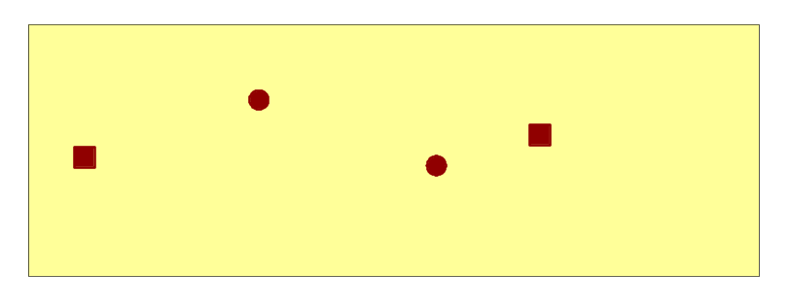B1 Miscanthus
Collar GPS Locations
North East Height Direction
1 1M4 1M1
1023277 | 1238369
1023221 | 1238346
1023028 | 1238353
1023124 | 1238394
2 1M3 36 1M2 33
3 35 34
4
North points (Meters from W edge, Meters from S edge) ^(39, 39) ^(85, 31)
S points (m from W edge, m from S edge) ^(10, 26) ^(68, 25)

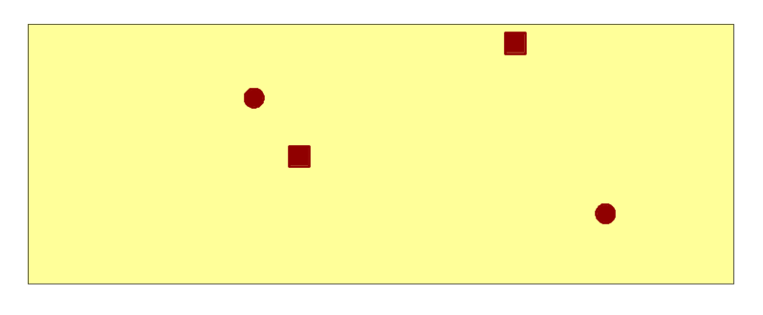
B2 Miscanthus
Collar GPS Locations 2M1
North East 2M4 37
1 40
1023701 | 1238874
1023752 | 1238753
1023578 | 1238794
1023553 | 1238835
2 2M3
3 39
4 2M2
38

N points (m from W edge, m from S edge) ^(39, 40) ^(84, 52)
S points (m from W edge, m from S edge) ^(47, 28) ^(100, 16)
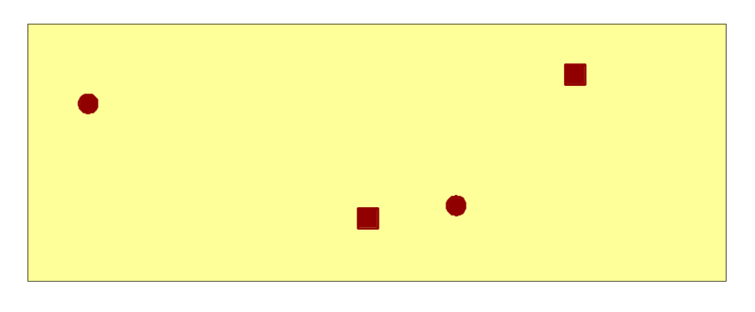
B3 Miscanthus 3M1
Collar GPS Locations 41
North East 3M4
1 44
1023761 | 1236891
1023693 | 1236798
1023642 | 1236789
1023482 | 1236870
2
3 3M3 3M2
4 43 42

N points (m from W edge, m from S edge) ^(11, 38) ^(95, 44)
S points (m from W edge, m from S edge) (60, 14)^ ^(75, 17)
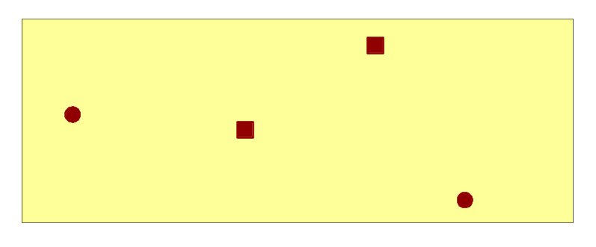
B4 Miscanthus
Collar GPS Locations 4M1
North East Offset (cm) 45
1
1023277 | 1236683
1023342 | 1236544
1023182 | 1236607
1023057 | 1236621
2 4M4 4M3
3 48 47
4 4M2
46

N points (m from W edge, m from S edge) ^(12, 30) ^(78, 48)
S points (m from W edge, m from S edge) ^(50, 26) ^(98, 6)

[North^]
Switchgrass Small Plots Plot Map
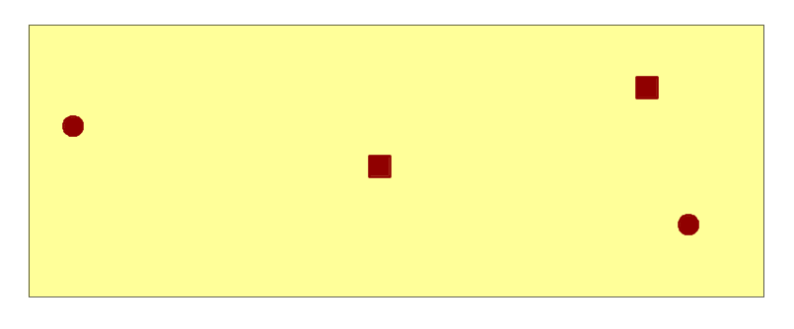B1 Switchgrass
Collar GPS Locations
North East 1S1
1 1S4 57
1023326 | 1238839
1023349 | 1238747
1023181 | 1238786
1023014 | 1238813
2 60 1S3
3 59
4 1S2
58

N points (m from W edge, m from S edge) ^(7, 35) ^(103, 43)
S points (m from W edge, m from S edge) ^(59, 27) ^(109, 15)

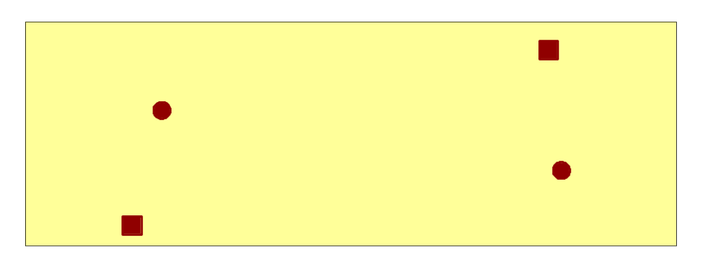B2 Switchgrass
Collar GPS Locations 2S1
North East 61
1 2S4
1023743 | 1239078
1023751 | 1238979
1023487 | 1238935
1023505 | 1239028
2 64
3
4 2S3 2S2
63 62

North points (Meters from W edge, Meters from S edge) ^(26, 34) ^(98, 48)
South points (Meters from W edge, Meters from S edge) ^(20, 5) ^(100, 19)

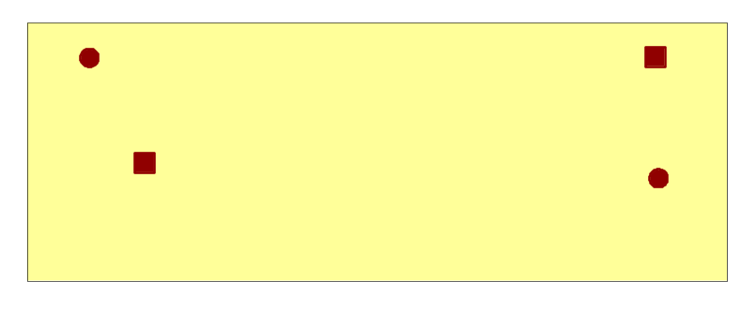
B3 Switchgrass 3S4 3S1
Collar GPS Locations 68 65
North East
1
1023809 | 1236688
1023811 | 1236602
1023517 | 1236612
1023486 | 1236687
2 3S3 3S2
3 67 66
4

N points (m from W edge, m from S edge) ^(11, 48) ^(109, 48)
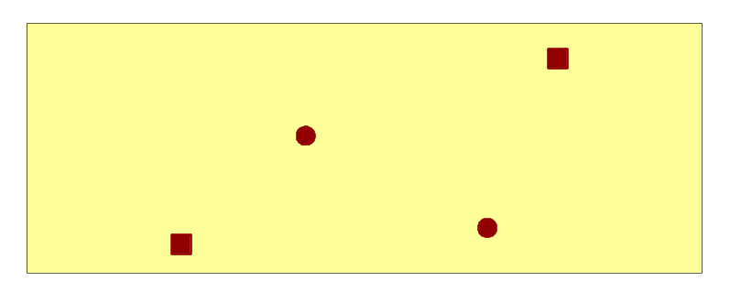S points (m from W edge, m from S edge) ^(20, 25) ^(110, 22)

B4 Switchgrass 4S1
Collar GPS Locations 69
North East
1 4S4
1023327 | 1237326
1023285 | 1237201
1023104 | 1237189
1023178 | 1237269
2 72
3 4S3 4S2
4 71 70
N points (m from W edge, m from S edge) ^(50, 31) ^(96, 48)
S points (m from W edge, m from S edge) ^(28, 7) ^(83, 10)
[North^]
Prairie Small Plots Plot Map
B1 Prairie
Collar GPS Locations
North East
1 1P1
1023215 | 1238599
1023226 | 1238495
1023158 | 1238534
1023094 | 1238579
2 1P4 81
3 84
4 1P3 1P2
83 82

North points (Meters from W edge, Meters from S edge) ^(31, 29) ^(68, 35)
South points (Meters from W edge, Meters from S edge) ^(51, 15) ^(71, 3)
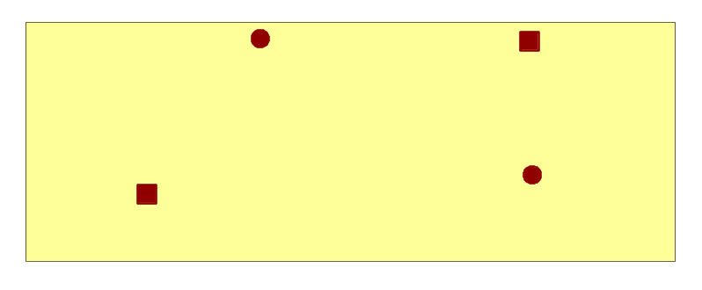
B2 Prairie
Collar GPS Locations 2P4 2P1
North East 88 85
1
1023738 | 1238441
1023740 | 1238338
1023503 | 1238324
1023573 | 1238443
2
3 2P2
4 2P3 86
87

N points (m from W edge, m from S edge) ^(44, 52) ^(94, 51)
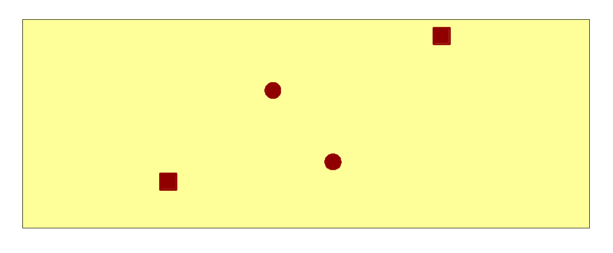S points (m from W edge, m from S edge) ^(23, 16) ^(95, 20)

B3 Prairie 3P1
Collar GPS Locations 89
North East 3P4
1 92
1023738 | 1237343
1023662 | 1237232
1023545 | 1237215
1023619 | 1237295
2
3 3P3 3P2
4 91 90

N points (m from W edge, m from S edge) ^(54, 37) ^(90, 52)
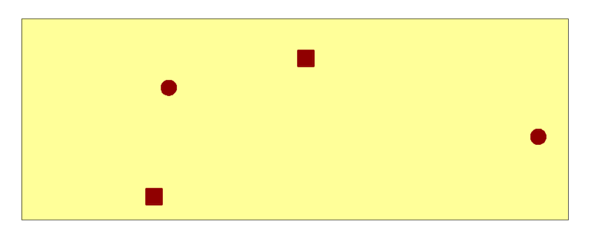S points (m from W edge, m from S edge) ^(32, 12) ^(67, 18)

B4 Prairie
Collar GPS Locations 4P1
North East 4P4 93
1 96
1023223 | 1237101
1023393 | 1237029
1023112 | 1236975
1023123 | 1237074
2 4P2
3 4P3 94
4 95

N points (m from W edge, m from S edge) ^(33, 37) (64, 45)
S points (m from W edge, m from S edge) ^(30, 6) ^(115, 23)

[North>]
Large Corn [Plot is 198 m (x) by 192 m (y)]

(C)
0C4
4
0C8 (C)
8

(C)

This map is useless for 2010. Soy layout not available. 0C3
3

0C2
2

0C7
7
0C1
0C6 (C) 1
6
0C5
5

(C) = Collar with no rhizotron tube.

Not to scale! Drawn by eye! Not measured! Beware! Offer not valid in 2010!

[North>]
Large Miscanthus [Plot is 198 m (x) by 192 m (y)]
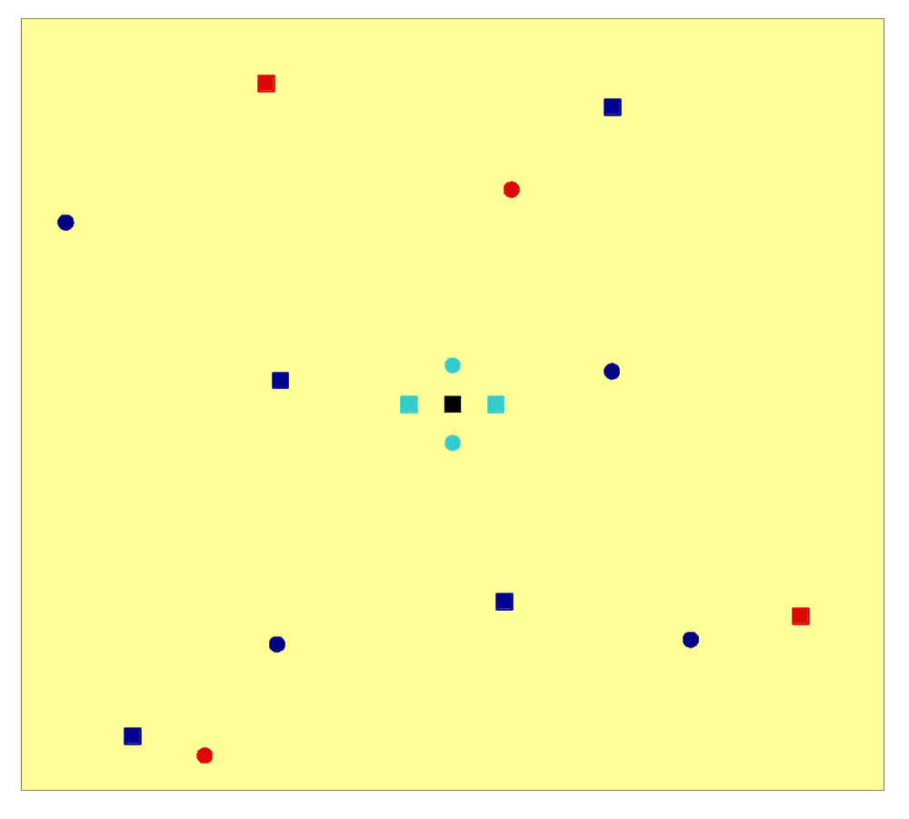

(56, 17)> 12
0M1 <(62, 22)
25

2 <(86, 43)
(10, 51)> 0M11
32

(59, 90)> 0M10 0M3 <(62, 88)
31 26

0M6 <(87, 47)
28 4 <(19, 43)
(59, 36)> 0M7 0M5 <(44, 37)
29 27

(26, 14)> 0M9
30
(42, 9) > 8
Red points have paired root exclosures, Coordinates represent distance from closest plot edge (Ex: the distance listed for points 1, 2, and 3 is that between the point and the E (x value) and the N (y value) edge.
Collar GPS Locations
North East
1
1022135 | 1237073
1022059 | 1237005
1022135 | 1236857
1022277 | 1236658
1022194 | 1236638
1022054 | 1236669
1021883 | 1236635
1021828 | 1236544
1021774 | 1236560
1021885 | 1236850
1021724 | 1236978
1021875 | 1237092
2
3
4
5
6
7
8
9
10
11
12
[North>]
Large Switchgrass [Plot is 198 m (x) by 192 m (y)]
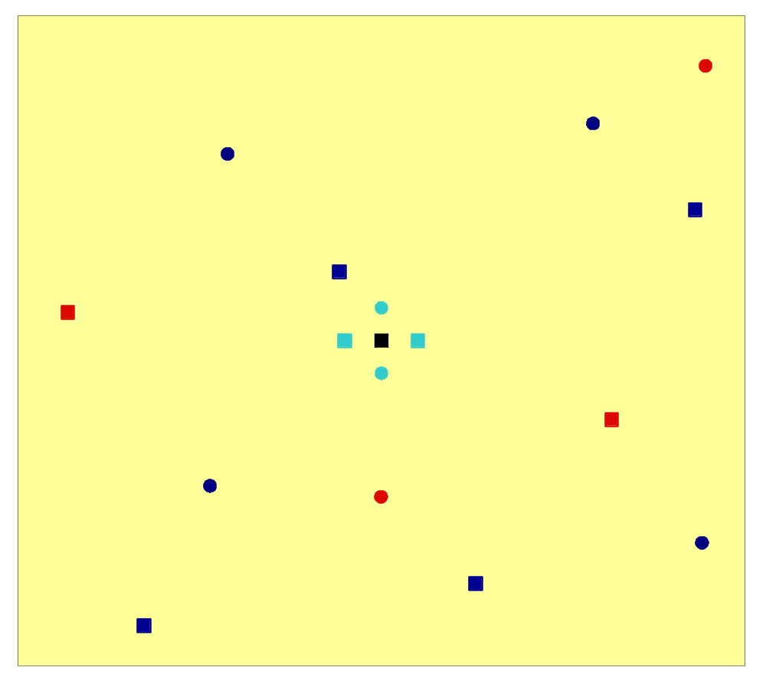

1 <(11, 15)

(Label says 0S12!) 0S2 <(41, 32)
(57, 41)> 0S11 49
55

0S3 <(14, 58)
50

(88, 76)> 0S12
56
(14, 88)> 10

4 <(36, 73)

(52, 53)> 0S8
(99, 50)> 53 7

0S5 <(12, 36)
51
0S6 <(73, 24)
52
(35, 12)> 0S9
54

Red points have paired root exclosures, Coordinates represent distance from closest plot edge (Ex: the distance listed for points 1, 2, and 3 is that between the point and the E (x value) and the N (y value) edge.
Collar GPS Locations
North East
1
1022970 | 1237741
1022869 | 1237685
1022960 | 1237601
1022885 | 1237398
1022966 | 1237279
1022764 | 1237239
1022680 | 1237323
1022527 | 1237334
1022468 | 1237199
1022400 | 1237502
1022543 | 1237655
1022642 | 1237541
2
3
4
5
6
7
8
9
10
11
12
[North>]
Large Prairie [Plot is 198 m (x) by 192 m (y)]
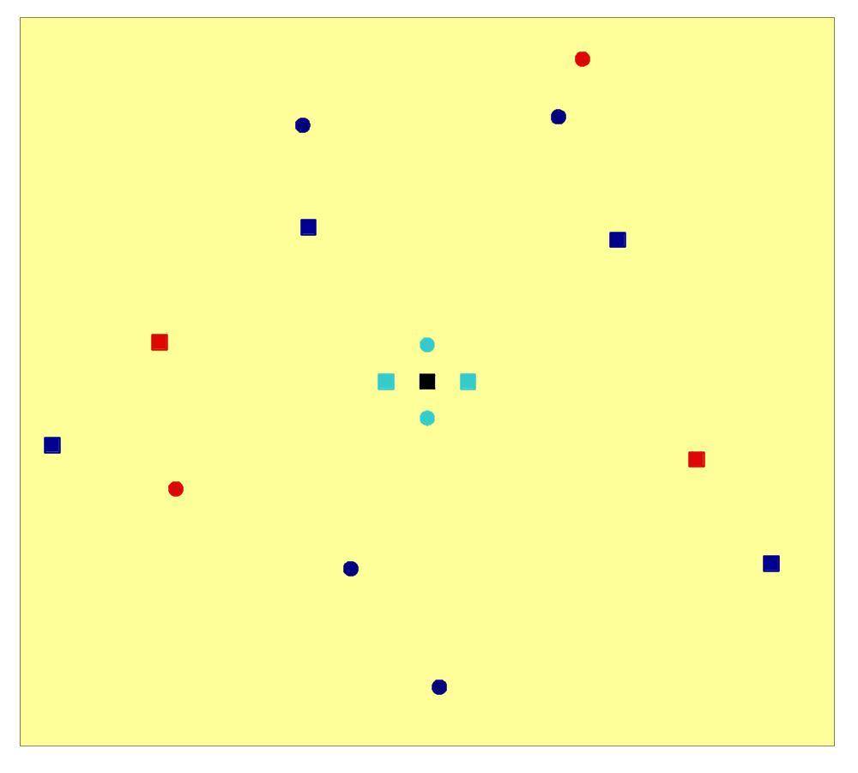

1 <(61, 11)

(69, 28)> 0P12 0P2 <(67, 26)
80 73

(70, 55)> 0P11 0P3 <(53, 59)
79 74

(34, 86)> 10

(8, 80) > 0P9
78 4 <(34, 75)
(38, 68)> 8

(80, 47)> 0P7 0P5 <(15, 48)
77 75

0P6 <(96, 16)
76

Red points have paired root exclosures, Coordinates represent distance from closest plot edge (Ex: the distance listed for points 1, 2, and 3 is that between the point and the E (x value) and the N (y value) edge.
Collar GPS Locations
North East
1
1022134 | 1237771
1022115 | 1237721
1022163 | 1237615
1022225 | 1237425
1022285 | 1237335
1022021 | 1237228
1021950 | 1237330
1021810 | 1237399
1021712 | 1237437
1021798 | 1237526
1021916 | 1237626
1021912 | 1237714
2
3
4
5
6
7
8
9
10
11
12

