**Step 1.** In order to run **ApiAdapter** application on your local machine or server you have to install Java first. Follow the instructions <https://docs.oracle.com/goldengate/1212/gg-winux/GDRAD/java.htm#BGBFJHAB> and make sure to setup **JAVA_HOME** and **Path** environment variables.

**Step 2.** Create folders **In**, **Out** and **config** on your drive (e.g on **D:\**)

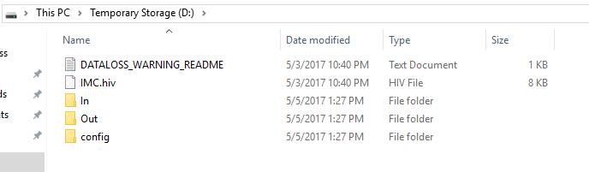

**In** folder will be used as input folder and **Out** as output folder.

**Step 3.** Download the following files from <https://github.com/infoviewsystems/rb-api-java>

* rb-api-java-1.0-SNAPSHOT.jar
* config.zip
* startClient.bat

Unzip config.zip content into **config** folder. Put other files at the same folder (e.g on **D:\**)

**Step 4.** Modify **application.properties** file in **config** folder according to your needs and requirements (api.clientId, api.clientSecret, api.countryCode, api.dbName, input.directory, output.directory):  
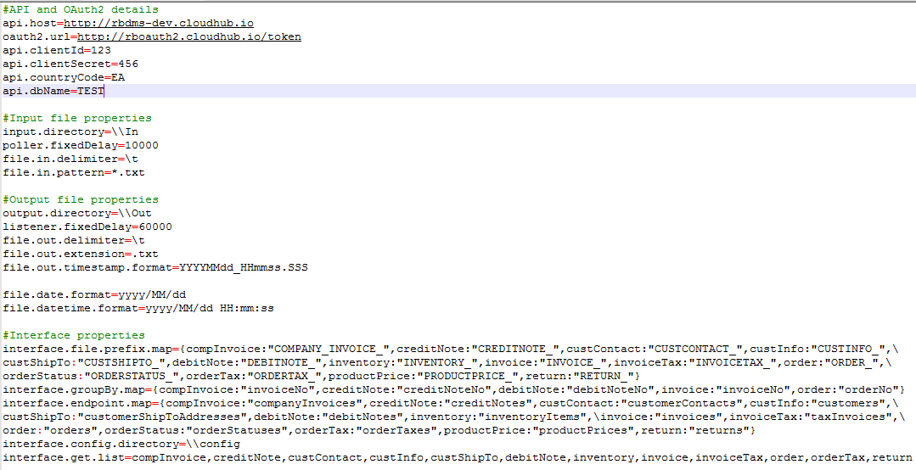

api.host – host for API calls

oauth2.url – url for security tokens check

api.clientId – API clientId

api.clientSecret – API clientSecret

api.countryCode – country code

api.dbName – distributor name

poller.fixedDelay – polling interval for input file, in ms

input.directory – directory for input files (mind double backslash)

file.in.delimiter – delimiter for input files

file.in.pattern – pattern for input files

listener.fixedDelay – polling interval for API GET methods, in ms

output.directory – directory for output files (mind double backslash)

file.out.delimiter – delimiter for output files

file.out.extension – extension for output files

file.out.timestamp.format – timestamp format for output files

file.date.format – date format in input and output files

file.datetime.format – datetime format in input and output files

interface.file.prefix.map – map of prefixes for interface files

interface.groupBy.map – map of fields to group by

interface.endpoint.map – map of endpoints

interface.config.directory – directory that contains schema files

interface.get.list – list of interfaces that should be checked by GET operation  
  
**Step 5.** Run **startClient.bat** file.

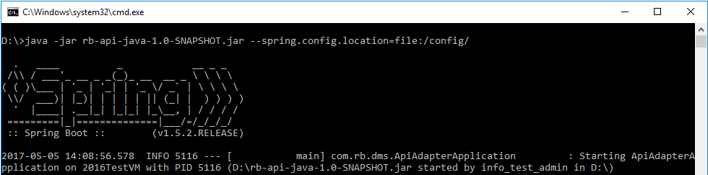

The program is running now. Put files for processing in **In** folder. Once NewsPage sends the file to SFTP server and it will be processed by Mulesoft application the output file will be written to **Out** folder.