INFOVISH ERP & CRM
SYSTEM ARCHITECTURE DOCUMENT
SAD v1.0 | INF-ERP-SAD-001

Prepared for: Infovish Systems
Reference: Product Requirements Document v1.1
Document status: Proposed engineering baseline
Date: 29 October 2026
UI wireframe: https://meta-drawn-18880799.figma.site
This document defines the proposed target architecture and phased implementation controls. No production readiness or implementation completion is implied.

Document control
Field | Value
Document ID | INF-ERP-SAD-001
Version | 1.0
Parent specification | Infovish ERP PRD v1.1
Architecture | Domain-oriented modular monolith with isolated services
Implementation | Incremental ChatGPT Codex milestones M00–M13
Figma wireframes | https://meta-drawn-18880799.figma.site
Approval | Pending M00 architecture review

Wireframe reference
Figma UI wireframe prototype supplied by the product owner: https://meta-drawn-18880799.figma.site. Treat this as a design reference, not an authoritative source of implemented behavior. Validate accessibility, responsive states, navigation, permissions and consistency against the PRD before coding screens.

1. Executive summary
Infovish ERP is a modular, multi-tenant ERP and CRM platform for organizations ranging from small businesses to enterprise deployments. Its core transactional services will use Laravel and PostgreSQL within a modular monolith; separately deployed services will support governed AI and selected integrations. React/TypeScript/Inertia serves the web interface; Flutter is planned for mobile.
Concern | Architecture baseline
Backend | Laravel / PHP modular monolith
Frontend | React + TypeScript + Inertia + Tailwind
Data | PostgreSQL platform database + database per tenant
Async | Redis queues, transactional outbox and idempotent consumers
AI | FastAPI with permission-scoped ERP tool gateway
Messaging | Official WhatsApp Business Platform Cloud API
Infrastructure | Docker, managed data services, IaC, CI/CD
APIs | Versioned REST, OpenAPI, authenticated webhooks

1.1 Architecture principles
- Enforce all financial, inventory and authorization invariants server-side.
- Each module owns its data and publishes explicit public contracts.
- Never authorize a tenant solely from untrusted client-provided identifiers.
- Treat external messages, AI retrieval and webhooks as untrusted inputs.
- Preserve transactional consistency; design async delivery as at-least-once.
- Favor reproducible infrastructure, observable behavior and testable boundaries.
- Build only the approved milestone and document deviations through ADRs.

2. C4 system architecture
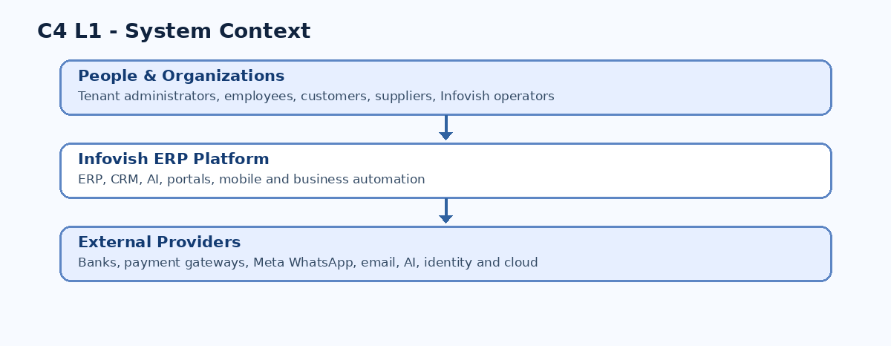
Figure 1. C4 Level 1 — people, ERP system and external dependencies.
Actors include tenant administrators, employees, managers, customers, suppliers, partner developers and Infovish operators. Trust boundaries separate each tenant, the platform control plane and external providers.
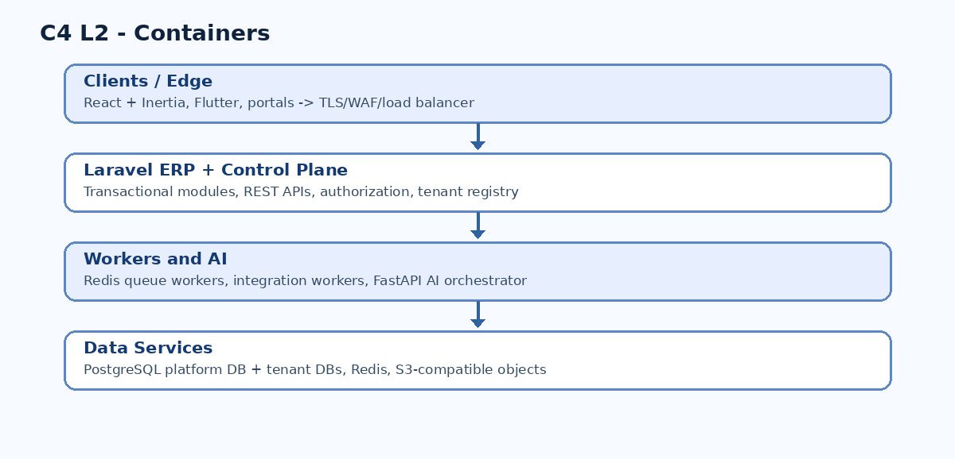
Figure 2. C4 Level 2 — deployable containers and state services.
Container | Primary responsibility
ERP Web | Authenticated user experience through Inertia
Laravel ERP | Business transactions, authorization and public REST APIs
Control plane | Tenant lifecycle, subscriptions and provisioning
FastAPI AI | Prompt/model routing, governed tools, evaluations
Integration workers | Provider callbacks, outbound delivery and retries
PostgreSQL | Authoritative platform and tenant business data
Redis | Queues, cache and coordination
Object storage | Authorized document and attachment storage

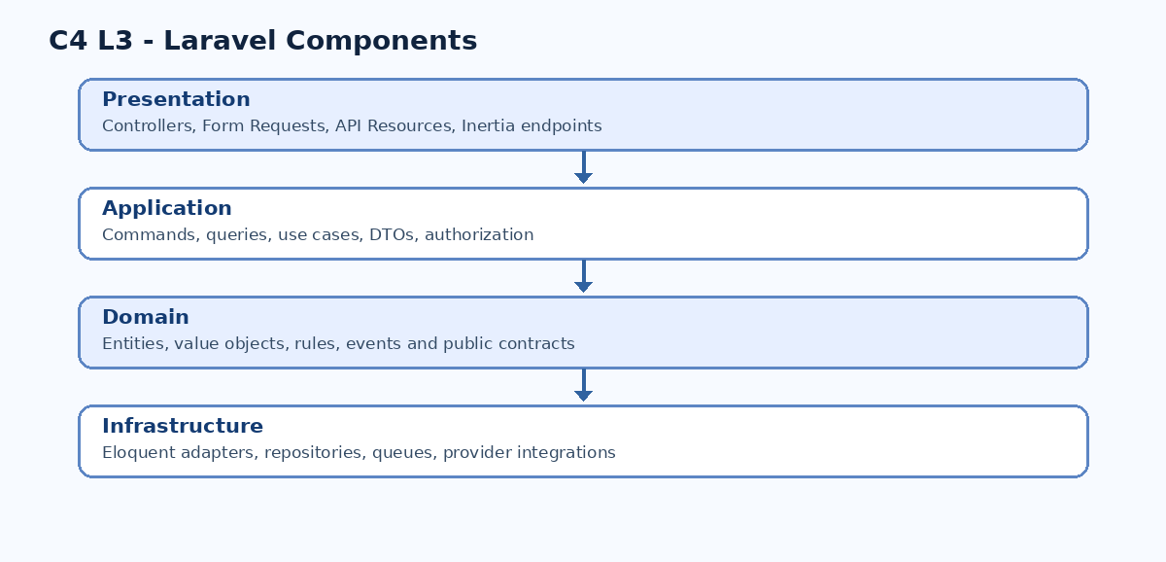
Figure 3. C4 Level 3 — application component layering.

2.4 C4 Level 4 — example implementation path
CreateLeadController -> CreateLeadCommand -> CreateLeadHandler
-> Lead domain model -> LeadRepository -> PostgreSQL
Handlers resolve tenant and actor context, authorize, validate, persist and record events. Where reliable publication is required, the outbox record commits in the same database transaction as business state.

3. Domain architecture and module boundaries
Bounded context | Ownership
Platform | Tenants, plans, provisioning, entitlements
Identity | Authentication, roles, membership, permissions
Organization | Companies, branches, departments, fiscal configuration
Parties | Customers, suppliers, contacts
Catalog | Products, variants, prices
CRM | Leads, opportunities, activities
Sales | Quotations, orders, fulfillment commitments
Finance | Journals, invoices, payments, reconciliation
Procurement | Requisitions, RFQs, purchase orders
Inventory | Stock ledger, reservations, locations
Manufacturing | BOM, work orders, production
HR | Employees, leave, attendance, payroll
Projects | Tasks, timesheets, field services
Communications | Email, WhatsApp, inbox, conversations
Documents | Files, versions, metadata, approvals
Automation | Workflow triggers, approvals, execution
Analytics | Governed reports and read models
AI | AI policies, orchestration requests, approvals

3.1 Module integration rules
- A module may not directly update another module’s private tables.
- Cross-module synchronous operations use public application contracts; async operations use versioned events.
- No module may bypass the central authorization or tenant context mechanisms.
- Publish stable identifiers and DTOs rather than leaking Eloquent internals.
- Use an orchestrated process manager for long-running workflows with explicit failure and compensation states.
- Define dependency manifests and validate installation/upgrade compatibility.

3.2 Representative workflows
Sales-to-invoice: confirmation creates an authorized order and event; downstream fulfillment and invoicing validate their own business rules and deduplicate retries. Procurement-to-stock: authorized receipt drives an idempotent inventory movement; finance applies approved valuation rules. Manufacturing: reserve inputs, consume, record output and costs, and support partial completion.

4. Tenant and database architecture
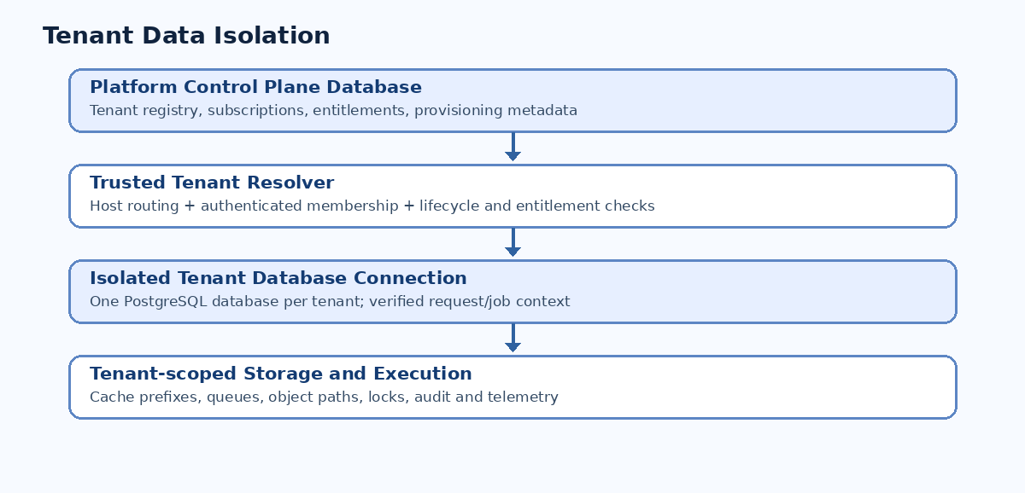
Figure 4. Platform database, tenant resolution and data isolation.

4.1 Tenant request lifecycle
- Resolve tenant from trusted host/routing metadata.
- Authenticate the principal and validate tenant membership.
- Check tenant lifecycle, company scope and entitlements.
- Bind an isolated tenant database connection.
- Execute authorized application operations.
- Clear tenant context on request completion and every queue job.

4.2 Data integrity
Use UUID-based public identifiers and separate company-scoped document numbers. Use PostgreSQL NUMERIC for currency and stock quantities, explicit rounding and unit conversion policies, foreign keys, uniqueness constraints, and appropriate locking. Posted journal and stock histories must be append-only or preserve equivalent immutable audit trails; corrections use reversals or adjustments.

4.3 Migration and backup strategy
Use controlled tenant-by-tenant migrations with version tracking, locks, failure reporting and expand/contract compatibility. Separate large backfills from schema releases. Backups must cover tenant databases and object storage consistently; restore tests must prove recovery, not merely confirm backup jobs ran.

5. Laravel backend design
backend/app/
Platform/{Tenancy,Identity,Subscriptions,Provisioning,ModuleRegistry}/
Shared/{Auth,Audit,Events,Money,Contracts}/
Modules/{Parties,Catalog,CRM,Sales,Finance,Procurement,Inventory,...}/
backend/{routes,database,tests,config}/
Each module follows Domain / Application / Infrastructure / Presentation layers with dedicated migrations, tests, module manifest and README as justified by complexity. Controllers stay thin; business logic belongs to domain/application services. Eloquent is a persistence tool, not an unrestricted cross-module interface.

5.1 Backend requirements
ID | Architectural control
ARC-BE-001 | Thin controllers; use-case services
ARC-BE-002 | Server-enforced business invariants
ARC-BE-003 | Verified tenant and actor context
ARC-BE-004 | No undocumented private-table coupling
ARC-BE-005 | Explicit financial and stock transactions
ARC-BE-006 | Retryable and idempotent background jobs
ARC-BE-007 | Versioned REST and response contracts
ARC-BE-008 | Reliable critical event publication
ARC-BE-009 | Validated module dependencies
ARC-BE-010 | Structured redacted error logging

5.2 API conventions
/api/v1/me
/api/v1/companies
/api/v1/crm/leads
/api/v1/sales/orders
/api/v1/finance/invoices
/api/v1/inventory/stock-movements
/api/v1/communications/conversations
Standardize pagination, filters, error envelopes, correlation IDs, rate limits, API authorization and idempotency keys for repeated write operations. Maintain OpenAPI contracts and compatibility tests.

6. React / TypeScript / Inertia architecture
The ERP web app uses React, TypeScript, Inertia.js, Vite and Tailwind. Select one canonical frontend source location during M00; do not create a competing React app alongside Laravel resources. Group frontend features by bounded context; share accessible UI primitives, tables, forms, charts, feedback and navigation.
erp-web/src/{app,components,features,hooks,lib,services,types,styles}/
features/{crm,sales,finance,inventory,...}/
UI requirements include a responsive shell, permission-aware navigation, company switcher, reusable list/form/Kanban/calendar views, global search, keyboard accessibility, light/dark themes, localization-ready formatting, and clear loading/empty/error states. UI permission hiding never replaces server authorization.
Figma wireframes: https://meta-drawn-18880799.figma.site. Validate all design assumptions against actual business workflows and the requirements before implementation.

7. AI orchestration
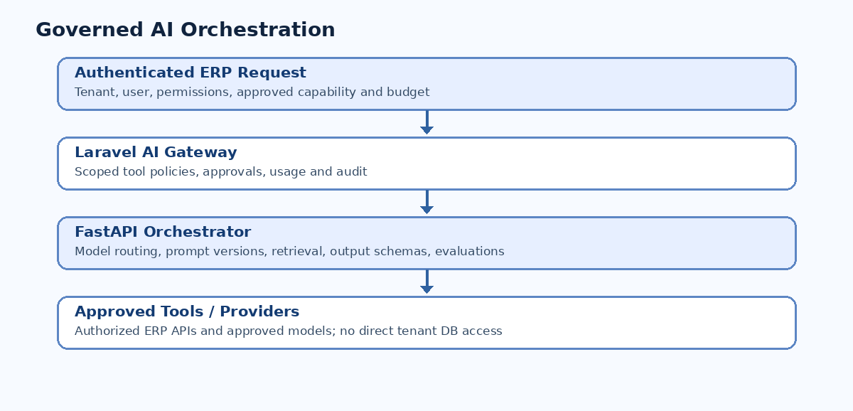
Figure 5. AI execution trust boundary and tool governance.
AI requests originate from authenticated ERP contexts. Laravel verifies tenant, actor, permissions, entitlements and budgets; FastAPI orchestrates approved models, retrieval and structured outputs. Every read/write tool is reauthorized by the ERP gateway. High-impact actions require explicit approval. No direct AI-to-tenant-database credentials are permitted.
Risk | Required mitigation
Prompt injection | Untrusted retrieval; independent tool authorization
Cross-tenant data exposure | Tenant-scoped retrieval and API policies
Sensitive data leakage | Minimization, approved provider handling
Unauthorized writes | Approval and deterministic domain checks
Hallucinated metrics | Traceable structured calculations
Model outage/cost | Circuit breakers, quotas, fallback

8. Official WhatsApp Business integration
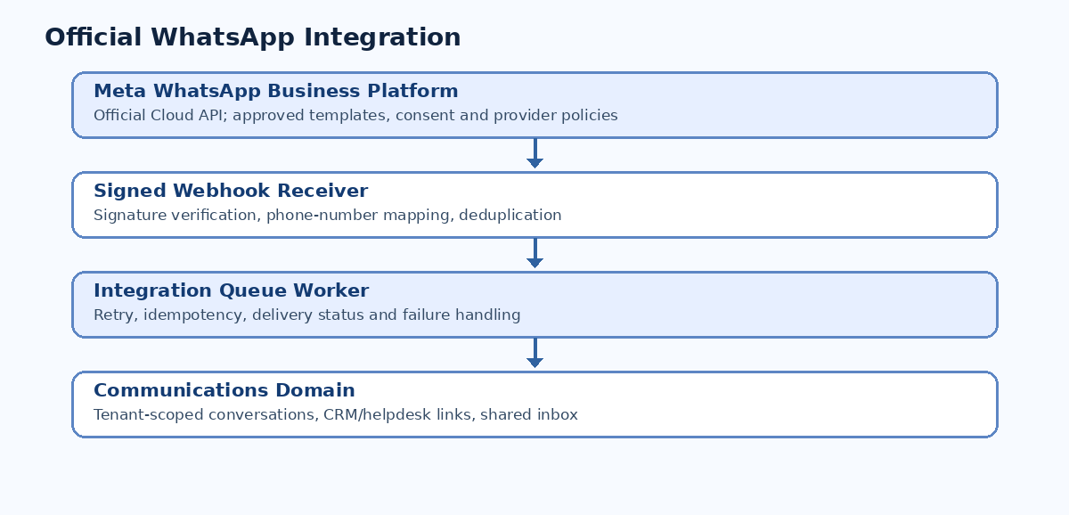
Figure 6. Official provider webhook and communications flow.
Use Meta WhatsApp Business Platform Cloud API or an authorized provider, with current supported API versions and policy checks at implementation. Validate webhook signatures and map registered business number identifiers to authorized tenants. Deduplicate inbound events; queue processing; maintain conversation/message/template/consent/delivery records. For outbound messages enforce opt-in, approved templates and applicable messaging windows.

9. Event-driven integration
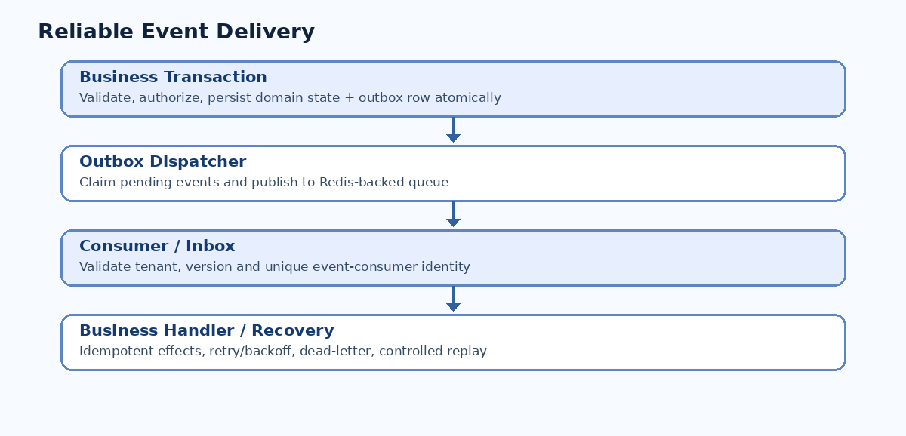
Figure 7. Transactional outbox, queue and idempotent consumer.
Delivery semantics are at-least-once. Outbox rows commit atomically with business transactions; a dispatcher publishes them to Redis-backed queues. Consumers validate schema/version/tenant and record processed event IDs. Retry transient errors with bounded exponential backoff; classify permanent failures; expose dead-letter replay and monitoring.
{
"event_id": "<uuid>",
"event_type": "sales.order.confirmed",
"event_version": 1,
"tenant_id": "<uuid>",
"aggregate_id": "<uuid>",
"correlation_id": "<id>",
"occurred_at": "<UTC timestamp>",
"payload": { "order_id": "<uuid>" }
}

10. Security architecture
- TLS, trusted proxy configuration, WAF and rate limits at the edge.
- Secure session and CSRF protection for Inertia; scoped tokens/OAuth for mobile and integrations.
- Role, tenant, company, record and field-level authorization enforced server-side.
- MFA for privileged users; OIDC SSO for approved enterprise deployments.
- Secret management and rotation; no credentials in logs, source or AI prompts.
- Encrypted backups and authorized object access; retention and privacy workflows.
- Structured audit logs for privileged actions, financial changes and integrations.
- Security testing for tenant escape, IDOR, CSRF, injection, webhook replay and AI misuse.
ID | Security acceptance test
SEC-001 | Cross-tenant read/write isolation
SEC-002 | Privilege escalation prevention
SEC-003 | IDOR prevention
SEC-004 | Session revocation
SEC-005 | CSRF and injection defense
SEC-006 | Malicious file handling
SEC-007 | Webhook authenticity/replay
SEC-008 | Secrets and dependency scans
SEC-009 | AI prompt-injection/tool misuse
SEC-010 | Backup and sensitive-data protection
SEC-011 | Rate limiting
SEC-012 | Audit integrity

11. Infrastructure and deployment
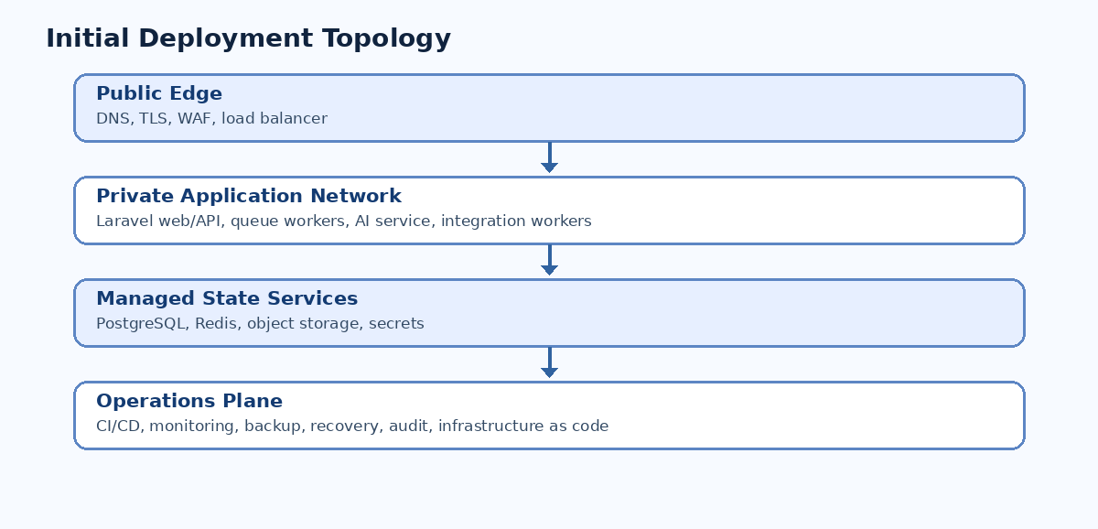
Figure 8. Proposed production deployment topology.
Environment | Purpose
Local | Developer Docker stack and synthetic fixtures
CI | Ephemeral test services
Development | Shared integration with synthetic data
Staging | Production-like validation with sanitized data
Production | Protected customer workloads

Use containerized services, managed PostgreSQL, Redis, S3-compatible object storage, dedicated secrets and observability. Provision infrastructure with Terraform or approved IaC. Kubernetes is deferred until operational scale justifies it. Use independent queue classes for critical transactions versus reporting, marketing and AI jobs.

11.1 Proposed operational targets
Measure | Initial target / qualification
Availability | 99.9% monthly managed service target, not yet guaranteed
RPO | 1 hour for qualifying managed tiers
RTO | 4 hours for qualifying managed tiers
Performance | Representative p95 reads under 500 ms only after workload definition and tests
Recovery | Scheduled verified restore drills
Scaling | Measured workload-driven capacity planning

12. CI/CD, testing and operations
CI should perform PHP formatting/static analysis/tests, TypeScript lint/typecheck/build, Python checks when present, migrations, architecture boundary tests, OpenAPI validation, secret/dependency scanning, integration and critical E2E tests. Protected branches and reviewed changes feed staged deployments. Schema changes must use compatibility-aware migration strategies; container rollback does not imply automatic database rollback.
Capture structured logs, metrics and distributed traces across Laravel, queues, FastAPI and providers. Monitor request latency, database locks, queue depth, outbox lag, AI cost, webhook errors, backup success and tenant provisioning/migration status. Maintain runbooks for outages, tenant restores, failed migrations and security incidents.

13. Mobile and extension architecture
Flutter mobile uses feature-based modules, secure API access and explicit offline workflow design. Offline writes require encrypted local storage where applicable, reconciliation and conflict policies; financial and inventory-critical writes cannot be assumed safe offline.
Infovish Studio uses versioned metadata for fields, forms, views and workflows. Extensions declare dependencies, capabilities, permissions and compatible platform versions. Never execute arbitrary untrusted customer PHP code inside the shared SaaS application.

14. Architecture decision register
ADR | Proposed decision | Status
ADR-001 | Modular monolith | Proposed — M00 review
ADR-002 | Laravel transactional backend | Proposed — M00 review
ADR-003 | React/TypeScript/Inertia frontend | Proposed — M00 review
ADR-004 | PostgreSQL database per tenant | Proposed — M00 review
ADR-005 | Separate platform control plane | Proposed — M00 review
ADR-006 | Redis queues and transactional outbox | Proposed — M00 review
ADR-007 | FastAPI AI service | Proposed — M00 review
ADR-008 | Official WhatsApp Business APIs | Proposed — M00 review
ADR-009 | REST and OpenAPI | Proposed — M00 review
ADR-010 | Flutter mobile | Proposed — M00 review
ADR-011 | Docker managed deployment | Proposed — M00 review
ADR-012 | Metadata-driven customization | Proposed — M00 review
ADR-013 | Governed AI tools | Proposed — M00 review
ADR-014 | Domain ownership boundaries | Proposed — M00 review
ADR-015 | Managed database and object storage | Proposed — M00 review
ADR-016 | Defer Kubernetes | Proposed — M00 review
ADR-017 | Automated security and architecture tests | Proposed — M00 review
ADR-018 | Industry extension isolation | Proposed — M00 review

Every ADR must document context, alternatives, rationale, consequences, security/operational implications, migration approach and related requirements. Do not silently mark disputed decisions accepted.

15. Codex repository standards
infovish-erp/
apps/{erp-web,platform-admin,customer-portal,mobile}/
backend/{app,bootstrap,config,database,routes,tests}/
services/{ai-service,integration-workers}/
packages/{api-contracts,ui,module-sdk,shared-types}/
infrastructure/{docker,terraform,deployment,monitoring}/
docs/{requirements,architecture,engineering,modules,api,security,operations}/
.github/workflows/
AGENTS.md README.md CHANGELOG.md
The root AGENTS.md must require reading PRD/SAD/ADRs, implementing only approved milestones, respecting module boundaries, tenant authorization, financial precision, test evidence, purposeful comments, documentation updates and review gates. Do not generate empty scaffolding for all future modules.

16. Codex milestone roadmap
Milestone | Implementation scope
M00 | Architecture validation and ADRs
M01 | Monorepo, Laravel/React, Docker, CI
M02 | Tenancy, IAM, organization, audit
M03 | Module registry and shared catalog
M04 | CRM
M05 | Sales and first commercial release
M06 | Accounting
M07 | Inventory and procurement
M08 | HR, projects, helpdesk, portals, documents
M09 | Email, WhatsApp, inbox, automation
M10 | AI and document intelligence
M11 | Manufacturing, POS, commerce, subscriptions
M12 | Studio and industry extensions
M13 | Enterprise scale and cloud maturity

M00 must validate the architecture, select compatible tool versions, resolve blocking decisions and produce ADRs. M01 then creates a working Laravel/React/Inertia foundation with PostgreSQL, Redis, Docker, health checks, tests, CI and documented developer setup. Stop before M02 for review.

17. Architecture acceptance gates
ID | Required validation
SAD-AC-001 | Reproducible repository setup
SAD-AC-002 | Automated module boundary validation
SAD-AC-003 | Cross-tenant isolation verification
SAD-AC-004 | Approved authentication controls
SAD-AC-005 | Transactional financial/inventory integrity
SAD-AC-006 | Outbox delivery and replay reliability
SAD-AC-007 | Webhook idempotency
SAD-AC-008 | AI permission enforcement
SAD-AC-009 | Module compatibility checks
SAD-AC-010 | CI prevents failing deployments
SAD-AC-011 | Distributed traceability
SAD-AC-012 | Verified restoration
SAD-AC-013 | Versioned API contracts
SAD-AC-014 | Measured performance targets
SAD-AC-015 | Security findings resolved

18. Open decisions and implementation dependencies
- Confirm database-per-tenant topology, provisioning approach, connection pooling and dedicated enterprise hosting.
- Select specific supported framework and runtime versions during M00.
- Finalize Sri Lankan accounting, tax, payroll and localization rules with qualified domain reviewers.
- Approve provider onboarding, payment integrations and WhatsApp credentials lifecycle.
- Define exact module data models, event schemas, public APIs and ownership before implementing each module.
- Specify cloud provider, capacity, monitoring, backup and recovery operations.
- Define offline mobile scope, AI provider policies and enterprise commitments.

19. Document status and next action
This SAD is an implementation-oriented architectural baseline, not evidence that all subsystems are coded or production-validated. Next: complete M00 architecture review, approve blocking ADRs, then implement M01 engineering foundation through Codex. Review Figma wireframes as a visual reference at https://meta-drawn-18880799.figma.site.

