STEP 1： RUN NAND TEST TOOLS

cd /nand_tools

./Nand_test_tools_v1_0.sh

STEP 2： CHOICE TEST CASE

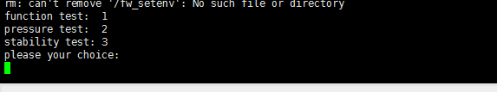

STEP 3: FUNCTION TEST

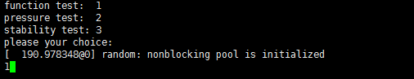

ONCE: bootloader 、env、unifykey、system , READ && WRITE && VERIFY

STEP 4： PRESURRE TEST CASE

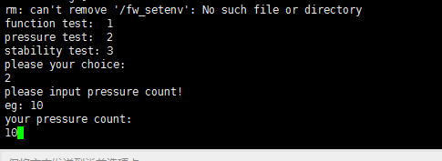

10 times FUNCTION TEST

STEP 5： STABILITY TEST

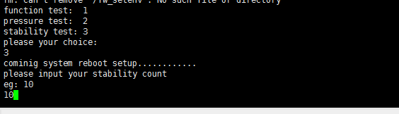

10 times : bootloader、system read && reboot and verify

Note: test arch

