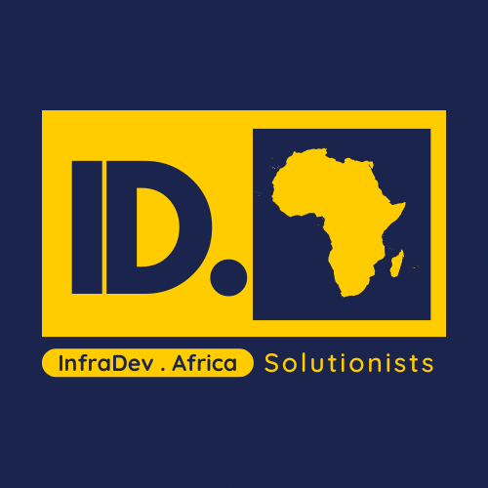 | CAPABILITY STATEMENT  InfraDev.Africa | Solutionists

Who we are  InfraDev.Africa is a strategic infrastructure advisory and delivery-support firm focused on making projects feasible, bankable, and executable in African contexts. | Sectors  - Power systems: transmission and distribution planning, renewables integration  - Decentralised energy: mini-grids, hybrid systems, storage deployment  - Urban infrastructure: mobility, housing enabling works, city services  - Water and sanitation: access systems, program design, delivery monitoring
Core services  - Master planning and investment roadmaps (cities, corridors, SEZs, utilities)  - Pre-feasibility and feasibility studies (technical, financial, ESG)  - PPP and transaction support (structuring, risk allocation, procurement packs)  - Lender and investor due diligence support (data rooms, technical review) | Why InfraDev  - Systems thinking: we treat energy, water, health, logistics and governance as one connected machine.  - Context fluency: African delivery realities, stakeholder dynamics, and procurement constraints.  - Boardroom plus field: rigorous documents that still survive real sites and messy data.
How we work
Typical engagement formats:
- Rapid diagnostic (2-4 weeks)
- Feasibility / structuring (6-16 weeks)
- Delivery support / PMO (3-18 months)
Primary geography: DRC with pan-African execution through partnerships.

Contact
Managing Director: Ted Kivoto Isengingo | Website: www.infradev.africa
Address: 16 Av Lokele, Gombe, Kinshasa, DRC

TRACK RECORD & DELIVERABLES
Representative experience of leadership and typical outputs
Experience  Selected leadership experience (prior roles) - used to inform InfraDev delivery quality and standards:  - Power networks planning and advisory across Africa (transmission/distribution, renewables integration).  - Senegal grid stability support (USAID/USEA programme with Mott MacDonald, 2017-2019): technical facilitation, bilingual delivery, data collection and dynamic model support (CYME), and capacity-building recommendations.  - Luanda integrated planning assignments (master planning / infrastructure coordination).  - Ghana gas-to-power strategy support (Genser Energy): commercial and delivery-oriented advisory.  - Company-managed healthcare system transformation (Watu Wetu Health System): multi-phase programme design, governance and performance tracking. | Deliverables  Outputs we produce (examples):  - Feasibility reports (technical, economic, financial model interface, ESG)  - Investment notes and decision memos for boards and DFIs  - PPP / procurement packs: TORs, RFPs, evaluation frameworks, draft risk matrices  - Implementation plans: phased roadmaps, CAPEX/OPEX logic, governance and reporting systems  - Dashboards: progress tracking, KPI trees, action logs, stakeholder maps
Delivery principles
- Evidence-first: assumptions labelled, data gaps logged, decisions traceable.
- Bankability: we write for lenders, not for theatre.
- Localisation: designs adapted to procurement, operations, and skills realities.
- Partner-ready: clear interfaces for OEMs, EPCs, DFIs and public agencies.
Relationship and disclaimer: InfraDev.Africa is an independent venture within the Kumea.Africa ecosystem (House of Brands). This document is for information only and does not constitute a binding offer; any engagement is subject to contract.

