# Ansible playbook to:

# Add a given user as Sudo and SSH enabled account

|  |  |
| --- | --- |
| Author | MGH |
| Audience | IT Team |
| Date of revision | 14/05/2025 11:24 |

Contents

Ansible playbook to: 1

Add a given user as Sudo and SSH enabled account 1

What does this playbook ? 2

Playbook files and folder overview 2

Set the required hosts in the inventory file 2

Upload the playbook to ansible server 3

Set permissions 3

Change running account 3

Run the playbook 3

Full playbook attached 4

# What does this playbook ?

This playbook adds a given user as “sudoers” and “ssh enabled” user on a list of hosts, restarting needed services.

It backup all modified files and upload logs to the ansible log folder.

# Playbook files and folder overview

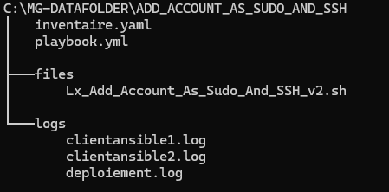

# Set the required hosts in the inventory file



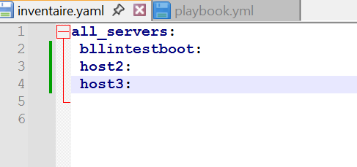

Beware of the YAML file format. Only one space by indentation !

# Upload the playbook to ansible server

1°) copy the playbook (and all related files and folders) to server “bllintestboot3” (Ansible Master Server) in “/tmp/ansible” folder

# cp /home/C95059561/ansible /tmp/ -R



# Set permissions

2°) give the ansible account access to the folder:

# chmod ugo+rwx /tmp/ansible -R



# Change running account

3°) change identity to ansible account

# su fr-726-ansible



# Run the playbook

4°) Run the playbook with the correct inventory file and parameters

Go in the playboob folder and run:

# cd /tmp/ansible/Add_Account_As_Sudo_And_SSH



# ansible-playbook -K -k -u fr-726-ansible -i inventaire.yaml --extra-vars "utilisateur=C95059561 no_create=true"



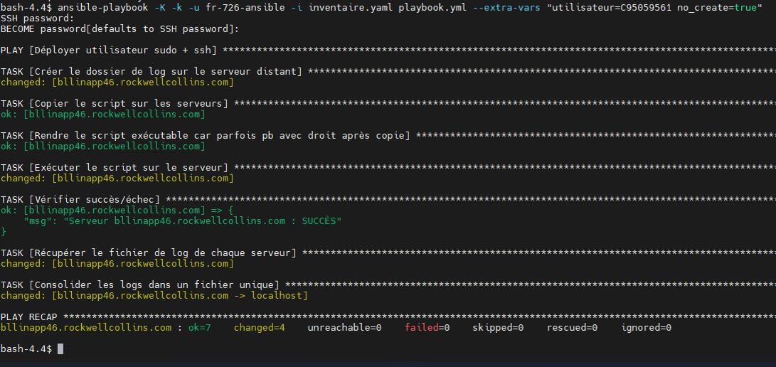

# Full playbook attached

