Freelance Electronics Engineer EasyEDA Redesign and Prototype Validation

Project overview
I am looking for an electronics engineer to redesign and industrialize an existing PCB-based controller around a seed Xiao ESP32 S3 (https://wiki.seeedstudio.com/xiao_esp32s3_getting_started/). The current PCB is functional but unreliable, with Ethernet startup initialisation failures, sensitivity to nearby conductive objects, and suspected ground-return, power, reset, and SPI signal-integrity issues.

Product description
The product is a compact, battery-powered footswitch controller based on an ESP32 module. It includes:
- Three analog footswitch/button inputs using resistor-ladder detection.
- One dedicated digital push button for power-on, shutdown, and startup control.
- A TFT display for user feedback and configuration.
- A W5500 Ethernet interface for wired network connectivity.
- USB connectivity for power, debugging, firmware updates, and configuration.
- Battery-powered operation with a controlled peripheral power rail.
- A shared SPI bus between the TFT display and the W5500 Ethernet controller.
The design must operate reliably from both USB power and 1 18650 battery power and ideally keep the 2 connector for 2 103450 lithium battery
Work must be done on collaborative existing shared easyeda project (online)

Current schematic and reference files
Current schematic: (see easyeda project) https://easyeda.com/editor#id=|88f0b735e5064ff687d942bcdb5f23a0|d46b98c45d2248ef8b3bf59c53f1c2f8

The base design in easyeda is « v02 fix 2 », but I made a few change to 2.2 which should be the new baseline. I have added two wire on the v02 fix 2 to link GND from ESP to GND w5500 and TFT which enables this magnetic field/effect that allow starting up

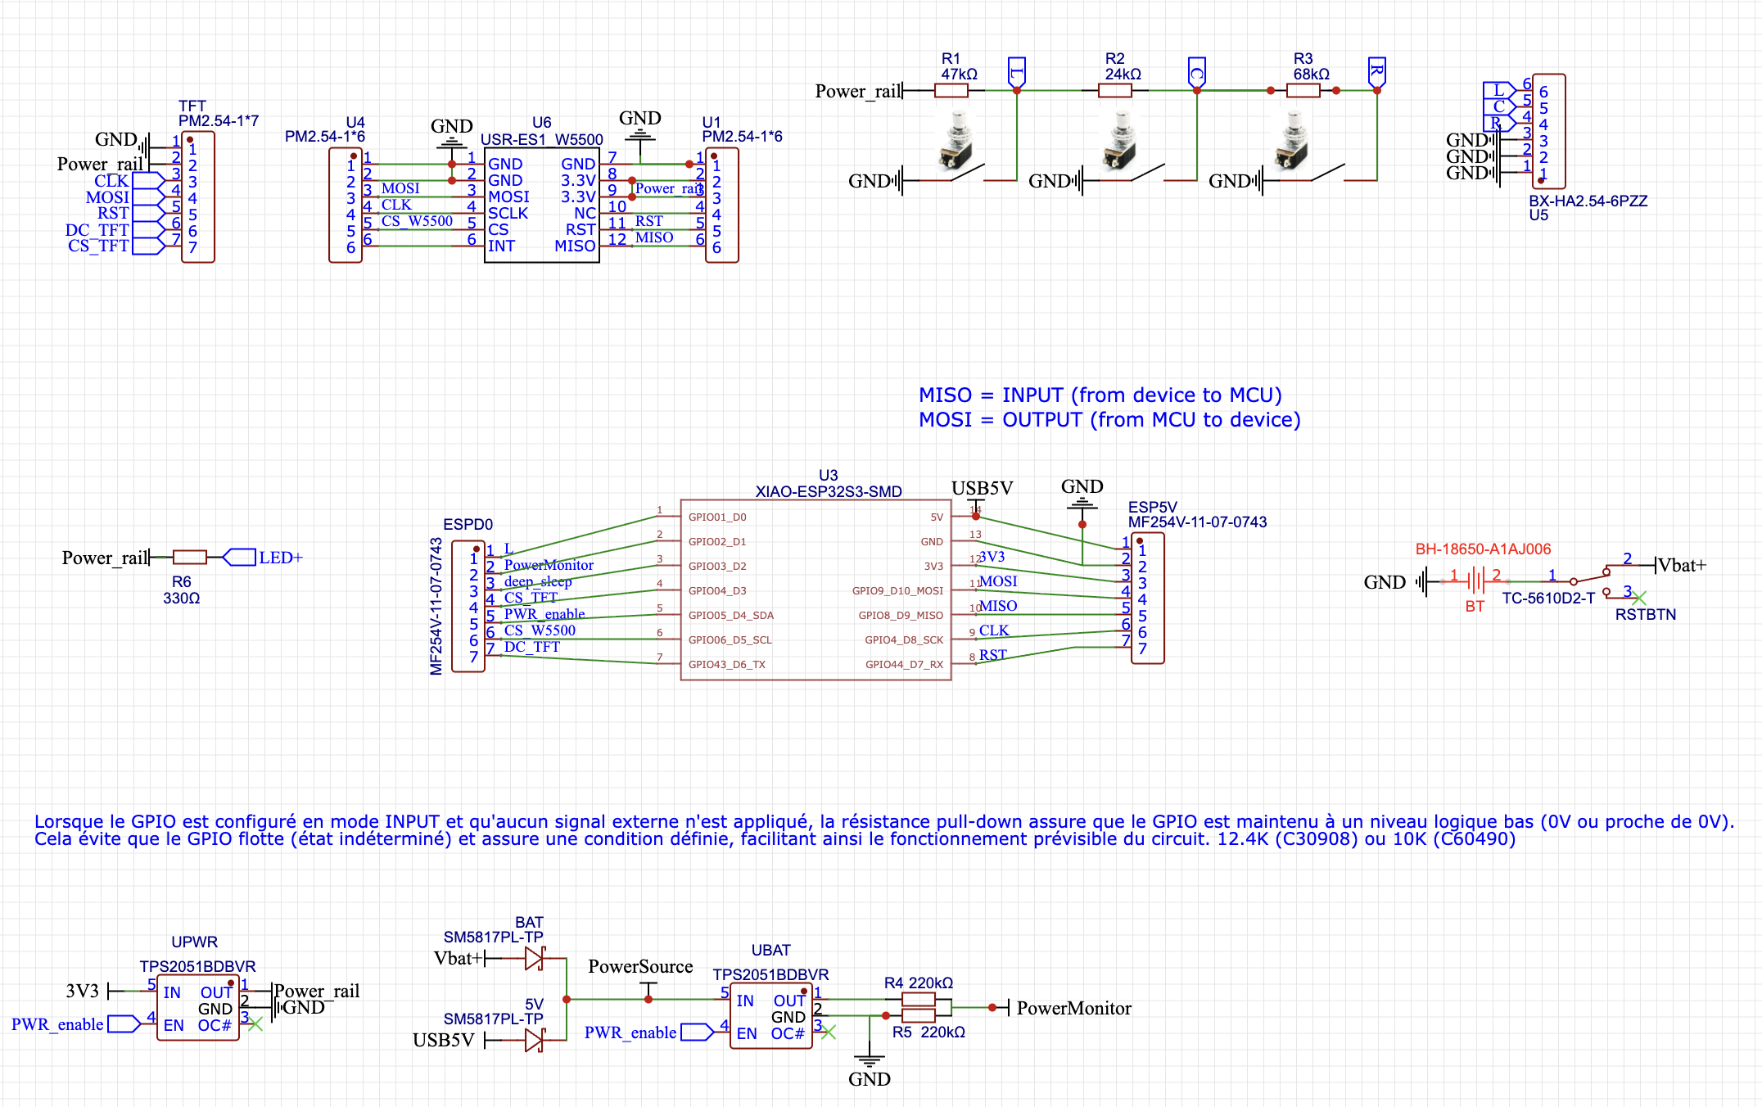
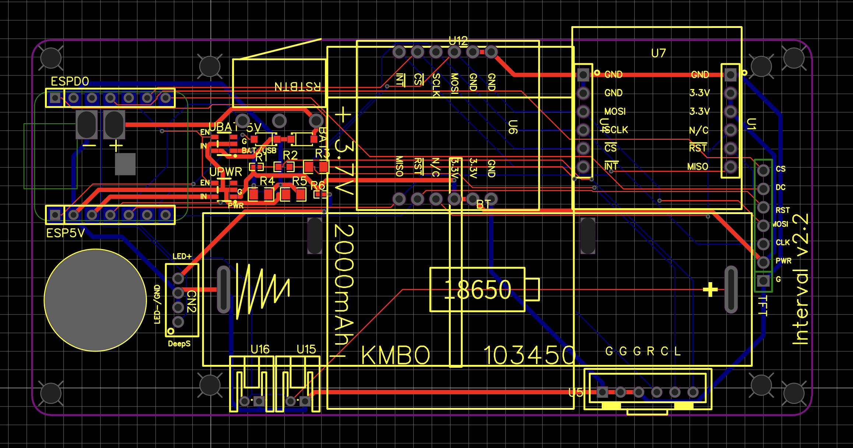
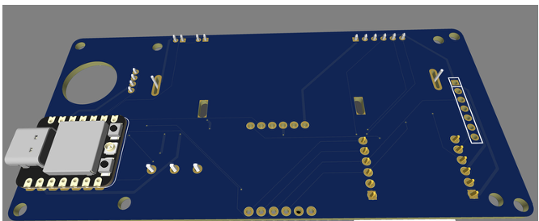
Config 1 : with lithium battery and w5500 in position 1
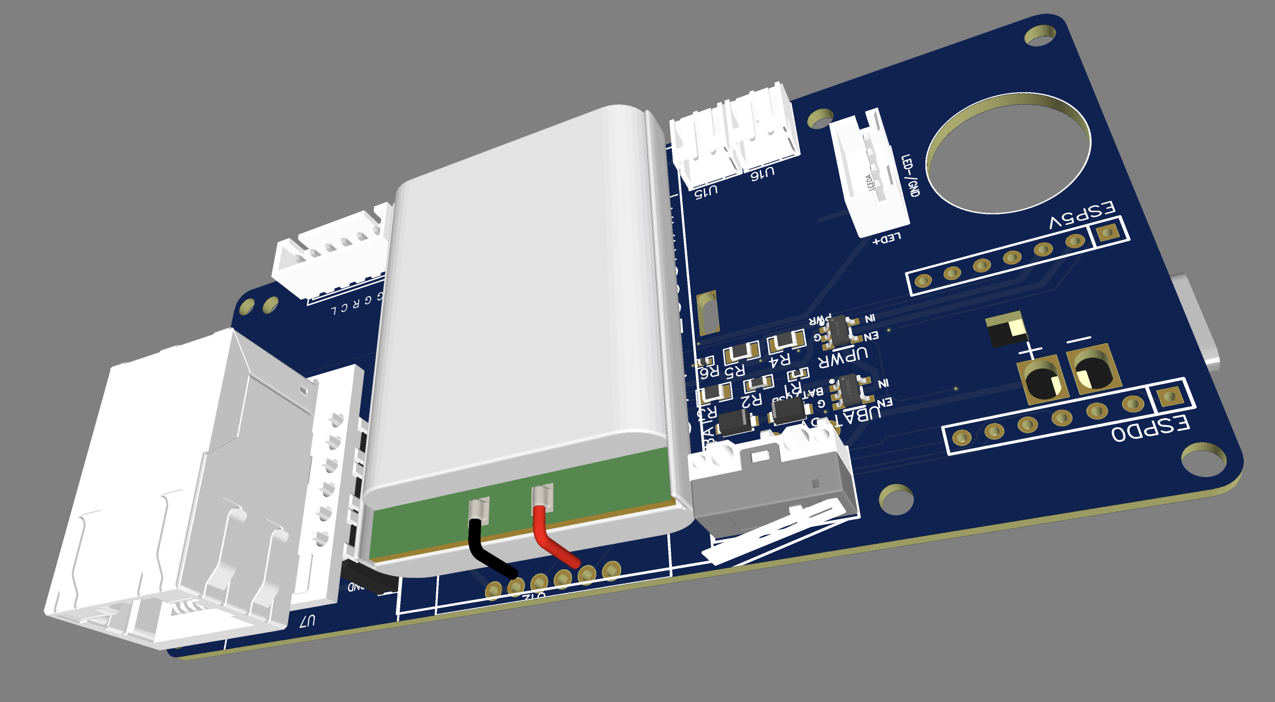
Config 2 : with 18650 battery and w5500 in position 2
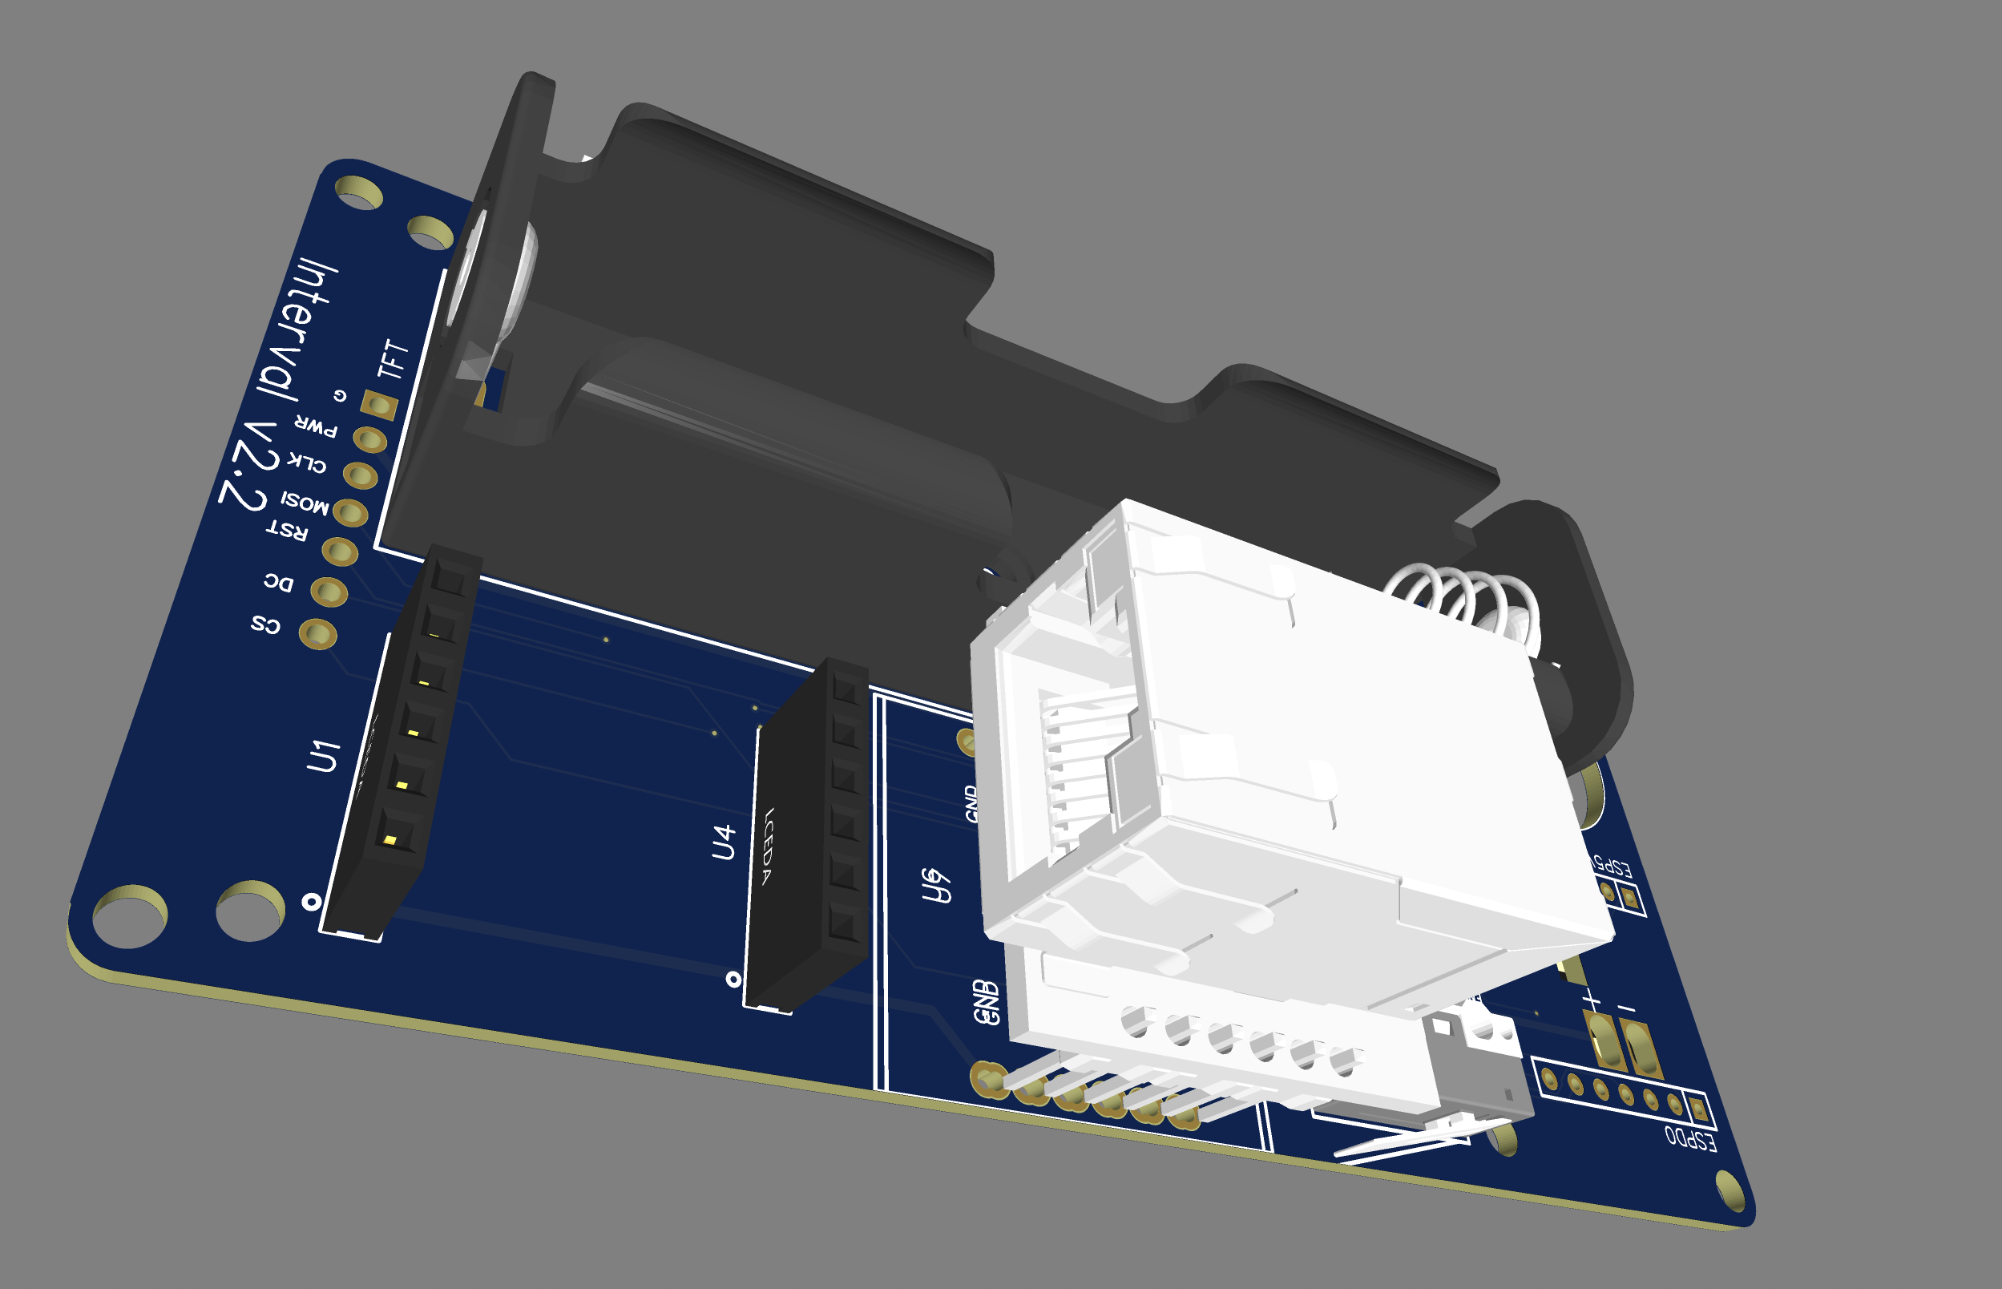
Picture of current proto :
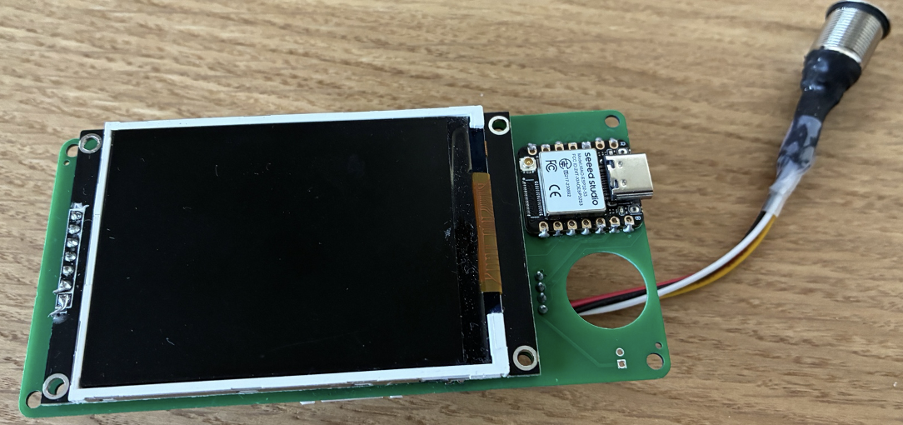
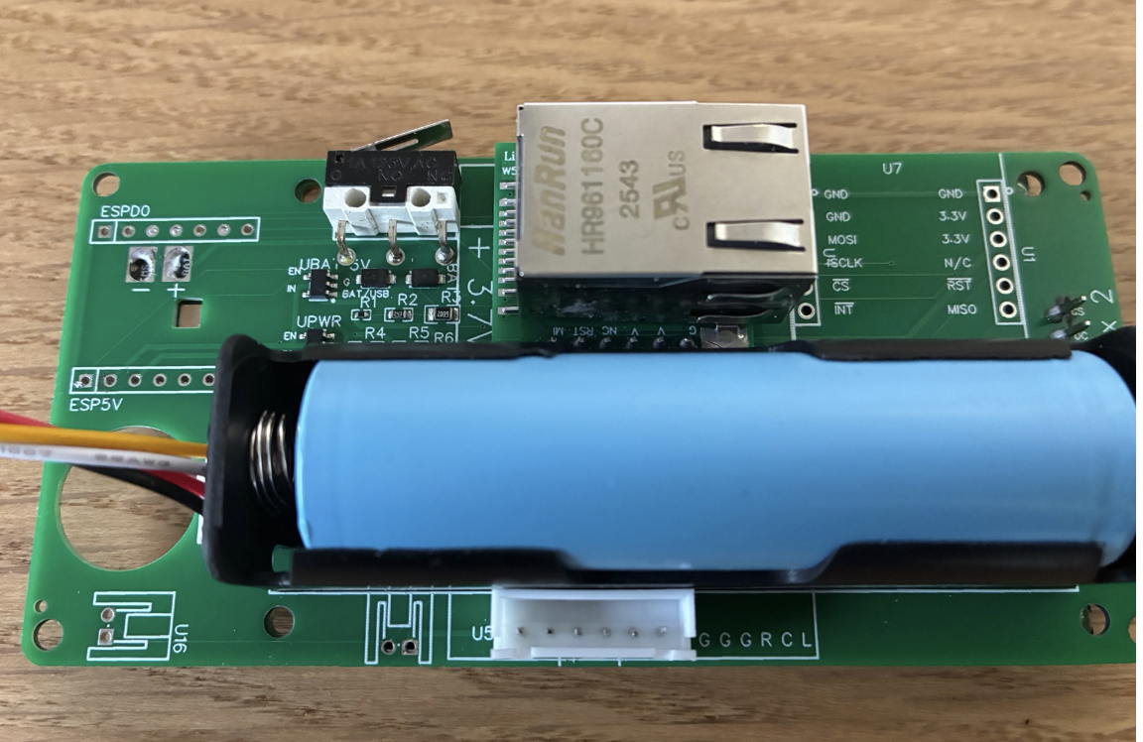
Scope of work
1. Recreate and improve the complete design in EasyEDA using the curent design as baseline
2. Work collaboratively in EasyEDA using shared project access and regular design reviews.
3. Use only standard components available from JLCPCB/LCSC so the PCB and components can be ordered directly through JLCPCB.
4. Review and improve the ground-plane strategy, power distribution, decoupling, return-current paths, reset and enable signals, SPI routing, signal integrity, floating inputs, capacitive coupling, protection, startup sequencing, manufacturability, and assembly reliability.
5. Produce a robust prototype suitable for direct JLCPCB assembly (see milestones)

Power :
The ESP32 integrates a PMS that allow charging battery (see https://wiki.seeedstudio.com/xiao_esp32s3_getting_started/)

you will have to check if 2 battery 103450 in parrallel this would safely manage the transition between USB and battery power and make sure the final PCB would be ready for electrical safety test (CE marking), same for 1 battery 18650.

The design should consider when the battery is close to its limit, (after certain time the deep sleep will suck all the battery), to prevent damaging the battery

Mechanical constraints
The following must remain compatible with the existing product and enclosure:
- PCB outline and dimensions.
- Mounting holes and hole locations.
- Battery position and dimensions. (2 possible configs)
- USB connector position.
- ESP32 module position.
- W5500 module/socket position. (2 possible configs)
- TFT connector and other major connector locations.
- Required clearances and enclosure interfaces.
- board able to support both configuration so when soldering component I choose which one to use
Components locked must not be moved. These are the mecanical constraints to be be fulfilled. The exception is that you cam move the U15 & U16 (battery connector) provided they can be easily accessible with some margina round to plug the cable

Component cost target
The total component cost must not exceed USD 10 per assembled PCB, excluding PCB fabrication and shipping. Any proposed component that threatens this target must be identified before approval.
the $10 limit does not include the ESP32 module, the W5500 module, and the TFT display, it is only apply to the base components soldered by JLCPCB.
The manufacturing, assembly and all major components are born by me (buying the W5500, TFT, etc…)

Required deliverables
- Complete EasyEDA schematic.
- Complete PCB layout.
- Production-ready Gerber files.
- JLCPCB/LCSC-compatible BOM.
- Pick-and-place/CPL files where applicable.
- Design notes explaining grounding, power, reset, and SPI improvements.
- ERC/DRC-clean project.
- Prototype ordered through JLCPCB.
- Bring-up and validation report.
- Recommendations for any remaining hardware improvements.

Acceptance criteria
The prototype must boot reliably from USB and battery power, initialize the ESP32, TFT, and W5500 reliably, maintain stable 3.3 V and ground references, pass repeated cold-start and power-cycle tests, preserve mechanical compatibility, use only JLCPCB/LCSC-sourced components, and remain within the USD 10 component-cost target. A « Diagnose » application demonstrate proper working.

Payment terms
A reasonable fee will be paid for the engineering work performed, including design and documented effort. Final payment will be released only after the EasyEDA design has been used to order and assemble a prototype that meets the agreed acceptance criteria.
Milestones:
- Q&A & kick off : session between the 2 of us during a teams, zoom or platform video tool (to avoid breaking rules) (mandatory + oral english is a must) where I show you the PCB , how it works and how to diagnose success, from that point in time we decide if we go ahead together or not.

- Initial design and schematic milestone : first delivered PCB/layout review milestone : payment released : 100€

- Prototype-order milestone : I take care of ordering the PCB from JLCPCB, test it and if it works, we reach milestone 4. In case the proposed design do not work, we go for a new iteration. Pay attention that one iteration may last for 3 to 4 weeks as it will include the elapsed time for manufacturing and delivering the prototype from china to Europe.
After 3 iteration each of us can decide unilateraly to continue or not, if one decide to stop, milestone 4 will not be paid but it allows to safely dis-engage from the project without penalties. A design delivery must not exceed 7 days. Payment released : 100€

- Final validation and acceptance milestone : payment released : 100€

