**NGO-Hub : CLIENT WEBAPP**

**Introduction**

The NGO-hub website is the platform for the NGOs to reduce their efforts in contacting volunteers and to expand their work areas and their service. It also helps the NGOs to post their work in this website. It also helps new volunteers to join new NGOs and serve more to the people. This website helps the NGOs to expand more and gives them a platform to serve more.

This webapp is the user-end of the NGO-hub webapp. This webapp facilitates the user to post their works through the content uploader form and send requests to the NGO webapp. If the NGO accepts the post the recent activity feed of the user gets updated.

**Design Interface**

The front end design is simple and user friendly. The index page is the login page where the user can login through either facebook account or google account. Once the user is logged in, the content uploader page gets opened where the user can upload the posts. This page also includes recent activity feed where it shows the previous posts uploaded by the user. If the user clicks on read more, the post gets opened and the user can see the full post. If the user wants to logout their session, there is a logout button in the profile icon.

**Software Development Tools**

The following software tools were used to develop this website:

* HTML, CSS, JAVASCRIPT , AJAX
* Notepad ++
* Semantic UI and Bootstrap

**Implementation**

At first the login page comes up where the user can login through either facebook or google account.

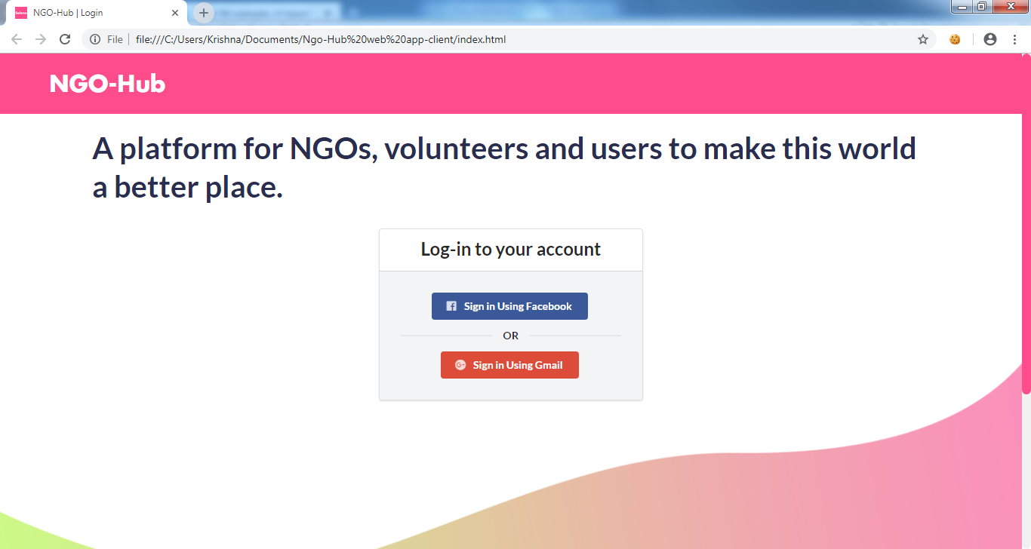

Fig. 1 : Login page

Now , After the user gets logged in the content uploader page with recent activity feed will be opened.

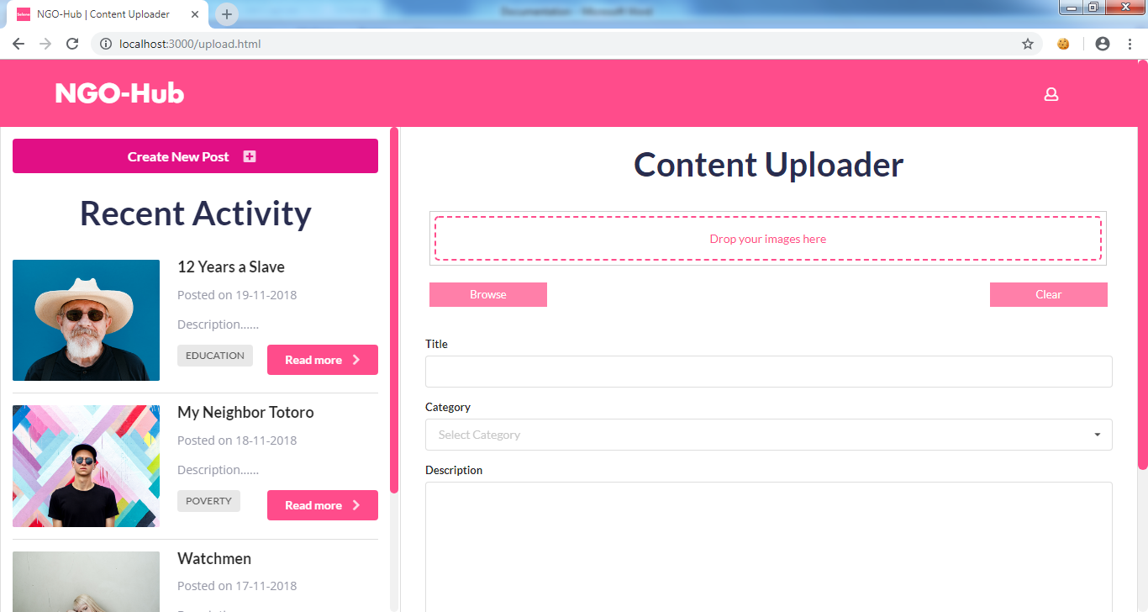

Fig. 2 : Content Uploader

When the user clicks on read more in the recent activity feed, the full post gets opened up.

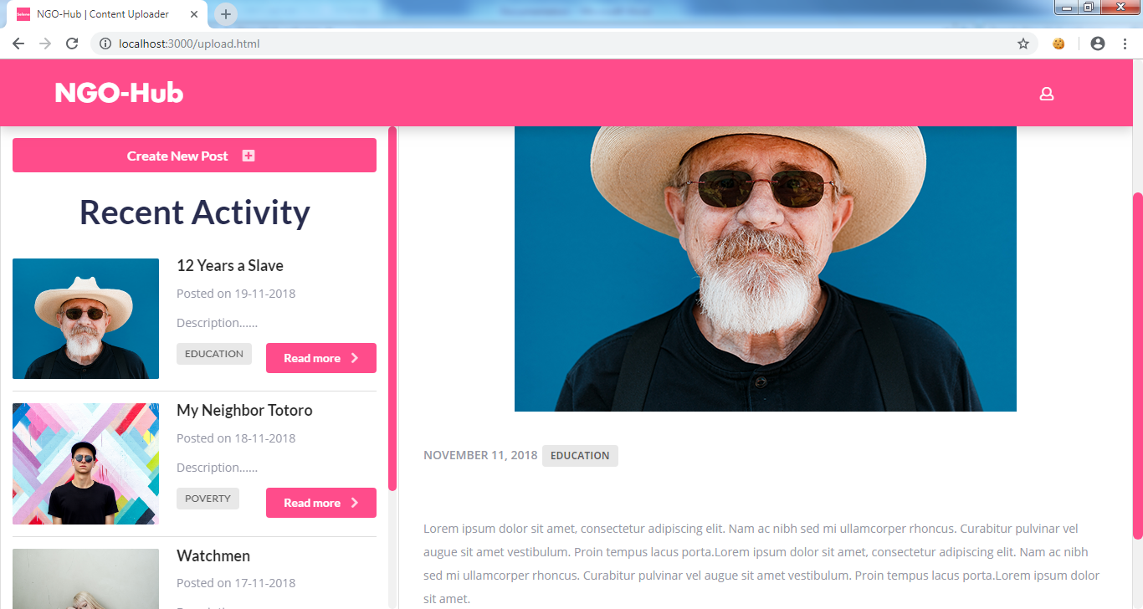

Fig.3 : Full post

**Conclusion**

The major goal of this client webapp is to post their works to the NGO and the backend of this webapp sends the posts to the NGO app. The NGO can either accept or reject the post if they found suitable. If the NGO accepts the post the recent activity feed of the client gets updated.