**NGO-Hub : NGO WEBAPP**

**Introduction**

The NGO-hub website is the platform for the NGOs to reduce their efforts in contacting volunteers and to expand their work areas and their service. It also helps the NGOs to post their work in this website. It also helps new volunteers to join new NGOs and serve more to the people. This website helps the NGOs to expand more and gives them a platform to serve more.

This webapp is for the NGOs. The NGOs can register their NGO in this app through the registration page. After registration they can see the request page in which they can accept or reject the posts uploaded by the client according to their preferences. They can also view their volunteers’ data like how many volunteers they have and their distribution in the form of graphs and charts. They can also reach out to their volunteers through the reach out section for their future works and serves and they can also reach out to external volunteers but for that they have to donate to the NGO-hub foundation. In the profile section they can update their details and see their details.

**Design Interface**

The front end design is simple and user friendly. The first page is the login page where the NGO can login if they are existing users and if they are new users they can click on register and the registration page will open up where the NGO can register their NGO in the NGO-hub. Then after log in or successful registration the request page opens up in which they can accept or reject the posts uploaded by the client according to their preferences. They can also view their volunteers’ data like how many volunteers they have and their distribution in the form of graphs and charts. They can also reach out to their volunteers through the reach out section for their future works and serves and they can also reach out to external volunteers but for that they have to donate to the NGO-hub foundation. In the profile section they can update their details and see their details.

**Software Development Tools**

The following software tools were used to develop this website:

* HTML, CSS, JAVASCRIPT , AJAX , PHP
* Notepad ++
* Semantic UI and Bootstrap

**Implementation**

At first the login page comes up where the NGO can login if they are existing users.

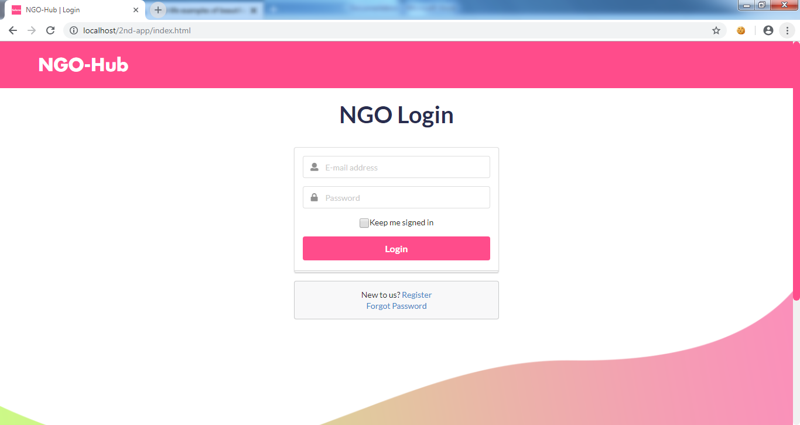

Fig. 1 : Login page

Now , If the NGO isn’t the existing users of the NGO-hub then they can register through the registration page.

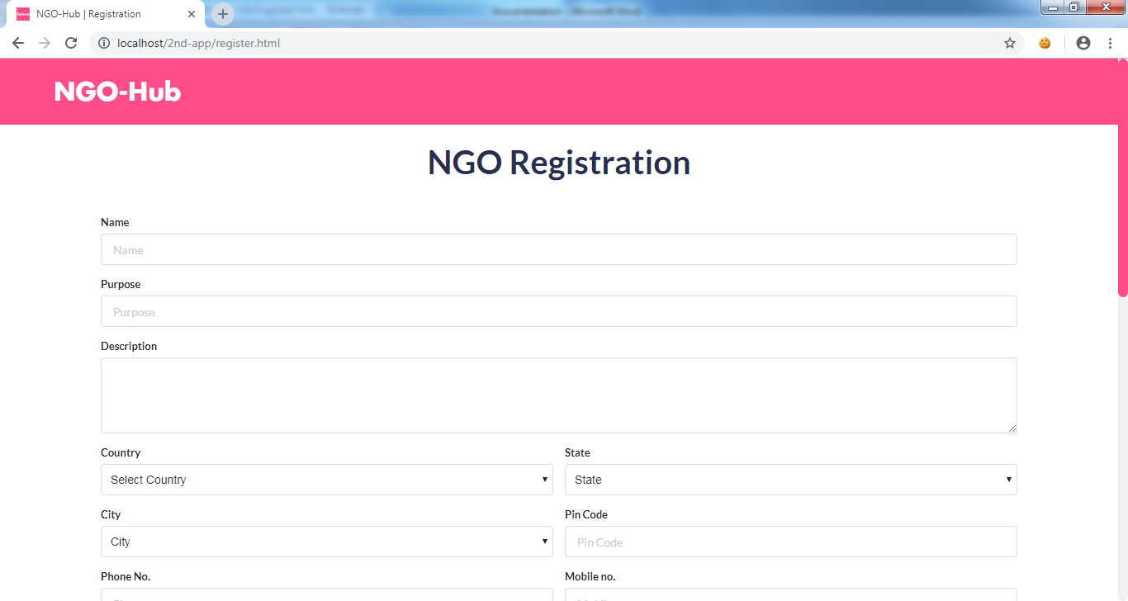

Fig. 2 : Registration

After successful registration or log in the request page opens up where the NGO approve or reject the posts uploaded by client app.

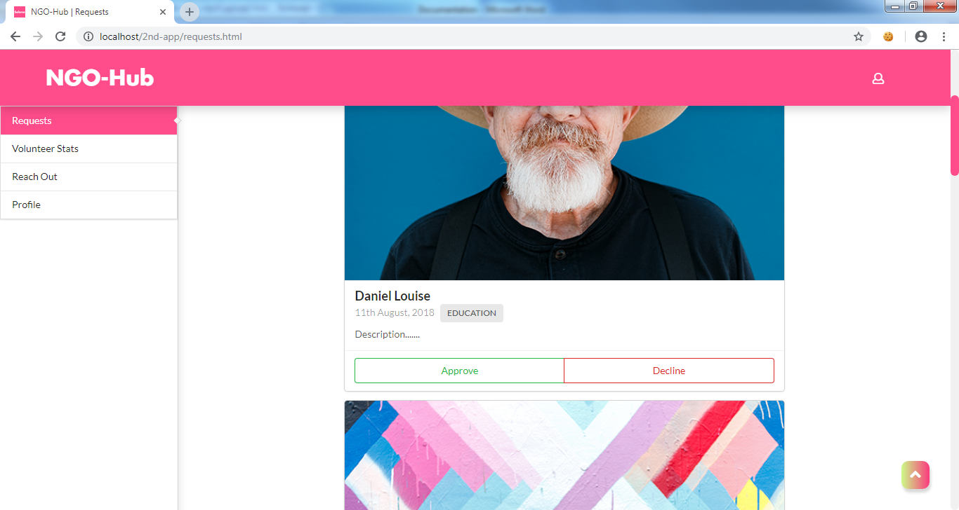

Fig.3 : Request Page

If the user clicks on volunteer stats tab it shows the volunteers data of the NGO.

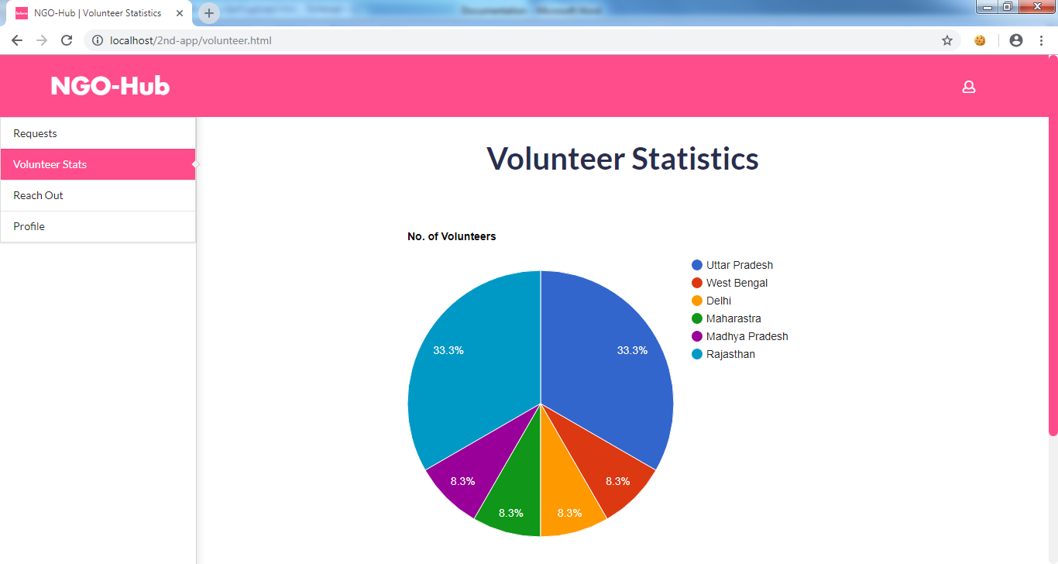

Fig.4 : Volunteer Stats

If the user clicks on reach out tab, in this NGO can send messages and contact to their volunteers and the volunteers gets filtered through the region and the tags they choose.

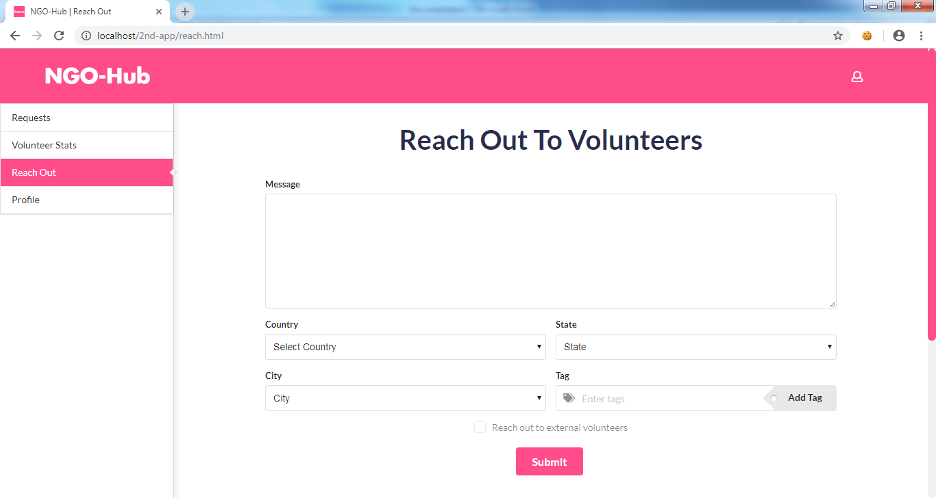

Fig. 5 : Reach out to Volunteers

The profile tab shows the details of the NGO and they can update their additional details.

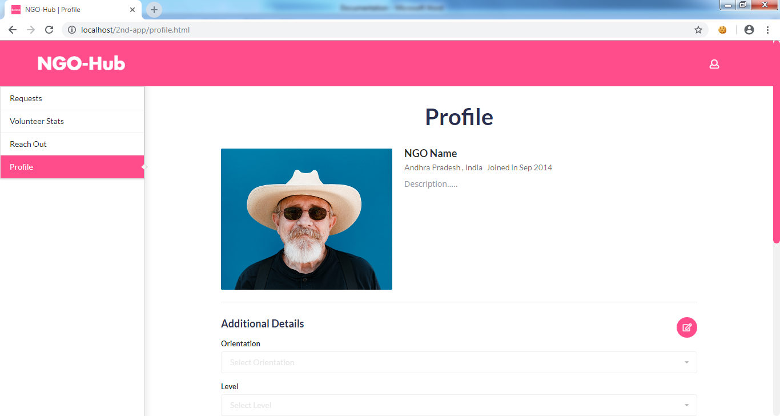

Fig. 6 : Profile page

**Conclusion**

The major goal of this NGO webapp is to approve or reject the post uploaded by the clients and contacting to their volunteers for their future works and service. They can also reach out to external volunteers if they need more volunteers for their work by donating to the NGO-hub foundation. They can also update their fund details in the profile page to activate donation.