**Framework Documentation**

**What are frameworks?**

* A framework is an application or system foundation that is pre-built and used by developers to build applications or systems more quickly.
* It offers a collection of standardized tools, libraries, and protocols that, by providing reusable parts and fixes for frequent issues, aid in streamlining development.
* Note: Software frameworks are typically associated with specific programming languages. They're also appropriate for various tasks depending on the situation.

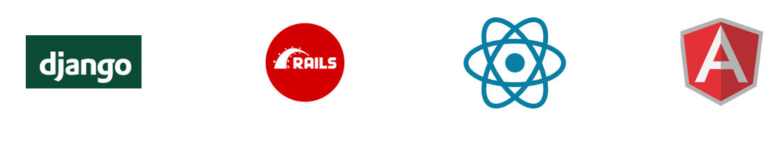

**Why do we need one?**

1. Efficiency and Speed

* Code Reusability: Frameworks provide pre-built components, tools, and libraries that developers can reuse, reducing the amount of code they have to write from scratch.
* Faster Development: With frameworks, common tasks (like database access, session management, or form handling) are automated or simplified. This speeds up the development process, allowing developers to focus on business logic rather than low-level implementation details.

1. Scalability
   * Modular Design: Frameworks are designed to handle the growth of applications. They provide the structure to easily add new features, modules, or even scale the application to handle more users.
   * Performance Optimization: Many frameworks come optimized for performance, allowing applications to run efficiently even as they scale up.
2. Cross-Platform Development
   1. Frameworks enable cross-platform development, meaning the same code can run on multiple platforms (e.g., web, mobile, or desktop) with minimal changes. This is especially important for mobile app development, where frameworks like React Native or Flutter allow developers to create apps for both Android and iOS using the same codebase.

What does framework a consist of?

* **Libraries**: Provides a set of reusable code for performing common tasks (e.g., handling HTTP requests, working with databases, managing sessions).
* **Tools**: Often comes with command-line tools or integrated development environments (IDEs) for tasks like generating boilerplate code, running tests, or deploying applications.
* **Testing**: Built-in tools or support for writing and running tests to ensure code quality.

Advantages of creating a framework?

1. Tailored to Specific Needs

* Custom Solutions: A custom framework can be designed to fit the exact requirements of a particular project or a set of projects. You can avoid the overhead and unnecessary features that come with generic frameworks and build only what you need.
* Optimization for Specific Use Cases: You can optimize performance, security, and scalability for your specific use cases, focusing on the most important features without the bloat of additional, unused components.

1. Reduced Learning Curve for Internal Teams

* Familiarity: If a team is involved in creating the framework, they will already be familiar with its architecture, design patterns, and core principles, reducing the time required to onboard new team members and ensuring smoother development.
* Consistency Across Projects: A custom framework can ensure that all projects in an organization follow the same structure, conventions, and best practices, making it easier for developers to switch between projects.

1. Reuse Across Projects

* Internal Reusability: Once built, a custom framework can be reused across multiple projects, saving time and effort on new initiatives and reducing the need to reinvent solutions for common problems.
* Scalability Across Teams: If your organization is working on multiple projects with similar needs, a custom framework can scale across teams and projects, ensuring consistency in development practices and reducing duplication of efforts.