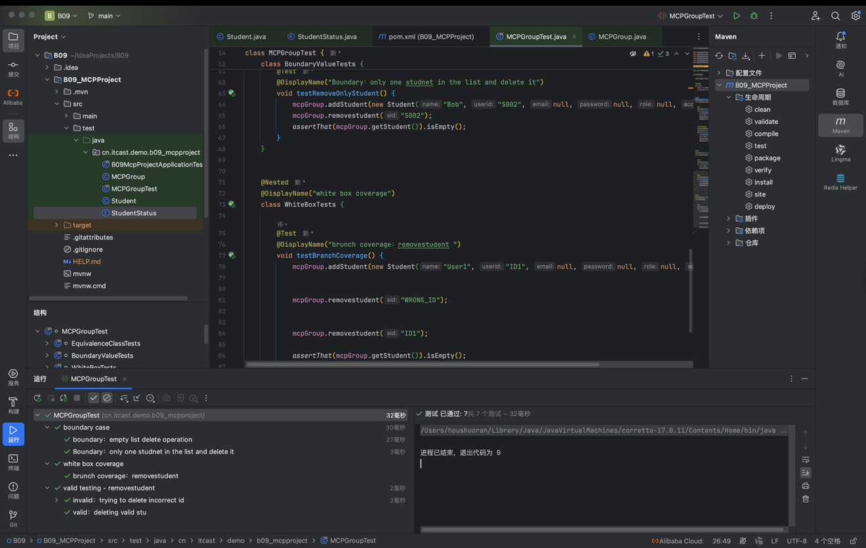1. Fundamental Testing Strategy
- Unit Testing: We performed unit testing, which is the process of testing a single program or function in isolation. For this project, the "unit" is the MCPGroup class.
- Test Oracles: We used JUnit assertions as a test oracle to determine the expected output for each input, comparing actual results with the requirements specification.
- Test Automation: The testing process was automated to execute test cases, compare results, and generate reports efficiently.
2. Black-box Testing (Functional Testing)
This method generates test cases based on the requirements specification rather than the source code.
- Equivalence-Class Testing:
The input domain for removestudent(String sid) was divided into disjoint sub-domains.
Valid Equivalence Class: A student ID that exists in the current group (e.g., "S001").
Invalid Equivalence Class: A student ID that does not exist in the group or is an empty string.
- Boundary Value Testing:
We focused on values near the borders of the input domain to catch errors where single keying mistakes might occur.
Case 1 (Empty List): Testing the system's behavior when trying to remove a student from a list with 0 elements.
Case 2 (Single Element): Testing a list with exactly one student to ensure the removal logic handles the minimum non-empty state correctly.
3. White-box Testing
This method generates test cases based on the internal source code and logic of the software.
- Branch Testing:
The objective was to ensure that every branch in the code is executed at least once.
In the removestudent method, we covered the branch where the userid.equals(sid) condition is True (student found and removed) and the branch where it is False (no match found).
- Statement Testing:
We ensured that every statement within the MCPGroup methods (like adding or getting students) was executed at least once.
4. Verification and Validation (V & V)
- Verification: We checked if the system met the specifications (e.g., does addStudent return a boolean as specified?).
- Validation: We ensured the system met the user's requirements (e.g., does it actually help a user manage a group of students as expected?).

