**Credit Card Management System Modules**

Integration of the following modules constitutes the overall system

**Modules:**

* Credit Card Application Submission
* Credit Card Application Enquiry Screen
* Credit Card Application Decisioning
* Report – Application Summary
* Report – User List Extraction for Auditing
* User Maintenance (New User, Modify User, Access Rights)
* General System Configuration
* Product Setup

**Credit Card Application Submission**

This module is accessed by Sales & Operation team to perform data entry of the customer credit card application form. Other users cannot access this screen. Once the application is submitted it will generate a reference number and application gets processing immediately. Those application already submitted can be searched using **Enquiry Screen** to get the current application status and to refer the details.

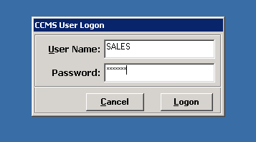

Fig 1. Login Screen – Menu access will get vary based on user rights

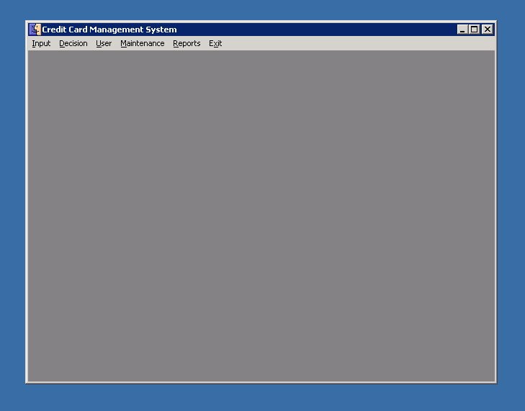Fig 2. Main Screen – menu access based on user rights only

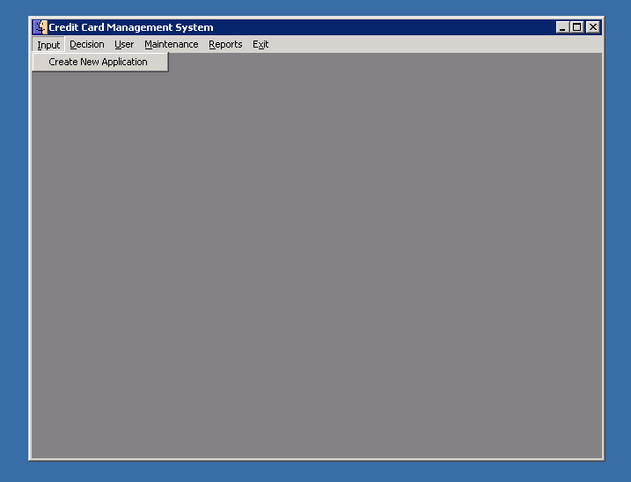

Fig 3. Menu – New Credit Card Application Submission

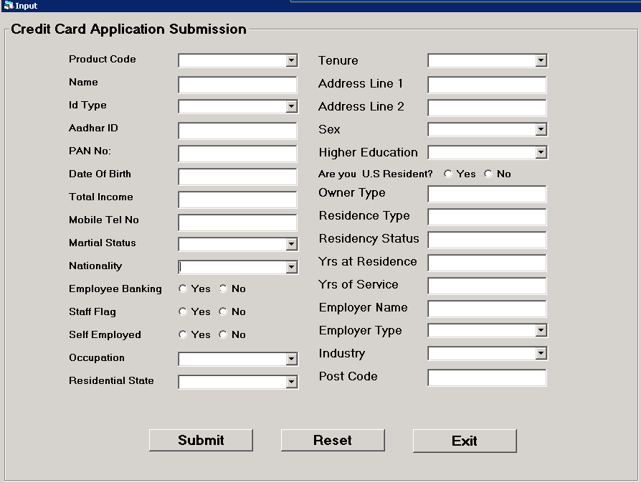

Fig 4. Credit Card Application Submission Form

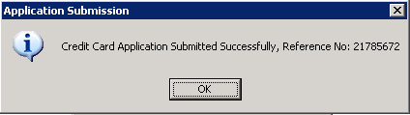

Fig 5. Submission Confirmation with Reference No

**Credit Card Application Decisioning**

This module is accessed only by Credit Approver team to perform final decision on the credit card application. Other users cannot access this screen. Once the application is submitted, system will perform recommendation to that application based on pre-defined business rules set in the system. If the application is not outright rejected due to various checks, then it will be listed in the Approver Queue for final recommendation to either approve or reject the application. Once decision is made, the application will move of the approver queue.

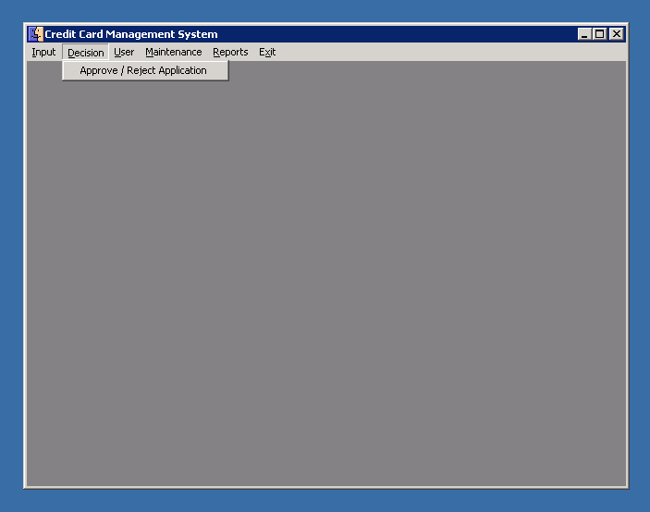

Fig 6. Menu – Approve / Reject Applications

**Reports**

This module can be accessed by all users. This module includes,

* Report to extract all the submitted application based on filter condition with start and end dates
* Report to extract all the users exist in the system for admin management & for auditing.

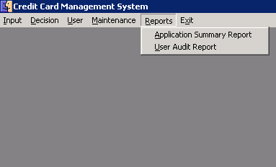

**User Maintenance**

This module is only for users who having administrator access. Other users cannot access to this screen.

This module includes,

* New User Creation with access rights as Sales or Approver or Admin as per request.
* Existing User modification like name, designation, access rights.
* Deleting User Accounts if not needed.
* Password Reset for users.
* Verify password of users to troubleshoot login issues.

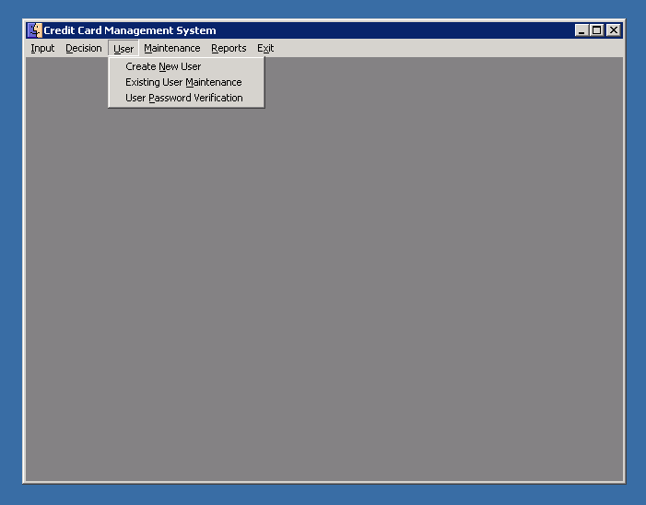

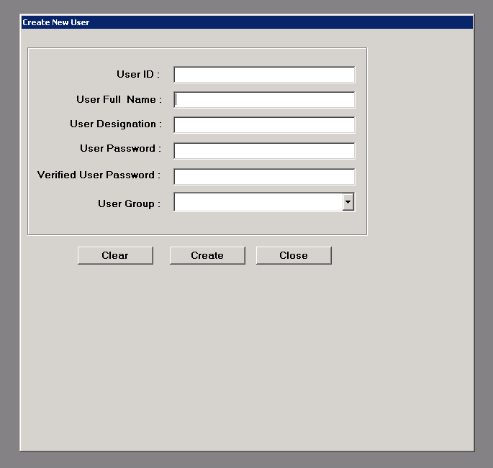

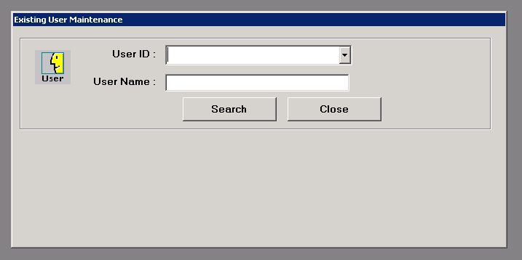

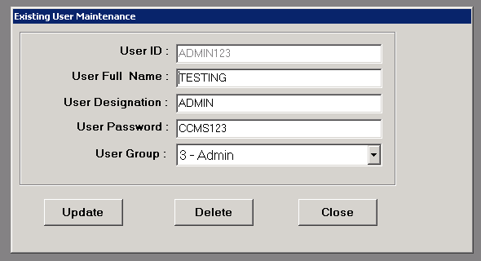

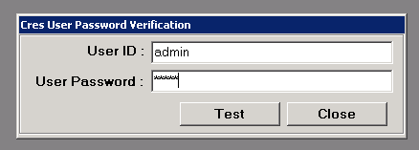

**Maintenance & Product Setup**

This module is only for users who having administrator access. Other users cannot access to this screen.

This module includes,

* General System Level Parameter Setup
* Product Maintenance (Add, Edit, Delete – new products)

