1. import numpy as np
3. ## Integral module from comphy209 github
4. from gaussQuad2 import *
5. from triangleQuad import *
7. ## Problem 1
9. print("\n #### Problem 1. ####")
11. def printIntegral(f,xs,ys,m=5):
12. gauss = gaussQuad2(f,xs,ys,m)
13. triangle = triangleQuad(f,xs[:2]+xs[3:4],ys[:2]+ys[3:4])\
14. + triangleQuad(f,xs[1:4],ys[1:4])
15. print(" Gauss Integral ",gauss)
16. print(" Triangle Integral ",triangle)
17. return gauss, triangle
19. print(" 1) f(x,y) = (1 - x^2)(1 - y^2)")
20. f = lambda x,y:(1 - x**2)*(1 - y**2)
21. printIntegral(f,[-1, 1, 1,-1],[-1,-1, 1, 1])
23. print("\n 2) f(x,y) = x^2 y^2")
24. f = lambda x,y:x**2*y**2
25. printIntegral(f,[0,3,3,0],[0,0,2,2])
27. print("\n 3) f(x,y) = exp(-(x^2+y^2))")
28. f = lambda x,y:np.exp(-(x**2+y**2))
29. printIntegral(f,[-1, 1, 1,-1],[-1,-1, 1, 1])
31. print("\n 4) f(x,y) = cos(pi(x-y)/2")
32. f = lambda x,y:np.cos(np.pi*(x-y)/2)
33. printIntegral(f,[-1, 1, 1,-1],[-1,-1, 1, 1])

36. ## Problem 2
37. print("\n\n #### Problem 2. ####")
38. f = lambda x,y:x
39. printIntegral(f,[-1, 1, 4, 0],[ 0, 0, 4, 4])

42. ## Problem 3
43. print("\n\n #### Problem 3. ####")
44. f = lambda x,y:x**2
45. printIntegral(f,[ 0, 3, 0, 0],[-2, 0, 4, 4])
47. ## Problem 4
48. print("\n\n #### Problem 4. ####")
50. xs = [-3, 1, 3,-1]; ys = [-2,-2, 2, 2]
52. print(" 1) f(x,y) = (2 - x^2)(2 - x*y)")
53. f = lambda x,y:(2-x**2)*(2-x*y)
54. printIntegral(f,xs,ys)
56. print("\n 2) f(x,y) = xy exp(-x^2)")
57. f = lambda x,y:x*y*np.exp(-x**2)
58. printIntegral(f,xs,ys)

out

|  |
| --- |
| #### Problem 1. ####  1) f(x,y) = (1 - x^2)(1 - y^2)  Gauss Integral 1.777777777728277  Triangle Integral 1.6355555555555554  2) f(x,y) = x^2 y^2  Gauss Integral 23.999999999392585  Triangle Integral 23.520000000000014  3) f(x,y) = exp(-(x^2+y^2))  Gauss Integral 2.2310319079502987  Triangle Integral 2.005408235168953  4) f(x,y) = cos(pi(x-y)/2  Gauss Integral 1.6211391170197167  Triangle Integral 1.1209041432289477  #### Problem 2. ####  Gauss Integral 13.333333332986866  Triangle Integral 13.333333333333336  #### Problem 3. ####  Gauss Integral 13.499999999664036  Triangle Integral 13.5  #### Problem 4. ####  1) f(x,y) = (2 - x^2)(2 - x*y)  Gauss Integral 38.39999999906208  Triangle Integral 38.39999999999999  2) f(x,y) = xy exp(-x^2)  Gauss Integral 0.3952044648231357  Triangle Integral -0.8070124608470459 |

I made function printIntegral

It print results of gauss-legendre integral and triangle integral

1. def printIntegral(f,xs,ys,m=5):
2. gauss = gaussQuad2(f,xs,ys,m)
3. triangle = triangleQuad(f,xs[:2]+xs[3:4],ys[:2]+ys[3:4])\
4. + triangleQuad(f,xs[1:4],ys[1:4])
5. print(" Gauss Integral ",gauss)
6. print(" Triangle Integral ",triangle)
7. return gauss, triangle

In problem 1., gauss-legendre integral is larger than triangle integral.

but In other problem, gauss-legendre integral and triangle integral is same.

Because triangle integral not evaluate value of diagonal of integrate range.

#### problem 2 ####

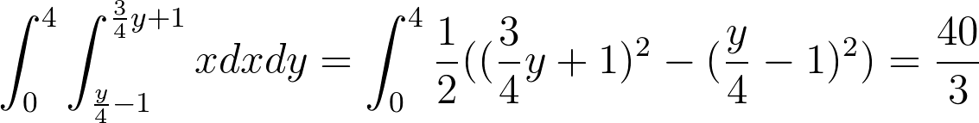

40/3 = 13.3333…

Gauss Integral 13.333333332986866

Triangle Integral 13.333333333333336

#### problem 3 ####

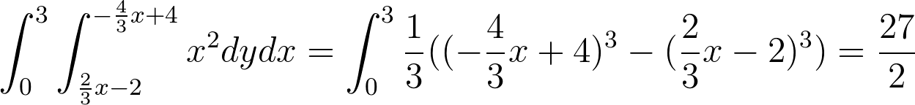

27/5 = 13.5

Gauss Integral 13.499999999664036

Triangle Integral 13.5