Project

2017550029 최효규

3. Dynamics of multiple particles interacting

1-D collision

1. import numpy as np
2. import matplotlib.pyplot as plt
4. ## distance of 2-D
5. ## x = [ x, x', y, y']
6. ## distance(particle 1,particle 2) = ( (x1-x2)^2 + (y1-y2)^2 )^0.5
7. distance = lambda x1,x2:((x1[0]-x2[0])**2+(x1[2]-x2[2])**2)**0.5
9. ## x = [ x, x', y, y']
10. ## F = dx/dt = [ v_x, a_x, v_y, a_y ]
11. def F(t,x):
12. g = -9.8 # m/sec^2
13. F = np.zeros(4)
14. F[0] = x[1]
15. F[1] = 0
16. F[2] = x[3]
17. F[3] = g
18. return F
20. ## using runge-kutta method
21. def integrate(F,tStart,x_init,tStop,h):
22. def dx(F,t,x,h):
23. k0 = h*F(t,x)
24. k1 = h*F(t+h/2.0,x+k0/2.0)
25. k2 = h*F(t+h/2.0,x+k1/2.0)
26. k3 = h*F(t+h,x+k2)
27. return (k0 + 2.0*k1 + 2.0*k2 + k3)/6.0
28. n = len(x_init)
29. t = tStart
30. x = x_init
31. ts = []
32. ts.append(t)
33. xs = []
34. for i in range(n):
35. xs.append([])
36. xs[i].append(x[i])
37. while t < tStop:
38. # collision test
39. for i in range(n):
40. for j in range(i+1,n):
41. if distance(x[i],x[j]) < d:
42. temp = x[i][1]; x[i][1] = x[j][1]; x[j][1] = temp
43. for i in range(n):
44. x[i] = x[i] + dx(F,t,x[i],h)
45. xs[i].append(x[i])
46. t = t + h
47. ts.append(t)
48. for i in range(n):
49. xs[i] = np.array(xs[i])
50. return np.array(ts),xs
52. d = 1.0e-03
53. h = 0.01
55. x0 = np.array([1.5,-0.5,0.0,9.8])
56. x1 = np.array([-1 ,2 ,9.8,0.0])
57. x2 = np.array([0.5,-1 ,9.8,0.0])
58. x3 = np.array([6.4599999999,-5 ,2.499,4.9])
59. x_init = [x0,x1,x2,x3]
61. ts, xs = integrate(F,0.0,x_init,2.0,h)
63. legend = []
64. for i in range(len(xs)):
65. plt.plot(xs[i][:,0],xs[i][:,2],'-')
66. legend.append('particle '+str(i))
68. plt.legend(legend)
70. plt.grid()
71. plt.show()

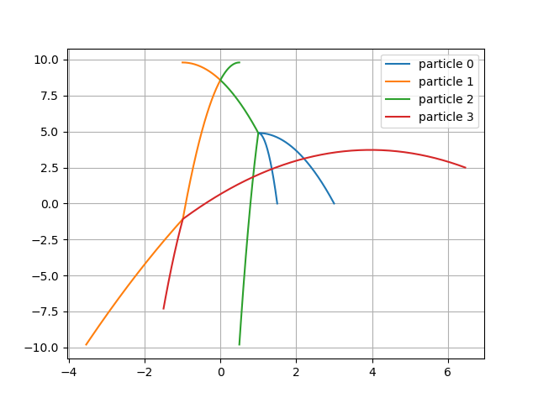

Integrate function.

if x1 collide with x2, v1_xf = v2_xi, v2_xf = v1_xi. ( Momentum, Kinetic Energy conservation, e = 1.0 )

1. ## using runge-kutta method
2. def integrate(F,tStart,x_init,tStop,h):
3. def dx(F,t,x,h):
4. k0 = h*F(t,x)
5. k1 = h*F(t+h/2.0,x+k0/2.0)
6. k2 = h*F(t+h/2.0,x+k1/2.0)
7. k3 = h*F(t+h,x+k2)
8. return (k0 + 2.0*k1 + 2.0*k2 + k3)/6.0
9. n = len(x_init)
10. t = tStart
11. x = x_init
12. ts = []
13. ts.append(t)
14. xs = []
15. for i in range(n):
16. xs.append([])
17. xs[i].append(x[i])
18. while t < tStop:
19. # collision test
20. for i in range(n):
21. for j in range(i+1,n):
22. if distance(x[i],x[j]) < d:
23. temp = x[i][1]; x[i][1] = x[j][1]; x[j][1] = temp
24. for i in range(n):
25. x[i] = x[i] + dx(F,t,x[i],h)
26. xs[i].append(x[i])
27. t = t + h
28. ts.append(t)
29. for i in range(n):
30. xs[i] = np.array(xs[i])
31. return np.array(ts),xs

2-D collision

1. import numpy as np
2. import matplotlib.pyplot as plt
4. ## distance of 2-D
5. ## x = [ x, x', y, y']
6. ## distance(particle 1,particle 2) = ( (x1-x2)^2 + (y1-y2)^2 )^0.5
7. distance = lambda x1,x2:((x1[0]-x2[0])**2+(x1[2]-x2[2])**2)**0.5
9. ## x = [ x, x', y, y']
10. ## F = dx/dt = [ v_x, a_x, v_y, a_y ]
11. def F(t,x):
12. F = np.zeros(4)
13. F[0] = x[1]
14. F[1] = 0
15. F[2] = x[3]
16. F[3] = 0
17. return F
19. ## runge-kutta methon in many body problem
20. def integrate(F,tStart,x_init,tStop,h):
21. def dx(F,t,x,h):
22. k0 = h*F(t,x)
23. k1 = h*F(t+h/2.0,x+k0/2.0)
24. k2 = h*F(t+h/2.0,x+k1/2.0)
25. k3 = h*F(t+h,x+k2)
26. return (k0 + 2.0*k1 + 2.0*k2 + k3)/6.0
27. n = len(x_init)
28. t = tStart
29. x = x_init
30. E = energy(x)
31. Es = []
32. Es.append(E)
33. ts = []
34. ts.append(t)
35. xs = []
36. for i in range(n):
37. xs.append([])
38. xs[i].append(x[i])
39. while t < tStop:
40. # collision test
41. for i in range(n):
42. if x[i][0] < -2 or x[i][0] > 2: x[i][1] = -x[i][1]
43. if x[i][2] < -2 or x[i][2] > 2: x[i][3] = -x[i][3]
44. for j in range(i+1,n):
45. if distance(x[i],x[j]) < d:
46. collision(x[i],x[j],e)
47. for i in range(n):
48. x[i] = x[i] + dx(F,t,x[i],h)
49. xs[i].append(x[i])
50. E = energy(x)
51. Es.append(E)
52. t = t + h
53. ts.append(t)
54. for i in range(n):
55. xs[i] = np.array(xs[i])
56. return np.array(ts),xs,np.array(Es)
58. ## 2-D collision
59. ## e is coefficient of restitution
60. ## p = [ x, x', y, y']
61. def collision(p1,p2,e):
62. tan = (p2[2] - p1[2])/(p2[0] - p1[0])
63. cos = 1/(tan**2+1)**0.5
64. sin = (1-cos**2)**0.5
66. u1 = p1.copy()
67. u2 = p2.copy()
69. p1[1] = e*((u2[1]*cos*cos - u2[3]*sin*cos) + u1[1]*sin*sin + u1[3]*sin*cos)
70. p1[3] = e*(u1[1]*sin*cos + u1[3]*cos*cos - (u2[1]*sin*cos - u2[3]*sin*sin))
72. p2[1] = e*((u1[1]*cos*cos - u1[3]*sin*cos) + u2[1]*sin*sin + u2[3]*sin*cos)
73. p2[3] = e*(u2[1]*sin*cos + u2[3]*cos*cos - (u1[1]*sin*cos - u1[3]*sin*sin))
74. return 0
76. e = 1.0 # elastic collision
77. d = 5.0e-02 # (radius * 2) of particle
78. h = 0.01 # time interval
79. n = 10 # count of particles
81. ## Calculate total Kinetic Energy
82. def energy(x):
83. E_tot = 0
84. for i in range(len(x)):
85. E_tot = E_tot + (x[i][1]**2 + x[i][3]**2)/2
86. return E_tot
88. ## Initial condition of particles
89. from random import random
90. x_init = []
91. for i in range(n):
92. x_init.append(np.array([(random()-0.5)*4,(random()-0.5)*4,(random()-0.5)*4,(random()-0.5)*4]))
94. ## Plot Energy graph
95. ## e = 1.0, 0.75, 0.5, 0.25
96. legend = []
97. for i in [1,0.75,0.5,0.25]:
98. e = i
99. legend.append('e = '+str(e))
100. x = x_init.copy()
101. ts, xs, Es = integrate(F,0.0,x,100.0,h)
102. plt.plot(ts,Es,'-')
104. plt.legend(legend)
105. plt.grid()
106. plt.savefig('n-body_energy.png')
107. plt.close()
109. ## Plot orbitals of particles graph
110. ## Elastic collision, e = 1
111. legend = []
112. for i in range(len(xs)):
113. plt.plot(xs[i][:,0],xs[i][:,2],'-')
114. if range(len(xs)<6): legend.append('particle '+str(i))
116. plt.legend(legend)
117. plt.grid()
118. plt.savefig('n-body_orbit.png')

 n-body_energy.png

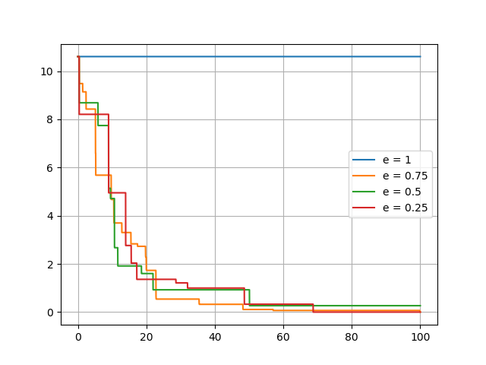

n-body_orbit.png

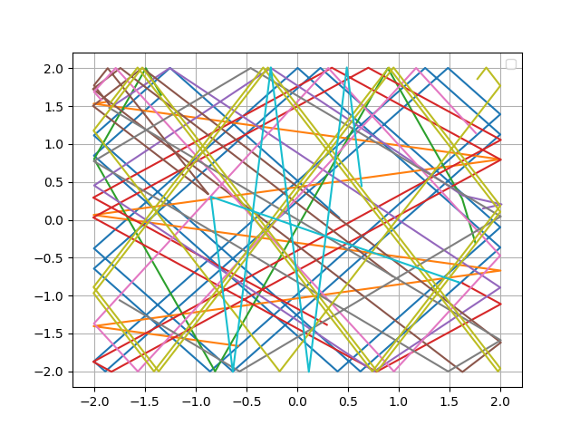

2-D collision function in integrate

1. ## 2-D collision
2. ## e is coefficient of restitution
3. ## p = [ x, x', y, y']
4. def collision(p1,p2,e):
5. tan = (p2[2] - p1[2])/(p2[0] - p1[0])
6. cos = 1/(tan**2+1)**0.5
7. sin = (1-cos**2)**0.5
9. u1 = p1.copy()
10. u2 = p2.copy()
12. p1[1] = e*((u2[1]*cos*cos - u2[3]*sin*cos) + u1[1]*sin*sin + u1[3]*sin*cos)
13. p1[3] = e*(u1[1]*sin*cos + u1[3]*cos*cos - (u2[1]*sin*cos - u2[3]*sin*sin))
15. p2[1] = e*((u1[1]*cos*cos - u1[3]*sin*cos) + u2[1]*sin*sin + u2[3]*sin*cos)
16. p2[3] = e*(u2[1]*sin*cos + u2[3]*cos*cos - (u1[1]*sin*cos - u1[3]*sin*sin))
17. return 0

use rotate matrix to calculate.

Visualizing 2-D collision. (OpenGL)

1. import numpy as np
2. from time import time
3. from sys import exit
5. ## distance of 2-D
6. ## x = [ x, x', y, y']
7. ## distance(particle 1,particle 2) = ( (x1-x2)^2 + (y1-y2)^2 )^0.5
8. distance = lambda x1,x2:((x1[0]-x2[0])**2+(x1[2]-x2[2])**2)**0.5
10. ## x = [ x, x', y, y']
11. ## F = dx/dt = [ v_x, a_x, v_y, a_y ]
12. def F(t,x):
13. g = -9.8 # m/sec^2
14. F = np.zeros(4)
15. F[0] = x[1]
16. F[1] = 0
17. F[2] = x[3]
18. F[3] = 0
19. return F
21. ## runge-kutta methon in many body problem
22. def integrate(F,t,x,h):
23. def dx(F,t,x,h):
24. k0 = h*F(t,x)
25. k1 = h*F(t+h/2.0,x+k0/2.0)
26. k2 = h*F(t+h/2.0,x+k1/2.0)
27. k3 = h*F(t+h,x+k2)
28. return (k0 + 2.0*k1 + 2.0*k2 + k3)/6.0
29. n = len(x_init)
30. # collision test
31. for i in range(n):
32. if x[i][0] < -2 or x[i][0] > 2:
33. x[i][1] = -x[i][1]
34. if x[i][0] < -2: x[i][0] = -2
35. else: x[i][0] = 2
36. if x[i][2] < -2 or x[i][2] > 2:
37. x[i][3] = -x[i][3]
38. if x[i][2] < -2: x[i][2] = -2
39. else: x[i][2] = 2
40. for j in range(i+1,n):
41. if distance(x[i],x[j]) < d:
42. collision(x[i],x[j],e)
43. for i in range(n):
44. x[i] = x[i] + dx(F,t,x[i],h)
46. ## 2-D collision
47. ## e is coefficient of restitution
48. ## p = [ x, x', y, y']
49. def collision(p1,p2,e):
50. tan = (p2[2] - p1[2])/(p2[0] - p1[0])
51. cos = 1/(tan**2+1)**0.5
52. sin = (1-cos**2)**0.5
54. u1 = p1.copy()
55. u2 = p2.copy()
57. p1[1] = e*((u2[1]*cos*cos - u2[3]*sin*cos) + u1[1]*sin*sin + u1[3]*sin*cos)
58. p1[3] = e*(u1[1]*sin*cos + u1[3]*cos*cos - (u2[1]*sin*cos - u2[3]*sin*sin))
60. p2[1] = e*((u1[1]*cos*cos - u1[3]*sin*cos) + u2[1]*sin*sin + u2[3]*sin*cos)
61. p2[3] = e*(u2[1]*sin*cos + u2[3]*cos*cos - (u1[1]*sin*cos - u1[3]*sin*sin))
62. return 0
64. e = 1.0 # elastic collision
65. d = 5.0e-02
66. h = 0.01
68. def energy(x):
69. E_tot = 0
70. for i in range(len(x)):
71. E_tot = E_tot + (x[i][1]**2 + x[i][3]**2)/2
72. return E_tot
74. n = 100
75. from random import random
76. x_init = []
77. for i in range(n):
78. x_init.append(np.array([(random()-0.5)*3.9,(random()-0.5)*2,(random()-0.5)*3.9,(random()-0.5)*2]))
79. x = x_init.copy()
81. ts = [0]
82. Es = [energy(x)]
84. def changeSize(w,h):
85. if h==0: h=1
86. ratio = w/h
88. glMatrixMode(GL_PROJECTION)
89. glLoadIdentity()
91. glViewport(0,0,w,h)
93. gluPerspective(45,ratio,0.1,1000)
94. glMatrixMode(GL_MODELVIEW)
95. glLoadIdentity()
96. gluLookAt(0.0,0.0,10.0,0.0,0.0,-1.0,0.0,1.0,0.0)
98. def drawSphere(x,y,z):
99. glTranslatef(x,y,z)
100. glutSolidSphere(d/2,10,10)
101. glTranslatef(-x,-y,-z)
103. time1 = time(); time2 = time(); t = 0; ite = 0
104. def renderScene():
105. global time1, time2, t, ite, x
106. ite = ite + 1
107. glClearColor(0,0,0,0)
108. glClear(GL_COLOR_BUFFER_BIT | GL_DEPTH_BUFFER_BIT)
109. glPushMatrix()
111. for i in range(len(x)):
112. glColor3f(0.1,0.1,0.1)
113. drawSphere(x[i][0],x[i][2],0)
115. glColor3f(0.9,0.9,0.9)
116. glBegin(GL_QUADS)
117. glVertex3f(2,2,0)
118. glVertex3f(-2,2,0)
119. glVertex3f(-2,-2,0)
120. glVertex3f(2,-2,0)
121. glEnd()
123. glColor3f(0,1,0)
124. drawSphere(2,2,0)
126. glColor3f(0,0,0)
127. drawSphere(-2,2,0)
129. glColor3f(1,0,0)
130. drawSphere(-2,-2,0)
132. glColor3f(0,0,1)
133. drawSphere(2,-2,0)
135. glPopMatrix()
136. dt = time2 - time1
137. glutSwapBuffers()
138. if ite > 1:
139. integrate(F,t,x,dt)
140. t = t + dt
141. E = energy(x)
142. Es.append(E)
143. ts.append(t)
144. time1 = time2
145. time2 = time()
147. from OpenGL._bytes import as_8_bit
148. ESC = as_8_bit('\033')
149. def exitKey(key,x,y):
150. if key == ESC:
151. exit()
152. if key == as_8_bit('m'):
153. import matplotlib.pyplot as plt
154. plt.plot(ts,Es,'-')
155. plt.grid()
156. plt.savefig('n-body_'+str(ite)+'.png')
158. ## GLUT animation in main function
159. from OpenGL.GL import *
160. from OpenGL.GLU import *
161. from OpenGL.GLUT import *
163. if __name__ == '__main__':
164. glutInit()
165. glutInitDisplayMode(GLUT_DEPTH | GLUT_DOUBLE | GLUT_RGBA)
166. glutInitWindowPosition(0,30)
167. glutInitWindowSize(1280,720)
168. glutCreateWindow('n-body problem')
169. glutDisplayFunc(renderScene)
171. glutIdleFunc(renderScene)
173. glutReshapeFunc(changeSize)
175. glutKeyboardFunc(exitKey)
177. glEnable(GL_DEPTH_TEST)
178. glutMainLoop()