**ЛАБОРАТОРНА РОБОТА № 3**

**ДОСЛІДЖЕННЯ МЕТОДІВ РЕГРЕСІЇ ТА НЕКОНТРОЬОВАНОГО НАВЧАННЯ**

***Мета:*** *використовуючи спеціалізовані бібліотеки і мову програмування Python дослідити методи регресії та неконтрольованої класифікації даних у машинному навчанні*.

**GitHub**: <https://github.com/ingaliptn/AI>

**Хід роботи:**

**Завдання 2.1.** Створення регресора однієї змінної

|  |
| --- |
| import pickle  import numpy as np  from sklearn import linear_model  import sklearn.metrics as sm  import matplotlib.pyplot as plt  input_file = 'data_singlevar_regr.txt'  data = np.loadtxt(input_file, delimiter=',')  X, y = data[:, :-1], data[:, -1]  num_training = int(0.8 * len(X))  num_test = len(X) - num_training  X_train, y_train = X[:num_training], y[:num_training]  X_test, y_test = X[num_training:], y[num_training:]  regressor = linear_model.LinearRegression()  regressor.fit(X_train, y_train)  y_test_pred = regressor.predict(X_test)  plt.scatter(X_test, y_test, color='green')  plt.plot(X_test, y_test_pred, color='black', linewidth=4)  plt.xticks(())  plt.yticks(())  plt.show()  print("Linear regressor performance:")  print("Mean absolute error =", round(sm.mean_absolute_error(y_test, y_test_pred), 2))  print("Mean squared error =", round(sm.mean_squared_error(y_test, y_test_pred), 2))  print("Median absolute error =", round(sm.median_absolute_error(y_test, y_test_pred), 2))  print("Explain variance score =", round(sm.explained_variance_score(y_test, y_test_pred), 2))  print("R2 score =", round(sm.r2_score(y_test, y_test_pred), 2))  output_model_file = 'model.pkl'  with open(output_model_file, 'wb') as f:  pickle.dump(regressor, f)  with open(output_model_file, 'rb') as f:  regressor_model = pickle.load(f)  # Perform prediction on test data  print("\nNew mean absolute error =", round(sm.mean_absolute_error(y_test, y_test_pred_new), 2)) |

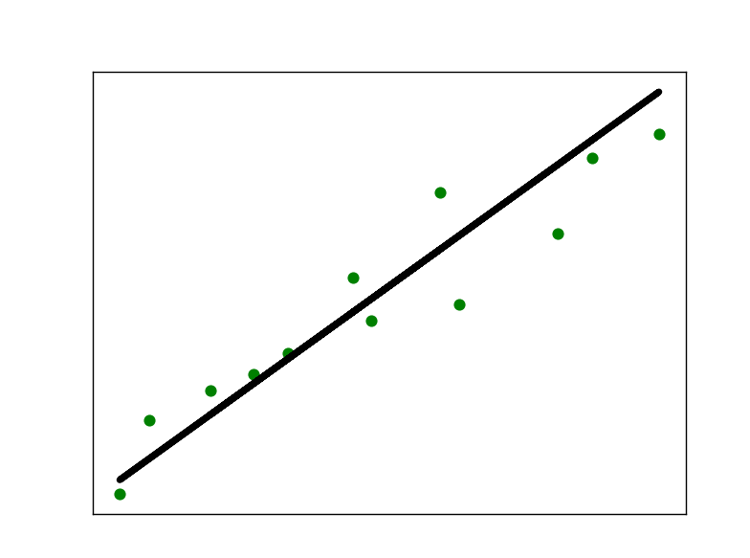

**Завдання 2.2. Передбачення за допомогою регресії однієї змінної**

|  |
| --- |
| import pickle  import numpy as np  from sklearn import linear_model  import sklearn.metrics as sm  import matplotlib.pyplot as plt  input_file = 'data_regr_5.txt'  data = np.loadtxt(input_file, delimiter=',')  X, y = data[:, :-1], data[:, -1]  num_training = int(0.8 * len(X))  num_test = len(X) - num_training  X_train, y_train = X[:num_training], y[:num_training]  X_test, y_test = X[num_training:], y[num_training:]  regressor = linear_model.LinearRegression()  regressor.fit(X_train, y_train)  y_test_pred = regressor.predict(X_test)  plt.scatter(X_test, y_test, color='green')  plt.plot(X_test, y_test_pred, color='black', linewidth=4)  plt.xticks(())  plt.yticks(())  plt.show()  print("Linear regressor performance:")  print("Mean absolute error =", round(sm.mean_absolute_error(y_test, y_test_pred), 2))  print("Mean squared error =", round(sm.mean_squared_error(y_test, y_test_pred), 2))  print("Median absolute error =", round(sm.median_absolute_error(y_test, y_test_pred), 2))  print("Explain variance score =", round(sm.explained_variance_score(y_test, y_test_pred), 2))  print("R2 score =", round(sm.r2_score(y_test, y_test_pred), 2))  output_model_file = 'model.pkl'  with open(output_model_file, 'wb') as f:  pickle.dump(regressor, f)  with open(output_model_file, 'rb') as f:  regressor_model = pickle.load(f)  y_test_pred_new = regressor_model.predict(X_test)  print("\nNew mean absolute error =", round(sm.mean_absolute_error(y_test, y_test_pred_new), 2)) |

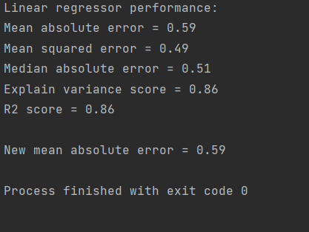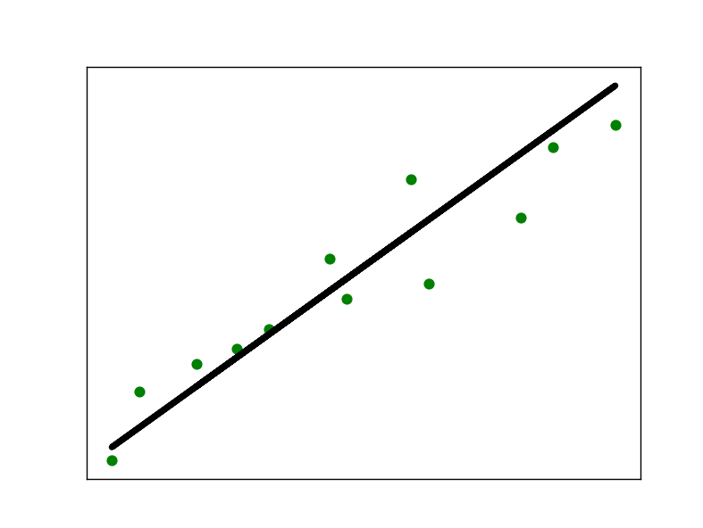

**Завдання 2.3. Створення багатовимірного регресора**

|  |
| --- |
| import numpy as np  from sklearn import linear_model  import sklearn.metrics as sm  from sklearn.preprocessing import PolynomialFeatures  input_file = 'data_multivar_regr.txt'  data = np.loadtxt(input_file, delimiter=',')  X, y = data[:, :-1], data[:, -1]  num_training = int(0.8 * len(X))  num_test = len(X) - num_training  X_train, y_train = X[:num_training], y[:num_training]  X_test, y_test = X[num_training:], y[num_training:]  linear_regressor = linear_model.LinearRegression()  linear_regressor.fit(X_train, y_train)  y_test_pred = linear_regressor.predict(X_test)  print("Linear Regressor performance:")  print("Mean absolute error =", round(sm.mean_absolute_error(y_test, y_test_pred), 2))  print("Mean squared error =", round(sm.mean_squared_error(y_test, y_test_pred), 2))  print("Median absolute error =", round(sm.median_absolute_error(y_test, y_test_pred), 2))  print("Explained variance score =", round(sm.explained_variance_score(y_test, y_test_pred), 2))  print("R2 score =", round(sm.r2_score(y_test, y_test_pred), 2))  polynomial = PolynomialFeatures(degree=10)  X_train_transformed = polynomial.fit_transform(X_train)  datapoint = [[7.75, 6.35, 5.56]]  poly_datapoint = polynomial.fit_transform(datapoint)  poly_linear_model = linear_model.LinearRegression()  poly_linear_model.fit(X_train_transformed, y_train)  print("\nLinear regression:\n", linear_regressor.predict(datapoint))  print("\nPolynomial regression:\n", poly_linear_model.predict(poly_datapoint)) |

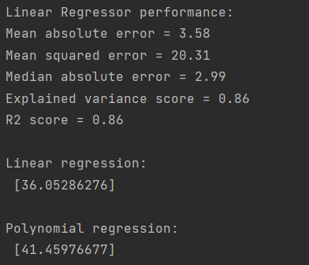

**Завдання 2.4. Регресія багатьох змінних**

|  |
| --- |
| import matplotlib.pyplot as plt  import numpy as np  from sklearn import datasets, linear_model  from sklearn.metrics import mean_squared_error, r2_score  from sklearn.metrics import mean_absolute_error  from sklearn.model_selection import train_test_split  diabetes = datasets.load_diabetes()  X = diabetes.data  y = diabetes.target  Xtrain, Xtest, ytrain, ytest = train_test_split(X, y, test_size=0.5, random_state=0)  regr = linear_model.LinearRegression()  regr.fit(Xtrain, ytrain)  ypred = regr.predict(Xtest)  # Обрахування метрик  print("regr.coef =", np.round(regr.coef_, 2))  print("regr.intercept =", round(regr.intercept_, 2))  print("R2 score =", round(r2_score(ytest, ypred), 2))  print("Mean absolute error =", round(mean_absolute_error(ytest, ypred), 2))  print("Mean squared error =", round(mean_squared_error(ytest, ypred), 2))  fig, ax = plt.subplots()  ax.scatter(ytest, ypred, edgecolors=(0, 0, 0))  ax.plot([y.min(), y.max()], [y.min(), y.max()], 'k--', lw=4)  ax.set_xlabel('Виміряно')  ax.set_ylabel('Передбачено')  plt.show() |

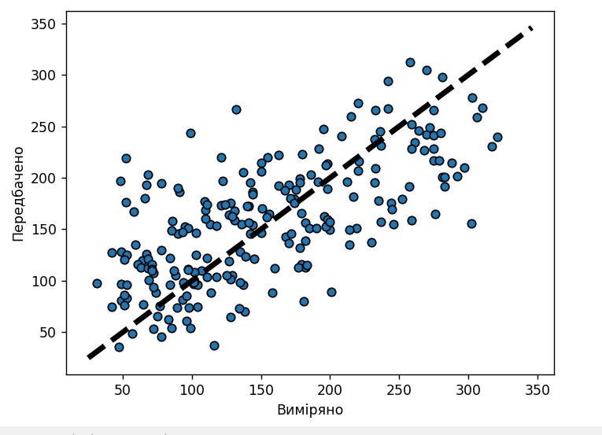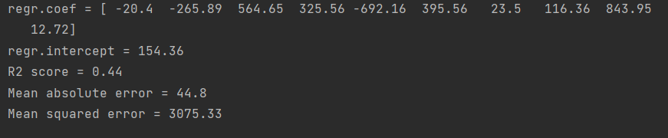

**Завдання 2.5. Самостійна побудова регресії**

|  |
| --- |
| import numpy as np  from matplotlib import pyplot as plt  from sklearn import linear_model  import sklearn.metrics as sm  from sklearn.preprocessing import PolynomialFeatures  m = 100  X = 6 * np.random.rand(m, 1) - 3  y = 0.4 * X ** 2 + X + 4 + np.random.randn(m, 1)  X = X.reshape(-1, 1)  y = y.reshape(-1, 1)  linear_regressor = linear_model.LinearRegression()  linear_regressor.fit(X, y)  polynomial = PolynomialFeatures(degree=2, include_bias=False)  X_poly = polynomial.fit_transform(X)  polynomial.fit(X_poly, y)  poly_linear_model = linear_model.LinearRegression()  poly_linear_model.fit(X_poly, y)  y_pred = poly_linear_model.predict(X_poly)  print("\nr2: ", sm.r2_score(y, y_pred))  plt.scatter(X, y, color='red')  plt.plot(X, linear_regressor.predict(X), color='blue', linewidth=1)  plt.title("Лінійна регресія")  plt.show()  plt.scatter(X, y, color='red')  plt.plot(X, y_pred, "*", color='blue', linewidth=2)  plt.title("Поліноміальна регресія")  plt.show() |

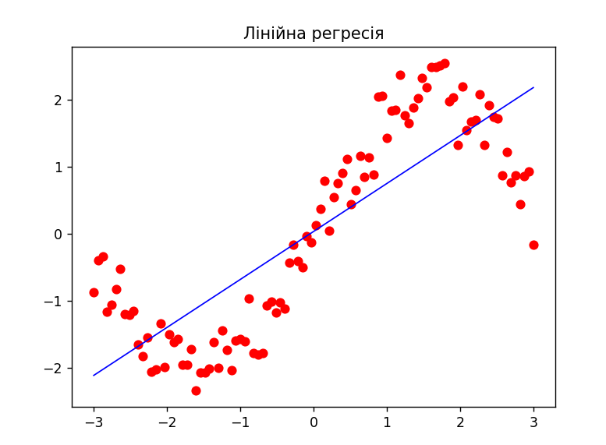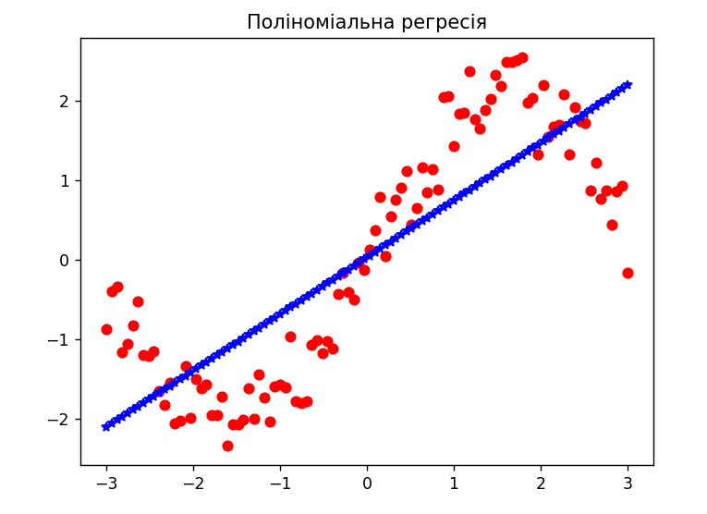

**Завдання 2.6. Побудова кривих навчання**

|  |
| --- |
| import matplotlib.pyplot as plt  import numpy as np  from sklearn import linear_model  from sklearn.metrics import mean_squared_error  from sklearn.model_selection import train_test_split  from sklearn.preprocessing import PolynomialFeatures  from sklearn.pipeline import Pipeline  m = 100  X = 6 * np.random.rand(m, 1) - 5  y = 0.7 * X ** 2 + X + 3 + np.random.randn(m, 1)  def plot_learning_curves(model, X, y):  X_train, X_val, y_train, y_val = train_test_split(X, y, test_size=0.2)  train_errors, val_errors = [], []  for m in range(1, len(X_train)):  model.fit(X_train[:m], y_train[:m])  y_train_predict = model.predict(X_train[:m])  y_val_predict = model.predict(X_val)  train_errors.append(mean_squared_error(y_train_predict, y_train[:m]))  val_errors.append(mean_squared_error(y_val_predict, y_val))  plt.plot(np.sqrt(train_errors), "r-+", linewidth=2, label='train')  plt.plot(np.sqrt(val_errors), "b-", linewidth=3, label='val')  plt.legend()  plt.show()  lin_reg = linear_model.LinearRegression()  polynomial_regression = Pipeline([  ("poly_features",  PolynomialFeatures(degree=10, include_bias=False)),  ("lin_reg", linear_model.LinearRegression())  ])  plot_learning_curves(polynomial_regression, X, y) |

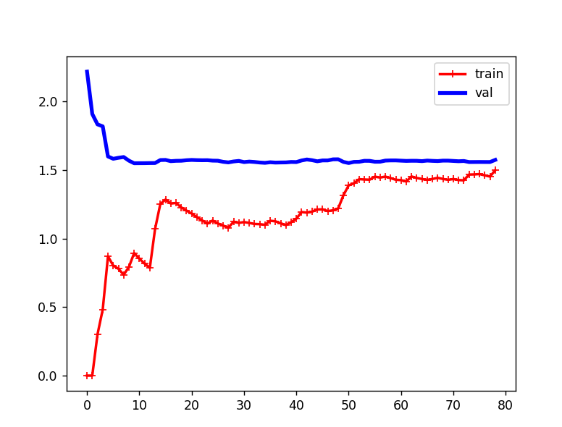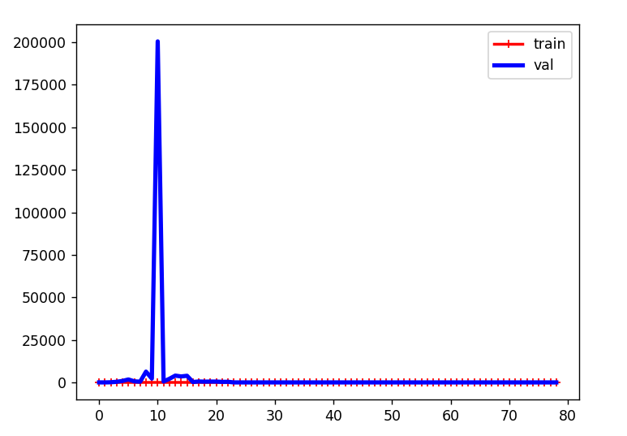

**Завдання 2.7. Кластеризація даних за допомогою методу k-середніх**

|  |
| --- |
| import numpy as np  import matplotlib.pyplot as plt  from sklearn.cluster import KMeans  X = np.loadtxt('data_clustering.txt', delimiter=',')  num_clusters = 5  plt.figure()  plt.scatter(X[:, 0], X[:, 1], marker='o', facecolors='none', edgecolors='black', s=80)  x_min, x_max = X[:, 0].min() - 1, X[:, 0].max() + 1  y_min, y_max = X[:, 1].min() - 1, X[:, 1].max() + 1  plt.title('Input data')  plt.xlim(x_min, x_max)  plt.ylim(y_min, y_max)  plt.xticks(())  plt.yticks(())  # Створення об'єкту КМеаns  kmeans = KMeans(init='k-means++', n_clusters=num_clusters, n_init=10)  kmeans.fit(X)  step_size = 0.01  x_min, x_max = X[:, 0].min() - 1, X[:, 0].max() + 1  y_min, y_max = X[:, 1].min() - 1, X[:, 1].max() + 1  x_vals, y_vals = np.meshgrid(np.arange(x_min, x_max, step_size),  np.arange(y_min, y_max, step_size))  output = kmeans.predict(np.c_[x_vals.ravel(), y_vals.ravel()])  output = output.reshape(x_vals.shape)  plt.figure()  plt.clf()  plt.imshow(output, interpolation='nearest',  extent=(x_vals.min(), x_vals.max(),  y_vals.min(), y_vals.max()),  cmap=plt.cm.Paired,  aspect='auto',  origin='lower')  plt.scatter(X[:, 0], X[:, 1], marker='o', facecolors='none',  edgecolors='black', s=80)  cluster_centers = kmeans.cluster_centers_  plt.scatter(cluster_centers[:, 0], cluster_centers[:, 1],  marker='o', s=210, linewidths=4, color='black',  zorder=12, facecolors='black')  x_min, x_max = X[:, 0].min() - 1, X[:, 0].max() + 1  y_min, y_max = X[:, 1].min() - 1, X[:, 1].max() + 1  plt.title('Межі кластерів')  plt.xlim(x_min, x_max)  plt.ylim(y_min, y_max)  plt.xticks(())  plt.yticks(())  plt.show() |

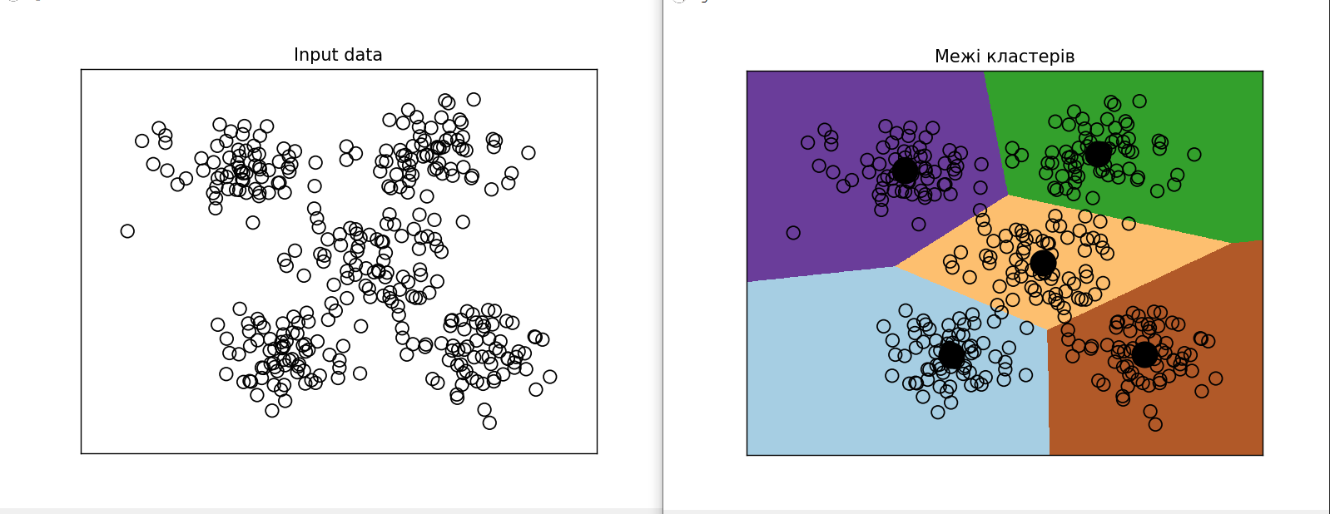

**Завдання 2.8. Кластеризація K-середніх для набору даних Iris**

|  |
| --- |
| import matplotlib.pyplot as plt  from sklearn import datasets  from sklearn.cluster import KMeans  from sklearn.metrics import pairwise_distances_argmin  import numpy as np  iris = datasets.load_iris()  X = iris.data[:, :2]  Y = iris.target  kmeans = KMeans(n_clusters=Y.max() + 1, init='k-means++', n_init=10, max_iter=300,  tol=0.0001, verbose=0, random_state=None, copy_x=True)  kmeans.fit(X)  y_pred = kmeans.predict(X)  print("n_clusters: 3, n_init: 10, max_iter: 300, tol: 0.0001, verbose: 0, random_state: None, copy_x: True")  print(y_pred)  plt.figure()  plt.scatter(X[:, 0], X[:, 1], c=y_pred, s=50, cmap='viridis')  centers = kmeans.cluster_centers_  plt.scatter(centers[:, 0], centers[:, 1], c='black', s=200, alpha=0.5)  plt.show()  def find_clusters(X, n_clusters, rseed=2):  rng = np.random.RandomState(rseed)  i = rng.permutation(X.shape[0])[:n_clusters]  centers = X[i]  while True:  labels = pairwise_distances_argmin(X, centers)  new_centers = np.array([X[labels == i].mean(0) for i in range(n_clusters)])  if np.all(centers == new_centers):  break  centers = new_centers  return centers, labels  print("using find_clusters():")  centers, labels = find_clusters(X, 3)  print("n_clusters: 3, rseed: 2")  plt.scatter(X[:, 0], X[:, 1], c=labels, s=50, cmap='viridis')  plt.show()  centers, labels = find_clusters(X, 3, rseed=0)  print("n_clusters: 3, rseed: 0")  plt.scatter(X[:, 0], X[:, 1], c=labels, s=50, cmap='viridis')  plt.show()  labels = KMeans(3, random_state=0).fit_predict(X)  print("n_clusters: 3, rseed: 0")  plt.scatter(X[:, 0], X[:, 1], c=labels, s=50, cmap='viridis')  plt.show() |

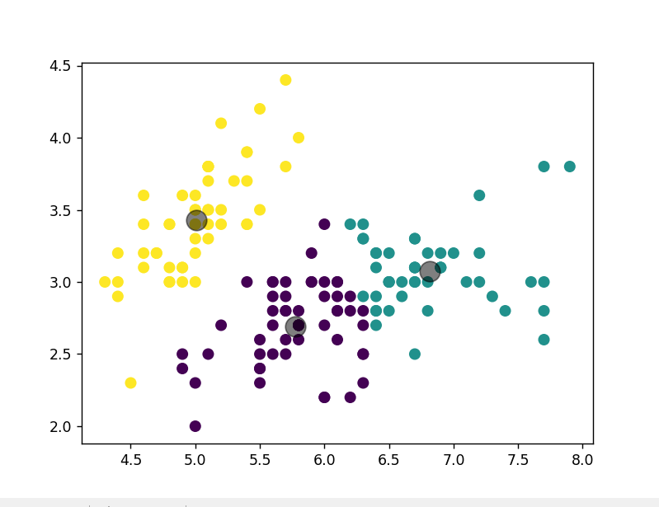

**Завдання 2.9. Оцінка кількості кластерів з використанням методу зсуву середнього**

|  |
| --- |
| import numpy as np  import matplotlib.pyplot as plt  from sklearn.cluster import MeanShift, estimate_bandwidth  X = np.loadtxt('data_clustering.txt', delimiter=',')  bandwidth_X = estimate_bandwidth(X, quantile=0.1, n_samples=len(X))  meanshift_model = MeanShift(bandwidth=bandwidth_X, bin_seeding=True)  meanshift_model.fit(X)  cluster_centers = meanshift_model.cluster_centers_  print('\nCenters of clusters:\n', cluster_centers)  labels = meanshift_model.labels_  num_clusters = len(np.unique(labels))  print("\nNumber of clusters in input data =", num_clusters)  plt.figure()  markers = 'o*xvs'  for i, marker in zip(range(num_clusters), markers):  plt.scatter(X[labels == i, 0], X[labels == i, 1], marker=marker,  color=np.random.rand(3,))  cluster_center = cluster_centers[i]  plt.plot(cluster_center[0], cluster_center[1], marker='o',  markerfacecolor='black', markeredgecolor='red',  markersize=15)  plt.title('Кластери')  plt.show() |

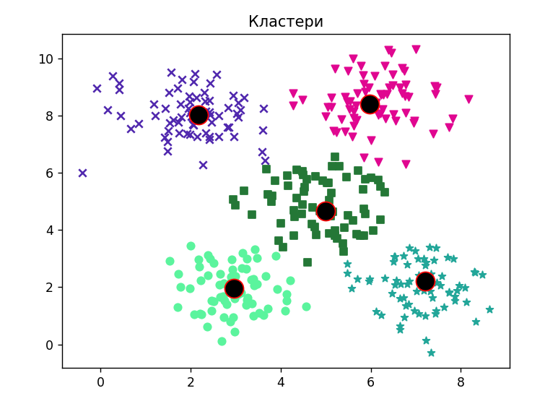

***Висновки:***.в ході виконання дабораторної роботи я використовуючи спеціалізовані бібліотеки і мову програмування Python дослідив методи регресії та неконтрольованої класифікації даних у машинному навчанні.