**ЛАБОРАТОРНА РОБОТА № 4**

**ДОСЛІДЖЕННЯ МЕТОДІВ АНСАМБЛЕВОГО НАВЧАННЯ ТА СТВОРЕННЯ РЕКОМЕНДАЦІЙНИХ СИСТЕМ**

***Мета:*** *використовуючи спеціалізовані бібліотеки та мову програмування Python дослідити методи ансамблів у машинному навчанні та створити рекомендаційні системи*..

**GitHub**: <https://github.com/ingaliptn/AI>

**Хід роботи:**

**Завдання 2.1. Створення класифікаторів на основі випадкових та гранично випадкових лісів**

|  |
| --- |
| import argparse  import numpy as np  import matplotlib.pyplot as plt  from sklearn.metrics import classification_report  from sklearn.ensemble import RandomForestClassifier, ExtraTreesClassifier  from utilities import visualize_classifier  from sklearn.model_selection import cross_val_score, train_test_split  # Парсер аргументів  def build_arg_parser():  parser = argparse.ArgumentParser(description='Classify data using Ensemble Learning techniques')  parser.add_argument("--classifier-type", dest="classifier_type", required=True, choices=['rf', 'erf'],  help="Type of classifier to use; can be either 'rf' or 'erf'")  return parser  if __name__ == '__main__':  args = build_arg_parser().parse_args()  classifier_type = args.classifier_type  input_file = 'data_random_forests.txt'  data = np.loadtxt(input_file, delimiter=',')  X, Y = data[:, :-1], data[:, -1]  print(X)  class_0 = np.array(X[Y == 0])  class_1 = np.array(X[Y == 1])  class_2 = np.array(X[Y == 2])  plt.figure()  plt.scatter(class_0[:, 0], class_0[:, 1], s=75, facecolors='red', edgecolors='black', linewidth=1, marker='s')  plt.scatter(class_1[:, 0], class_1[:, 1], s=75, facecolors='green', edgecolors='black', linewidth=1, marker='o')  plt.scatter(class_2[:, 0], class_2[:, 1], s=75, facecolors='blue', edgecolors='black', linewidth=1, marker='^')  plt.title('Input data')  plt.show()  X_train, X_test, Y_train, Y_test = train_test_split(X, Y, test_size=0.25, random_state=5)  params = {'n_estimators': 100, 'max_depth': 4, 'random_state': 0}  if classifier_type == 'rf':  classifier = RandomForestClassifier(**params)  else:  classifier = ExtraTreesClassifier(**params)  classifier.fit(X_train, Y_train)  visualize_classifier(classifier, X_train, Y_train, 'Training dataset')  class_names = ['Class-0', 'Class-1', 'Class-2']  print("\n" + "#" * 40)  print("\nClassifier performance on training dataset\n")  Y_train_pred = classifier.predict(X_train)  print(classification_report(Y_train, Y_train_pred, target_names=class_names))  print("#" * 40 + "\n")  print("#" * 40)  print("\nClassifier performance on test dataset\n")  Y_test_pred = classifier.predict(X_test)  print(classification_report(Y_test, Y_test_pred, target_names=class_names))  print("#" * 40 + "\n") |

**Завдання 2.2. Обробка дисбалансу класів**

|  |
| --- |
| import sys  import numpy as np  import matplotlib.pyplot as plt  from sklearn.model_selection import train_test_split  from sklearn.ensemble import ExtraTreesClassifier  from sklearn.metrics import classification_report  from utilities import visualize_classifier  if __name__ == '__main__':  input_file = 'data_imbalance.txt'  data = np.loadtxt(input_file, delimiter=',')  X, Y = data[:, :-1], data[:, -1]  # Поділ вхідних даних на два класи на підставі міток  class_0 = np.array(X[Y == 0])  class_1 = np.array(X[Y == 1])  # Візуалізація вхідних даних  plt.figure()  plt.scatter(class_0[:, 0], class_0[:, 1], s=75, facecolors='black', edgecolors='black', linewidth=1, marker='x')  plt.scatter(class_1[:, 0], class_1[:, 1], s=75, facecolors='white', edgecolors='black', linewidth=1, marker='o')  plt.title('Input data')  X_train, X_test, Y_train, Y_test = train_test_split(X, Y, test_size=0.25, random_state=5)  params = {'n_estimators': 100, 'max_depth': 4, 'random_state': 0}  if len(sys.argv) > 1:  if sys.argv[1] == 'balance':  params['class_weight'] = 'balanced'  else:  raise TypeError("Invalid input argument; should be 'balance' or nothing")  classifier = ExtraTreesClassifier(**params)  classifier.fit(X_train, Y_train)  visualize_classifier(classifier, X_train, Y_train)  Y_test_pred = classifier.predict(X_test)  class_names = ['Class-0', 'Class-1']  print("\n" + "#"*40)  print("Classifier performance on training dataset")  print(classification_report(Y_test, Y_test_pred, target_names=class_names))  print("#"*40)  print("Classifier performance on test dataset")  print(classification_report(Y_test, Y_test_pred, target_names=class_names))  print("#"*40 + "\n")  plt.show() |

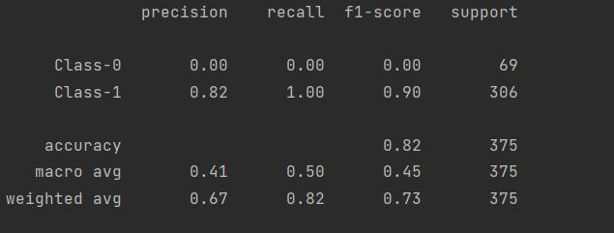

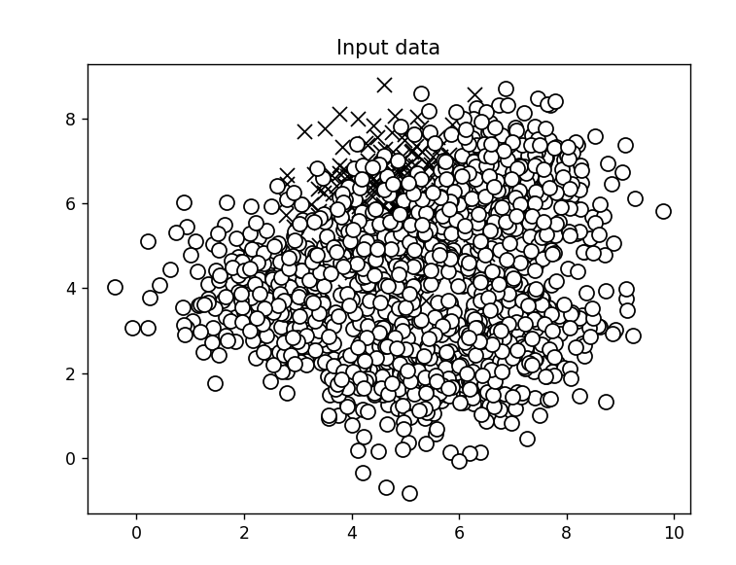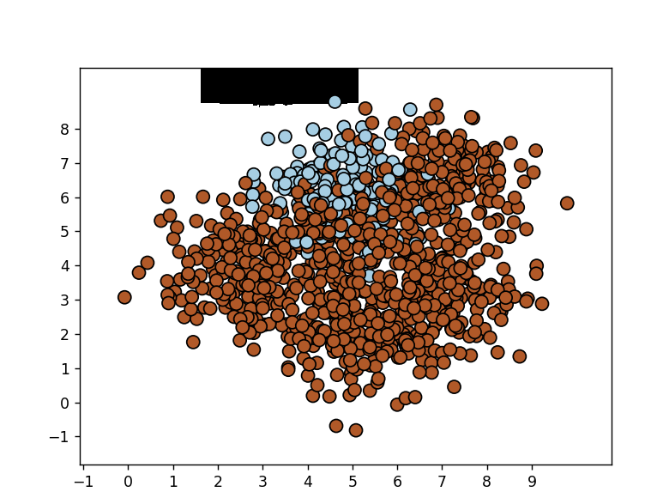

**Завдання 2.3. Знаходження оптимальних навчальних параметрів за допомогою сіткового пошуку**

|  |
| --- |
| import numpy as np  from sklearn.model_selection import train_test_split, GridSearchCV  from sklearn.ensemble import ExtraTreesClassifier  from sklearn.metrics import classification_report  from utilities import visualize_classifier  input_file = 'data_random_forests.txt'  data = np.loadtxt(input_file, delimiter=',')  X, Y = data[:, :-1], data[:, -1]  class_0 = np.array(X[Y == 0])  class_1 = np.array(X[Y == 1])  class_2 = np.array(X[Y == 2])  X_train, X_test, Y_train, Y_test = train_test_split(X, Y, test_size=0.25, random_state=5)  parameter_grid = [{'n_estimators': [100], 'max_depth': [2, 4, 7, 12, 16]},  {'max_depth': [4], 'n_estimators': [25, 50, 100, 250]}]  metrics = ['precision_weighted', 'recall_weighted']  for metric in metrics:  print("#### Searching optimal parameters for", metric)  classifier = GridSearchCV(ExtraTreesClassifier(random_state=0), parameter_grid, cv=5, scoring=metric)  classifier.fit(X_train, Y_train)  print("\nScores across the parameter grid:")  for params, avg_score in classifier.cv_results_.items():  print(params, '-->', avg_score)  print("\nHighest scoring parameter set:", classifier.best_params_)  Y_test_pred = classifier.predict(X_test)  class_names = ['Class-0', 'Class-1', 'Class-2']  print("#"*40)  print("Classifier performance on training dataset")  print(classification_report(Y_test, Y_test_pred, target_names=class_names))  print("#"*40 + "\n")  visualize_classifier(classifier, X_test, Y_test) |

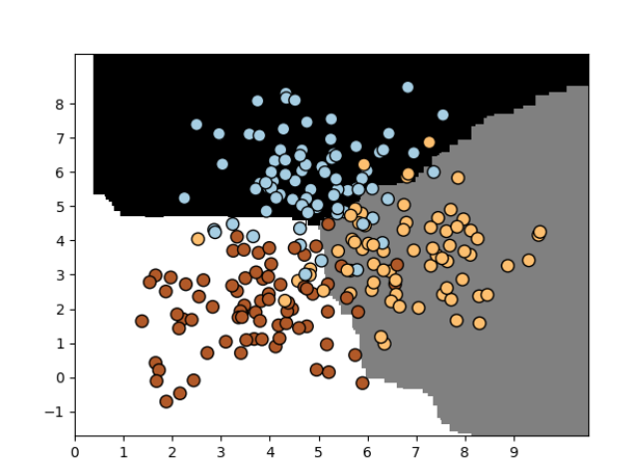

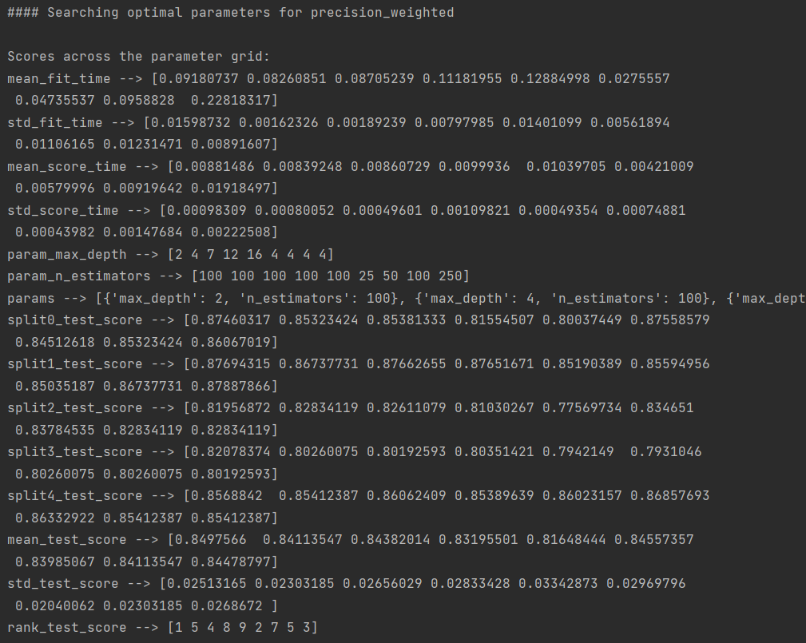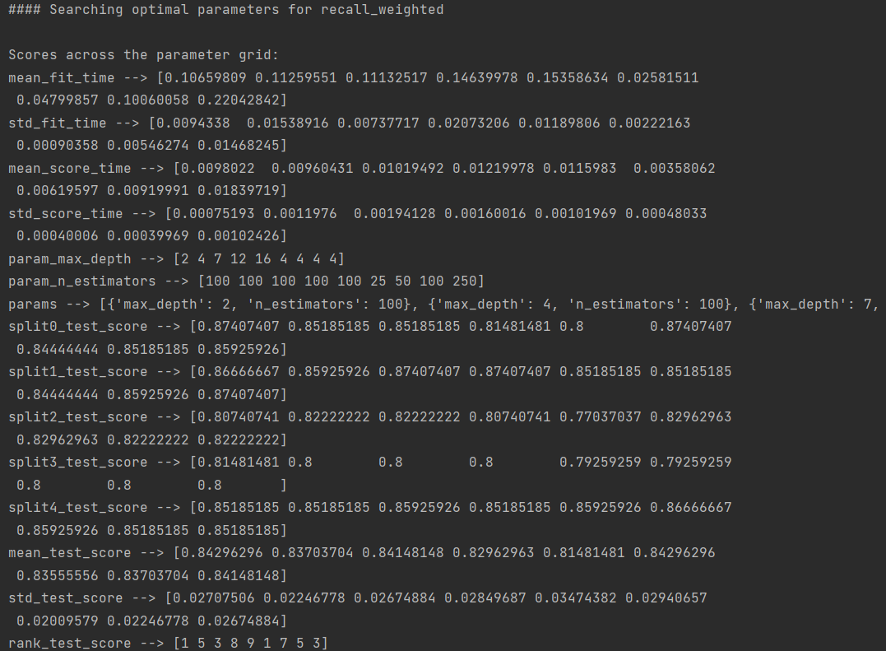

**Завдання 2.4. Обчислення відносної важливості ознак**

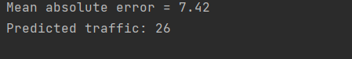

**Завдання 2.5. Прогнозування інтенсивності дорожнього руху за допомогою класифікатора на основі гранично випадкових лісів**

|  |
| --- |
| import numpy as np  from sklearn.metrics import mean_absolute_error  from sklearn.model_selection import train_test_split  from sklearn.ensemble import ExtraTreesRegressor  from sklearn import preprocessing  input_file = 'traffic_data.txt'  data = []  with open(input_file, 'r') as f:  for line in f.readlines():  items = line[:-1].split(',')  data.append(items)  data = np.array(data)  label_encoder = []  X_encoded = np.empty(data.shape)  for i, item in enumerate(data[0]):  if item.isdigit():  X_encoded[:, i] = data[:, i]  else:  label_encoder.append(preprocessing.LabelEncoder())  X_encoded[:, i] = label_encoder[-1].fit_transform(data[:, i])  X = X_encoded[:, :-1].astype(int)  Y = X_encoded[:, -1].astype(int)  X_train, X_test, Y_train, Y_test = train_test_split(X, Y, test_size=0.25, random_state=5)  params = {'n_estimators': 100, 'max_depth': 4, 'random_state': 0}  regressor = ExtraTreesRegressor(**params)  regressor.fit(X_train, Y_train)  Y_pred = regressor.predict(X_test)  print("Mean absolute error =", round(mean_absolute_error(Y_test, Y_pred), 2))  test_datapoint = ['Saturday', '10:20', 'Atlanta', 'no']  test_datapoint_encoded = [-1] * len(test_datapoint)  count = 0  for i, item in enumerate(test_datapoint):  if item.isdigit():  test_datapoint_encoded[i] = int(test_datapoint[i])  else:  test_datapoint_encoded[i] = int(label_encoder[count].transform([test_datapoint[i]]))  count = count + 1  test_datapoint_encoded = np.array(test_datapoint_encoded)  print("Predicted traffic:", int(regressor.predict([test_datapoint_encoded])[0])) |

**Завдання 2.6. Створення навчального конвеєра (конвеєра машинного навчання)**

|  |
| --- |
| from sklearn.datasets import _samples_generator  from sklearn.feature_selection import SelectKBest, f_regression  from sklearn.pipeline import Pipeline  from sklearn.ensemble import ExtraTreesClassifier  X, Y = _samples_generator.make_classification(n_samples=150, n_features=25, n_classes=3,  n_informative=6, n_redundant=0, random_state=7)  k_best_selector = SelectKBest(f_regression, k=10)  classifier = ExtraTreesClassifier(n_estimators=60, max_depth=4)  processor_pipeline = Pipeline([('selector', k_best_selector), ('erf', classifier)])  processor_pipeline.set_params(selector__k=7, erf__n_estimators=30)  processor_pipeline.fit(X, Y)  print("Predicted output:", processor_pipeline.predict(X))  print("Score:", processor_pipeline.score(X, Y))  status = processor_pipeline.named_steps['selector'].get_support()  selected = [i for i, x in enumerate(status) if x]  print("Selected features:", selected) |

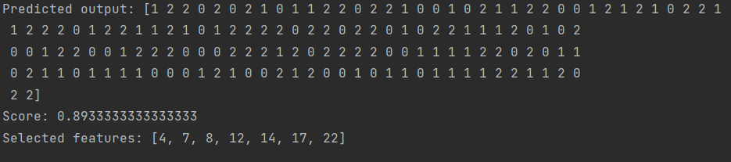

**Завдання 2.7. Пошук найближчих сусідів**

|  |
| --- |
| import numpy as np  import matplotlib.pyplot as plt  from sklearn.neighbors import NearestNeighbors  X = np.array([[2.1, 1.3], [1.3, 3.2], [2.9, 2.5], [2.7, 5.4], [3.8, 0.9],  [7.3, 2.1], [4.2, 6.5], [3.8, 3.7], [2.5, 4.1], [3.4, 1.9],  [5.7, 3.5], [6.1, 4.3], [5.1, 2.2], [6.2, 1.1]])  k = 5  test_datapoint = [4.3, 2.7]  plt.figure()  plt.title('Input data')  plt.scatter(X[:,0], X[:,1], marker='o', s=75, color='black')  knn_model = NearestNeighbors(n_neighbors=k, algorithm='ball_tree').fit(X)  distances, indices = knn_model.kneighbors([test_datapoint])  print("\nK Nearest Neighbors:")  for rank, index in enumerate(indices[0][:k], start=1):  print(str(rank) + " ==>", X[index])  plt.figure()  plt.title('Nearest neighbors')  plt.scatter(X[:, 0], X[:, 1], marker='o', s=75, color='k')  plt.scatter(X[indices][0][:][:, 0], X[indices][0][:][:, 1],  marker='o', s=250, color='k', facecolors='none')  plt.scatter(test_datapoint[0], test_datapoint[1],  marker='x', s=75, color='k')  plt.show() |

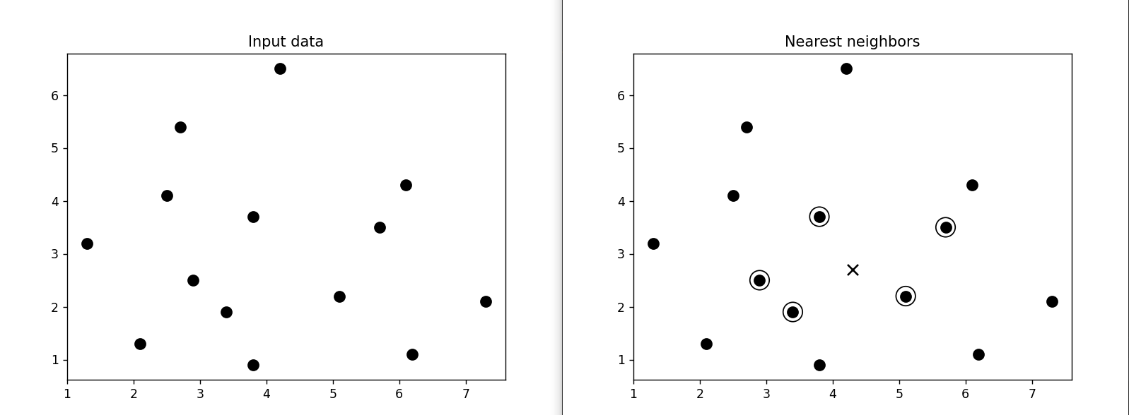

**Завдання 2.8. Створити класифікатор методом *k* найближчих сусідів**

|  |
| --- |
| import numpy as np  import matplotlib.pyplot as plt  import matplotlib.cm as cm  from sklearn import neighbors  input_file = 'data.txt'  data = np.loadtxt(input_file, delimiter=',')  X, y = data[:, :-1], data[:, -1].astype(int)  plt.figure()  plt.title('Input data')  marker_shapes = 'v^os'  mapper = [marker_shapes[i] for i in y]  for i in range(X.shape[0]):  plt.scatter(X[i, 0], X[i, 1], marker=mapper[i],  s=75, edgecolors='black', facecolors='none')  num_neighbors = 12  step_size = 0.01  classifier = neighbors.KNeighborsClassifier(num_neighbors, weights='distance')  classifier.fit(X, y)  x_min, x_max = X[:, 0].min() - 1, X[:, 0].max() + 1  y_min, y_max = X[:, 1].min() - 1, X[:, 1].max() + 1  x_values, y_values = np.meshgrid(np.arange(x_min, x_max, step_size),  np.arange(y_min, y_max, step_size))  output = classifier.predict(np.c_[x_values.ravel(), y_values.ravel()])  output = output.reshape(x_values.shape)  plt.figure()  plt.pcolormesh(x_values, y_values, output, cmap=cm.Paired)  for i in range(X.shape[0]):  plt.scatter(X[i, 0], X[i, 1], marker=mapper[i],  s=50, edgecolors='black', facecolors='none')  plt.xlim(x_values.min(), x_values.max())  plt.ylim(y_values.min(), y_values.max())  plt.title('K Nearest Neighbors classifier model boundaries')  test_datapoint = [5.1, 3.6]  plt.figure()  plt.title('Test datapoint')  for i in range(X.shape[0]):  plt.scatter(X[i, 0], X[i, 1], marker=mapper[i],  s=75, edgecolors='black', facecolors='none')  plt.scatter(test_datapoint[0], test_datapoint[1], marker='x',  linewidth=6, s=200, facecolors='black')  _, indices = classifier.kneighbors([test_datapoint])  indices = indices.astype(int)[0]  plt.figure()  plt.title('K Nearest Neighbors')  for i in indices:  plt.scatter(X[i, 0], X[i, 1], marker=mapper[y[i]],  linewidth=3, s=100, facecolors='black')  plt.scatter(test_datapoint[0], test_datapoint[1], marker='x',  linewidth=6, s=200, facecolors='black')  for i in range(X.shape[0]):  plt.scatter(X[i, 0], X[i, 1], marker=mapper[i],  s=75, edgecolors='black', facecolors='none')  print("Predicted output:", classifier.predict([test_datapoint])[0])  plt.show() |

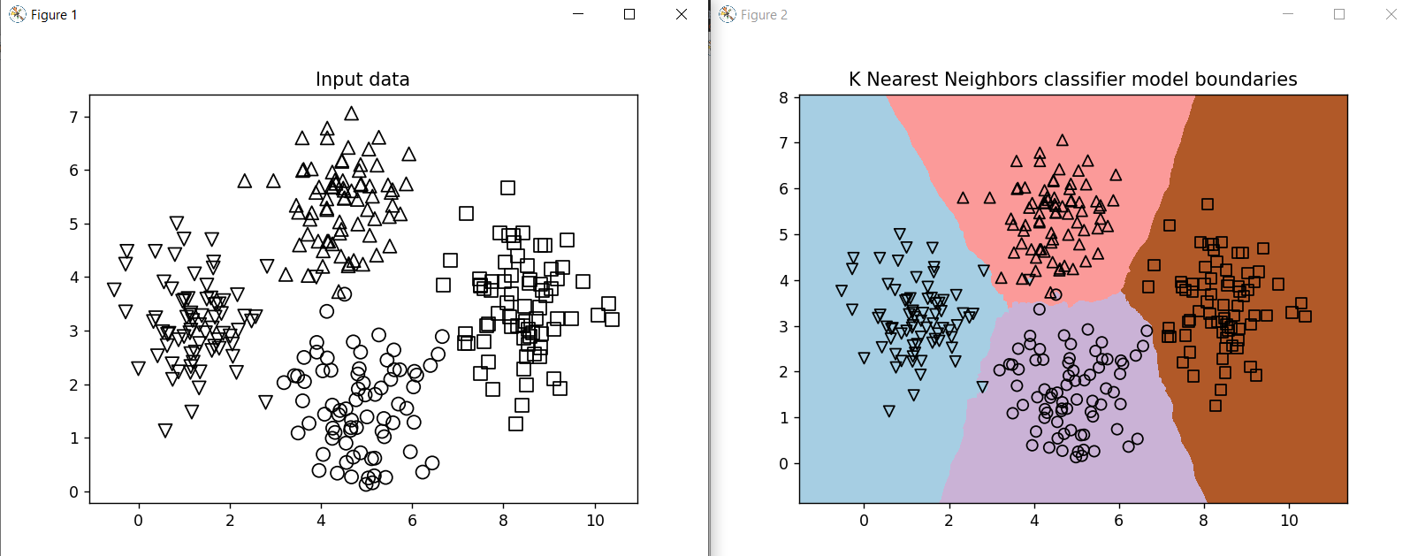

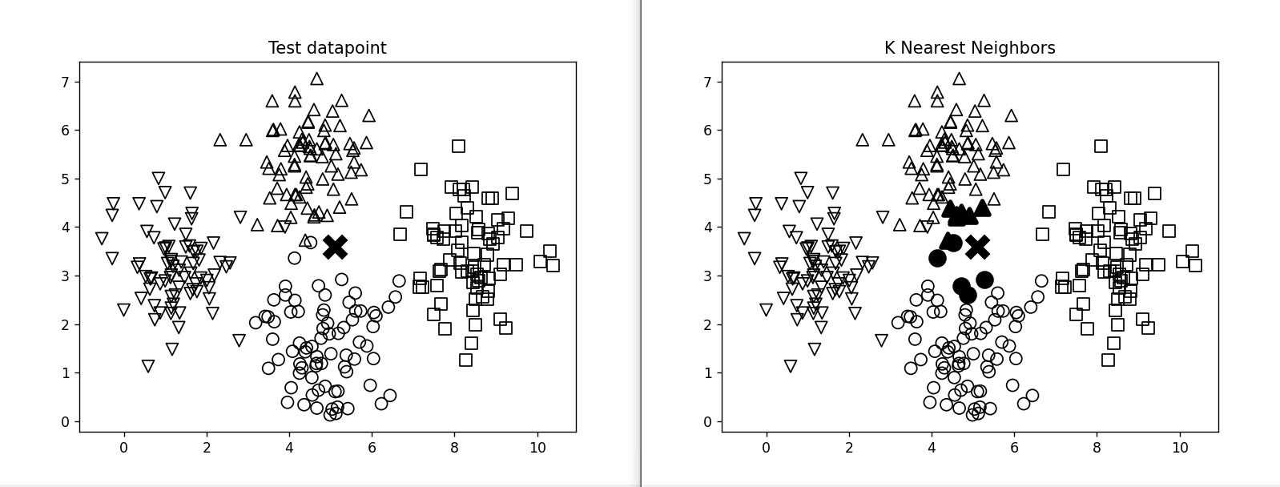

**Завдання 2.9. Обчислення оцінок подібності**

|  |
| --- |
| import argparse  import json  import numpy as np  def build_arg_parser():  parser = argparse.ArgumentParser(description='Compute similarity score')  parser.add_argument('--user1', dest='user1', required=True,  help='First user')  parser.add_argument('--user2', dest='user2', required=True,  help='Second user')  parser.add_argument("--score-type", dest="score_type", required=True,  choices=['Euclidean', 'Pearson'], help='Similarity metric to be used')  return parser  def euclidean_score(dataset, user1, user2):  if user1 not in dataset:  raise TypeError('Cannot find ' + user1 + ' in the dataset')  if user2 not in dataset:  raise TypeError('Cannot find ' + user2 + ' in the dataset')  common_movies = {}  for item in dataset[user1]:  if item in dataset[user2]:  common_movies[item] = 1  if len(common_movies) == 0:  return 0  squared_diff = []  for item in dataset[user1]:  if item in dataset[user2]:  squared_diff.append(np.square(dataset[user1][item] - dataset[user2][item]))  return 1 / (1 + np.sqrt(np.sum(squared_diff)))  def pearson_score(dataset, user1, user2):  if user1 not in dataset:  raise TypeError('Cannot find ' + user1 + ' in the dataset')  if user2 not in dataset:  raise TypeError('Cannot find ' + user2 + ' in the dataset')  common_movies = {}  for item in dataset[user1]:  if item in dataset[user2]:  common_movies[item] = 1  num_ratings = len(common_movies)  if num_ratings == 0:  return 0  user1_sum = np.sum([dataset[user1][item] for item in common_movies])  user2_sum = np.sum([dataset[user2][item] for item in common_movies])  user1_squared_sum = np.sum([np.square(dataset[user1][item]) for item in common_movies])  user2_squared_sum = np.sum([np.square(dataset[user2][item]) for item in common_movies])  sum_of_products = np.sum([dataset[user1][item] * dataset[user2][item] for item in common_movies])  Sxy = sum_of_products - (user1_sum * user2_sum / num_ratings)  Sxx = user1_squared_sum - np.square(user1_sum) / num_ratings  Syy = user2_squared_sum - np.square(user2_sum) / num_ratings  if Sxx * Syy == 0:  return 0  return Sxy / np.sqrt(Sxx * Syy)  if __name__ == '__main__':  args = build_arg_parser().parse_args()  user1 = args.user1  user2 = args.user2  score_type = args.score_type  ratings_file = 'ratings.json'  with open(ratings_file, 'r') as f:  data = json.loads(f.read())  if score_type == 'Euclidean':  print("\nEuclidean score:")  print(euclidean_score(data, user1, user2))  else:  print("\nPearson score:")  print(pearson_score(data, user1, user2)) |





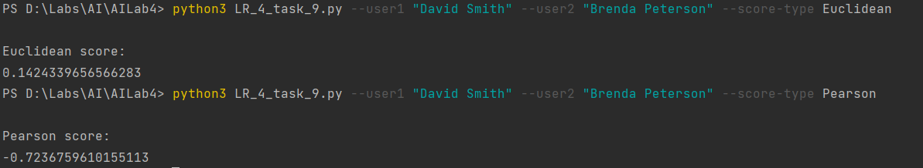

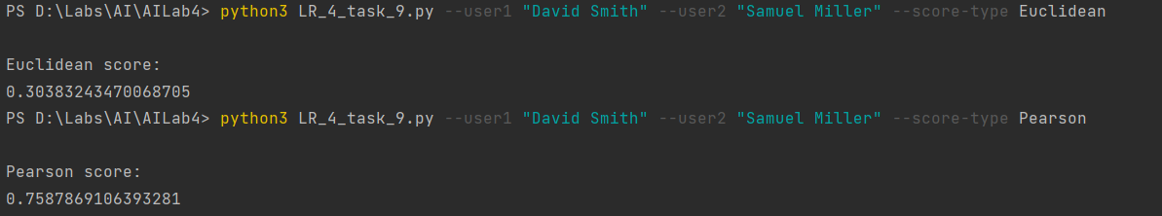

***Висновки:***. *В ході виконання лабораторної, я,використовуючи спеціалізовані бібліотеки та мову програмування Python дослідив методи ансамблів у машинному навчанні та створив рекомендаційні системи*..