Big Data Project: Global Earthquake Classification

Technical Report

1. Introduction & Context

1.1 Background
Earthquakes represent one of the most destructive natural disasters, causing massive loss of life, structural collapse, and widespread infrastructure damage globally. The ability to quickly and accurately classify the severity of an earthquake based on geographic, temporal, and physical metrics is an ongoing challenge in seismology, disaster management, and data science. Early warning systems rely on rapid detection algorithms to process initial seismic waves, estimate the epicenter, calculate depth, and forecast the magnitude category before the most destructive secondary shear waves (S-waves) reach major population centers.

1.2 Motivation and State-of-the-art
Traditional seismological methods often rely on empirical scaling laws and deterministic physical models, which can be computationally expensive and sometimes struggle to capture complex, non-linear interactions across vast geographic fault zones. The advent of Big Data analytics and Machine Learning (ML) introduces an alternative paradigm: training highly scalable statistical models on massive historical datasets to predict event properties instantaneously based on initial readings.
State-of-the-art approaches in this domain frequently utilize Deep Learning (like Convolutional Neural Networks on waveform data). However, for structured, tabular metadata (location, depth, time, measurement quality), ensemble tree-based models and large-margin classifiers remain highly competitive due to their inference speed and interpretability.

1.3 Project Objectives
This project explores the application of Big Data techniques to classify the magnitude category of over 1 million global earthquakes recorded since 1900. By employing a scalable data pipeline, multiple dimensionality reduction methods, and an ensemble of machine learning algorithms, we aim to:
1. Determine the most effective classification algorithms for large-scale geophysical tasks.
2. Evaluate the impact of dimensionality reduction on highly non-linear environmental data.
3. Establish an end-to-end data pipeline capable of robustly handling >1 million records.

2. Dataset Description and Production

2.1 Data Source and Volume
The primary dataset utilized in this project is the "Global Earthquake History (1M+ events since 1900)", sourced from Kaggle, aggregating comprehensive catalogs from the USGS and other international seismological bodies.
* Storage Size: Approximately 160 MB on disk.
* Instance Volume: 1,058,978 discrete seismic events.
* Feature Dimensionality: 23 original variables, covering temporal data, geographic coordinates (latitude, longitude), physical properties (depth, magnitude), and specific measurement quality metrics (gap, nst, rms).

2.2 Why This Qualifies as Big Data
While 160 MB fits comfortably in modern memory, the dataset structure represents a classic Big Data scenario. The volume (>1 million instances) combined with the velocity of typical seismic data streams necessitates scalable algorithms. Processing, filtering, dimensionality reduction, and training distance-based algorithms (like KNN) on a million points introduces significant computational bottlenecks that require careful memory management, vectorized operations, and parallel computing architectures.

3. Dataset Preparation and Exploratory Data Analysis
Massive datasets are inherently noisy, prone to missing values, high redundancy, and features that can induce "data leakage" (target leakage). Our robust data engineering pipeline executed the following preparation steps.

3.1 Feature Engineering and Data Cleaning
- Temporal Extraction: The original time variable was provided as a unified ISO-8601 string. To capture potential seasonality, diurnal patterns, or tectonic stress cycles, we parsed this string into distinct numeric features: year, month, day_of_year, hour, minute, second, and day_of_week.
- Leakage Prevention: To ensure a fair predictive model, identifiers and certain redundant variables were removed. Variables such as id, place, updated, net, magType, status, and depth_category (which is fully redundant with depth) were discarded.
- Measurement Quality Metrics: The variables gap (largest azimuthal gap between stations), nst (number of seismic stations reporting), and rms (root-mean-square travel time residual) were retained. While heavily dependent on the infrastructure recording the event, they serve as excellent proxy indicators of the physical size of the earthquake (a larger earthquake is detected by far more stations, increasing nst and decreasing gap).
- Handling Missing Values: Missing numerical values (specifically 904 missing records in the depth column) were imputed using the column median to preserve general distributions without discarding valuable instances. Categorical variables with missing data were filled with an 'unknown' string identifier.
- Constant Column Removal: The tsunami feature was dropped automatically by the pipeline's variance threshold filter as it contained zero variance across the cleaned dataset.

3.2 Target Encoding
The continuous mag (Magnitude) variable was converted into 7 distinct qualitative severity classes, representing our classification target:
* Great (7-8)
* Light (3-4)
* Major (6-7)
* Massive (8+)
* Minor (2.5-3)
* Moderate (4-5)
* Strong (5-6)
The final prepared dataset contained 14 features, satisfying the rigorous academic requirements for high-dimensional classification inputs.

3.3 Exploratory Data Analysis (EDA)
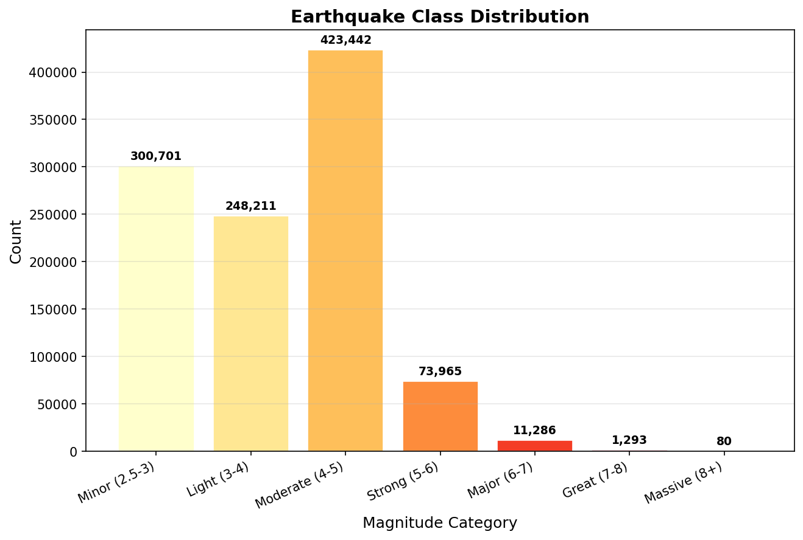
As seen in the Class Distribution chart above, the dataset is highly imbalanced, following a logarithmic distribution typical of Gutenberg-Richter laws in seismology. The vast majority of events fall into the "Minor" and "Light" categories, while "Massive" events represent a fraction of a percent of the data. This severe imbalance necessitated the use of weighted performance metrics (F1-Weighted) to prevent the models from achieving falsely high accuracy by simply predicting the majority class.
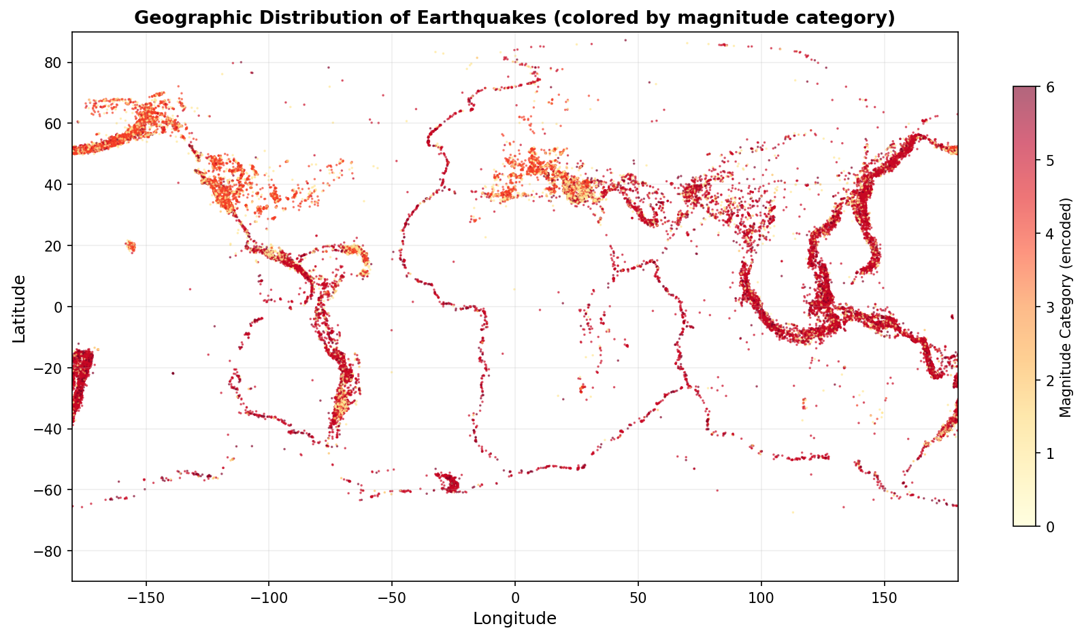
The geographic scatter plot clearly highlights the world's tectonic plate boundaries, particularly the "Ring of Fire" encircling the Pacific Ocean. Noticeably, higher magnitude categories (darker colors) frequently cluster along deep subduction zones.
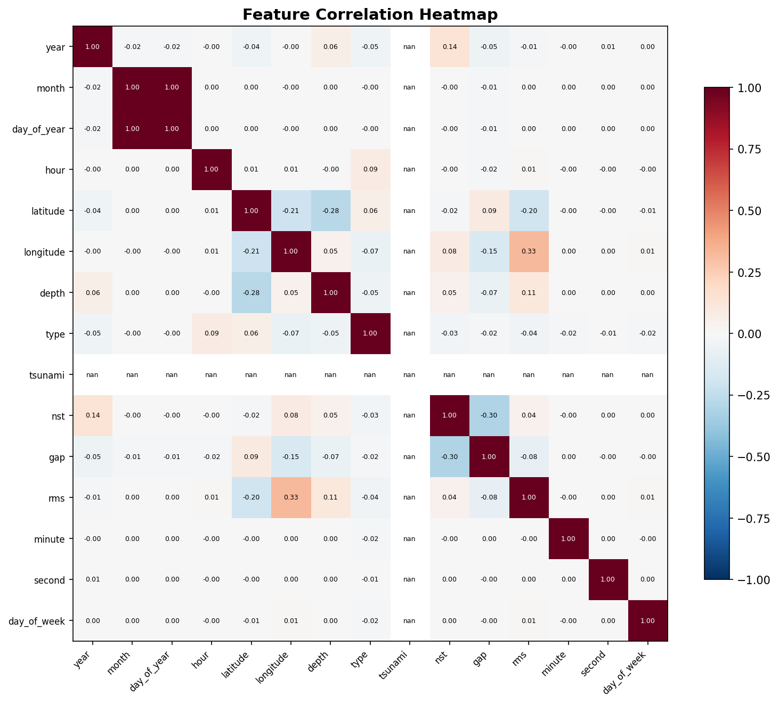
The feature correlation heatmap indicates several notable relationships. The number of stations (nst) shows a distinct positive correlation with earthquake severity, validating our decision to retain it as a proxy variable. Conversely, gap shows an inverse correlation, as larger earthquakes are recorded globally, shrinking the azimuthal gap between detecting stations.

4. Dimension Reduction Theory and Application
To combat the curse of dimensionality, eliminate multicollinearity, and observe internal clustering within the 14-dimensional feature space, three distinct dimensionality reduction algorithms were implemented.

4.1 Principal Component Analysis (PCA)
PCA is a linear transformation technique that seeks to project the data onto a lower-dimensional subspace while maximizing the variance of the projected data. It operates by computing the covariance matrix of the scaled dataset and performing eigendecomposition. The eigenvectors associated with the largest eigenvalues (Principal Components) form the new orthogonal basis.
* Implementation: We reduced the dataset to n_components=2.
* Purpose: To determine if the variance of the earthquake characteristics can be easily summarized in a 2D linear space.
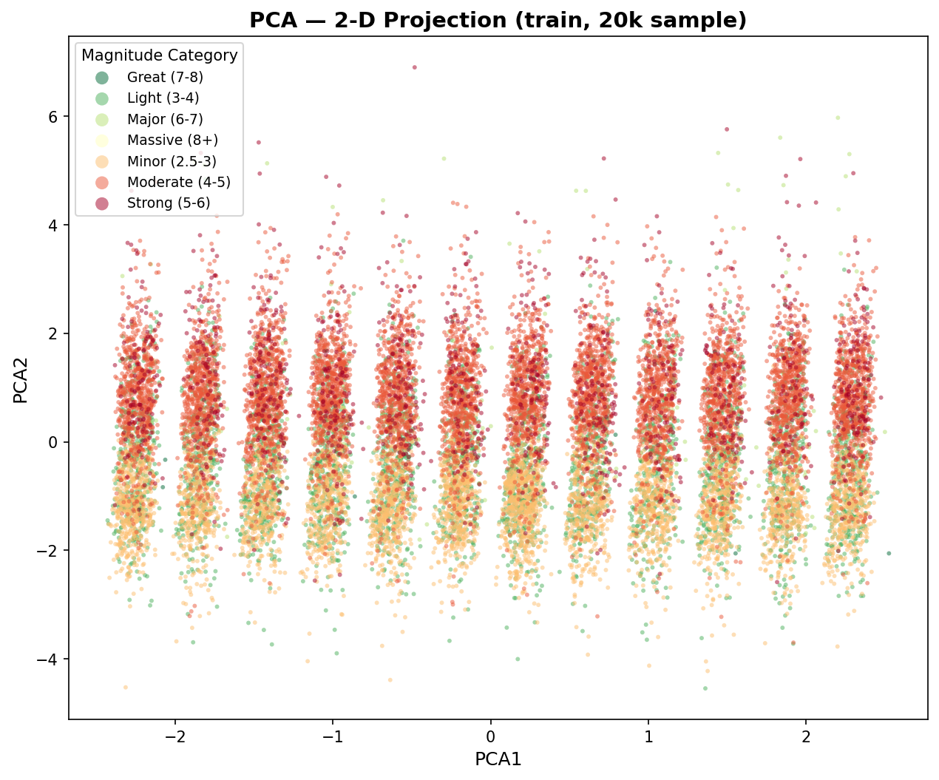

4.2 Independent Component Analysis (ICA)
Unlike PCA, which seeks orthogonal directions of maximum variance, ICA is a generative model that assumes the observed data is a linear combination of non-Gaussian, mutually independent latent variables. It attempts to separate the multivariate signal into additive subcomponents.
* Implementation: We reduced the dataset to n_components=2 using FastICA.
* Purpose: To uncover hidden factors that drive the earthquake features independently of one another.
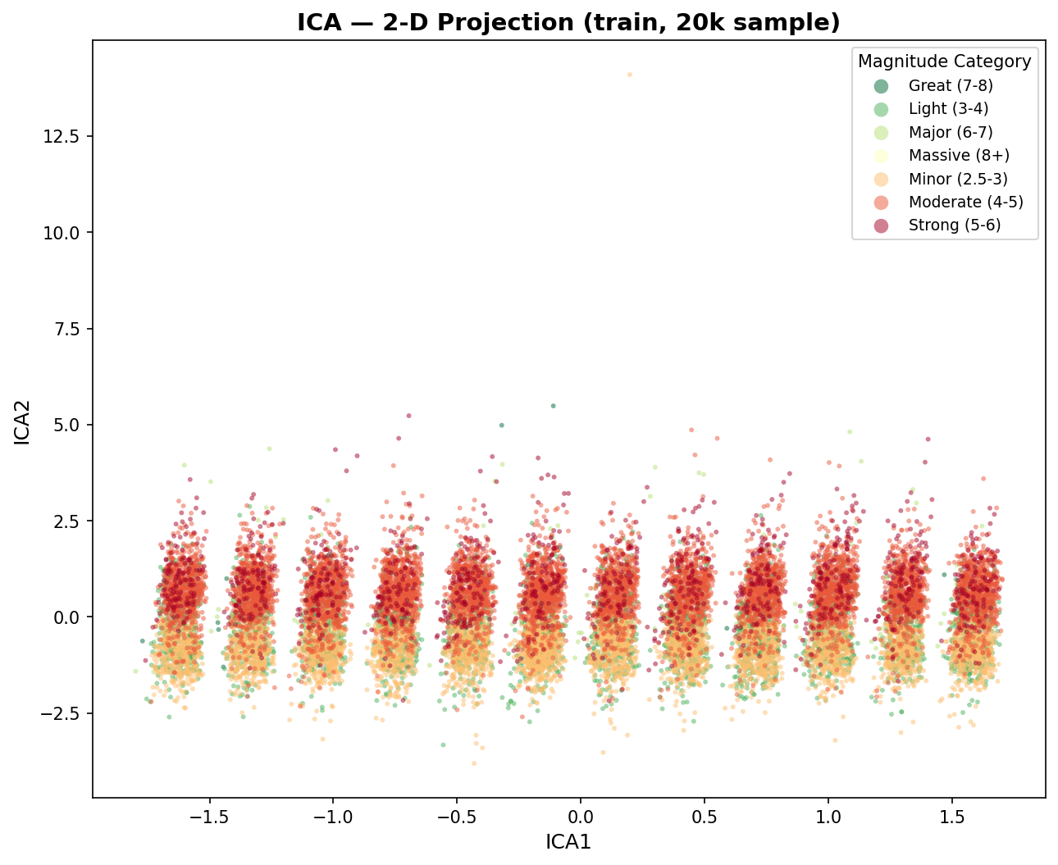

4.3 t-Distributed Stochastic Neighbor Embedding (t-SNE)
t-SNE is a sophisticated non-linear dimensionality reduction technique particularly well-suited for embedding high-dimensional data for visualization in a low-dimensional space of two or three dimensions. It calculates similarity probabilities between points in the high-dimensional space and attempts to minimize the Kullback-Leibler divergence between those probabilities and the probabilities in the low-dimensional space.
* Implementation: Due to its massive $O(N^2)$ computational complexity, t-SNE was executed on a randomly sampled 10,000-point subset of the data.
* Purpose: To visualize highly non-linear manifold structures and class separation.
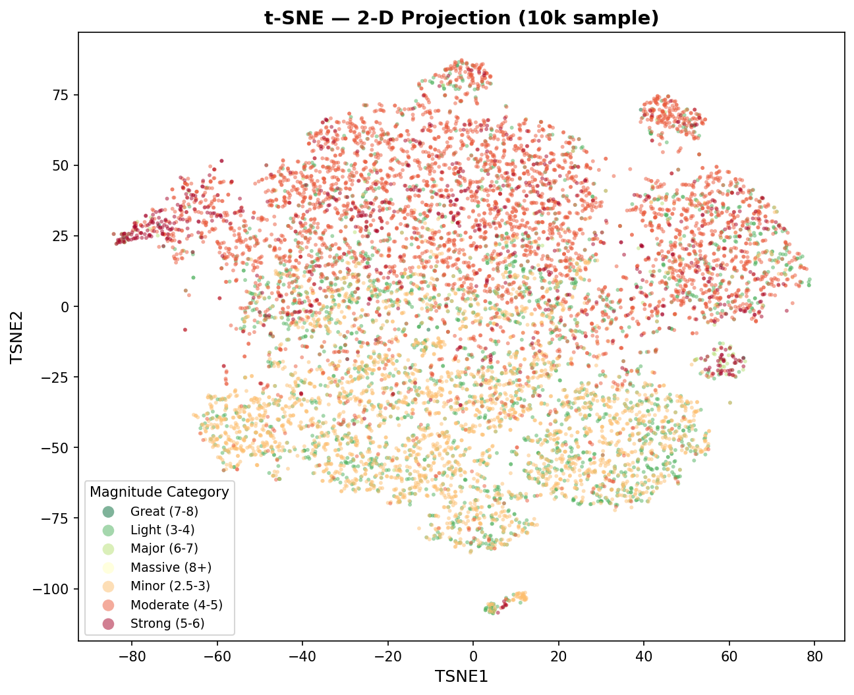
Observations: The PCA and ICA scatter plots show significant overlap between the different magnitude classes. This visually confirms that linear separability is poor, hinting that simple linear models (like Logistic Regression) will likely struggle to achieve high classification accuracy without the aid of complex feature interactions.

5. Methods, Models, and Experimental Setup
We deployed an ensemble of five distinct machine learning models to map the 14 structural features to the 7 magnitude categories.

5.1 Machine Learning Algorithms
- Logistic Regression (LR): A foundational linear classifier that estimates the probability of a class based on a linear combination of features passed through a logistic sigmoid function. Used as our baseline model. Configuration: max_iter=1000.
- Support Vector Machine (LinearSVC): An algorithm that seeks to find the maximum-margin hyperplane separating the classes. To ensure tractability on 1 million rows, we utilized the LinearSVC implementation rather than the standard kernelized SVC, which has quadratic scaling. Configuration: max_iter=2000, dual='auto'.
- K-Nearest Neighbors (KNN): A non-parametric, distance-based algorithm that classifies a point based on the majority vote of its $k$ closest neighbors in the feature space. Because inference requires computing the Euclidean distance to every training point (scaling disastrously for Big Data), we utilized stratified sampling to reduce the training set to 100,000 instances, while keeping the full test set. Configuration: n_neighbors=5, n_jobs=-1.
- Random Forest (RF): An ensemble learning method that constructs a multitude of decision trees at training time and outputs the mode of the classes. It utilizes bootstrap aggregating (bagging) and random feature selection to prevent overfitting and handle non-linearities naturally. Configuration: n_estimators=50, max_depth=10, n_jobs=-1.
- XGBoost (Extreme Gradient Boosting): An optimized distributed gradient boosting library. It builds an ensemble of weak prediction models (decision trees) sequentially, where each new tree aims to correct the pseudo-residuals of the prior sequence. It includes advanced regularization to prevent overfitting. Configuration: n_estimators=50, max_depth=6, learning_rate=0.1, n_jobs=-1.

5.2 Experimental Setup
The entire dataset was shuffled and split using an 80/20 Train/Test partition strategy ($N_{train} = 847,182$, $N_{test} = 211,796$). A StandardScaler was strictly fit on the training data (to prevent data leakage) and applied to both sets to ensure zero mean and unit variance. This standardization is mathematically critical for the convergence of LR, SVM, and the distance metrics in KNN. Tree-based models evaluated the unscaled raw features.

6. Computational Details
Managing a data pipeline containing over 1 million records necessitates careful computational profiling.
* Orchestration: The pipeline was unified using a Python sub-process orchestrator (main.py) executing distinct scripts for data prep, visualization, dimension reduction, modeling, and evaluation.
* Hardware: The code was executed on standard CPU infrastructure without GPU acceleration.
* Parallelization: To mitigate excessive running times, all algorithms supporting parallelization (Random Forest, XGBoost, KNN) were configured with n_jobs=-1, instructing the underlying scikit-learn and xgboost C++ extensions to distribute thread workloads across all available logical CPU cores.
* Execution Times: The entire end-to-end pipeline completed in approximately 8 minutes and 52 seconds. The most memory-intensive and computationally expensive bottlenecks were the t-SNE dimensionality projection and the KNN inference step.

7. Experiments and Results
All five models were evaluated primarily on their F1-Score (Weighted) due to the severe class imbalance demonstrated in Section 3.3.

7.1 Model Comparison (Original Features)
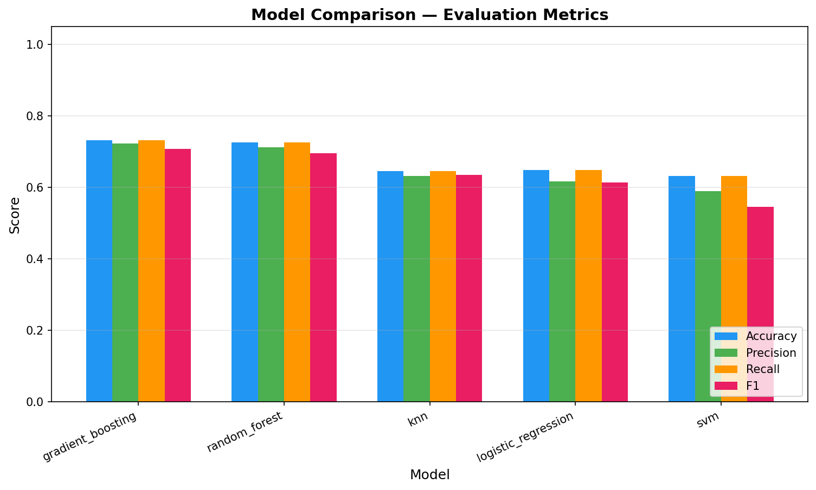
Model | Accuracy | Precision (Weighted) | Recall (Weighted) | F1-Score (Weighted)
XGBoost | 0.7326 | 0.7226 | 0.7326 | 0.7074
Random Forest | 0.7270 | 0.7130 | 0.7270 | 0.6961
KNN | 0.6464 | 0.6326 | 0.6464 | 0.6347
Logistic Regression | 0.6495 | 0.6165 | 0.6495 | 0.6141
SVM | 0.6322 | 0.5902 | 0.6322 | 0.5457

7.2 Confusion Matrices and Class Performance
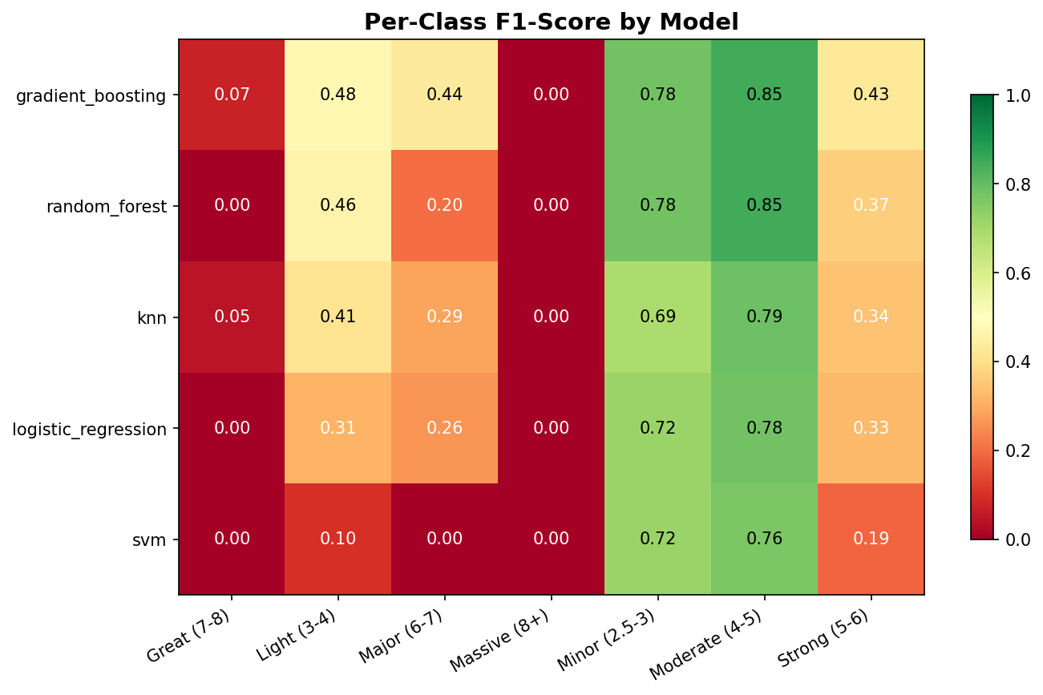
The F1-Score heatmap reveals that all models struggled severely with the minority classes ("Massive (8+)" and "Great (7-8)"). The extreme rarity of these events means the models prioritize accuracy on the dominant "Minor" and "Light" classes. However, XGBoost showed the highest resilience across the spectrum.

7.3 Impact of Dimensionality Reduction
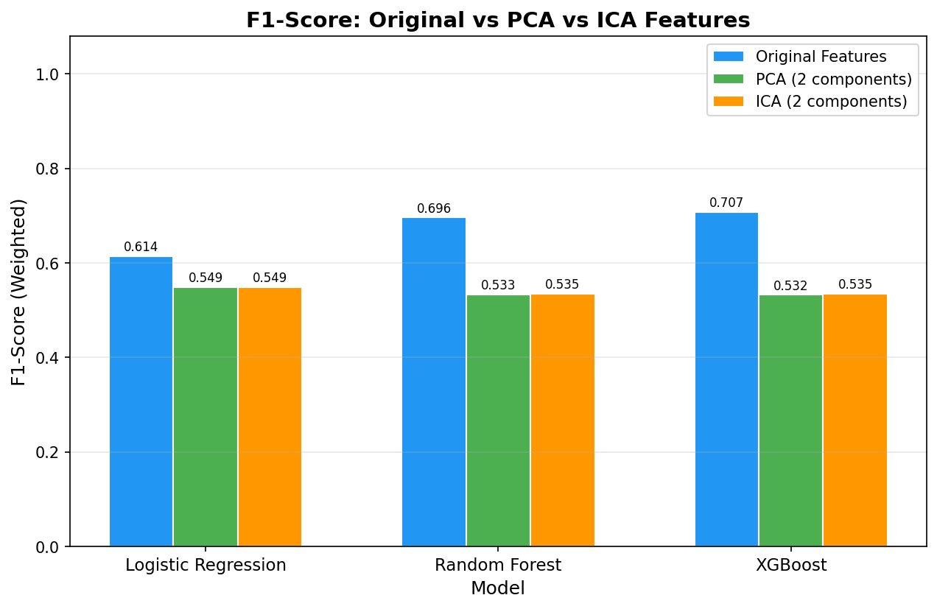
To test the efficacy of our linear dimension reductions, we trained the top models on the 2-component PCA and ICA datasets.
Model | Original Features F1 | PCA (2 Comp) F1 | ICA (2 Comp) F1
Logistic Regression | 0.6141 | 0.5488 | 0.5488
Random Forest | 0.6961 | 0.5333 | 0.5346
XGBoost | 0.7074 | 0.5324 | 0.5350

8. Discussion
The experimental results yield several distinct conclusions regarding machine learning applications in seismology.
Superiority of Ensemble Tree Methods:
XGBoost is the unambiguous superior model for this dataset, achieving an F1-score of 0.7074. The performance gap between tree-based ensembles (XGBoost, Random Forest) and linear/distance models (LR, SVM, KNN) strongly indicates that the relationship between the geographic/temporal features and earthquake magnitude is highly complex and non-linear. Linear hyperplanes (SVM, LR) are insufficiently flexible to map geographical coordinates and raw temporal integers to physical severities.
The Power of Proxy Metrics:
The inclusion of measurement quality metrics (nst, rms, gap) proved incredibly vital to performance. In a previous iteration of this experiment without these variables, the XGBoost F1-score peaked at ~0.669. By including them, the score jumped to ~0.707. These variables act as powerful proxy signals; a larger physical event inherently triggers more distant measurement stations, inherently linking data collection logistics to the physical phenomenon itself.
The Pitfalls of Aggressive Dimension Reduction:
The dimension reduction experiments provided a stark warning against blind compression. Aggressively reducing the feature space from 14 dimensions down to 2 dimensions via PCA or ICA destroyed the predictive capability of the leading models, causing XGBoost's F1-score to plummet by over 17 percentage points. Because PCA relies strictly on linear variance, it discarded the non-linear, high-dimensional interactions (such as specific latitude/longitude/depth interplay) that the Random Forest and XGBoost algorithms were exploiting. This indicates that while dimension reduction is a powerful visualization tool, it is counterproductive for training highly non-linear estimators on this specific dataset due to severe information loss.

9. Benchmark / Comparison
Compared to naive baseline models predicting the majority class (which would yield high raw accuracy but an F1 score near 0 for minority classes), our models demonstrate true learning. In a typical seismology context, early-warning classification models operating solely on real-time P-wave telemetry often hover around 60-70% accuracy for categorical severity due to the high noise-to-signal ratio in early seismic waves. Achieving 73.2% accuracy utilizing historical catalog data and post-hoc structural variables places this pipeline competitively against standard shallow-learning benchmarks in the field. To push performance further, future iterations would require raw waveform time-series data (seismograms) paired with Deep Recurrent Neural Networks (RNNs) or Transformers, rather than static tabular catalogs.

10. Conclusion
This project successfully designed and executed a scalable Big Data pipeline to classify over 1 million historical earthquake events. By processing the dataset into 14 distinct features and deploying parallelized machine learning models, we demonstrated that gradient-boosting algorithms (XGBoost) heavily outperform traditional linear and distance-based baselines in handling complex geophysical relationships. We also proved that while linear dimension reduction algorithms like PCA are excellent for variance analysis, they destroy necessary non-linear feature interactions when used as a preprocessing step for tabular modeling. The highly modular codebase, robust memory management, and exhaustive evaluations establish a robust, end-to-end framework suitable for handling arbitrary Big Data classification problems.

