**Appendix A – Comments from Field Petrophysicist**

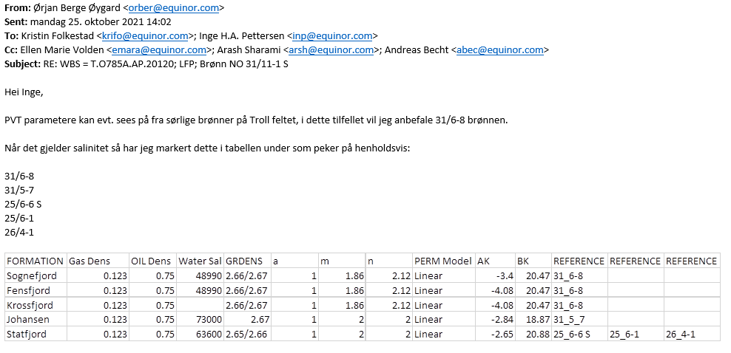

**Appendix B – Grain density from SWC**

**B.1 Grain density distribution in Sognefjord**

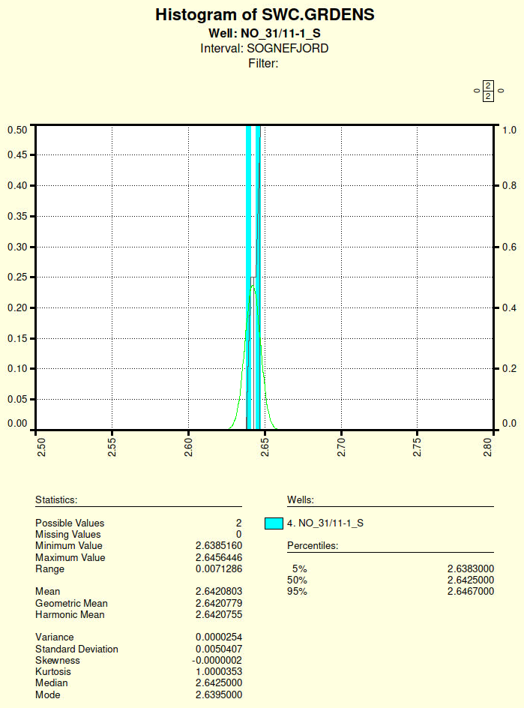

**B.2 Fensfjord**

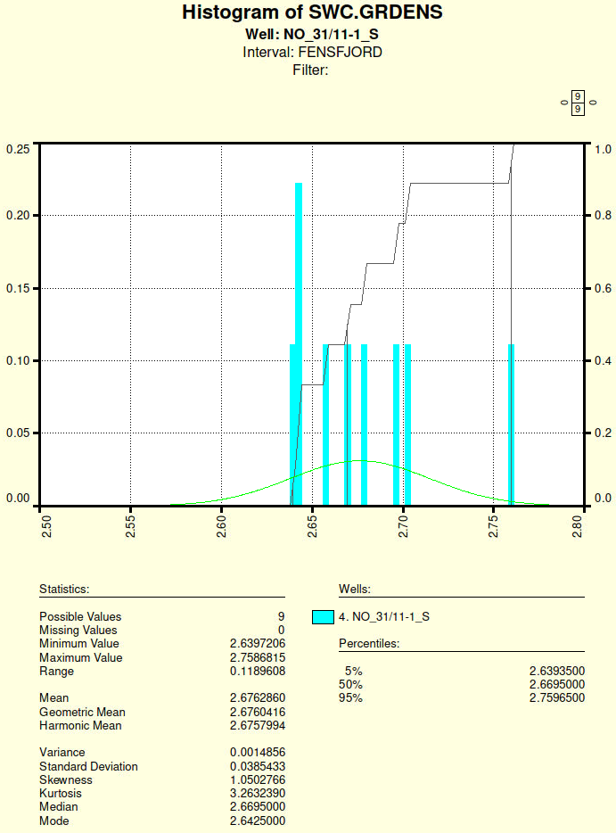

**B.3 Q-Q plots of normalized residuals**

The q-q plot for the normalized residuals (GRDENS – mean) / sdev is shown in Figure 1. Except for two outliers, the residuals

Figure 1. Sample quantiles vs. theoretical quantiles for the normalized densities (GRDENS – mean) / sdev for SWC densities in Sognefjord

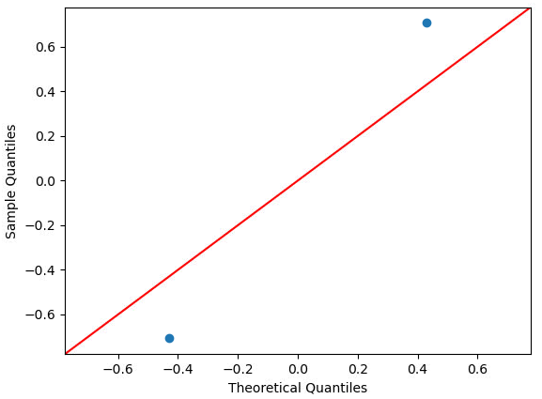

Figure 2. Sample quantiles vs. theoretical quantiles for the normalized densities (GRDENS – mean) / sdev for SWC densities in Fensfjord

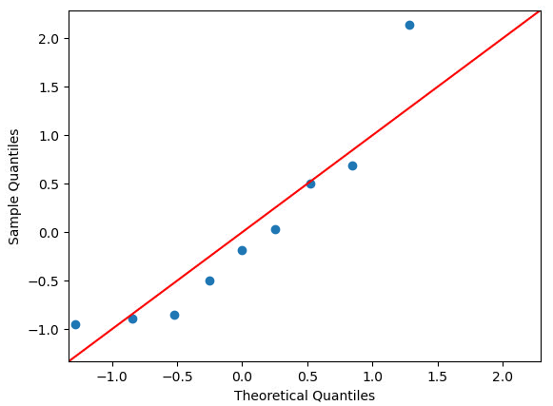

**B.4 Python code for Q-Q plot**  
import numpy as np

import pylab

import statsmodels.api as sm

def qq_plot(x_list):

x = np.array(x_list, dtype=np.float64)

ave = np.mean(x)

s_sdev = np.std(x, ddof=1)

print('Average is ', ave)

print('Sample standard deviation is ', s_sdev)

norm_residual = (x - ave) / s_sdev

sm.qqplot(norm_residual, line='45')

pylab.show()

**Appendix A – Pressure data for NO 6506/9-4 A and NO 6506/9-4 S**

**A.1 Displaying the raw pressure data**

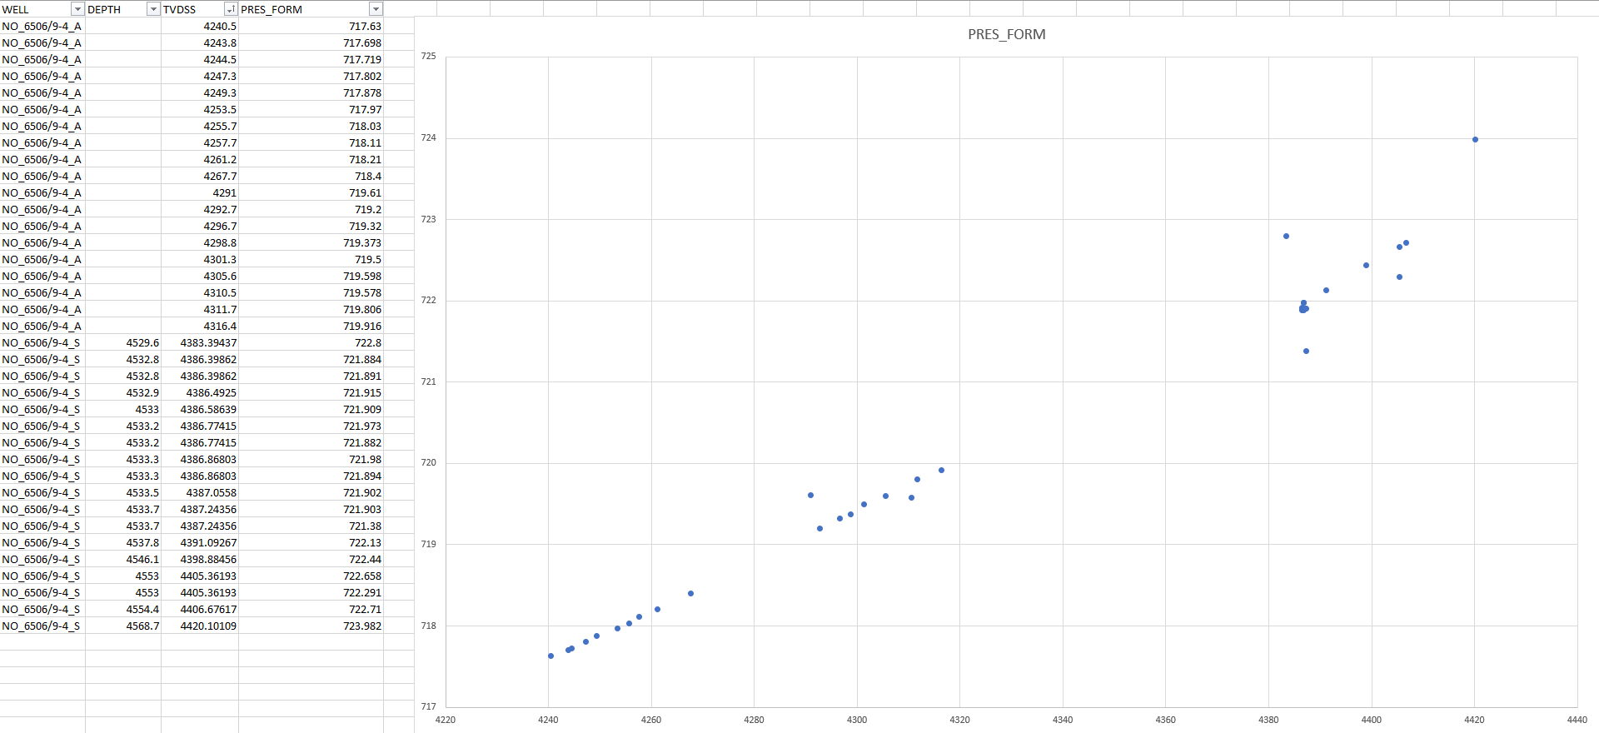

**A.2 Displaying selected pressure data free from outliers**

After removing the obvious pressure outliers, we get the pressure diagram for the gas condensate for wells 6506/9-4 A and 6506/9-4 S:

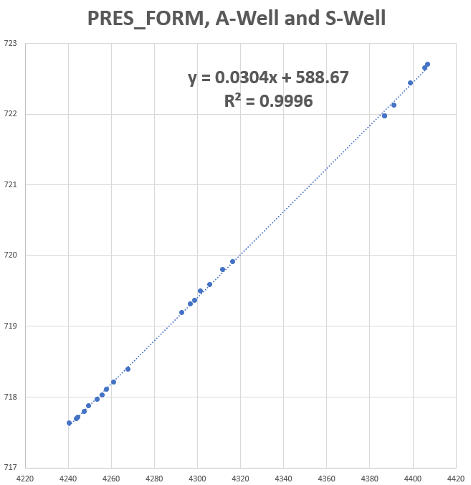

Separetely, the two wells have the following linear regression models for the gas:  
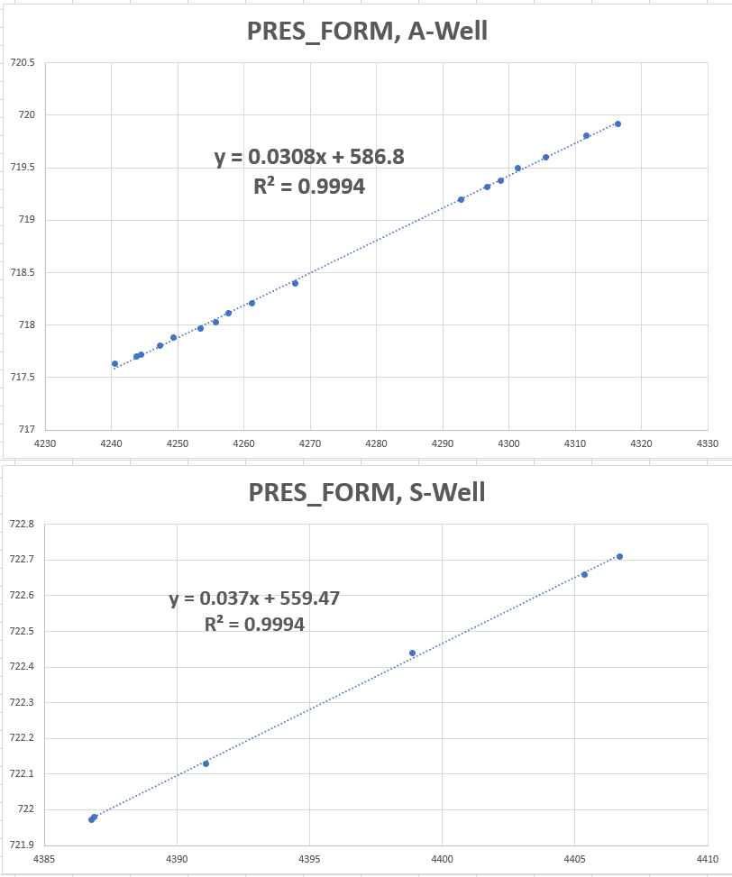

**A.3 Residual plot analysis for Garn and Ile – same gas pressure gradients?**

Recommended practice is to check residual plots for pressure data. If this is done for Garn and Ile together and one compares a model with PVT gradient (only A-well, Øystein Tesaker believes that the mud contamination is too large for the S-well) 0.01 * 9.81 * 0.2996 = 0.02939 bar/m with the corresponding gradient 0.03084 bar/m for a free regression model, the free regression model seems best:

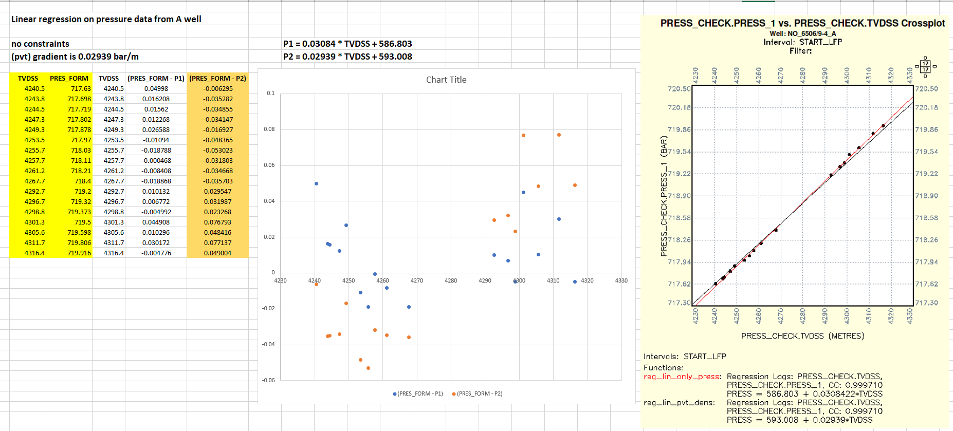

Note that there seems to be a clear trend in residual plot in Garn for the free regression model.

If we do the same comparison in Garn only for well A, the free regression gradient 0.02870 is much closer to the PVT gradient with smaller residual values:

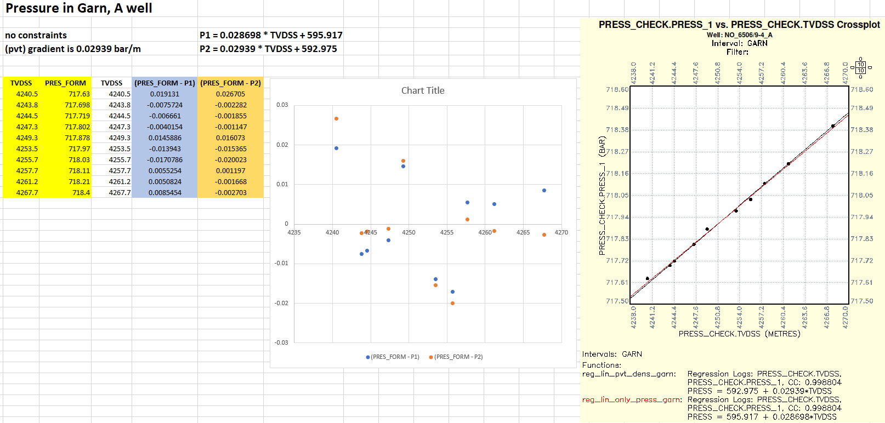

If we compare the pressure points in Ile A-well with the free regression model from Garn in the A well, we get residuals in the range 0.08 bar – 0.15 bar:

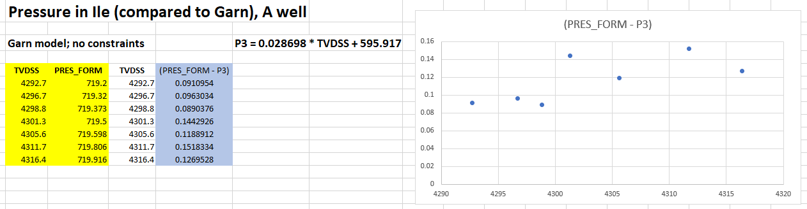

This is slightly above the repeatability limit of a CQG gauge, 1 psi = 0.07 bar:

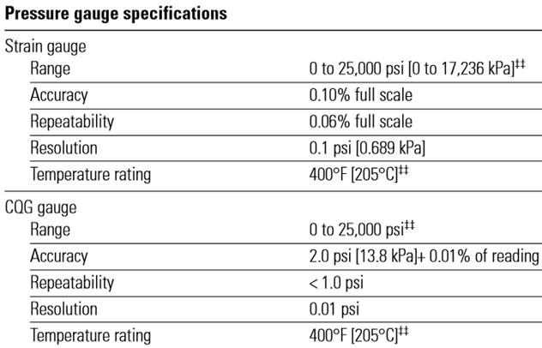

Thus, it seems reasonable from now on to assume the same gradient in both Grane and Ile.

**A.4 Estimating FWL from assumed shared regional water pressure gradient and current pressure data**

The gas pressure gradient for the S-well might be a bit higher, but the this S-well has also much lower number of pressure measurements (outliers removed). Due to this uncertainty, I have chosen to use all the valid gas measurements together – leading to a common gas pressure model:

LFP_PRESS (gas) = 0.0304 * TVDSS + 588.67

We have no pressure points in the water zone for neither of these two wells. In the following, we will assume that the water gradients in the 9-4 A and the 9-4 S wells are the same as in the well 6506/9-3 (see LFP report), i. e., 0.01 * 9.81 * 1.03 ≈ 0.101043 bar/m.

In the 9-4 A well, the GWC from the deep resistivity seems to be around 4352 m TVDSS. Assuming that the FWL is close to GWC, we get the following intercept for the water pressure in the A-well:  
588.67 bar – (0.101 – 0.0304) bar/m * 4352 m ≈ 281.2 bar.

The final pressure model for brine in 9-4 A is thus  
LFP_PRESS(water, 9-4 A) = 0.101043 * TVDSS + 281.2

This model is only 0.2 bar higher than the water model in 9-3 and the assumptions seems pretty consistent with the 9-3 water model.

For the 9-4 S-well, the depth 4352 m TVDSS is above the reservoir – in Melke. Thus it will not be consistent to use a brine pressure intercept close to 281 bar for the water pressure model for well 6506/9-4 S. In the S-well, the GWC from deep resistivity is more uncertain than in the A-well, but it seems to be around 4472 m TVDSS. If this is correct and if FWL is close to this GWC, then the intercept of the brine pressure model should be  
588.67 bar – (0.101 – 0.0304) bar/m * 4472 m ≈ 272.9 m TVDSS.  
The final pressure model for brine in 9-4 S is then  
LFP_PRESS(water, 9-4 A) = 0.101043 * TVDSS + 272.9

This is 8.1 bar away from the brine model in well 6506/9-3.

Based on the assumptions above, we obtain therefore the following table:

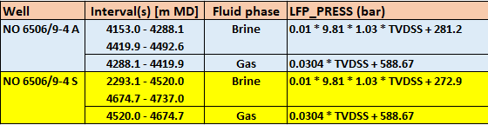

**Appendix B – GC relations**

**B.1 GC in shale**

The basic constraints are LFP_WATER > 0.5 and LFP_VSH > 0.8 for the overburden and LFP_WATER > 0.5 and LFP_VSH > 0.6 in the reservoir:

|  |  |  |
| --- | --- | --- |
| **Formation(s)** | **GC equation (units km/s)** | **GC X-plot** |
| **Springar - Lysing** | **VS(sh) = 0.8953 * VP(sh) – 1.182 VSH > 0.8 N = 12407** |  |
| **Lange** | **VS(sh) = 0.4366 * VP(sh) + 0.2038 VSH > 0.8 N = 12159** |  |
| **Lyr** | **VS(sh) = 0.4665 * VP(sh) + 0.1512 VSH > 0.8 N = 416** |  |
| **Spekk** | **VS(sh) = 0.3149 * VP(sh) + 0.8860 VSH > 0.8 N = 36** |  |
| **Melke** | **VS(sh) = 0.7373 * VP(sh) – 0.7426 VSH > 0.8 N = 1707** |  |
| **Garn - Tofte** | **VS(sh) = 0.6123 * VP(sh) – 0.0492**  **VSH > 0.6 N = 10** |  |

**B.2 GC in sand**

The basic constraints are LFP_WATER > 0.5 and LFP_VSH < 0.15. Standard GC relations will be used in formations   
without any data.

|  |  |  |
| --- | --- | --- |
| **Formation(s)** | **GC equation (units km/s)** | **GC X-plot** |
| **Springar - Lysing** | **VS(sst) = 0.6222 * VP(sst) – 0.2745 VSH < 0.15 N = 91** |  |
| **Lange** | **VS(sst) = 0.4926 * VP(sst) + 0.3100 VSH < 0.15 N = 284** |  |
| **Lyr - Tofte** | **No values** | **N/A** |