Implementation of A Non-linear Sonic-based Temperature Model – Comparison with Linear Models and DST Experimental Values

1 Physical framework
The thermal conductivity k in the temperature model of Kjetil Hokstad is determined by the logs VCLDRY and VP and a constant of proportionality 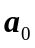 according to the formula
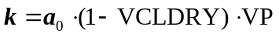 .
The resulting temperature distribution may then be calculated if the heat flow Q is assumed to be a known constant and if the seabed temperature 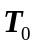 is known:
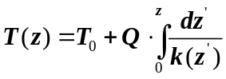
If the temperature at bottom hole is 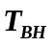, we get the following expression for the heat flow:
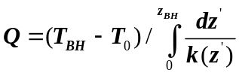
Inserting this expression back into the temperature function, we get
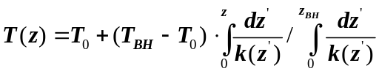
From the last equation we notice that the temperature function is independent of the constant of proportionality .
2 Constraints on Calculation
2.1 Method of Extension of Logs to Seabed
The Kenneth Duffaut model for extending logs beyond the logged intervals should be used: If the value of the compressional velocity 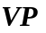at the seabed and the bottom hole are respectively 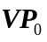 and 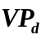, then for 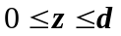the Kenneth Duffaut model suggests an interpolation
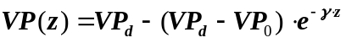
for a constant 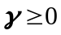.
2.2 Preferability of VCLDRY to VSHDRY
The log LFP_VCLDRY has priority to the log LFP_VSHDRY. Only if LFP_VCLDRY is missing, then LFP_VSHDRY should be used.
2.3 Consistency between LFP_VP_V and LFP_VSHDRY
Assume that the only non-MISSING values of LFP_VP_V and LFP_VSHDRY are in a single continuous range – the range of evaluation of an LFP interpretation.
3 Determination of the Extension coefficients in section 1.2.1
3.1 Geometrical approach
Make an educated guess of the compressional velocity at seabed , say 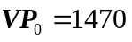. If the logs start at TVDML = s, choose the depth TVDML = d such that d > s. For depths in the range 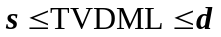, make a plot of 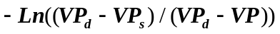vs TVDML. According to the model in section 1.2.1, the points should lie on a straight line through the origin with gradient .
3.2 Optimalization approach
This approach involves the Excel Solver add-in where both and are unknown. If the logs start at TVDML = s, choose the depth TVDML = d such that d > s. For depths in the range , make columns of TVDML, VP, and 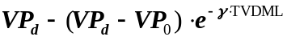. Choose now as objective function the sum of squared deviation between VP and for all increments in the range . Minimize the objective function with the following constraints: 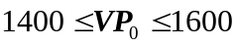 and 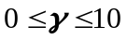.
4 Numerical approach
The first approach was to do the programming in two separate programs that are supposed to merge in the end. The purpose of the first program is to determine the heat flow (section 2) and the other is to determine the temperature log (section 3).
4.1 Interface for temp_v5.lls
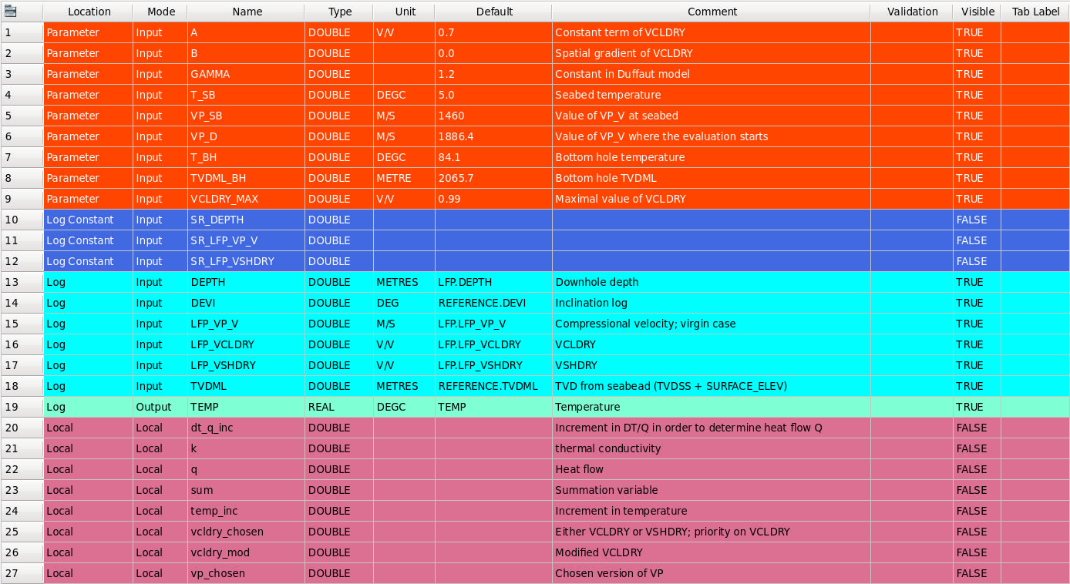Figure 1. Interface for temp_v5.lls.
4.2 Code for temp_v5.lls
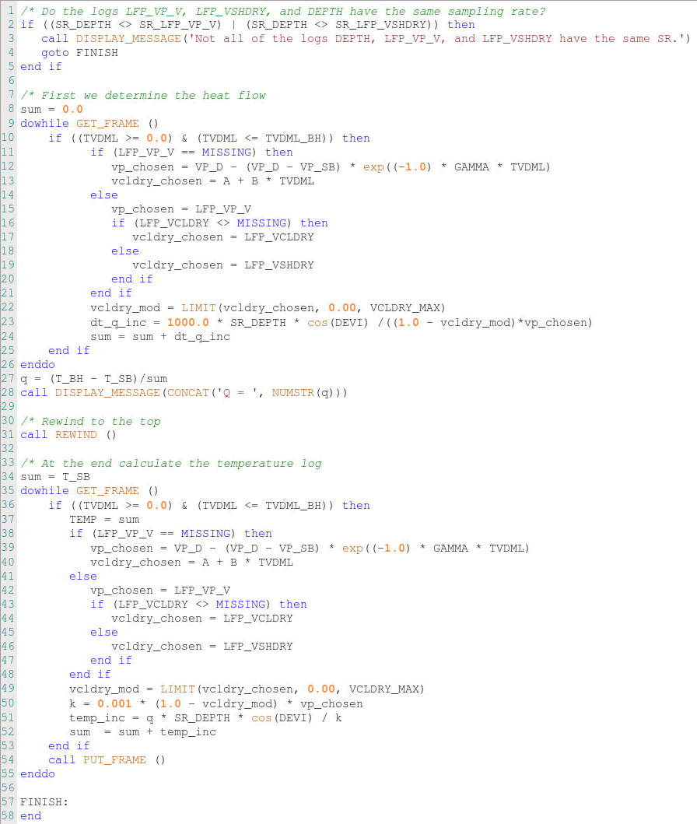Figure 2. Code for temp_v5.lls.

4.3 Test of temp_v5.lls
We tested the compiled version of the code given in section 2.2 on well BR_1-ALS-47 with input variables as given in Figure 3.
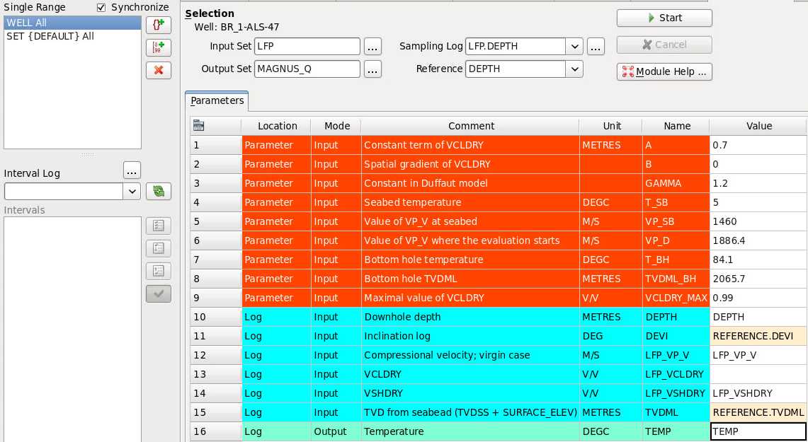Figure 3. Test configuration for code in section 2.2.
The feedback by running this test is Q = 0.020453 as shown in Figure 4 and the temperature log TEMP is as shown by Figure 5. Notice that the final temperature is 84.0839 °C which is close to the theoretical value 84.1 °C.
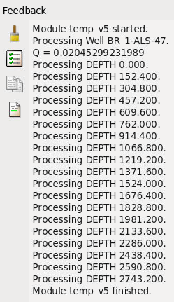
Figure 4. Test result of temp_v5.lls.
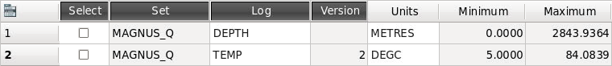
Figure 5. Temperature log generated by temp_v5.lls.

