READ ALL INSTRUCTIONS AND THEN PERFORM THE FOLLOWING STEPS IN ORDER
- Click on the Office Button, select save as and save this document to your computer.
- Double click on the copy of this file you just saved. Type the title of your document in the indicated area as instructed. Select other information as indicated – will highlight as your cursor rolls over them.
- Read Chapter 1
- Scroll to Chapter 2 to read about the automatic Table of Contents, Heading Styles, Tables, Figures, References and Appendices.
- To remove this box, click on it, point to the out edge until you see the Move icon, click to select and press the Delete key.
If you have questions regarding this document please call Graduation Services at (614)-292-6031

Enter Title Here - Mixed Case Preferred.

Select Document Type from list

Presented in Partial Fulfillment of the Requirements for the Degree Select Correct Degree in the Graduate School of The Ohio State University

By
Enter Your Legal Name
Graduate Program in Choose an item.

The Ohio State University
Select Year of Graduation

Choose an item. Committee:
Enter member names in indicated format, indicate advisor with “, Advisor” after name

Copyright by
Enter your legal name
Year of Graduation

Abstract

An abstract is a concise account of the thesis or dissertation and should state the problem, describe the procedure or method used, and summarize the conclusions reached. An abstract is required for all papers. A maximum of 500 words are recommended for all documents. Format paragraphs with the same layout used in the document. All lines on this page are double spaced.
An optional Dedication Page may follow the Abstract. The text on the Dedication Page is centered horizontally and vertically on the page. Always use the page break command (in Microsoft Word, use CTRL-Enter or Insert/Page Break/Next Page) to move to a new page anytime text does not fill a page. This reduces the number of codes in your document and helps assure proper page placement when converting to an Adobe PDF file.
To add a Dedication Page, move to the end of the final paragraph, press the Enter key once, and press CTRL-Enter to begin a new page. You do not need to place the title “Dedication” on the dedication page.

Dedication

This document is dedicated to my family.

Acknowledgments

The Acknowledgments page is optional. This page includes a brief, sincere, professional acknowledgment of the assistance received from individuals, advisor, faculty, and institution.

Vita

March 1900 Moscow Jr. High
1950 B.S. Chemistry, Idaho State University
1970 M.A. History, Boise State University
1980 to present Graduate Teaching Associate, Department of Physics, The Ohio State University

Publications

If you have no publications, remove this entire section, including the heading “Publications”

Fields of Study

Major Field: Select Graduate Program.

Table of Contents

Abstract ii
Dedication iii
Acknowledgments iv
Vita v
List of Tables vii
List of Figures viii
Chapter 1: Using This Document 1
Chapter 2: How to Modify Your Document 2
Indenting Paragraphs 2
Changing Heading Style 2
Table of Contents 4
Updating the Table of Contents 5
Tables and Figures 6
Landscaped Tables and Figures 9
References 12
Appendix A: Formatting Appendix Pages 15

List of Tables

Table 1. Graduate Degree Recipients 2004-2008 6

List of Figures

Figure 1. Opening the Style menu 3
Figure 2. Using Styles Menu to Format Headings 4
Figure 3. Inserting Captions 7
Figure 4. Inserting List of Tables or List of Figures 8
Figure 5. Sample Landscaped Figure 10
Figure 6. Text Box Drop Down Menu 11
Figure 7. Close-up of Section of Format Bar 12
Figure 8. The Ruler Bar and Hanging Indent 13
Figure 9. The Ruler Bar with the Hanging Indent icon moved 1/2 inch to the right 13
Figure 10. Sample 1/2 title page 16

Chapter 1: Using This Document

This information refers to the PC version of Microsoft Word.
If you already have a thesis or dissertation file, you may want to copy only parts of this document into your current document. If you paste text into this document you may need to reformat your heading levels before regenerating the automated Table of Contents. Information on how to do this is contained in the next chapter.
Additional information on the required format for your graduate document can be found in the Guidelines for Formatting Theses, Dissertations and DMA Documents on the Graduate School website, www.gradsch.osu.edu under the Forms and Publications heading.
While this document does not indent the first line of each paragraph, it is perfectly acceptable to do so – just be consistent. If you start indenting then all paragraphs must have the first line indent. If the Guidelines for Formatting Thesis, Dissertation and DMA Documents does not specify a format, then select a format that is agreeable to you and your committee. You must be consistent in the format style once begun.

Chapter 2: How to Modify Your Document

This document includes the settings for margins, page numbers, an automatic Table of Contents, an automatic List of Figures and List of Tables, and pre-set styles for the first five levels of headings and sub-headings from the APA style manual. If you elect to use this template to format your document, delete any unwanted text and tables/figures from this template after reviewing all instructions and then copy and paste your chapters into this template. You may need to highlight each title in your document, format them to the Levels as discussed below, add them to the automatic Table of Contents if desired, and finish by updating the Table of Contents.

Indenting Paragraphs
This template does not indent the first line of each paragraph. However, it is perfectly acceptable to do so. The style must be consistent throughout your document.

Changing Heading Style
Go to the Home tab on the Word tool bar. You will see a box with the words “Change Styles” (see Figure 1). Directly below this box is an arrow. By clicking on this arrow, you will bring up the Styles menu which shows various heading styles for your document. This template uses the first five heading levels in the APA style manual as a standard format and these are pre-set on the Styles menu as Level 1 through Level 5. Other heading styles are acceptable if you are writing in another format (Chicago, journal-required style, etc) or if another format is suggested by an advisor.
If you click on the above chapter heading and open the Styles menu, you will notice that Level 5 is selected. To change the format of headings, highlight the heading you wish to change and open the Styles menu. Select the Level you wish to use, click on the symbol to the right of the style name, and select ‘modify’ (see Figure 2).

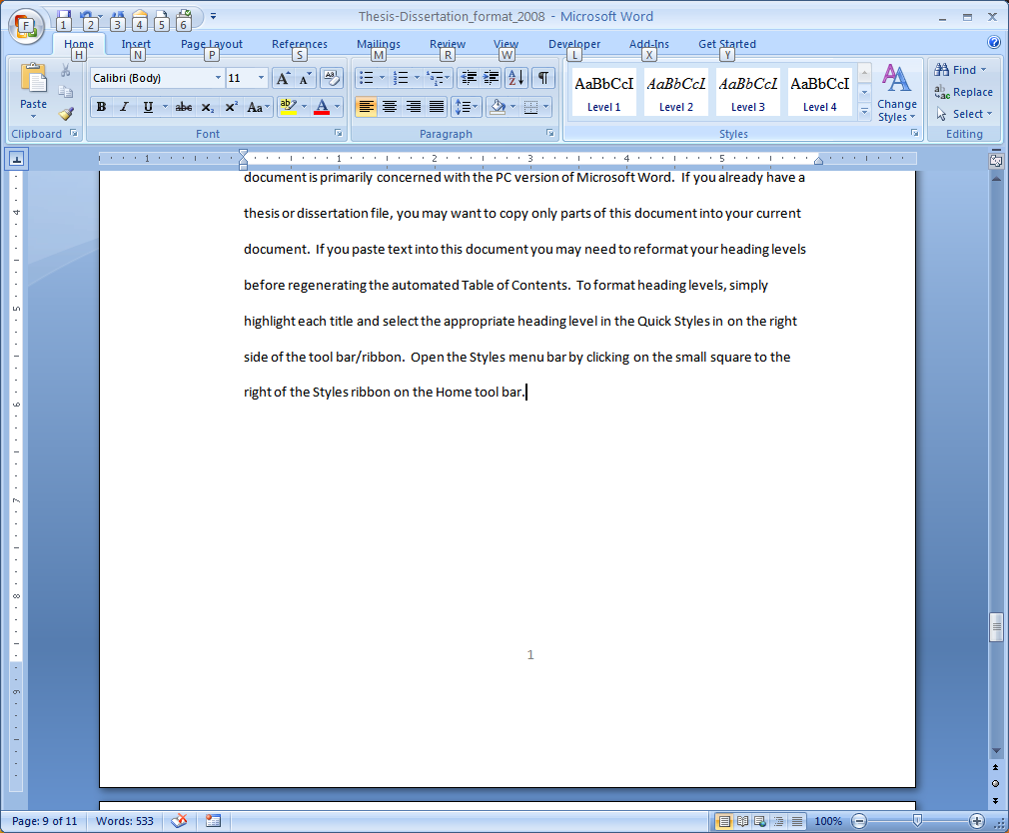
Click on box in this corner to open the Styles menu frame
Figure 1. Opening the Style menu

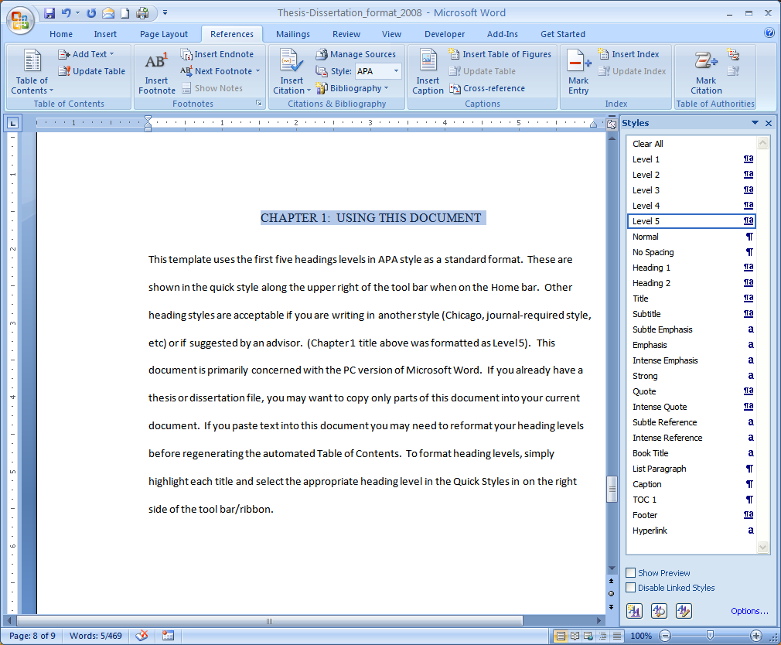
Highlight title.
Select Level 5 from Quick Styles or Styles Menu
Figure 2. Using Styles Menu to Format Headings

Table of Contents
Once you have added a title to your document and formatted it appropriately, you can add it to your Table of Contents. Highlight the title you wish to appear in the Table of Contents and click on Add Text which is found in the Table of Contents box of the References tab. Then select the appropriate level – Level 1 for chapter titles, Abstract, Dedication, Acknowledgments, List of Tables, List of Figures, and appendices (those items formatted using Level 5 on the Styles menu); Level 2 for the first level of subheadings within the chapter (those titles formatted using Level 1 on the Styles menu); Level 3 for the second level of subheadings within the chapter (those titles formatted using Level 2 on the Styles menu).

Updating the Table of Contents
While you have the option of doing your Table of Contents manually, this template does include an automated Table of Contents. To use this automated version, first format the headings as discussed above. Make sure you have opened the References tab, and go to the Table of Contents page. Click on any of the title appearing on the page. All of the heading in the Table of Contents should turn grey. Then, click on Update Table in the Table of Contents box on the References tab, select Update Entire Table and then click OK. You have now updated the Table of Contents for your document.
Titles appear in the Table of Contents in the same format as they were typed in the document (upper and lower case or all upper case).
Removing Unwanted Text from the Table of Contents
Sometimes when you update the Table of Contents, unwanted text appears. This usually happens with misplaced paragraph codes (obtained by pressing the Enter key), or a heading code in the text of the document. Locate and highlight the unwanted text in the body of the document. Select Normal from the Styles menu to reformat the text. Regenerate the Table of Contents as discussed above. If the unwanted text still appears, click the Show/Hide icon 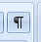 from the Paragraph box on the Home tab. Move through your document to the area where the unwanted text is appearing Determine where the code begins and ends in the text, highlight (select) the affected text and select Normal from the Styles menu. This should reformat the text correctly.

Tables and Figures
To place Tables or Figures in your document, at the end of the last line of text preceding the table or figure, press the Enter key two times while in double spacing. In addition, press the Enter key two times after inserting a table or figure before continuing with the text of your document (see Table 1). These steps allow for proper formatting of your table or figure.

Year | MS Recipients | MA Recipients | PhD Recipients
2004 | 674 | 657 | 555
2005 | 687 | 685 | 639
2006 | 635 | 658 | 638
2007 | 629 | 659 | 697
2008 | 688 | 585 | 707
TOTAL | 3313 | 3211 | 3231
Table 2. Graduate Degree Recipients 2004-2008

After inserting the image (without a number or caption), click on the image so it is the active segment of the document. Click on the References tab and select Insert Caption from the Captions box (see Figure 3). If the label does not indicate the correct type of illustration (Table or Figure) select the appropriate type in the Label box and type the title in the title box the way you want it to appear in the text. Be consistent – the captions for all figures must be the same (all upper case, upper and lower case, or only the initial word capitalized) and all tables the same. Do not alter the Position of the caption. Click OK to insert the caption.

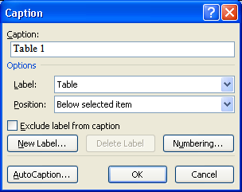
Select Table or Figure here using Drop-down menu
Type Caption in here.
Figure 3. Inserting Captions

Once you have inserted and captioned all of your tables and figures, you can automatically create a List of Tables or a List of Figures. Insert this page after the Table of Contents. Go to the List of Figures page. Place your cursor on the page and click. The contents of the current list should be highlighted in gray. Select the References tab, and from the Captions box select Insert Table of Figures (see Figure 4). Select the Figures as the label, and make sure that Include label and number is checked. Click OK. Repeat the process, if necessary, to create a List of Tables.

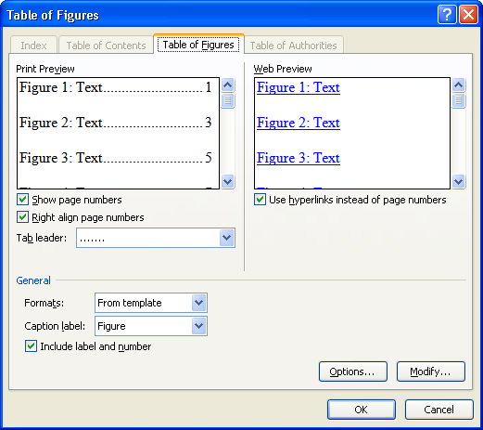
Select label according to type of List you are generating
Figure 4. Inserting List of Tables or List of Figures

Figures and Tables normally are mentioned in the text before they physically appear. However, they can also be placed at the end of the chapter in which they are discussed or at the end of the document in an appendix.
For tables or figures too long to fit on a single page, the caption appears at the bottom of the first page, with “continued” in the lower right corner of the page. On each subsequent page, type “Table/Figure # continued” in the upper left corner, and “continued” in the lower right corner of the page, as needed. (See Sample Pages for Theses, Dissertations, and DMA Documents on the Graduate School website.)
Always begin long or large tables and figures at the top of a page. If an illustration will fit on a single page it must be kept together on a single page. If the illustration will fit on the page, but there is no room for the caption, then the caption may be placed on a ½ title page proceeding the illustration. The figure/table number must appear on both the ½ title page and the page with the illustration. (see Figure 10)

Landscaped Tables and Figures
Some figures or tables will not fit on a standard portrait page. Landscaped pages in your document will have the same margin requirements, rotated 90 degrees. The binding edge will be at the top of the illustration and remains 1.5 inches. The page number remains bottom center but in the portrait position with a one-inch margin between the bottom of the page number and the left edge of the page. The other two margins remain at least one inch. The caption of the landscaped illustration is also landscaped. To insert a landscaped illustration (see Figure 5), begin by going to the Page Layout tab, selecting Breaks from the Page Setup box, and selecting Section Break (Next Page). Now that you are on a new page, on the Page Layout tab, select Orientation and then Landscape. On the Insert tab, select page Number, Format Page Numbers, and select Continue from Previous Section.
Then, press the enter key one or two times to be sure you are clear of the command line. You are now ready to insert your illustration. Insert in the same manner you would any other illustration. Add the caption as described above.
Once you have entered your landscaped page(s), repeat the steps and select Portrait orientation instead of Landscaped.

10
Figure 5. Sample Landscaped Figure

Use a Text Box (formatted for no border) to put the page number where it belongs in the bottom center portrait position.
To do this, select Text Box from the Insert tab. Select Draw Text Box (see Figure 6).

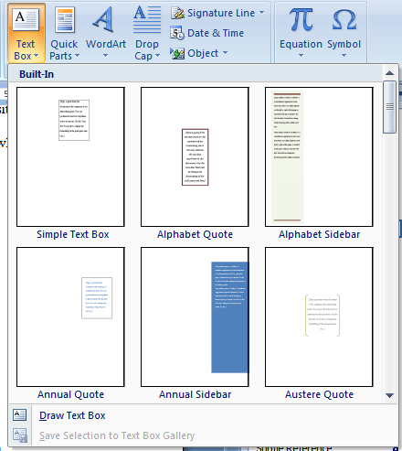
Figure 6. Text Box Drop Down Menu

Using the drawing tool that appears, draw a text box to cover the page number. You may need to create the initial Text Box in the body of the page and then drag it into the footer to cover the page number. Once it is covered, select Shape Outline from the Text Box format menu that appears on the Tool Bar and select No Outline (see Figure 7).
To put the page number in its proper location (bottom center portrait), again select the Text Box, and Draw Text Box, but draw the text box on the left side of the screen. Type in the correct page number. Using the Text Direction from the Text Box Tools (which appears when you have drawn the box) rotate the page number to the correct orientation. Remove the outline border and the page number is done.

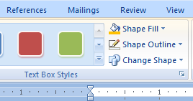
Select this drop down menu to remove the text box border/outline
Figure 7. Close-up of Section of Format Bar

References
References should be formatted according to your academic discipline requirements. If your department or discipline requires hanging indents, position the cursor in the entry (or highlight multiple entries) and on the Ruler Bar drag the Hanging Indent icon ½ inch to the right of the left margin. This will indent the second line of text in the entry ½ inch from the left margin.

Ruler Bar
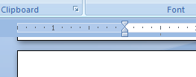
Hanging Indent Icon
Figure 8. The Ruler Bar and Hanging Indent

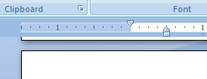
Hanging Indent icon moved ½ inch to the right
Figure 9. The Ruler Bar with the Hanging Indent icon moved 1/2 inch to the right

Sample references without hanging indent:

Wilson, Harold, Jr. Buckeye Olympians. New York, NY: Penguin Publishing, 2008.

McCaffrey, Anne. Pegasus in Space. New York, NY: Del Rey, the Ballantine Publishing Group, 2000.

Sayers, Dorothy L. Lord Peter: A Collection of all the Lord Peter Wimsey Stories. New York, NY: Avon Books, Arper & Row, Publishers, Inc., 1972.

Sample references with hanging indent:
Wilson, Harold, Jr. Buckeye Olympians. New York, NY: Penguin Publishing, 2008.

McCaffrey, Anne. Pegasus in Space. New York, NY: Del Rey, the Ballantine Publishing Group, 2000.

Sayers, Dorothy L. Lord Peter: A Collection of all the Lord Peter Wimsey Stories. New York, NY: Avon Books, Arper & Row, Publishers, Inc., 1972.

Sample references with first line indent:

Wilson, Harold, Jr. Buckeye Olympians. New York, NY: Penguin Publishing, 2008.

McCaffrey, Anne. Pegasus in Space. New York, NY: Del Rey, the Ballantine Publishing Group, 2000.

Sayers, Dorothy L. Lord Peter: A Collection of all the Lord Peter Wimsey Stories. New York, NY: Avon Books, Arper & Row, Publishers, Inc., 1972.

Any of these formats are acceptable. The style must be consistent throughout the reference section.

Appendix A: Formatting Appendix Pages

Appendices contain pages and materials that do not fit logically in the body of your text or stop the flow of your document. They typically contain data tables, raw data, consent forms, programming codes, permission to use copyrighted materials, etc. Any font and text size can be used in appendix so long as it remains legible.
There are two acceptable formats for the appendices:
- As shown above, the word “Appendix” followed by a letter and a title need to appear at the top of the first page of each appendix, centered on the line, two inches down from the top edge of the paper edge. The content of the appendix begins immediately below the title. The appendices begin with Appendix A and continue through the alphabet, as needed.
- If the use of a two-inch top margin on the first page of the appendix will interfere with the formatting of the contents of that appendix, the use of a ½ Title Page as the initial appendix page is allowed. This page would appear at the beginning of the related appendix, is paginated in sequence, and contains the correct appendix identifiers (see Figure 10).
The format must be consistent throughout the appendices

Title is centered on line, just above the middle of the page. Type it in the way you want it to appear in the Table of Contents, then highlight and select Level 5 from the Style menu.
Figure 10. Sample 1/2 title page

Each appendix should be listed in the Table of Contents along with the title. Tables and figures contained in the appendices must appear in the appropriate List of Tables or List of Figures. Label each in the order they physically appear in the document and continue the numbering sequence from the chapters – either sequential (1, 2, 3) or decimal (Chapter/Appendix #/Letter. # of illustration in that chapter/appendix).

