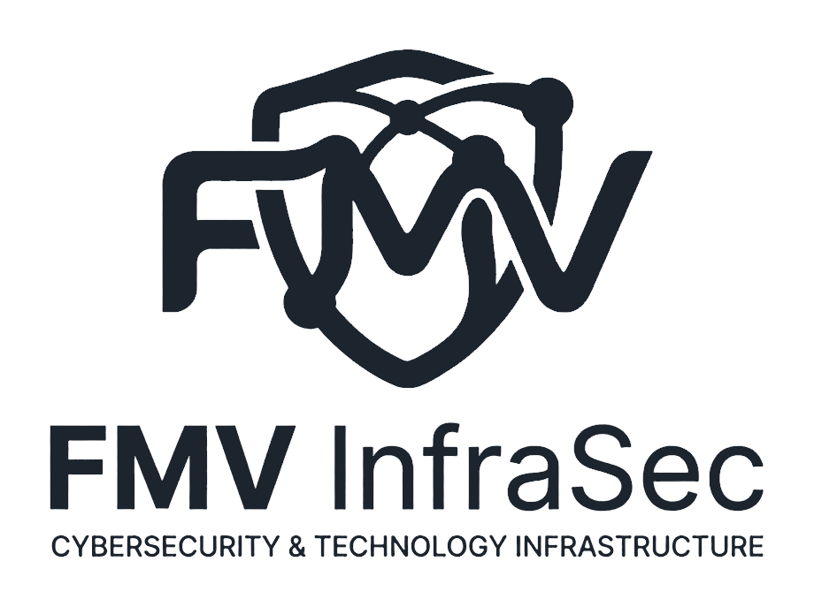

Portfolio implementation
manual
FMV InfraSec · Andrés Felipe Martínez Obando
Publishing, maintenance, domain and security guide

Document | Version | Audience
EN | 2026-08-14 | Owner or support person without advanced experience

Purpose — Put the site online, keep it current and protect personal information.

1. What is included
The portfolio is a bilingual web application for mobile and desktop with light and dark themes. It explains the professional profile in plain language and provides a deeper technical layer for specialist recruiters.
- Spanish and English website.
- Profile PDFs in both languages inside a secondary documents section.
- Hero without decorative rings or coordinates, focused on professional value and useful proof.
- Independent areas: cybersecurity, infrastructure, software, technical virtual assistance and automotive mechatronics.
- Theme-aware FMV InfraSec logo.
- SEO metadata, accessible navigation and saved preferences.

2. Information to complete before launch
Field | Action | Status
Corporate phone | +57 302 528 6029 · WhatsApp | Configured
Email | ingenierossoftware31@gmail.com | Configured
GitHub | github.com/ingesoft04 | Configured
LinkedIn | linkedin.com/in/anmartinez94 | Configured
Upwork | freelancers/~0199b81b4f763382ef | Configured
Workana | Add profile when ready | Optional
Dominio | Choose and purchase; example: fmv-infrasec.com | Optional

Privacy — Do not publish addresses, identity documents, credentials, IP addresses, client names or protected infrastructure details.

3. Computer requirements
- Windows 10/11, macOS or Linux.
- Node.js 22.13 or newer.
- pnpm installed.
- Git installed.
- A GitHub account and either a Vercel account or Codex Sites access.
node --version
pnpm --version
git --version
If any command does not return a version, install that tool from its official website and restart the terminal.

4. Project structure
Ruta | Contents
app/page.tsx | Main content, sections, buttons and interactions
app/components/ | Navigation, opportunity selector, projects, and contact
public/og.png | Social image for LinkedIn, WhatsApp, and other platforms
app/hooks/ | Reusable state for language and appearance
app/globals.css / recruiter.css | Colors, components, mobile layout and themes
app/layout.tsx | Title, description, keywords and icon
public/ | Logo and downloadable PDF files
build/ | Document generation and validation scripts
.openai/hosting.json | Sites hosting configuration

SOLID and responsive architecture — The main page coordinates; each component has one responsibility and the hook manages preferences only. Navigation is horizontal on desktop and becomes an accessible side drawer at 900 pixels or less, with a menu button, dismissible backdrop, and Escape-key support. The layout also responds at 720, 580, and 420 pixels.

5. Run the portfolio locally
1. Open PowerShell or Terminal.
2. Change to the project folder.
3. Install dependencies the first time.
4. Start the development server.
5. Open the displayed address, usually http://localhost:3000/.
cd "C:\Personal\Portafolio"
pnpm install
pnpm run dev
Stop — Press Ctrl+C in the terminal. This only stops the local preview; it does not delete files.

6. Customize the content
Edit app/page.tsx in Visual Studio Code. Search for existing text and change only the quoted value. Keep the surrounding structure, commas and braces. For the phone, use international format (+57...) and a https://wa.me/57NUMBER link without spaces.
- Apply each change in both Spanish and English.
- Do not invent metrics, clients, completed certifications or language levels.
- For confidential projects, describe the problem, responsibility, technologies and general outcome without identifying the client.
- Test every link after editing.

7. Logo, PDFs and public files
Use simple names without accents or spaces. Replace a file using exactly the same name to avoid code changes. Before replacing the logo, use a transparent PNG and verify both light and dark modes.
public/fmv-logo-white-transparent.png
public/fmv-logo-graphite-transparent.png
public/fmv-mark-color-transparent.png
public/og.png
public/perfil-andres-felipe-martinez-es.pdf
public/andres-felipe-martinez-profile-en.pdf

8. Pre-deployment validation
pnpm run build
- The build completes without errors.
- The ES/EN selector changes all content.
- Light and dark themes have good contrast and display the logo correctly.
- The hero shows no decorative rings, coordinates, or labels.
- Both PDFs are available from the secondary documents section.
- The site makes sense to a nontechnical reader.
- Mobile: the side menu opens, closes after choosing a section, and responds to Escape.
- Mobile: no clipped text or horizontal scrolling.
- Email, GitHub, LinkedIn and WhatsApp open the correct destination.

9. Choose a publishing route
Route | Best for | Advantage | Consideration
Codex Sites | Direct publishing from this project | Integrated workflow | Public access may require authorization
GitHub + Vercel | Ownership and automatic deployments | Every GitHub update deploys | Two accounts must be connected
Hosting propio | Advanced administration | Full control | More maintenance and security work

Recommendation — Use GitHub + Vercel for an easy-to-maintain professional portfolio; use Codex Sites when you prefer to publish and manage it from Codex.

10. Publish with Codex Sites
1. Open the project in Codex.
2. Ask: “Validate and publish this portfolio with Sites.”
3. Codex builds, packages and creates a hosting version.
4. Review the preview URL.
5. Explicitly approve open-world publishing if every recruiter should be able to access it.
6. Open the final URL and complete the validation checklist.
The .openai/hosting.json file identifies the project. Do not copy it between unrelated sites without checking the project identifier.

11. Publish with GitHub and Vercel
1. Create an empty private or public GitHub repository; do not add a README on GitHub.
2. Initialize and upload the code from the local folder.
3. In Vercel, select Add New Project, import the repository and accept the detected configuration.
4. Set the build command to pnpm run build if it is not detected.
5. Select Deploy and test the assigned URL.
git init
git add .
git commit -m "Publicar portafolio inicial"
git branch -M main
git remote add origin https://github.com/USUARIO/REPOSITORIO.git
git push -u origin main
Private repository — Vercel can deploy it when access is granted. The source remains private while the deployed website can be public.

12. Connect a custom domain
1. Purchase the domain from a reputable registrar.
2. In Sites or Vercel, open Domains and add the domain.
3. Copy the requested DNS records exactly (A, AAAA, CNAME or TXT).
4. Wait for DNS propagation, which may take minutes to 48 hours.
5. Confirm HTTPS, both www and root variants, and choose one canonical redirect.
Email — Do not delete existing MX or TXT records used by corporate email. Change only the records required for the website.

13. Publish updates
pnpm run build
git add .
git commit -m "Actualizar experiencia y enlaces"
git push
With Vercel, a push triggers a new deployment. With Sites, request a new version after validation. To roll back, select an earlier deployment in the provider dashboard; do not delete Git history.

14. Security and privacy
- Enable multi-factor authentication on GitHub, Vercel, the registrar and email.
- Never commit passwords, tokens, private keys or .env files.
- Use least-privilege access and revoke old integrations.
- Do not publish diagrams or data exposing defenses, IPs, ports or clients.
- Keep dependencies current and review security alerts.
- Back up the repository and keep a verifiable local copy.
- Review links, phone, rates, certifications and availability every quarter.

15. SEO, accessibility and international recruiting
- Keep a direct professional title and truthful keywords.
- Use clear English without awkward literal translations.
- Add verifiable outcomes when available.
- Preserve contrast, keyboard navigation and alternative text.
- Ensure the first section explains what you do, who you help and how to contact you.
- Keep timezone, availability and remote-work preferences current.
Public URL and social preview — Set NEXT_PUBLIC_SITE_URL in the hosting provider to the final URL, for example https://portfolio.example.com. This keeps the canonical URL and the og.png sharing card correct on LinkedIn and WhatsApp.

16. Troubleshooting
Symptom | Likely cause | Fix
pnpm is not recognized | Not installed or terminal not restarted | Install pnpm and open a new terminal
Port 3000 in use | Another server is running | Stop it with Ctrl+C or use the displayed alternative URL
Build fails | Syntax or dependency error | Read the first error, undo the last edit and run pnpm install
PDF will not download | File name or path mismatch | Check public/ and letter case
Domain does not open | DNS pending or incorrect record | Compare records and wait for propagation
Logo looks wrong | No transparency or poor contrast | Use a transparent PNG and test both themes

17. Final launch checklist
- [ ] Real phone number and links added
- [ ] ES/EN content reviewed
- [ ] In-progress certifications labelled accurately
- [ ] Successful build
- [ ] Mobile and desktop review
- [ ] Light and dark mode checked
- [ ] Correct PDFs
- [ ] HTTPS active
- [ ] Domain and redirect tested
- [ ] MFA and account recovery configured
- [ ] No secrets or confidential information
- [ ] A nontechnical reader understands the offer in under one minute

18. Short glossary
Term | Meaning
Build | Optimized version of the site ready to publish
Deploy | Publish a version to a server
DNS | Records connecting the domain to hosting
HTTPS | Encrypted browser connection shown by a padlock
Repositorio | Organized history of source code and changes
Rollback | Return to a previous stable deployment

19. Deployment on Windows, Linux, and Docker

Windows
Use PowerShell with Node.js 22 and pnpm. This route works for development, testing, or a managed Windows server.
cd "C:\Personal\Portafolio"
pnpm install
pnpm run build
pnpm start

Linux
Install Node.js 22 and pnpm, build the project, and manage the process with systemd or an equivalent service manager. Put Nginx, Caddy, or Traefik in front of it for HTTPS.
pnpm install
pnpm run build
PORT=3000 pnpm start

Docker Compose · Windows or Linux
This is the most reproducible route. It uses a Node.js 22 image, a health check, a read-only filesystem, and reduced Linux capabilities.
docker compose up -d --build
docker compose ps
docker compose logs -f portfolio
docker compose down
Alternative port — Use $env:PORTFOLIO_PORT=8080 in PowerShell or PORTFOLIO_PORT=8080 on Linux. Then open http://localhost:8080/.

20. Regenerate documents after every change
1. Save content or design changes.
2. Regenerate the Spanish and English profile PDFs.
3. Regenerate both DOCX manuals whenever instructions, contact details, or deployment change.
4. Visually inspect every document page.
5. Run the final production build.
6. Publish only after all checks pass.
pnpm run docs:profiles
pnpm run build
Project rule — Every future delivery must include refreshed documents and a successful build, even when the change appears minor.

Prepared for FMV InfraSec. Update this document whenever hosting, domain, contact details or project structure changes.

