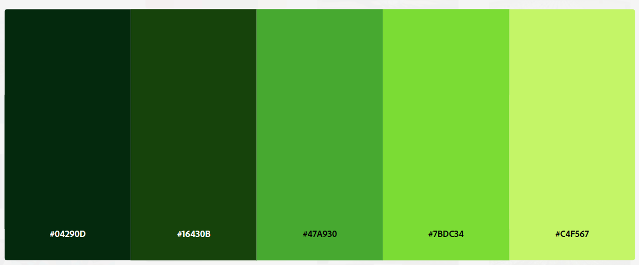
#04290D #16430B #47A930 #7BDC34 #C4F567

