**Sprint Report:**

**Sprint Dates:**

* Sprint 1: November 27, 2023, to December 22, 2023.

**Team Overview:**

* Team Capacity: 4 developers, 1 Scrum Master.
* Developers:
  + Rares Stefanoiu
  + Andrei Berbecaru-Iovan
  + Robert Barbu
  + Radu Ionescu
* Scrum Master:
  + Ruxandra Iftimi

**Backlog Items:**

1. Database Design
2. Database Implementation
3. Authentication
4. Authorization

**User Stories:**

1. User Story – As a user, I want to have an account to access the application features
   * Acceptance Criteria:
     + The user can create a new account or log in to an existing account
     + Due to security concerns, several security policies are required:
       1. The passwords must respect a minimal level of complexity: both upper and lower case letters, numbers, special characters, and a minimal length
       2. In the database, the passwords aren`t directly stored, instead they are stored in a hashed form
       3. To prevent providing too much information to a possible attacker, in case of a failed login attempt, a single type of user error feedback is shown
2. User Story – As a user, I want the application to support different roles for enhanced security and functionality
   * Acceptance Criteria:
     + Due to the requests of the stakeholders, the application must accommodate three types of users:
       1. Administrator: The chief manager of every aspect of the application, he can perform every possible action that others can, as well as granting or revoking the status of other users
       2. Hotel Manager: certain users are going to use this application to rent out their hotels
       3. Customer (normal user): the vast majority of users search for travel destinations and want to book and offer feedback on their experience at certain locations

**Changes During Sprint:**

* Added: Forgot Password Functionality, Login via Microsoft Authentificator
* Postponed: Database implementation (merging the Identity database with our conceptual model

**Status of Planned Items:**

Database Design: complete

Database Implementation: in progress (pushed to next sprint)

Authentication: complete

Authorization: complete

**Sprint Review:**

**Meeting Overview:**

* Sprint Meetings held on the 5th of December and on the 16th of December on Microsoft Teams.
* The functionalities that were part of this sprint were completed except the database which was pushed into the next sprint. We had an issue when trying to add the photos and with some of the relationships between the tables
* Considering that only the authentication is correct we consider that we are 5% of an MVP
* We discussed on how to solve the merging of the Identity Database (responsible for the proper functioning of authentication and authorization system) with our conceptual model (the database that includes locations, bookings, reviews etc)

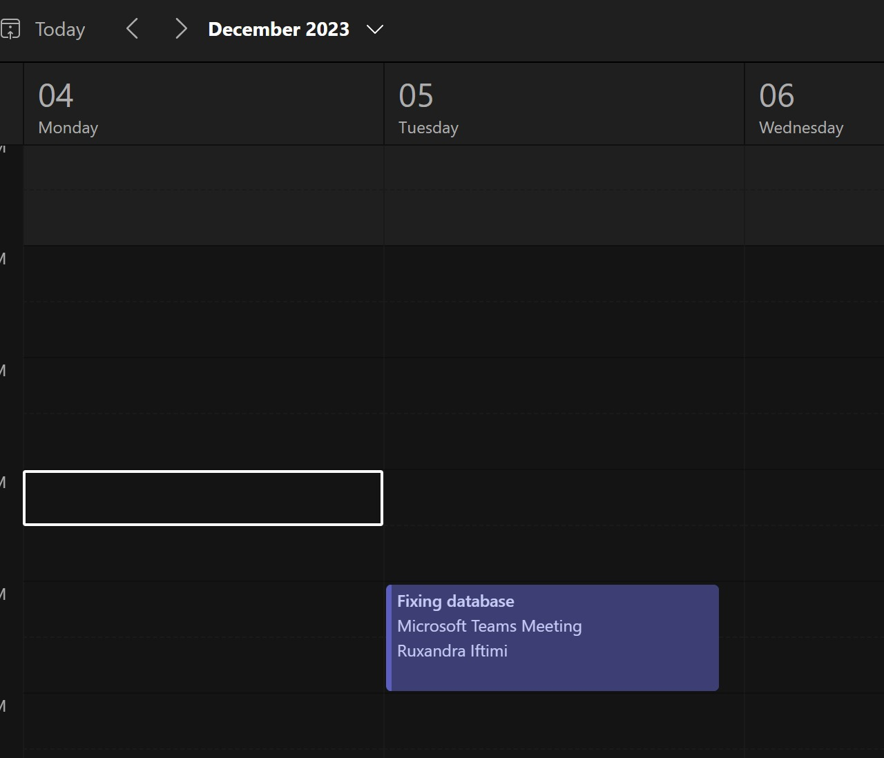

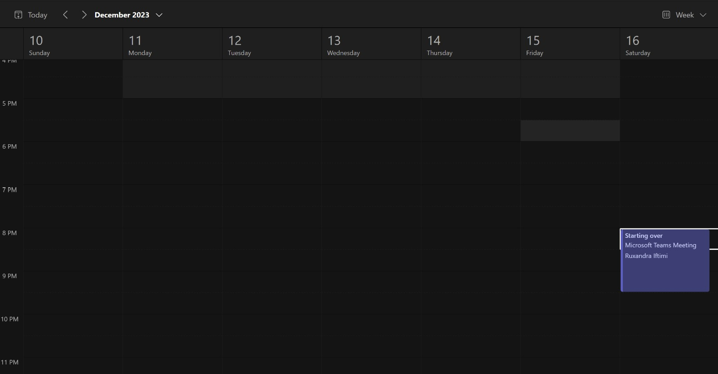

**Sprint Retrospective:**

* We postponed the tasks for this sprint
* What works well: We started over and discovered that, by using the ASP.NET Core Identity Framework, all of our requirements regarding authentication and authorization can be met and a few extra features, like the forgot password functionality and the external login method via Microsoft Authenticator
* What doesn’t work well: merging the Identity database with our initial database model
* What would you want to do better next sprint?
  + We would like to set more concrete deadlines and to properly delegate tasks among us so that we can effectively work