Sprint Number: 4 (second sprint of dev)
Link: https://github.com/orgs/inginerie-software-22-23/projects/139
Sprint period: 12.12.2022 – 23.12.2022
Sprint goal:
Create CRUD for review, student, announcement and mentor tables.

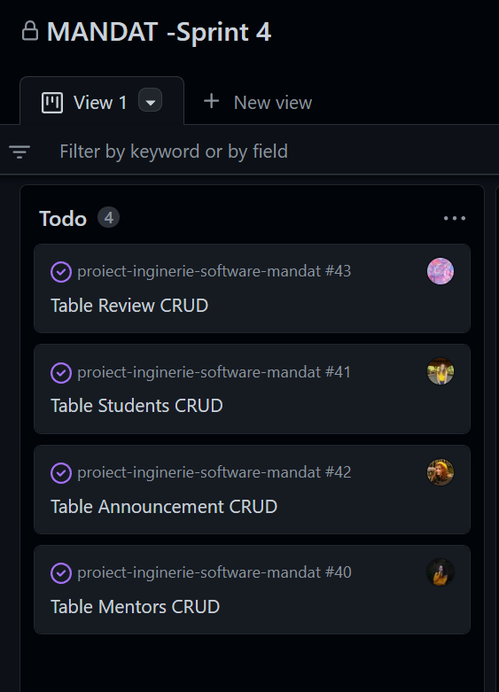

Stories/time committed: 7 stories - stories planned for this sprint from the beginning in prioritized backlog
1.As a register user I want to be able to manage my account so that I can leave my details up-to-date.
Acceptance Criteria:
GIVEN: User access his/her own profile
WHEN: Edit button actions are visible for a specific field or for all profile info
THEN: When edit button is clicked, user is redirected to edit page(if he wants to edit more than one field), or the respectively field he/she wants to change can be modified.
2.As a registered user I want to be able to have the ability to check the details of my profile so that I can view my personal info.
Acceptance Criteria:
GIVEN: After the user enters in his/her account, a photo for his/her profile is visible
WHEN: The user can be redirected to his/her profile
THEN: The page will contain personal informations in a nice format, profile image

3.As a student I want to see a mentor’s phone number if I am accepted by him/her so that I can call him/her and schedule a timeslot for the future sessions.
Acceptance Criteria:
GIVEN: A student can access his/her mentors to find more about them.
WHEN: The phone number visible for the student just in some pages.

4.As a mentor I want to be able to post announcements with subjects I can teach so that I can attract more students.
Acceptance Criteria:
GIVEN: On their own profile mentors can see a "Post an announcement" button.
WHEN: A text field and a submit button will appear after pressing the "Post an announcement" button. The mentor can write his/her announcement and post it on his public profile.
THEN: The post will be seen in the mentor's profile as a new announcement; the mentor can edit it or delete it when the message will not be need it.

5.As an unregistered user I want to be able to search the website/endpoints that are public/don’t have authorization so that I can check out the website without having to register.
Acceptance Criteria:
GIVEN: Unregistered user is in home page where the menu/navbar is accessible
WHEN: when user clicks one of the items from menu/navbar he/she is redirect to that page
THEN when the page is loaded the content can be seen or if the user doesn't have authorization "Not authorize/Not found" page appears

6.As a student I want to be able to see every mentor’s location on the map so that I can better estimate my route.
Acceptance Criteria:
GIVEN: A student can access his/her mentor profile to find more about him/her.
WHEN: On that page the student can see also a rectangular map with his/her mentor's location.
THEN: The view of the map can be a satellite or a normal one.

7.As a mentor I want to be able to accept/reject student requests so that I can be more selective with the students I work with.
Acceptance Criteria:
GIVEN: Logged in as a mentor, the user has in his/her profile a notifications option where he/she has access to requests from students. They can either accept it or reject it.
WHEN: When he/she goes to notifications, cards with every request can be seen. The mentor can press accept or reject button. By pressing the button, accepted requests are going to "My students" page; for the reject button the request will be deleted from the mentor profile.
THEN: The mentor's response will be received by the student; in database rejected requests will be deleted/moved in the deleted requests table.

Stories/time delivered: 5 stories
1.As a register user I want to be able to manage my account so that I can leave my details up-to-date.
2.As a registered user I want to be able to have the ability to check the details of my profile so that I can view my personal info.
4.As a mentor I want to be able to post announcements with subjects I can teach so that I can attract more students.
5.As an unregistered user I want to be able to search the website/endpoints that are public/don’t have authorization so that I can check out the website without having to register.
6.As a student I want to be able to see every mentor’s location on the map so that I can better estimate my route.

*The implementation was done just for backend, frontend was in progress.
**From the previous sprint, the login and register pages were created till the end of this sprint.

Comments on Sprint report:
During this sprint focus was to create CRUD for review, student, announcement and mentor tables.
We need to mention that during this sprint a large part of the team members had another important deadline.
Only part of the items planned in the first plan have been closed on time.
What was not implemented/in progress in previous and current sprints:
- Login with Facebook is still in research.
- Story 3 and 7 from this sprint and story 5 from the sprint 3 that was done just for backend– the one about admin actions : As an admin I want to be able to manage/delete any account so that I can enforce appropriate measures if needed –
- Also frontend pages that corresponds with stories that are done in backend.

Retrospective outcome:
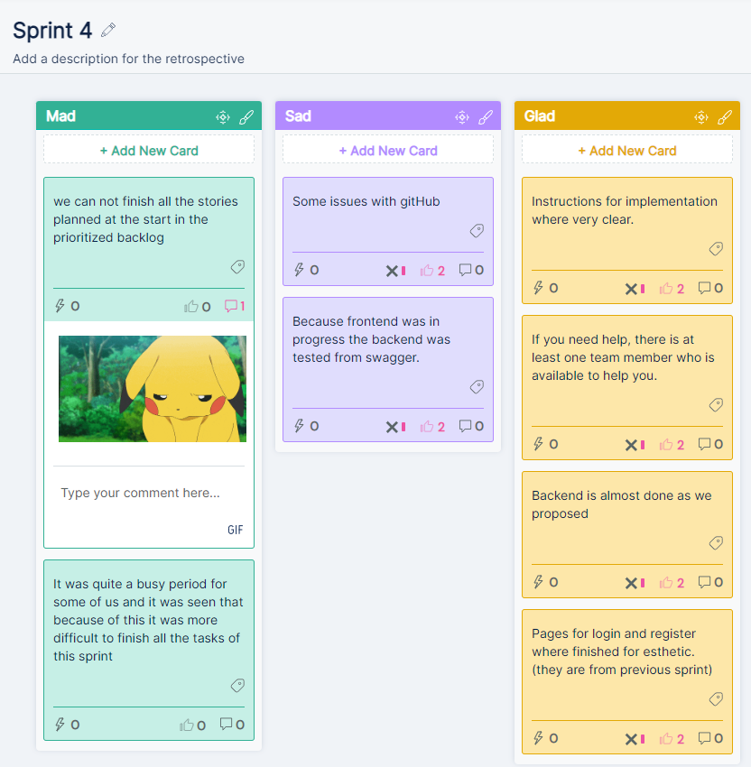
Review session: https://youtu.be/C-kA9EI7rl8

