Sprint Number: 6 (4-th sprint of dev)
Link: MANDAT -Sprint 6 (github.com)
Sprint period: 09.01.2023 – 20.01.2023
Sprint goal:
Create important pages for users like mentor page using match form to apply wanted filters, home page, requests page and pages when user’s students/mentors can be seen.
Some important methods are:
- the method which apply the student’s filters
- implementing Jitsi API for video calls
- implementation for showing on google maps user’s location
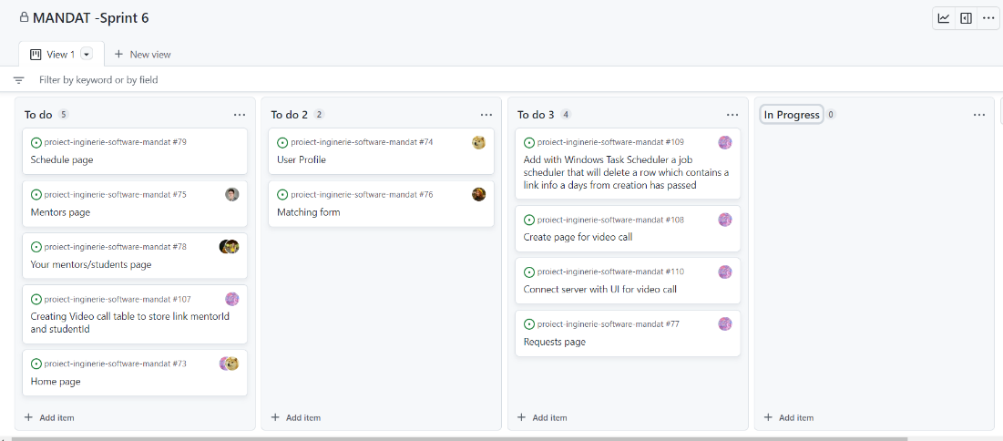

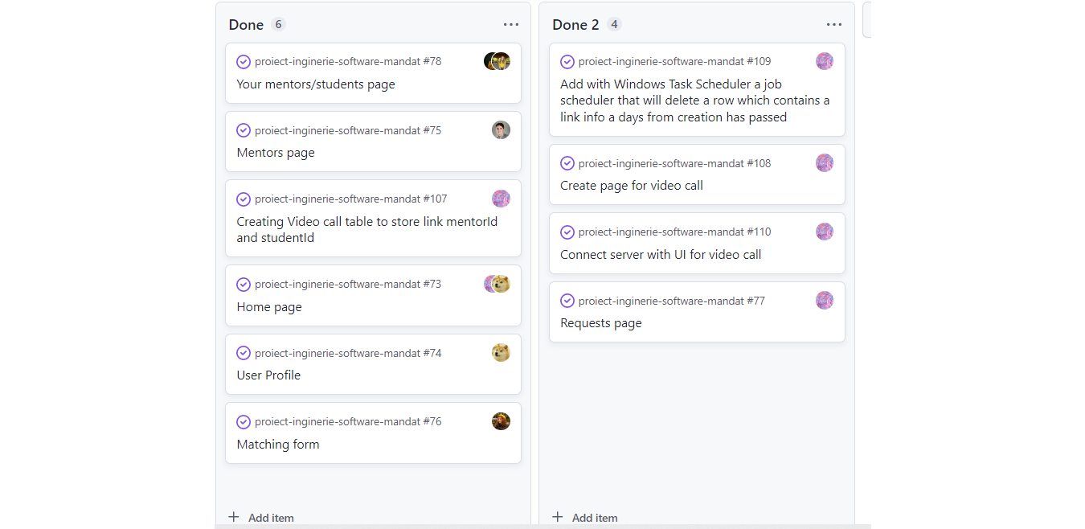

Stories/time committed: 4 stories - stories planned for this sprint from the beginning in prioritized backlog
1.As a logged in user I have the ability to check the details of my profile so that I can view my personal info.
Acceptance Criteria:
GIVEN: When a logged in user goes to sidebar a image of his/her profile is visible (click on user image from sidebar).
WHEN: User is redirected to his/her profile.
THEN: The page will contain personal info in a nice format. In profile it can be seen, name, description box and bio a map where the address is shown and a menu box. For mentors menu box cand redirect them to their students, announcements (done in hardening spring), notifications and video link page.
2.Sort mentors based on filters such as location/distance, rating, subject, price so that a student can make a better decision on which mentor to pick

Acceptance Criteria from user stories:
GIVEN: A student can access Mentors page, where he/she can see a list with all mentors.
WHEN: On that page the student can see cards with every mentor, where can be seen info as: name, subject, price, rating in stars.
THEN: On that page it can be seen some filters for location/distance, rating, subject, price; based on them the user can find more quickly a mentor. The mentors will appear in the right order of their wanted filters.
During the implementation the acceptance criteria changed.
New acceptance Criteria:
GIVEN: A student can access Mentors page, but if he/she wants to find a mentor based on some criteria the student can access match form page. The form’s fields include details about location, rating, subject and how many stars an ideal mentor can have.
WHEN: After pressing the submit form button, the user will be redirected to mentors page. There will be shown results based on what a student wanted in that form.
THEN: On that page it can be also seen some filters for name and stars. The mentors will appear in the right order of their wanted filters.

3. Can view all accepted students/the students he/she tutors so that the mentor can have an overview on them
Acceptance Criteria:
GIVEN: After the mentor accepts a student, their card will go to "My students" page.
WHEN: When "My students" page is accessed, a list with all accepted students and details about the meetings will be seen.
THEN (old): By clicking a student name a popup with more details will be seen/the mentor will be redirected to student's profile. (We changed the implementation for this)
THEN (new): The page will have in addition of student’s cards, filters for name and stars. Also, it can be seen a Reviews button when a popup with all the mentor’s reviews gave to his students.
4. To be able to accept/reject student requests so that a mentor can be more selective with the students he/she works with
Acceptance Criteria

GIVEN: Logged in as a mentor, the user has in his/her profile a notifications option where he/she has access to requests from students. They can either accept it or reject it.
WHEN: When he/she goes to notifications, cards with every request can be seen. The mentor can press accept or reject button. By pressing the button, accepted requests are going to "My students" page; for the reject button the request will be deleted from the mentor profile.
THEN: The mentor's response will be received by the student (the new mentor will appear in my mentors page); in database rejected requests will have a rejected status.
Stories/time delivered: 4 stories
1. As a logged in user I have the ability to check the details of my profile so that I can view my personal info.
2. Sort mentors based on filters such as location/distance, rating, subject, price so that a student can make a better decision on which mentor to pick
3 Can view all accepted students/the students he/she tutors so that the mentor can have an overview on them.
4. To be able to accept/reject student requests so that a mentor can be more selective with the students he/she works with.
*The implementation was done for frontend and in backend just some changes were made.
**From the previous sprint/user stories, we added some small changes to register – regex for password and now the submit button will be disable if email and password are not respecting the validations.
Stories added to this sprint:
- Can generate a Google Meet/Zoom link so that it would be easier to have online tutoring sessions.
We changed the acceptance criteria for this user story. Instead of adding Google Meet/Zoom API we used Jitsi API because our platform has tutoring session just between mentor and student, so a video call won’t exceed 100 people. Also, this API implementation was easier for us and the benefits are the same. For the video call page, the mentor will have a form when he/she can send the link to his student.
2. See mentor's location on the map(in case of physical sessions) so that for the user to estimate better his/her route
Acceptance Criteria:
GIVEN: A student can access his/her mentor profile to find more about him/her.
WHEN: On that page the student can see also a rectangular map with his/her mentor's location.
THEN: The view of the map can be a satellite or a normal one.
3. Match form. Even though it was not part of the backlog we decided to create this page for giving a more accurate result based on student’s preferences. This page is closely related to the Mentors Page.

In this sprint we succeeded to add automated tests for frontend pages as: my mentors page, my students page, requests page, match form page, mentors page (we also tested all the pages manually and the same for the backend).
Comments on Sprint report:
During this sprint, focus was to create the pages fully linked to the server, functional from user point of view and with a nice aesthetic. In the end, the flow of our app is linear and in the hardening sprint we added some new pages and methods to create a complete product.
We need to mention that during this sprint all team members worked hard to deliver the final product.
Most of the items planned in this sprint were closed on time.
What was not implemented/in progress in previous and current sprints:
- Login with Facebook is implemented but we decided that for the purpose of our application it does not have a useful impact.
- the user stories about admin actions is not implemented is moved to hardening sprint: As an admin I want to be able to manage/delete any account so that I can enforce appropriate measures if needed –
- Announcement page (view and create) and user setting (to manage "my account" <<update details/delete account>> so that an user can leave personal details up-to-date) are moved to hardening sprint)
We gathered some feedback for our app from some high school students. After explaining what our app has to offer and letting them to play with it most of them shared that our platform is helpful and that they are willing to use it if in the future it will appear on the market.

Retrospective outcome:
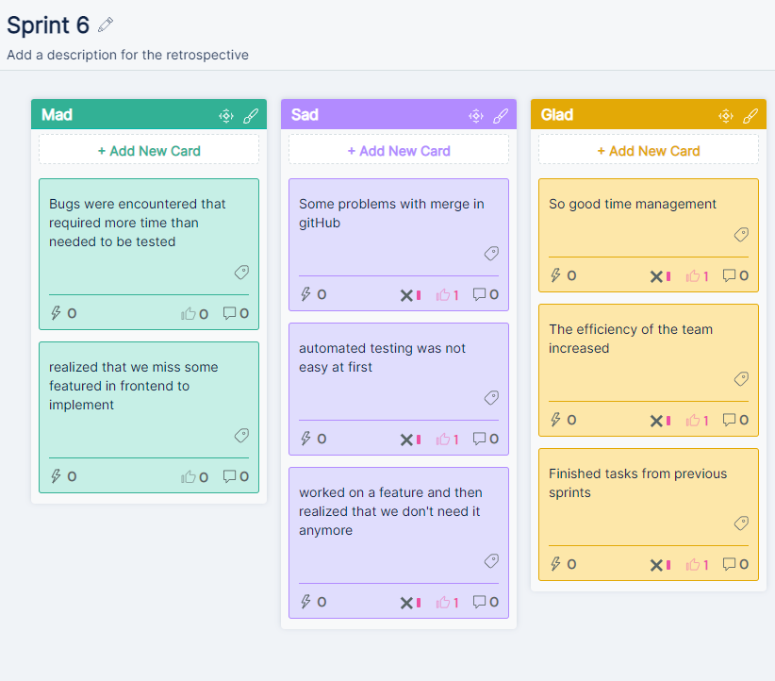
Review session:
MANDAT Sprint 6 Demo - YouTube

