Sprint Number: 5 (third sprint of dev - Holiday)
Link: https://github.com/orgs/inginerie-software-22-23/projects/147
Sprint period: 26.12.2022 – 08.01.2023
Sprint goal:
Create new methods for student and mentor tables and also create CRUD for match table.
Some important methods are:
- get mentor phone number by student
- method for accept/decline requests of match between student and mentor

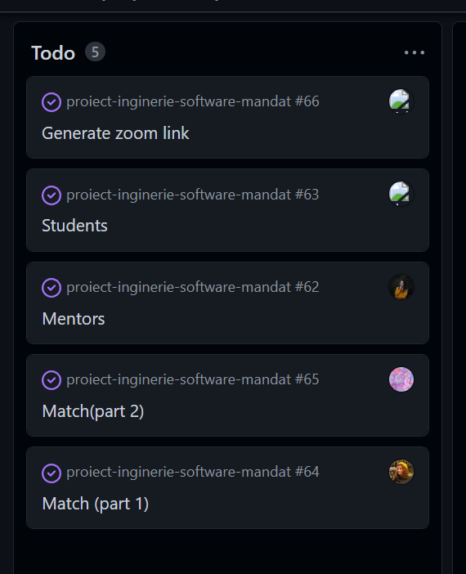

Stories/time committed: 3 stories - stories planned for this sprint from the beginning in prioritized backlog
1.As a mentor I want to be able view all my accepted students so that I can have an overview on them.
Acceptance Criteria:
GIVEN: After the mentor accepts a student, their card will go to "My students" page.
WHEN: When "My students" page is accessed, a list with all accepted students and details about the meetings will be seen.
THEN: By clicking a student name a popup with more details will be seen/the mentor will be redirected to student's profile.

2.As a mentor I want to be able to generate a Zoom link so that it would be easier to have online tutoring sessions.
Acceptance Criteria:
GIVEN: After deciding with the students on a meeting time, if it is online the mentor will generate a link for meeting
WHEN: When it's time for the session the study session cand begin.
THEN: A card with a button to enter the meeting will appear in student page.

3.As a registered users I want to be able to leave a review/rating score on the person I work with (mentors for students/ students for mentors) so that I can acknowledge my experience with them.
Acceptance Criteria:
GIVEN: A user has access to his mentors/student page. A "add review " button is visible
WHEN: When a user presses the review button will appear a popup with two inputs: message and number of stars. The user can write his/her review in the text box and can rate from 1 to 5 stars his experience with that person
THEN: After the review is written the user can make submit and it will be seen in his reviews and the average star score receive by the reviewed person will be modified.

Stories/time delivered: 2 stories
1.As a mentor I want to be able view all my accepted students so that I can have an overview on them.
3.As a registered users I want to be able to leave a review/rating score on the person I work with (mentors for students/ students for mentors) so that I can acknowledge my experience with them.

*The implementation was done just for backend, frontend was in progress.
**From the previous sprint, the login and register pages work well.

Comments on Sprint report:
During this sprint, focus was to create full CRUD for match table and also to add some function or update them for mentor and student tables.
We need to mention that during this sprint was the winter holiday and a part of the team members had to take some days of unpaid leave.
Only part of the items planned in the first plan have been closed on time.
What was not implemented/in progress in previous and current sprints:
- Login with Facebook is still in research and also link generator for Zoom.
- Story 2 this sprint and story 5 from the sprint 3 that was done just for backend– the one about admin actions : As an admin I want to be able to manage/delete any account so that I can enforce appropriate measures if needed –
- Also frontend pages that corresponds with stories that are done in backend.

Retrospective outcome:
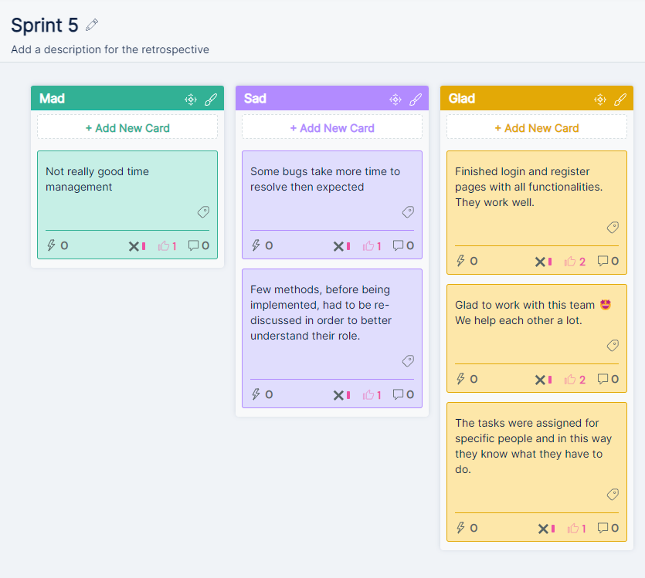
Review session:
https://youtu.be/NhJooU16zAY

