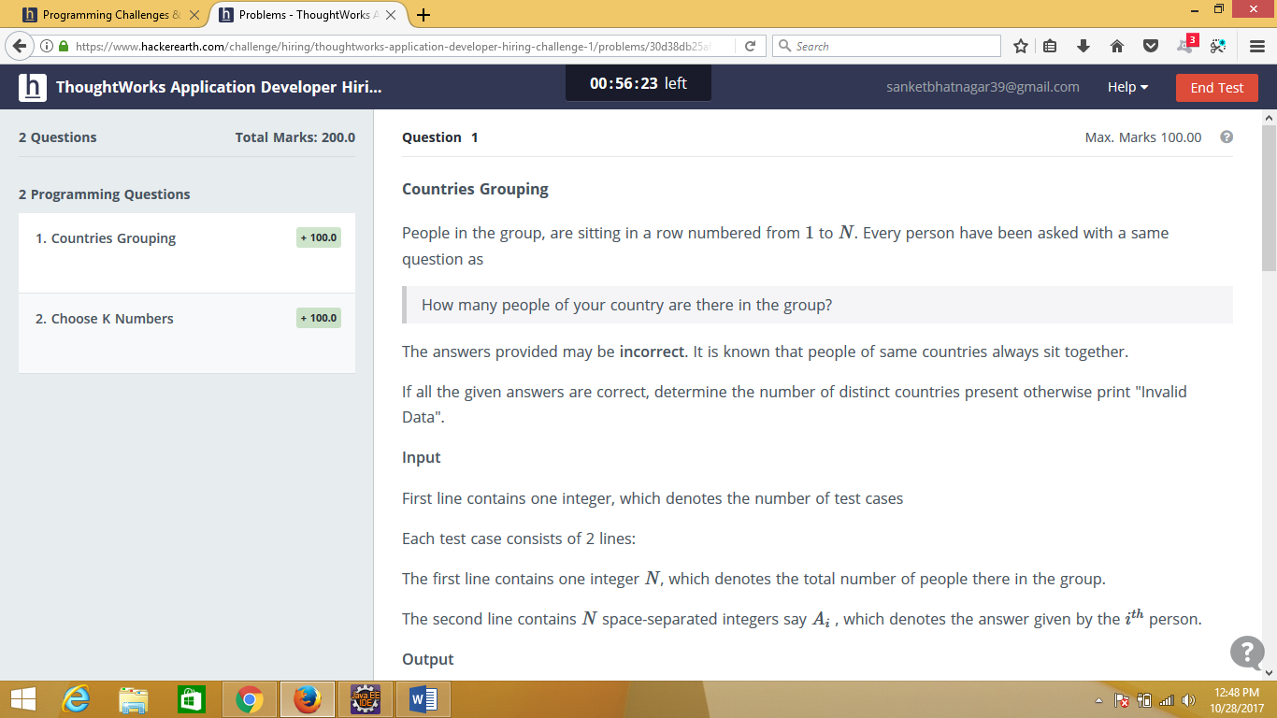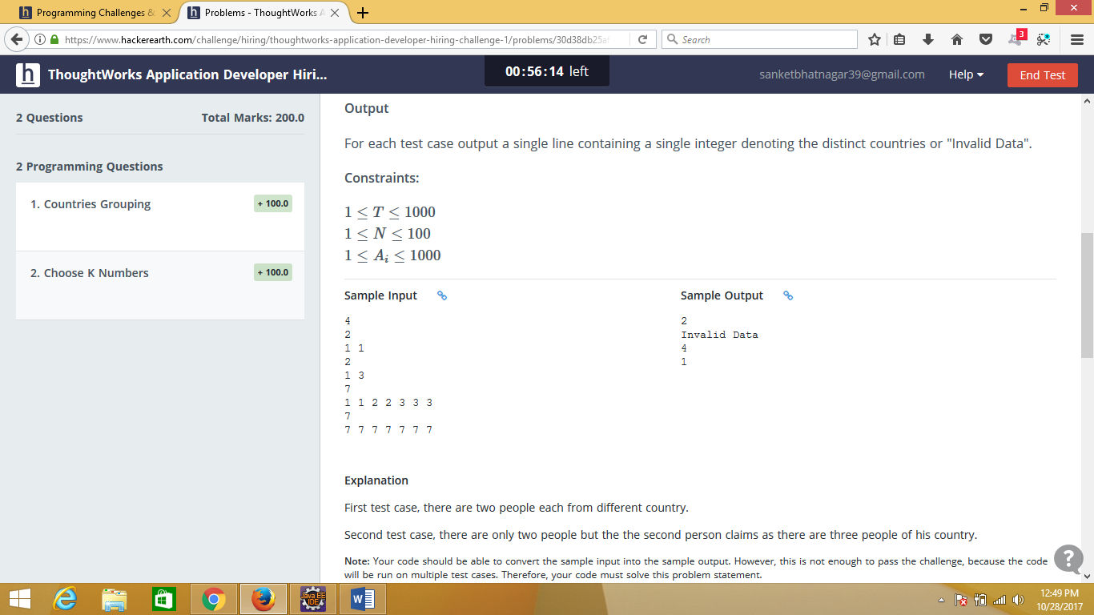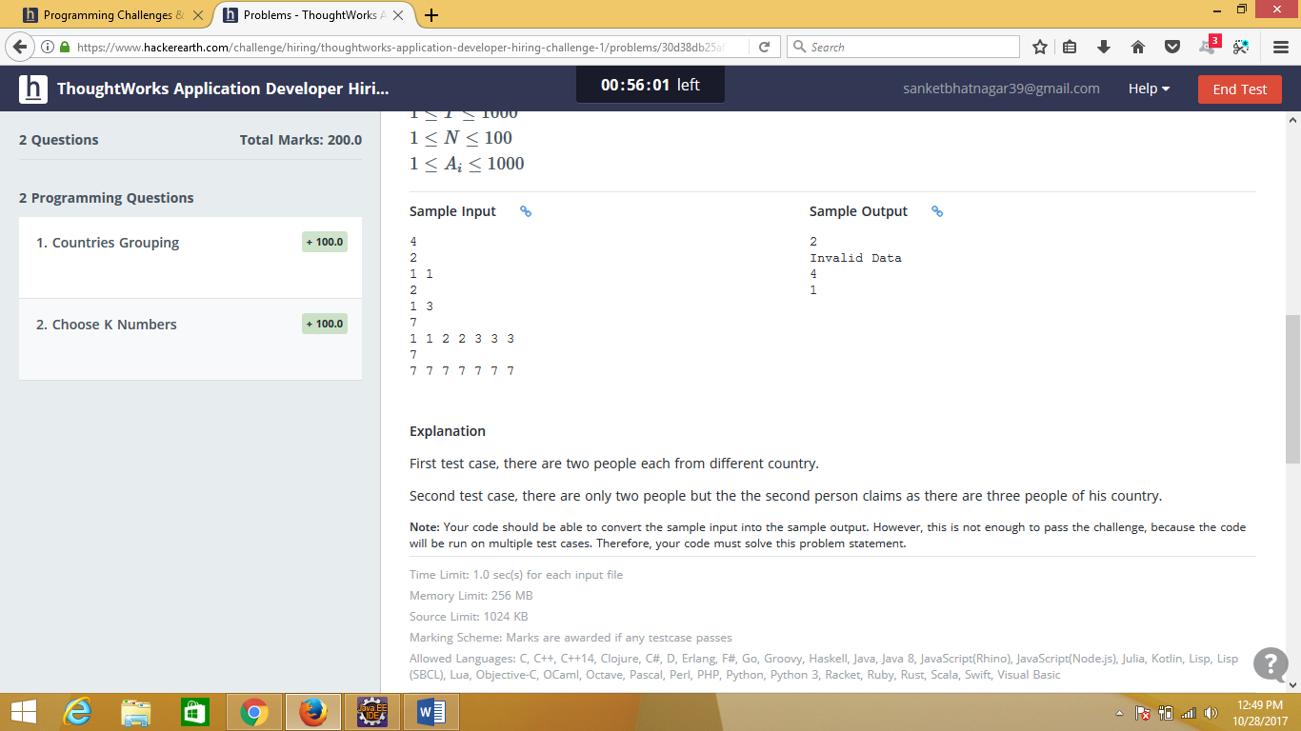

Sample input

4

2

1 1

2

1 3

7

1 1 2 2 3 3 3

7

7 7 7 7 7 7 7