Transcriptomics

organelles, microarray
Jens Ruppert
Adam Idoine, PhD student
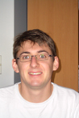
Loc: ground floor office
Tel: 8629

nuclear, qRT-PCR, microarrays
Flavia Wischi Wink, PhD student
Loc: 0.255
Tel: 8351

Samuel Arvidson

Polysome Analysis

Organelles, microarray

Jens Rupprecht
Adam Idoine

Cytoplasma, qRT-PCR
Sunil Kumar, PhD student
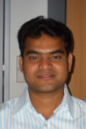
Loc: 1.132
Tel: 1.124

Proteomics
Dorothea Hemme, PhD student
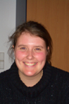
Loc: 1.157
Tel: 8126

Fred Sommer, Postdoc
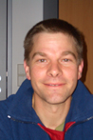
Loc: 1.157
Tel: 8126

Timo Muehlhaus
Julia Weiss, Phd student
Loc: ground floor office
Tel: 8629

Enzyme assays
Daniel Vosloh
Loc: 1.138
Tel: 8114

Metabolomics

GcxGC-MS (Overview measurements)
Daniel Veyel, PhD student
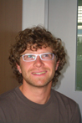
Loc: 1.157

Tel: 8126

LC-MS (Calvin Cycle)
Tabea Mettler, PhD student
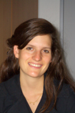
Loc: 1.140; 1.124
Tel: 8117

Photome

relative activities PSI, PSII, b6/f/ PQ, PMF; absolute activities
Mark Aurel Schoettler, Group Leader

Loc: 0.134
Tel: 8311; 0.124

NPQ

online PAM
Stephanie Schlede

Lipidomics
Susann Irgang, PhD student
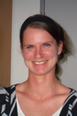
Loc: Big Office; 2.157
Tel: 8242; 8228

Starch
Michael Sandmann

Data Integration
Sylvain
Zoran

