JDBC:

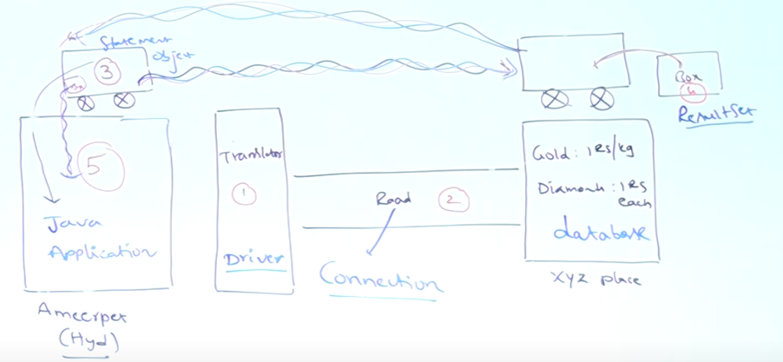

Java application -> JDBC Driver -> Connection -> Database ( any )

JDBC driver: used to get result from database to java application

Statement: it used as vehicle to get result from result set.

ResultSet: It is used as box which has result from database.

Connection : It is object used make communication between java app & db

Steps :

1. Load and register driver class
2. Establish connection between application and database
3. Creation of statement object
4. Send and execute sql query
5. Process result from result set
6. Close connection

JDBC features:

1. It is standard JDBC API because it is not change when we change database it is same for all database.
2. CRUD operation can be performed

ODBC [ open database connectivity ] – Any lang, Any database, only for window , developed by microsoft

JDBC [ java database connectivity] – Any database, Any platform, only for java lang , developed by sun microsystem.

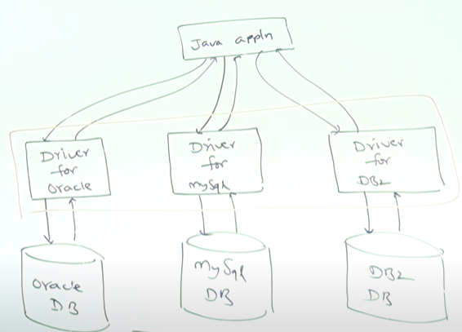

* Java is database independent
* Driver is database dependent
* Java is platform independent
* JVM is platform dependent

JDBC API – It is uses serval class and interface for communicated with database.

* java.sql => basic classes and interfaces for db connection
* Javax.sql => advance classes and interface for db connection

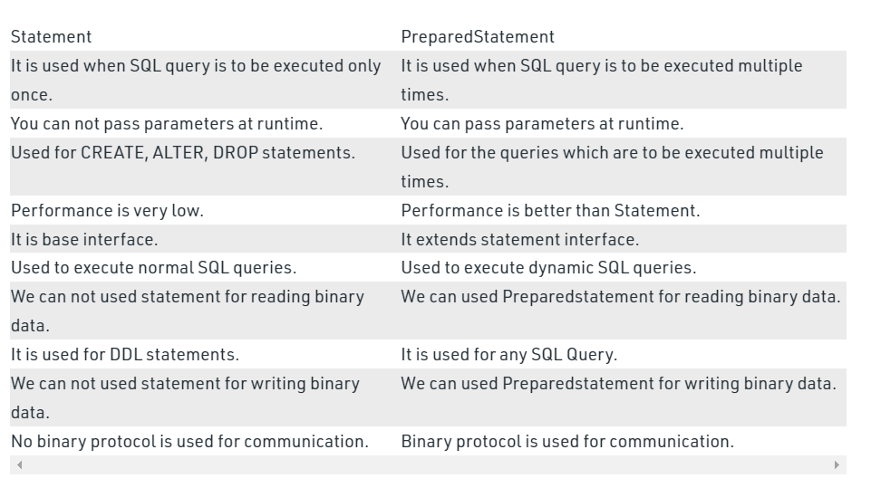

Mysql download - <https://dev.mysql.com/downloads/installer/>

