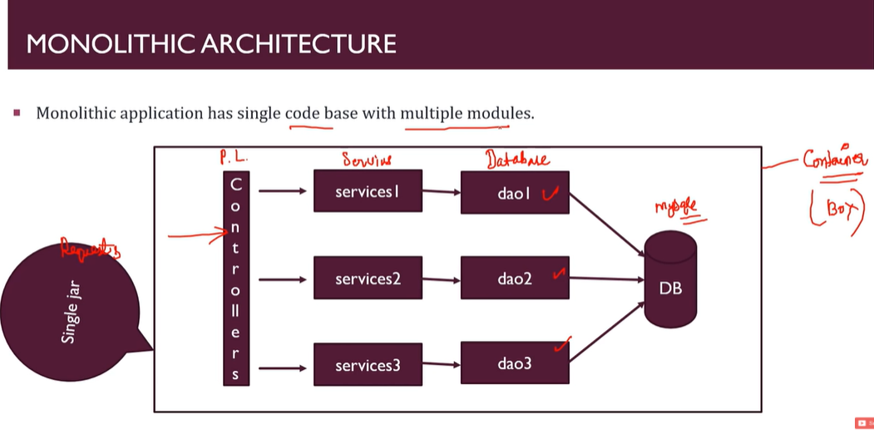

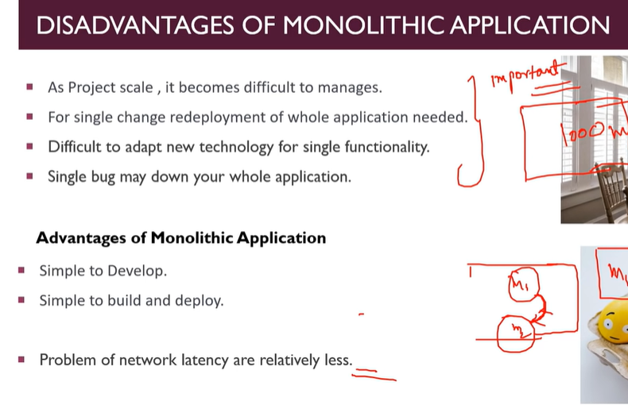

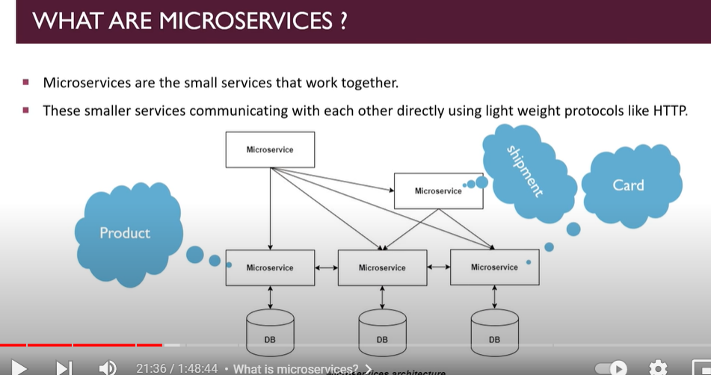

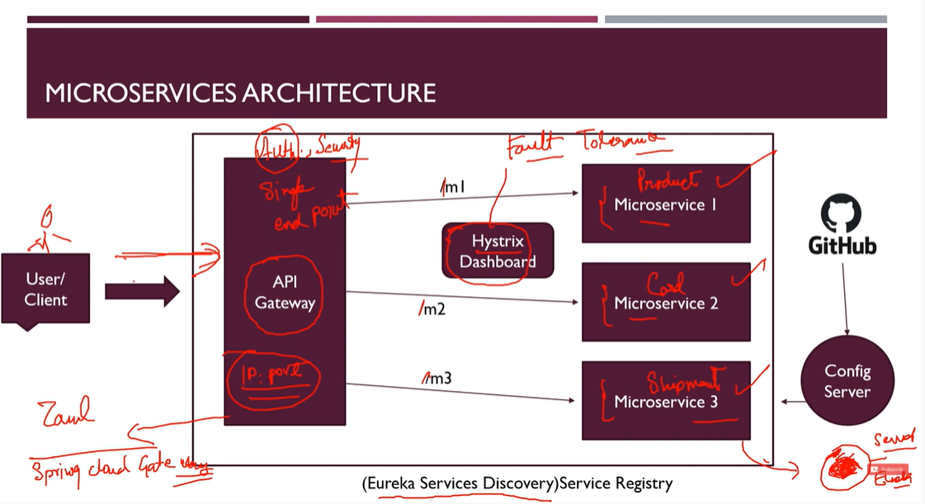

1. Api gateway – used to provide common single gateway to communicate with microsservices. and also we can do authentication on there.
2. We have Eureka services discovery in which keep all microservices register.
3. Hystrix lib – used when some fault tolerance occurs like if one microservice is down then it will handle.
4. We have Spring cloud and Zuul .

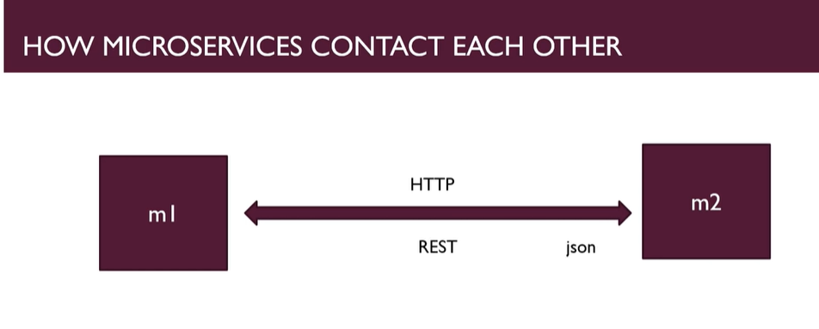

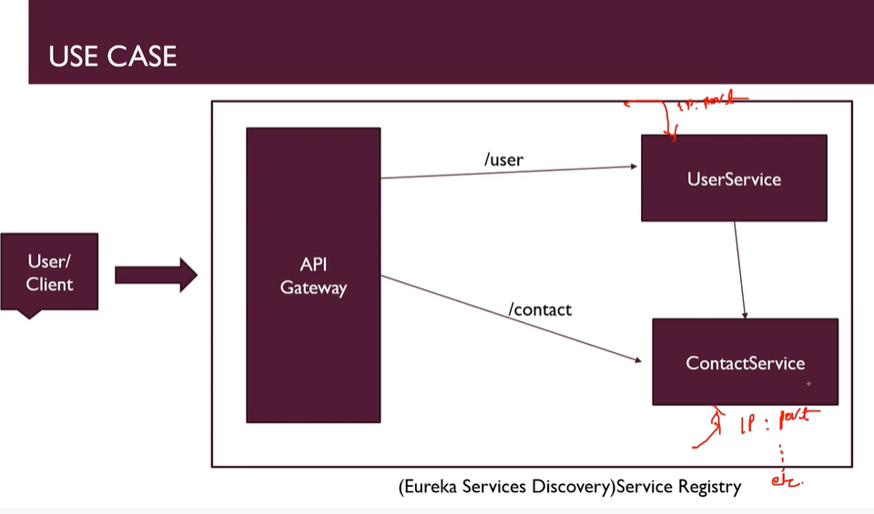

1. Create simple user micro service on port = 9001
2. Create simple contact micro service on port = 9002
3. Used rest template in user service for set contact for particular user
4. Create eureka server on port = 8761
5. Add spring cloud and dependency management in both make this as client user service and contact service
6. Set application name in both micro services
7. And also set hostname as localhost to e-server and contact and user service.
8. Change url of contact micro service in user service – instead write application name direct and also write @LoadBalanced in spring boot app of user service.
9. Make application gateway by spring boot actuator and eureka client and gateway and enable eurekaClient in spring boot application main file of apigateway services.

