**What is JDBC?**

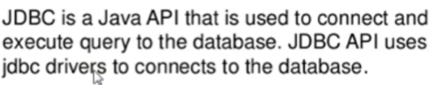

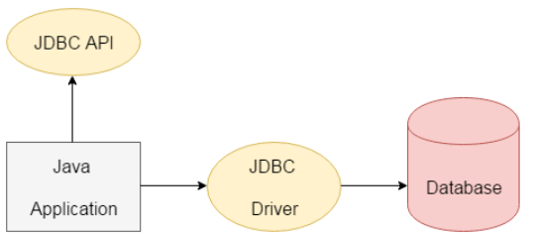

**What is JDBC Driver?**

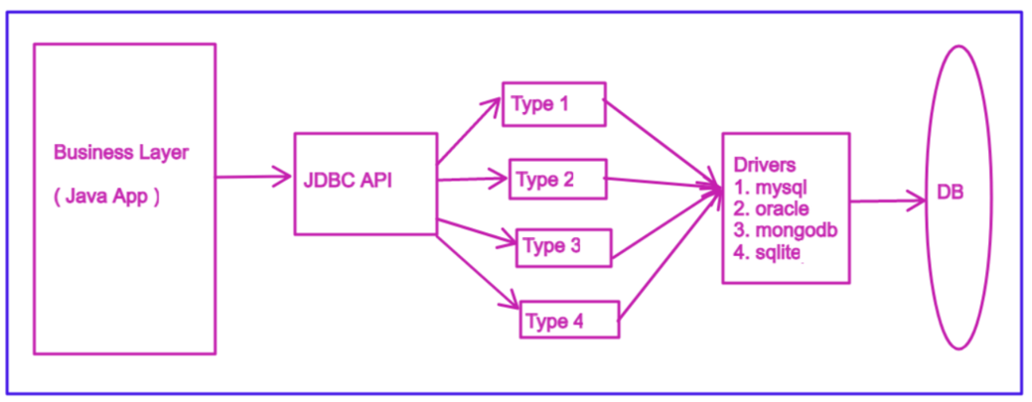

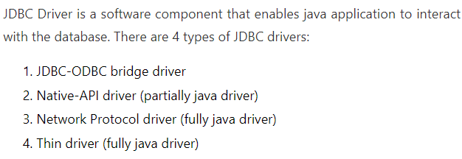

**What are steps to follow for JDBC connection?**

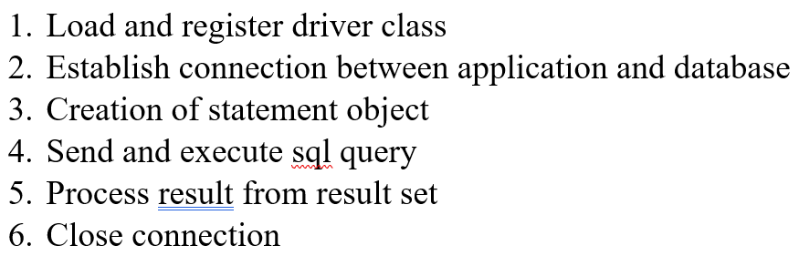

**What are differences of statement & prepared Statement?**

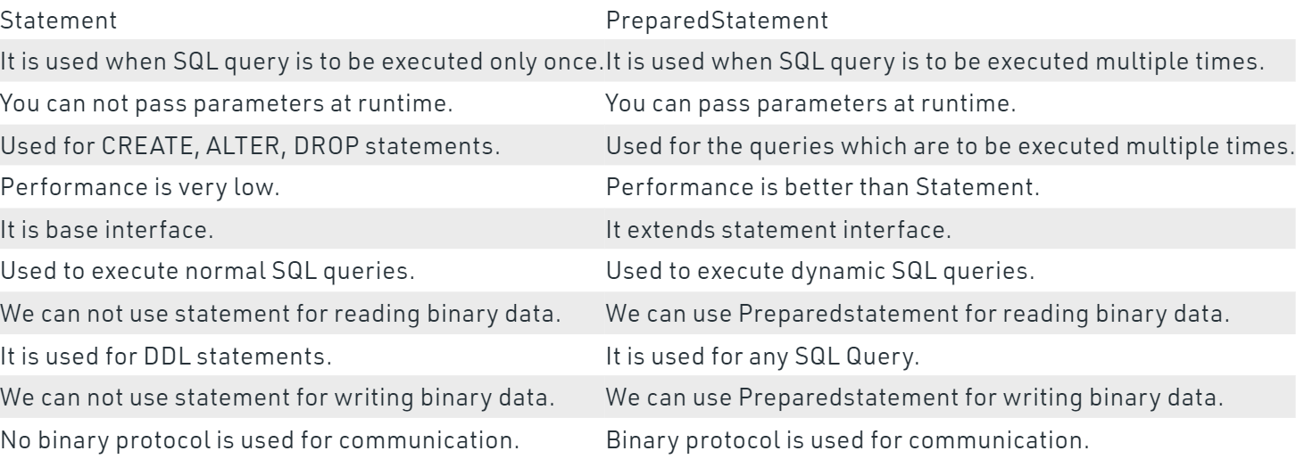

**What are differences of procedure & user define function?**

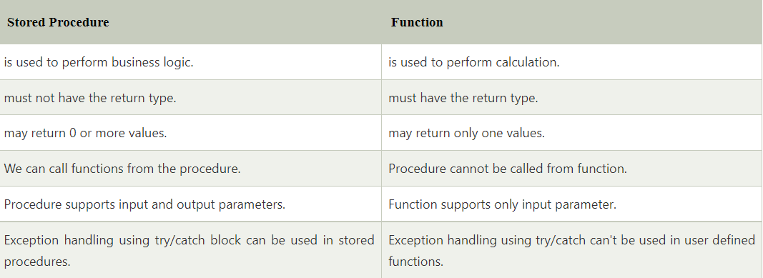

**What is callable Statement interface?**

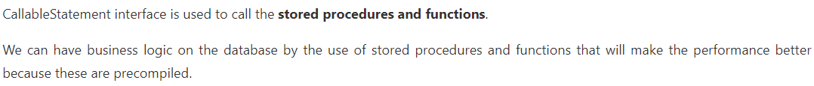

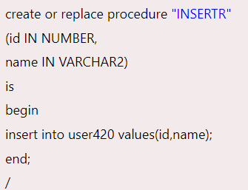 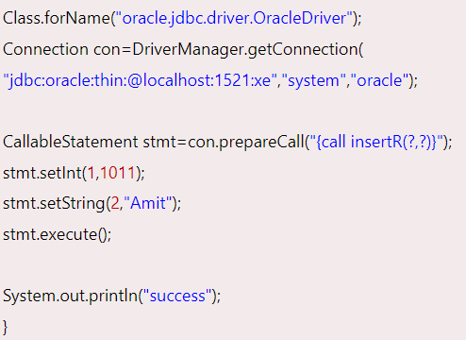

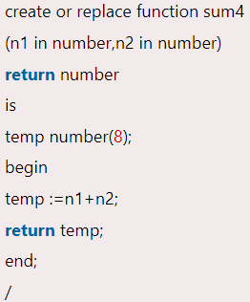 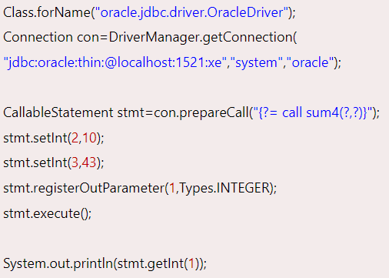

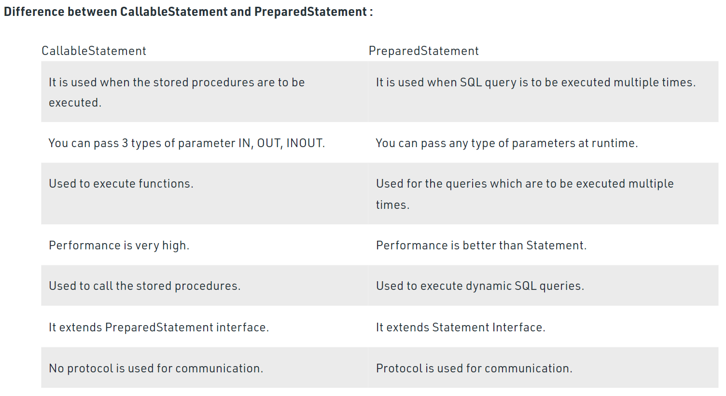

**What is role of JDBC driver manager?**



**What is role of Connection interface?**



**What is role of Result Set Interface?**



**What is role of Result Set Meta Data Interface?**

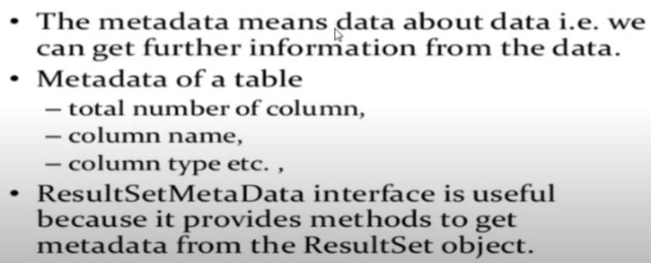

**What is role of Database Meta Data Interface?**



**How batch processing works in JDBC?**

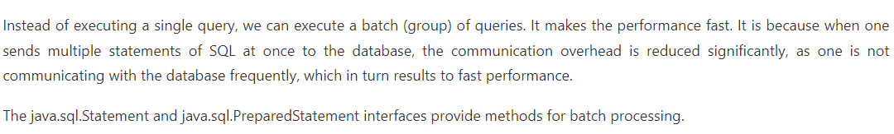

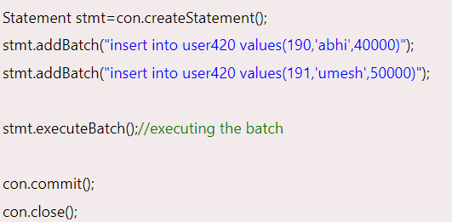

**How to store and get images in JDBC?**

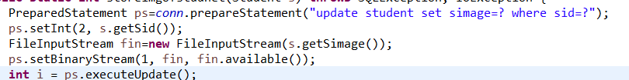

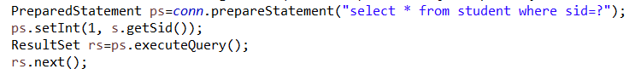

**What is JDBC Architecture?**

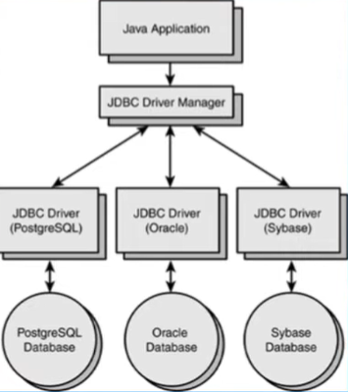

**What design pattern JDBC follow?**



**How do we register driver?**

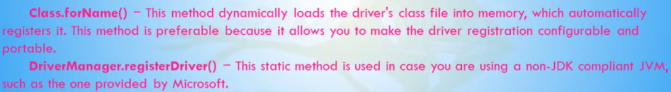

**How do you make connection?**

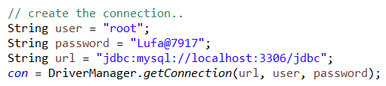

**What are differences of execute Query, execute update, execute?**

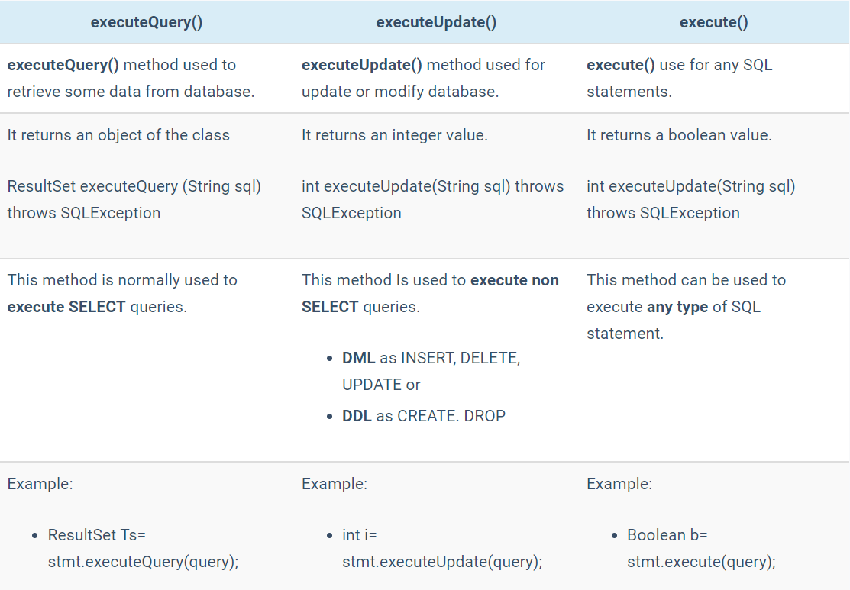

**What is use of blob and clob?**



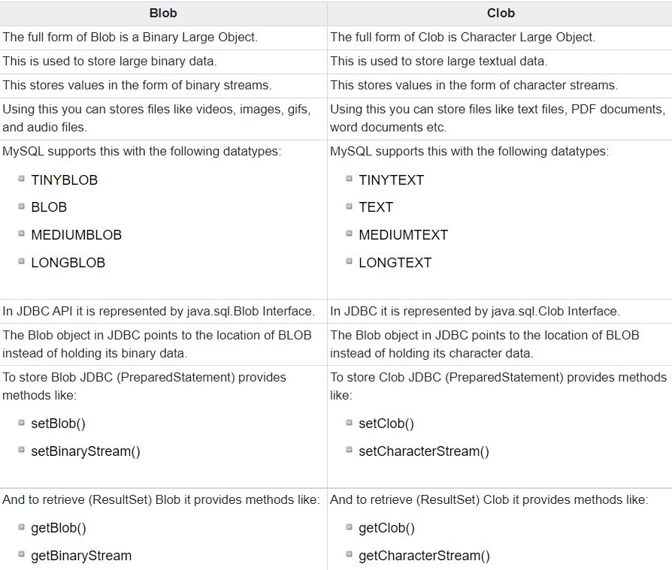

**How to use transaction in JDBC?**

