**What is oracle?**



**How to create database?**

There is no need to create the database in Oracle systems. In the Oracle database, we can directly create the database tables.

**How to create table?**

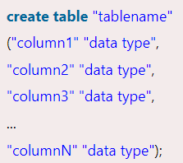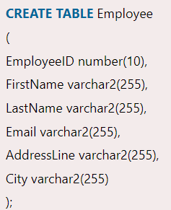

**How to drop table?**

* **DROP** **TABLE** table_name;
* **DROP** **TABLE** STUDENTS;

**How to delete table?**

The DELETE statement is used to delete rows from a table. If you want to remove a specific row from a table you should use WHERE condition.

* **DELETE** **FROM** table_name [**WHERE** condition];

But if you do not specify the WHERE condition it will remove all the rows from the table.

* **DELETE** **FROM** table_name;

Ex. - DELETE FROM Customers WHERE CustomerName='Alfreds Futterkiste';

Ex. DELETE FROM Customers;