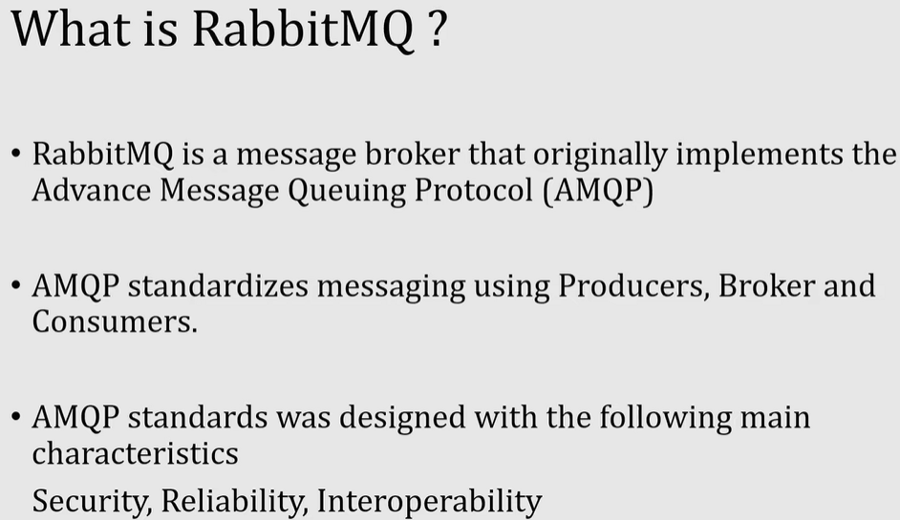

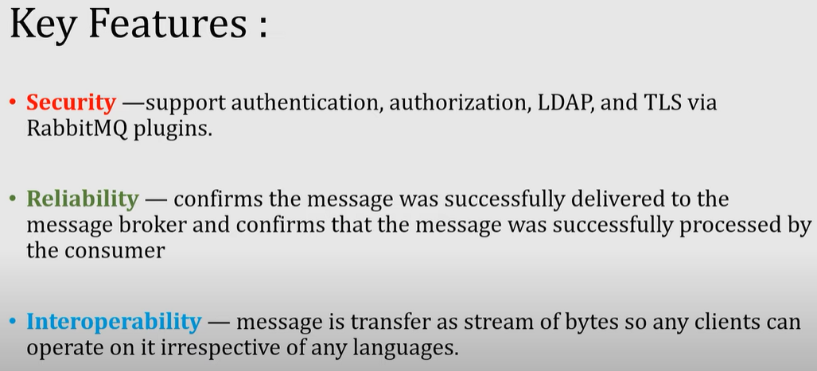





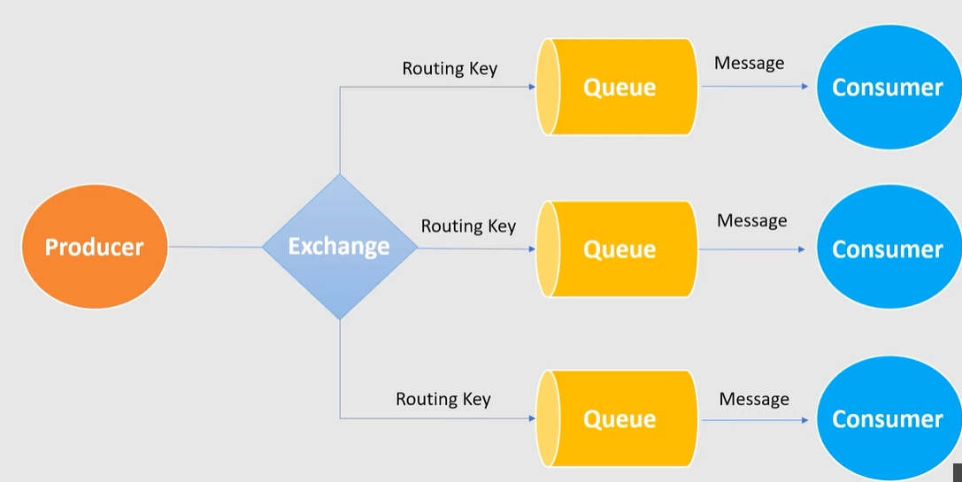

1. Download and install ERlang <http://erlang.org/download/otp_win64_22.3.exe>

Or [Downloads - Erlang/OTP](https://www.erlang.org/downloads) => https://www.erlang.org/news/137

1. Downlaod and install RabbitMQ <https://github.com/rabbitmq/rabbitmq-server/releases/download/v3.8.8/rabbitmq-server-3.8.8.exe>
2. Go to RabbitMQ Server install Directory C:\Program Files\RabbitMQ Server\rabbitmq_server-3.8.3\sbin
3. rabbitmq-server start
4. Run command rabbitmq-plugins enable rabbitmq_management
5. rabbitmq-service.bat start
6. Open browser and enter <http://localhost:15672/> to redirect to RabbitMQ Dashboard
7. Also we can Open it with IP Address [http://127.0.0.1:15672](http://127.0.0.1:15672/)
8. Login page default username and password is guest
9. After successfully login you should see RabbitMQ Home page

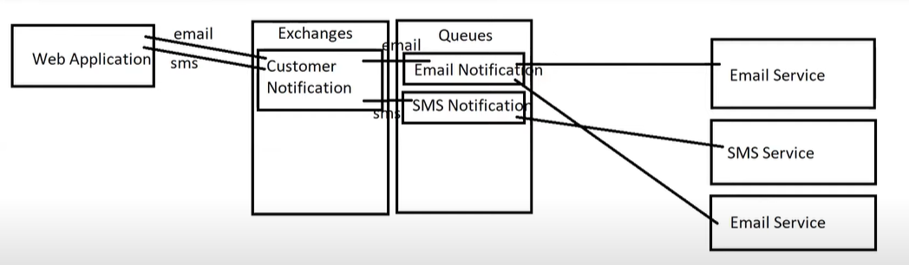

Direct exchange : only particular queue - consumer only get message from route exchange

Fanout exchange: broadcast your message to many queues