What is SQL?
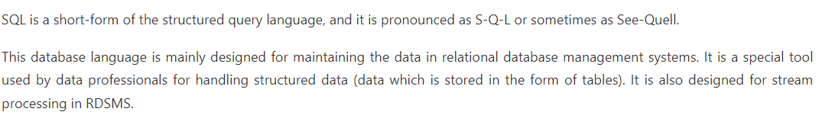
How to create database?
- CREATE DATABASE Database_Name;
- Ex. This example creates the Student database.
- CREATE DATABASE Student;

How to drop database?
- DROP DATABASE Student; => Student is database name

How to rename database?
- ALTER DATABASE Student MODIFY NAME = College ;
- Student is old database name and College is new data base name

How to select or use database?
- USE database_name;
- Ex.
- SHOW DATABASES;
- USE Hospital;

How to create table?
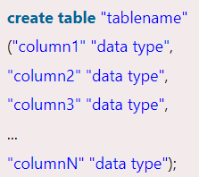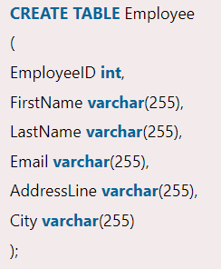

How to drop table?
- DROP TABLE table_name;
- DROP TABLE STUDENTS;
How to delete table?
The DELETE statement is used to delete rows from a table. If you want to remove a specific row from a table you should use WHERE condition.
- DELETE FROM table_name [WHERE condition];
But if you do not specify the WHERE condition it will remove all the rows from the table.
- DELETE FROM table_name;
Ex. - DELETE FROM Customers WHERE CustomerName='Alfreds Futterkiste';
Ex. DELETE FROM Customers;
What is differences of delete & drop?
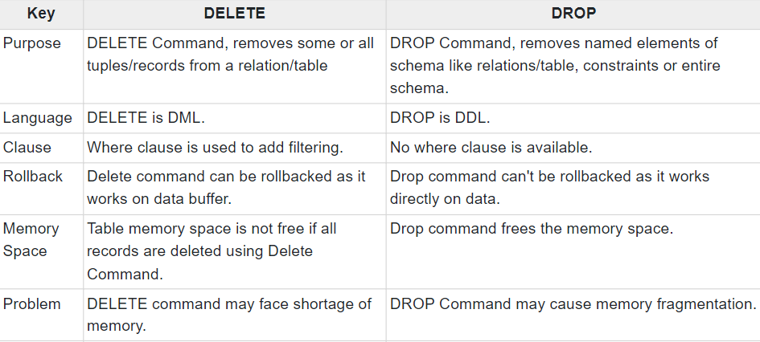
What is truncate command?
A truncate SQL statement is used to remove all rows (complete data) from a table. It is similar to the DELETE statement with no WHERE clause.
Truncate table is faster and uses lesser resources than DELETE TABLE command.
Drop table command can also be used to delete complete table but it deletes table structure too. TRUNCATE TABLE doesn't delete the structure of the table.
The rollback process is not possible after truncate table statement. Once you truncate a table you cannot use a flashback table statement to retrieve the content of the table.
- TRUNCATE TABLE table_name;
Ex. TRUNCATE TABLE Employee;

What are differences of truncate & delete & drop?
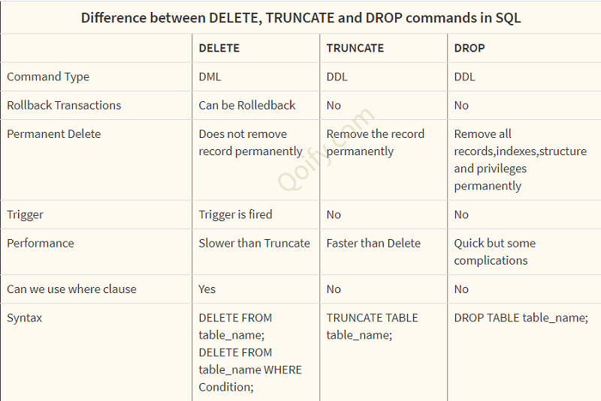
How to rename table?
- RENAME old_table _name To new_table_name ;
- RENAME Cars To Car_2021_Details;
- ALTER TABLE old_table_name RENAME TO new_table_name;
- ALTER TABLE Bikes RENAME TO Bikes_Details ;

How to copy data from one table to other?
- SELECT * INTO New_table_name FROM old_table_name;
- SELECT * INTO Car_Details FROM Cars;

How to select data from table?
- SELECT Column_Name_1, Column_Name_2, ....., Column_Name_N FROM Table_Name;
- Ex. SELECT Student_Id, Age, Percentage, Grade FROM Employee;

- SELECT * FROM table_name;
- Ex. SELECT * FROM Student_Records

- SELECT * FROM Name_of_Table WHERE [condition];
- Ex. SELECT * FROM Employee_Details WHERE Emp_Panelty = 500;

Select with Group by:
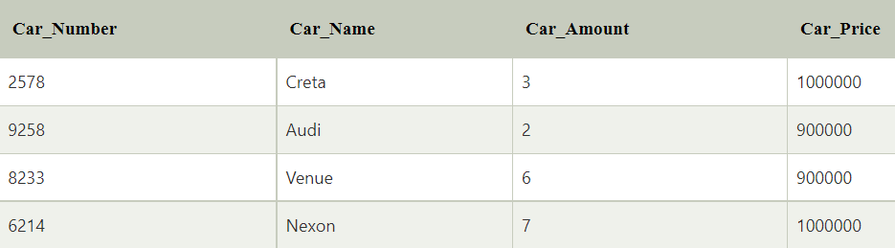
- The GROUP BY clause is used with the SELECT statement to show the common data of the column from the table:
- SELECT column_Name_1, column_Name_2, ....., column_Name_N aggregate_function_name(column_Name2) FROM table_name GROUP BY column_Name1;
- Ex. SELECT with GROUP BY query lists the number of cars of the same price:
- SELECT COUNT (Car_Name), Car_Price FROM Cars_Details GROUP BY Car_Price;
- 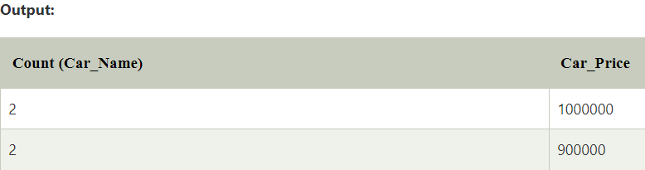

Select with having clause:

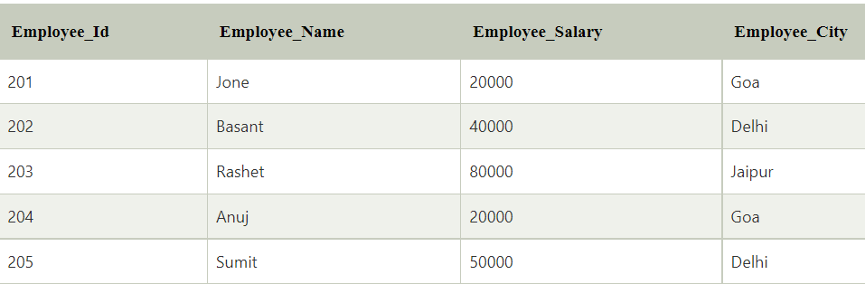
- The HAVING clause in the SELECT statement creates a selection in those groups which are defined by the GROUP BY clause.
- The following query shows the total salary of those employees having more than 50000 from the above Employee_Having table:
- SELECT SUM (Employee_Salary), Employee_City FROM Employee_Having GROUP BY Employee_City HAVING SUM(Employee_Salary)>50000;
- 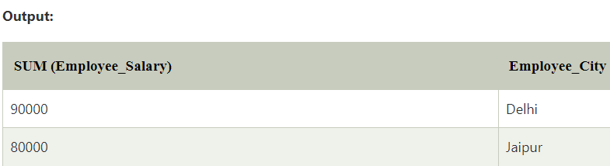
Select with order by clause:
- The ORDER BY clause with the SQL SELECT statement shows the records or rows in a sorted manner.
- The ORDER BY clause arranges the values in both ascending and descending order. Few database systems arrange the values of column in ascending order by default.
- SELECT Column_Name_1, Column_Name_2, ....., column_Name_N FROM table_name WHERE [Condition] ORDER BY[column_Name_1, column_Name_2, ....., column_Name_N asc | desc ];
- SELECT * FROM Employee_Order ORDER BY Emp_Salary DESC;
Select unique data
- SQL SELECT DISTINCT statement can also be used for the same cause.
- SELECT UNIQUE column_name
- FROM table_name;
- SELECT DISTINCT column_name
- FROM table_name;
Select top data from table
- SELECT TOP 4 * FROM Employee WHERE Emp_City = Goa ;
Select First data from table
- SELECT FIRST(column_name) FROM table_name;
Ex. SELECT FIRST (CUSTOMER_NAME) AS first_customer FROM CUSTOMERS;

Select Last data from table
- SELECT LAST(column_name) FROM table_name;
Ex. SELECT LAST (CUSTOMER_NAME) AS first_customer FROM CUSTOMERS;
Select Random data from table
- SELECT column FROM table ORDER BY RAND ( ) LIMIT 1
Select from set of values check it is present in or not
- SELECT * FROM students WHERE students_name IN ( Amit , Raghav, Rajeev)

Select date from table
- SELECT * FROM table-name WHERE your date-column >= '2013-12-12'

Select NULL Data
- SELECT SIR_NAME, FIRSTNAME, MARKS FROM STUDENTS WHERE MARKS IS NOT NULL

What are different clauses in SQL?
- A WHERE clause in SQL is a data manipulation language statement.
WHERE clauses are not mandatory clauses of SQL DML statements. But it can be used to limit the number of rows affected by a SQL DML statement or returned by a query.
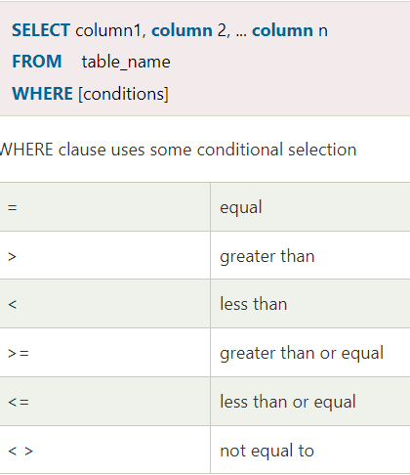
- The SQL AND condition is used in SQL query to create two or more conditions to be met.
Ex. SELECT *FROM emp WHERE Department = "IT" AND Location = "Chennai";
- SQL OR condition is used in SQL query to create a SQL statement where records are returned when any one condition met
Ex. SELECT *FROM emp WHERE Department = "IT" OR Location = "Chennai";
- SQL 'AS' is used to assign a new name temporarily to a table column or even a table.
- SELECT day_of_order AS 'Date', Customer As 'Client', Product, Quantity FROM orders;
- SELECT Student_Name AS Student, AVG (Student_Percentage) AS Average_Percentage FROM students;

What are differences of having & where clause?

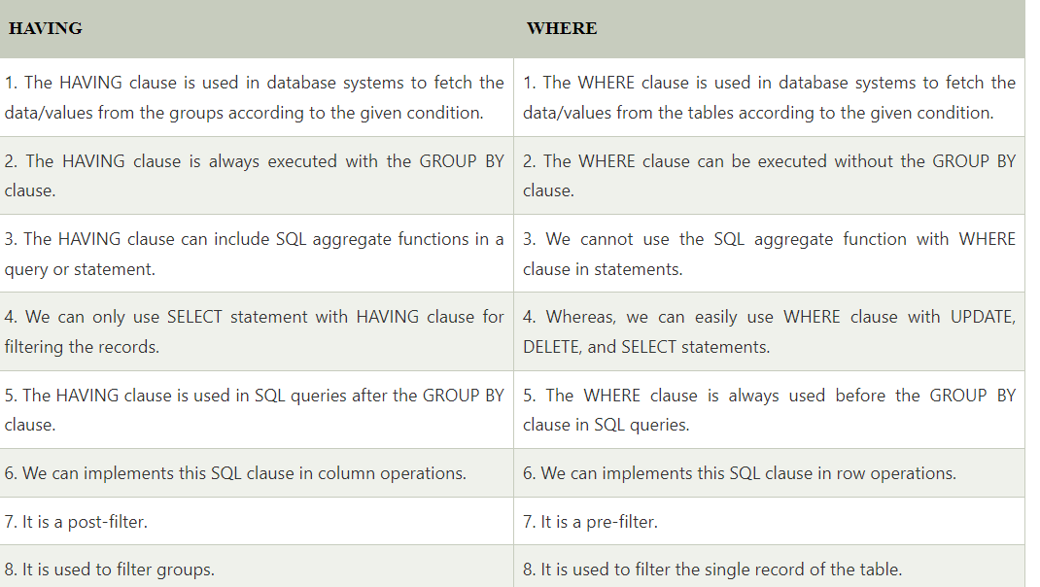
What are insert & update works in sql?
- INSERT INTO table_name VALUES (value1, value2, value3....);
- INSERT INTO STUDENTS VALUES (1, ABHIRAM, 22, ALLAHABAD);

- INSERT INTO table_name (column1, column2, column3....) VALUES (value1, value2, value3.....);
- INSERT INTO STUDENTS (ROLL_NO, NAME, AGE, CITY) VALUES (1, ABHIRAM, 22, ALLAHABAD);

- UPDATE table_name SET [column_name1= value1,... column_nameN = valueN] [WHERE condition]
- UPDATE students SET User_Name = 'beinghuman' WHERE Student_Id = '3'
- UPDATE students SET User_Name = 'beserious', First_Name = 'Johnny' WHERE Student_Id = '3'

What are joins in sql?
JOIN means to combine something. In case of SQL, JOIN means "to combine two or more tables".
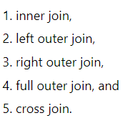
- Inner join – has equal condition from both table like one table has primary key and that column will be act as forgien key in second key
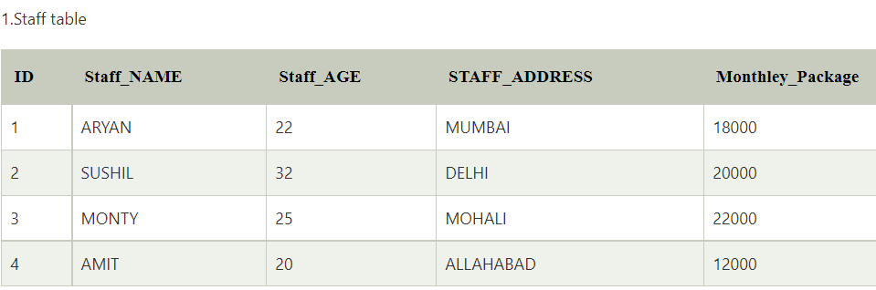
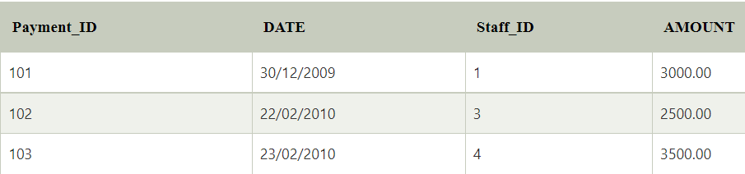

- SELECT Staff_ID, Staff_NAME, Staff_AGE, AMOUNT FROM STAFF s, PAYMENT p
WHERE s.ID =p.STAFF_ID;

- 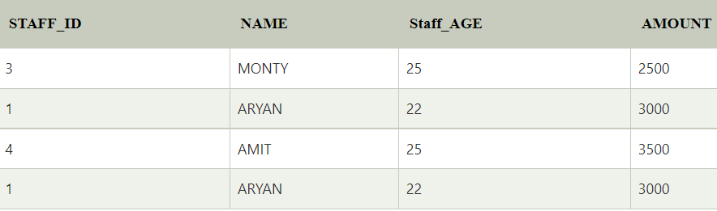

- Left Join : SQL left join returns all the values from the left table and it also includes matching values from right table, if there are no matching join value it returns NULL.
- 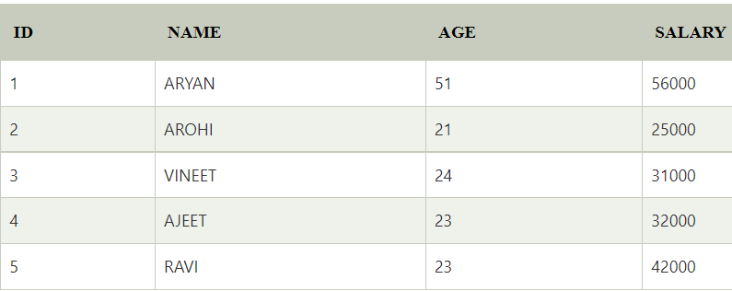
- 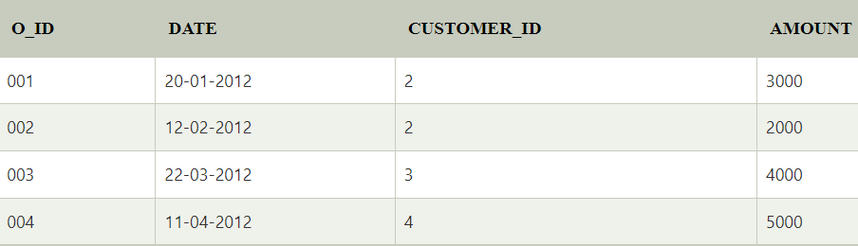
- SELECT ID, NAME, AMOUNT,DATE FROM CUSTOMER LEFT JOIN ORDER
ON CUSTOMER.ID = ORDER.CUSTOMER_ID;
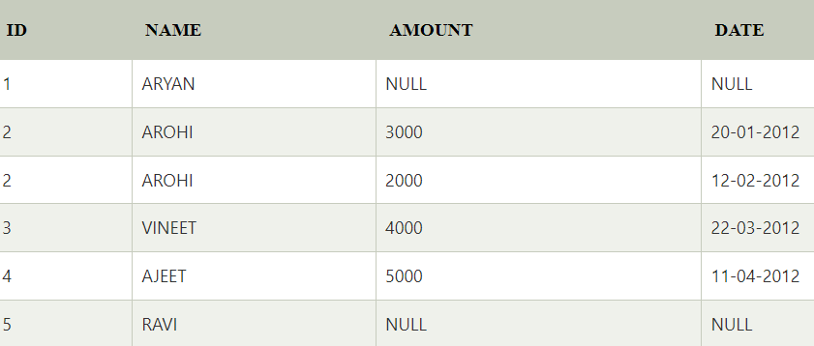
It taking value from left table customer and check condition like id of customer in right table whoever is match it printing data and if not then there is null value for right table column but left table column will print data.

- Right Join : SQL right join returns all the values from the rows of right table. It also includes the matched values from left table but if there is no matching in both tables, it returns NULL.

Uses same table as previous:
- SELECT ID, NAME, AMOUNT,DATE FROM CUSTOMER RIGHT JOIN ORDER
ON CUSTOMER.ID = ORDER.CUSTOMER_ID;
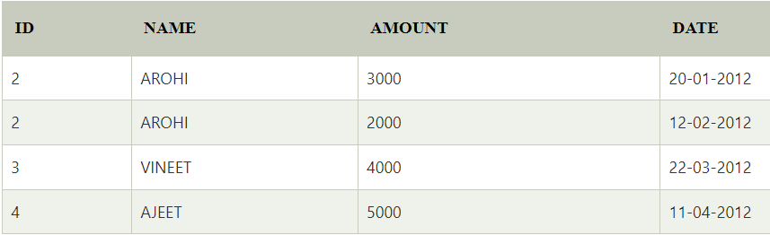
It taking value from right table order and check condition like id of customer in left table whoever is match it printing data and if not then there is null value for left table column but right table column will print data.

- The SQL full join is the result of combination of both left and right outer join and the join tables have all the records from both tables. It puts NULL on the place of matches not found.
- SELECT * FROM table1 FULL OUTER JOIN table2 ON table1.column_name = table2.column_name;
- 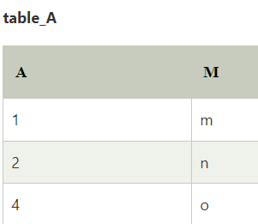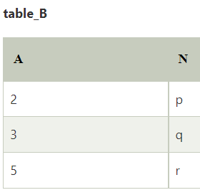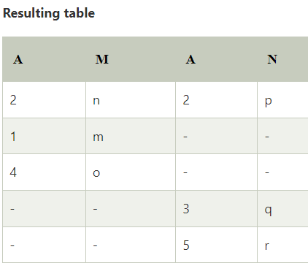
- Cross join : SQL is used to combine multiple tables together into a single table.
- SELECT *FROM customer CROSS JOIN orders;
- 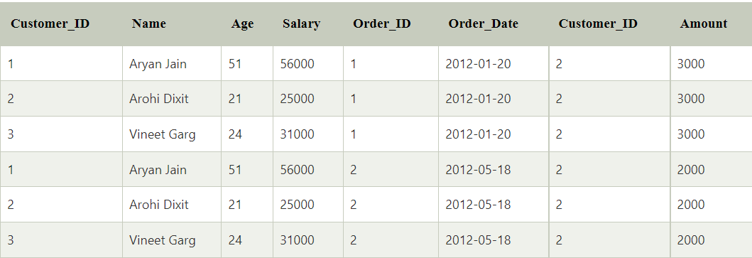

What are all keys in DBMS?
- Primary key: A column or columns is called primary key (PK) that uniquely identifies each row in the table. - A primary key cannot have null value.
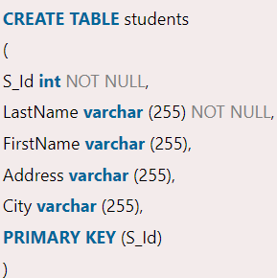

- Composite key: When multiple columns are used as a primary key, it is known as composite primary key.
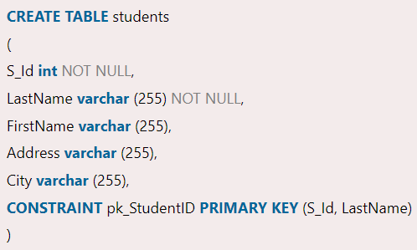

- Foreign key : is a field or a column that is used to establish a link between two tables.
- 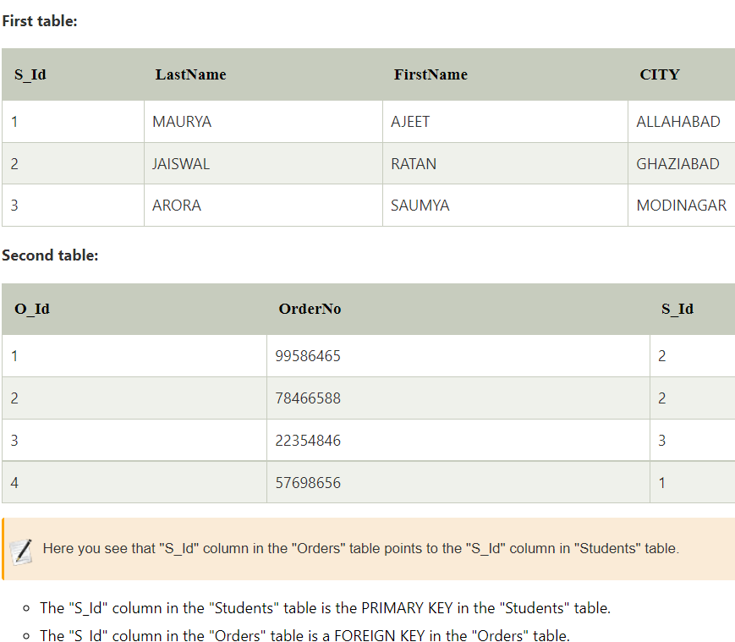

- 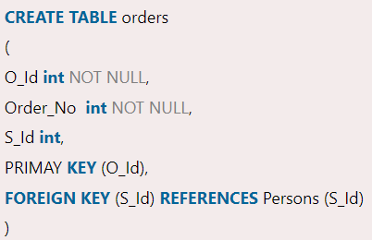

- unique key : is a set of one or more than one fields/columns of a table that uniquely identify a record in a database table.
- There may be many unique key constraints for one table, but only one PRIMARY KEY constraint for one table.
- The unique key and primary key both provide a guarantee for uniqueness for a column or a set of columns.
- You can say that it is little like primary key but it can accept only one null value and it cannot have duplicate values.
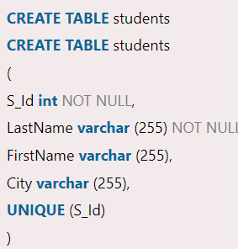

What is Exist keyword and how to use sub query?
EXISTS is a Boolean operator which checks the subquery result and returns an either TRUE or FALSE value.
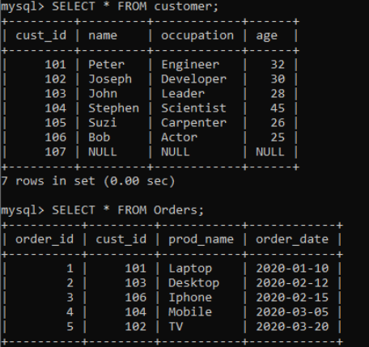
If we want to get all customer names and occupation who has placed at least one order, then we can use the statement as follows:
- SELECT name, occupation FROM customer WHERE EXISTS (SELECT * FROM Orders
WHERE customer.cust_id = Orders.cust_id);
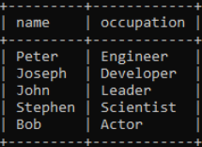

What are differences of In & Exists?

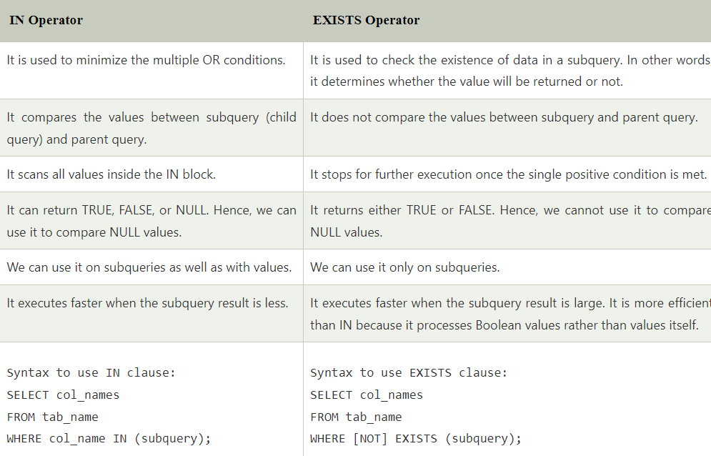

What is subquery?
- SELECT * FROM Student_Details WHERE Stu_Marks > ( SELECT AVG(Stu_Marks ) FROM Student_Details);
Here inner query will run first and it will keep data of inner query like avg of student marks
Now this marks is going compare with each value which is present in student detail table

- SELECT * FROM Department WHERE Faculty_ID IN (
SELECT Faculty_ID FROM Faculty WHERE City = 'Noida' OR City = 'Gurgaon' ) ;

- INSERT INTO New_Employee SELECT * FROM Old_Employee WHERE Emp_Salary > 40000;
Here it will first has data off inner query and then it is added to new table.

- UPDATE Employee_Details SET Emp_Salary = Emp_Salary + 50000 WHERE Emp_ID IN ( SELECT Emp_ID FROM Department WHERE Dept_Grade = 'A' ) ;
Here we have filter on employ with grade after that increment salary by 50000

- DELETE FROM Employee_Details WHERE Emp_ID IN ( SELECT Emp_ID FROM Department WHERE Dept_Grade = 'C' ) ;
Here we have deleted emp which has grade C

What is View?
SQL provides the concept of VIEW, which hides the complexity of the data and restricts unnecessary access to the database. It permits the users to access only a particular column rather than the whole data of the table.
The View in the Structured Query Language is considered as the virtual table, which depends on the result-set of the predefined SQL statement.
Syntax to Create View from Single Table
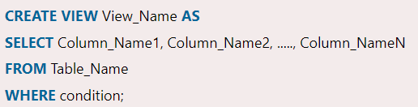
Syntax to Create View from Multiple Tables
CREATE VIEW View_Name AS
SELECT Table_Name1.Column_Name1, Table_Name1.Column_Name2, Table_Name2.Column_Name2, ....., Table_NameN.Column_NameN
FROM Table_Name1, Table_Name2, ....., Table_NameN
WHERE condition;

Ex.
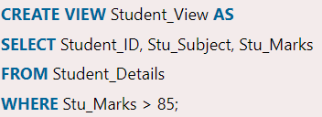

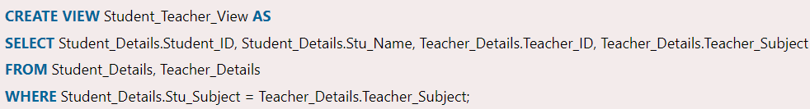

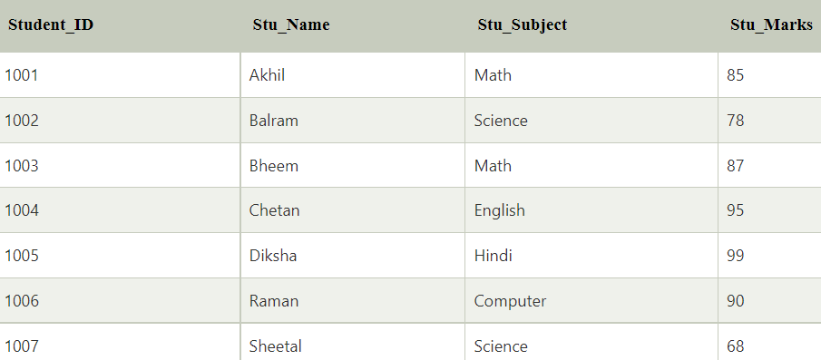

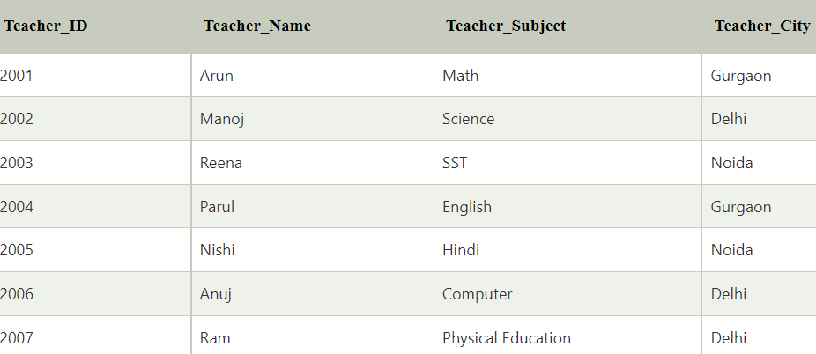
Output :
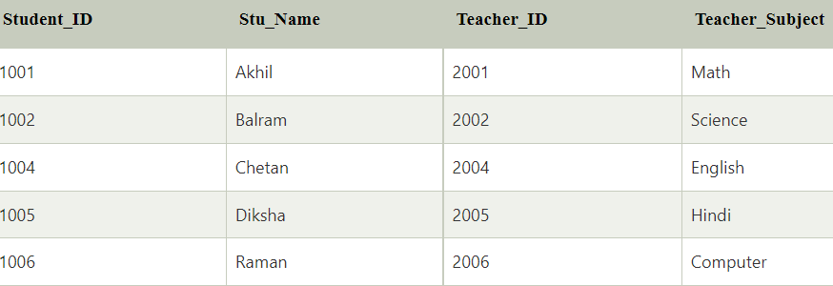

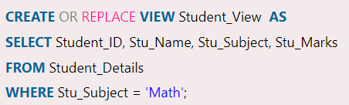

INSERT INTO Student_View (Student_ID, Stu_Subject, Stu_Marks) VALUES (1007, Hindi, 89);

What is Store procedure and how it works?
- A stored procedure is a group of one or more pre-compiled SQL statements into a logical unit.
- It is stored as an object inside the database server.
- We can invoke the procedures by using triggers, other procedures, and applications such as Java, Python, PHP, etc. It can support almost all relational database systems.
- Advantages :
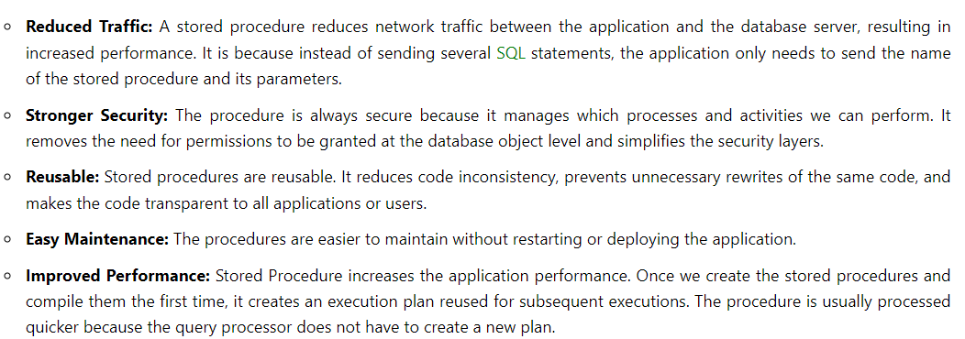

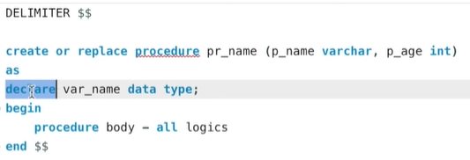
Schema_name: It is the name of your database or schema. By default, a procedure is associated with the current database, but we can also create it into another database by specifying the DB name.
Procedure_Name: It represents the name of your stored procedure that should be meaningful names so that you can identify them quickly. It cannot be the system reserved keywords.
Parameter_Name: It represents the number of parameters. It may be zero or more based upon the user requirements. We must ensure that we used the appropriate data type.
Without parameter :
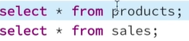
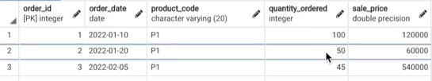
- Select iphone with 13 pro max name
- Create variable and store it so we will use for further queries
- Write insert query for product
- Once we insert quantitiy remaining is change and quantity sold is change so write update query
We will run all queries once with the help of procedure.

DELIMITER $$;
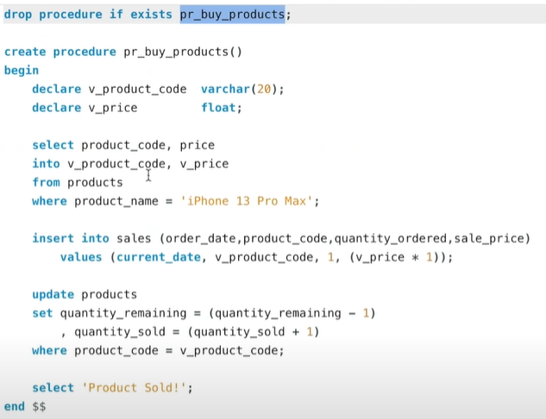
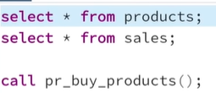

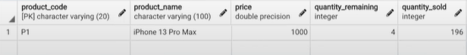
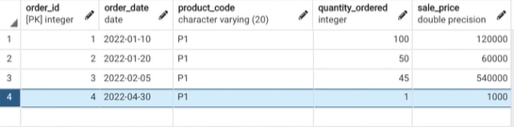

With Parameter :
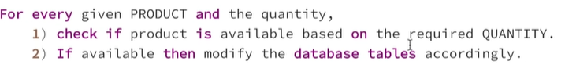
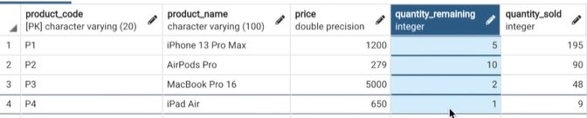
Check is sufficient amount of product is available
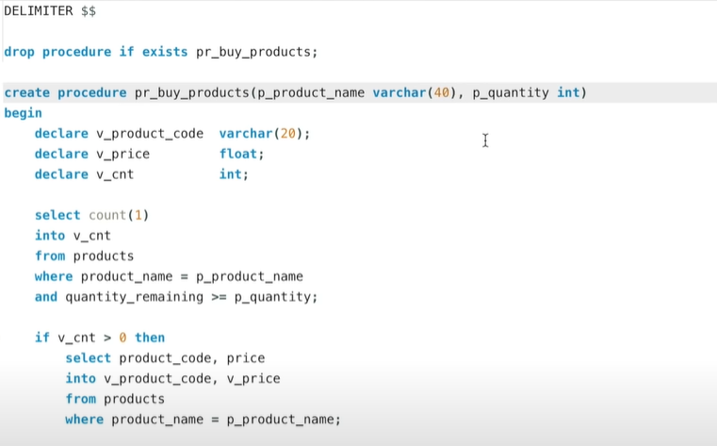
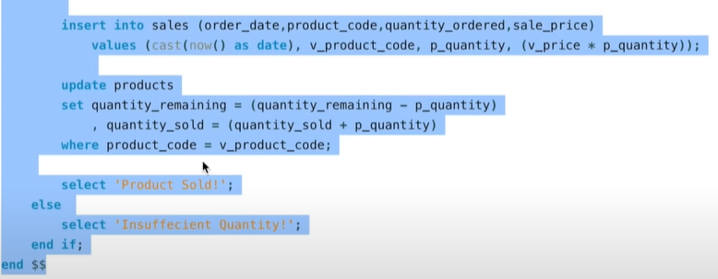
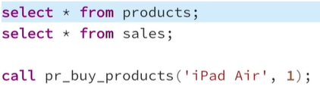

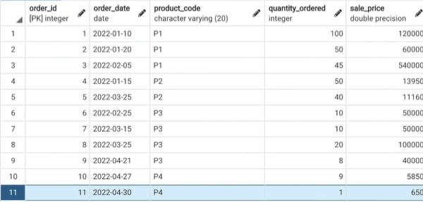
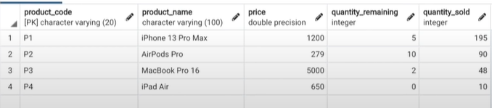

What is TRIGGER how it works?
A trigger is a set of SQL statements that reside in system memory with unique names. It is a specialized category of stored procedure that is called automatically when a database server event occurs. Each trigger is always associated with a table.
A trigger is called a special procedure because it cannot be called directly like a stored procedure. The key distinction between the trigger and procedure is that a trigger is called automatically when a data modification event occurs against a table. A stored procedure, on the other hand, must be invoked directly.
The following are the main characteristics that distinguish triggers from stored procedures:
- We cannot manually execute/invoked triggers.
- Triggers have no chance of receiving parameters.
- A transaction cannot be committed or rolled back inside a trigger.

