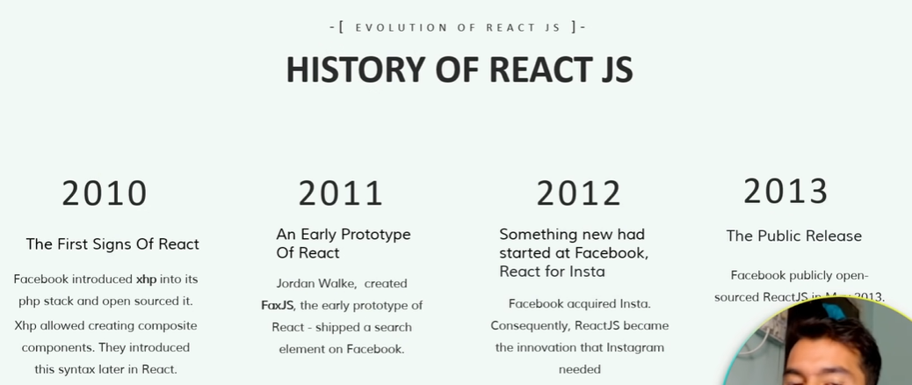

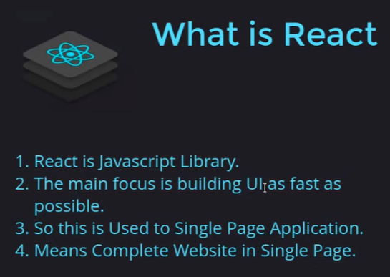

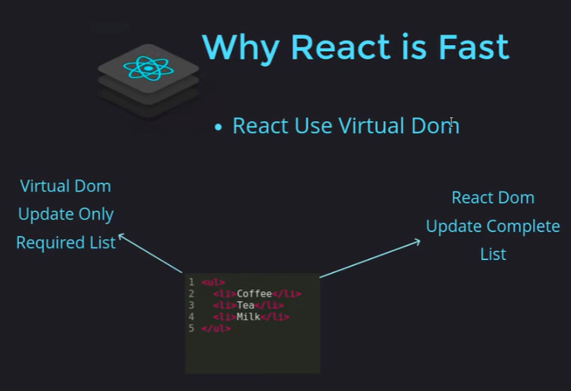

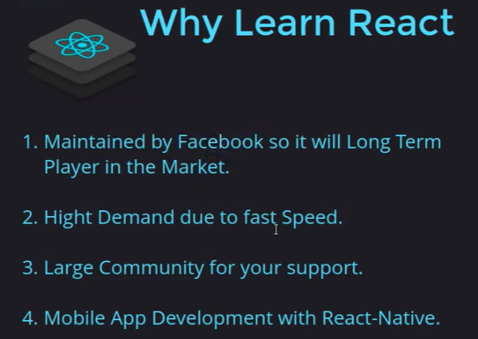

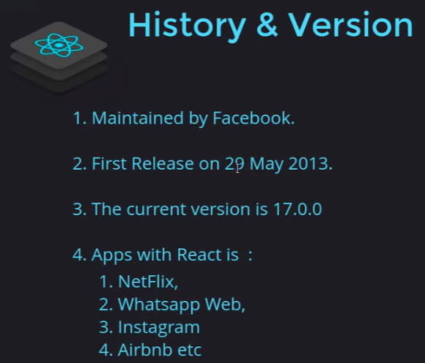

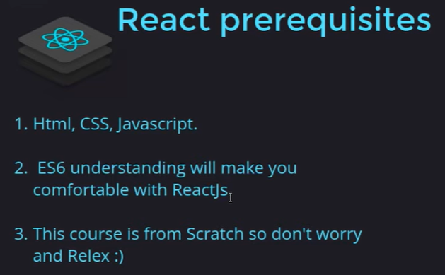

Installation :

1. React developer tool – extension
2. Nodejs installation
3. Vs code

Vs code extension :

1. Thunder Client
2. ES7 – grahql
3. Bracket color
4. Auto rename
5. live server
6. prettier
7. Material Icon theme

npm is basically for getting this ready all time.

Npx is just for one folder to create app no need to download npm

React is library not framework.

Create app:

npx create-react-app myapp

In App.js if we want to return multiple html then use JSX fragment ->

<>

<html>……code

<html>…….code

</>

**Props are used to pass data**, whereas state is for managing data.

Data from props is read-only, and cannot be modified by a component that is receiving it from outside.

State data can be modified by its own component, but is private (cannot be accessed from outside).

Props and prototypes :

Rfc short cut for creating react function

Imptr for prototype

Used to pass the data in component and prototypes is used to validate props types.

import PropTypes from 'prop-types'

export default function Navbar(props) {

    return (

<nav>………

<a className="navbar-brand" href="/">{props.title}</a>

)

Navbar.prototype = {

    title:PropTypes.string.isRequired,

}

App.js

function App() {

  return (

    <>

    <Navbar title="CodeOuter"/>

    </>

  );

}

React Hook :

1. useState – this is used to set and update value

const[text, setText] = useState("Enter your text here ");

const convertupper = () => {

        let newText = text.toUpperCase();

        setText(newText);

    }

    const textchange = (event) => {

        setText(event.target.value);

    }

    return (

        <>

        <div className="container my-3">

            <label htmlFor="textarea">{props.heading}</label>

            <textarea className="form-control" value={text}  onChange={textchange} id="mybox" rows="8"></textarea>

            <button className="btn btn-success my-3" onClick={convertupper}>Convert To Uppercase</button>

        </div>

        </>

    )

React router dom : npm install react-router-dom

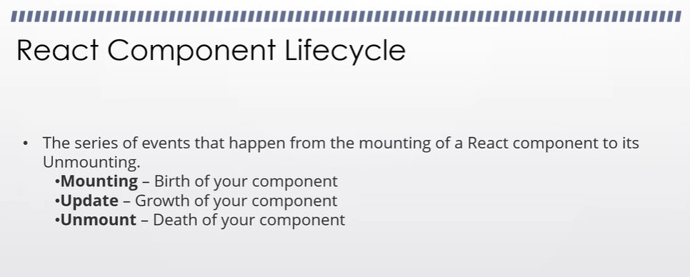

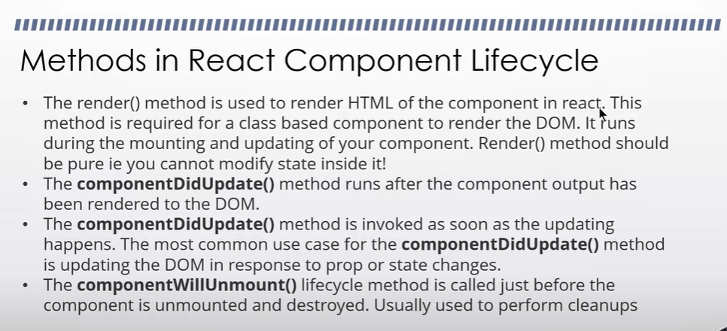

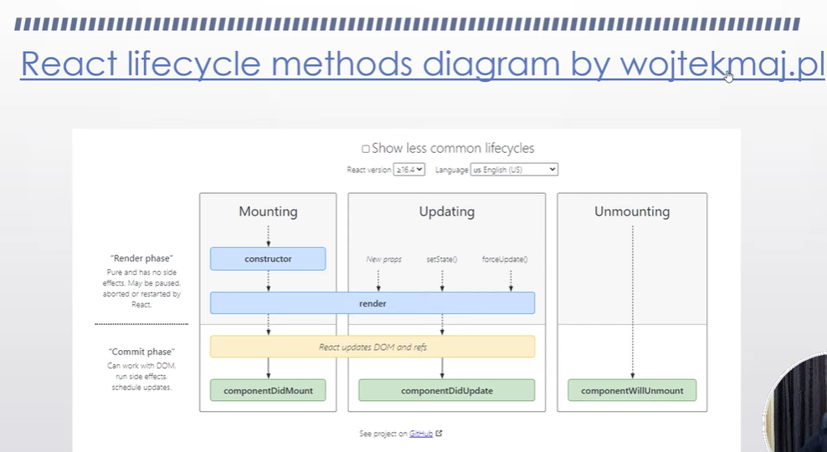

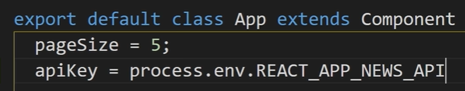

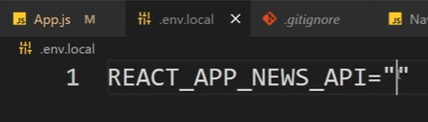

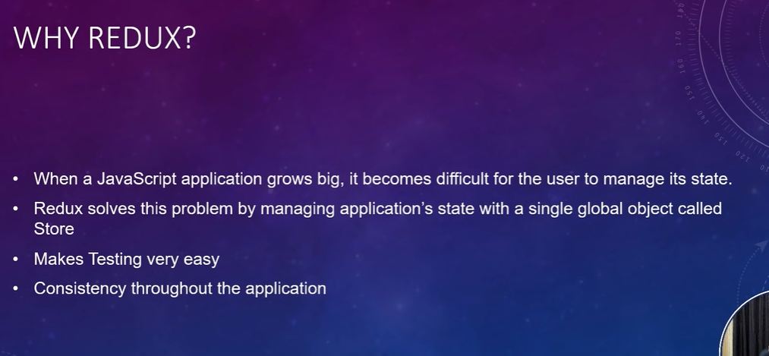

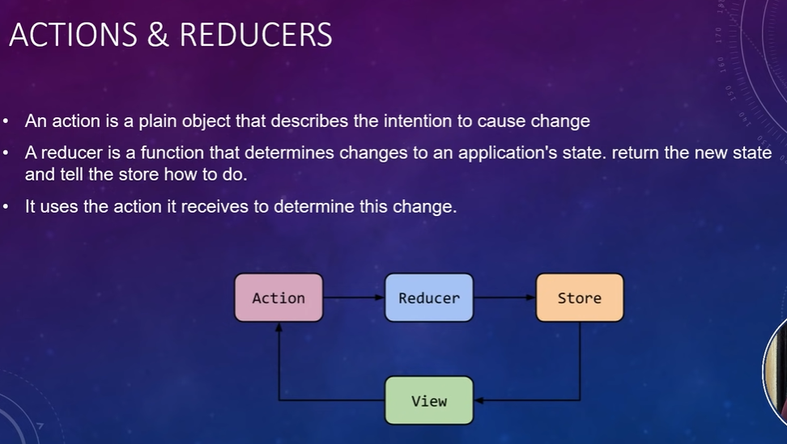

Action is just telling action that what we want to give to template

Reducer can be more than one like action is bring a water or bring a clothes then there are two reducer who does this works. And change their state and give back to template

If let say if you have more reducers then combine that all reducer and export it.

Intermediate folder structure

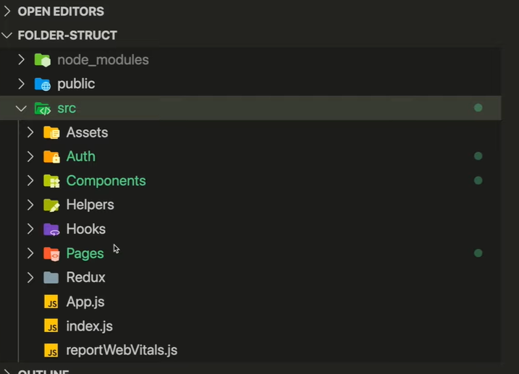

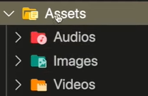

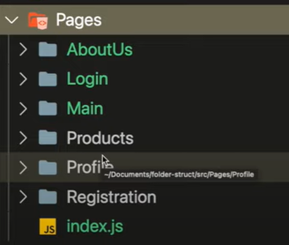

Advanced level

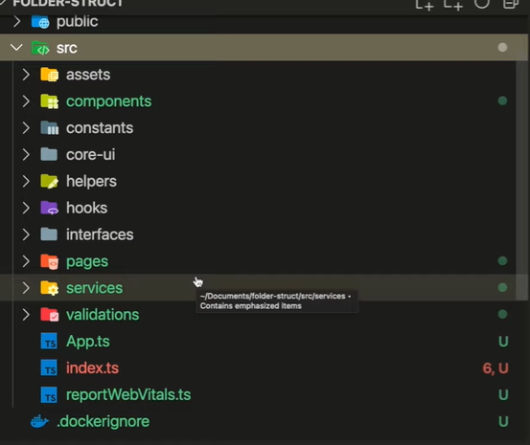

Redux took

npm install redux react-redux @reduxjs/toolkit

