What is API : Application Programming Interface

It is used to communicate with two or more apps

Zomato need google map api so that we can track where is delivery boy.

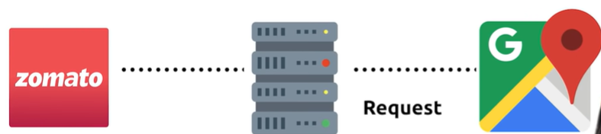

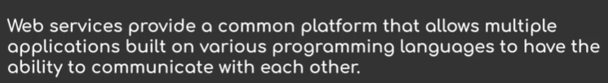

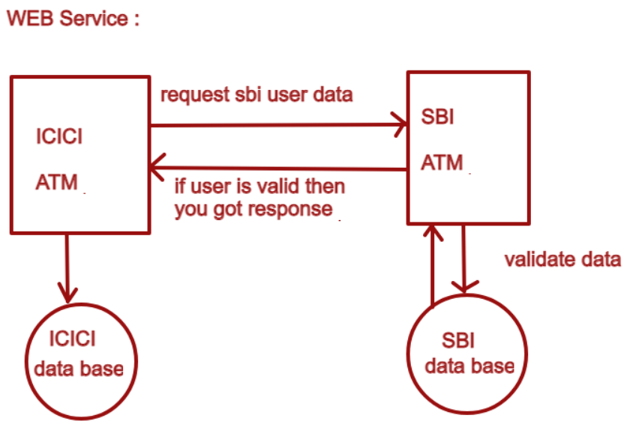

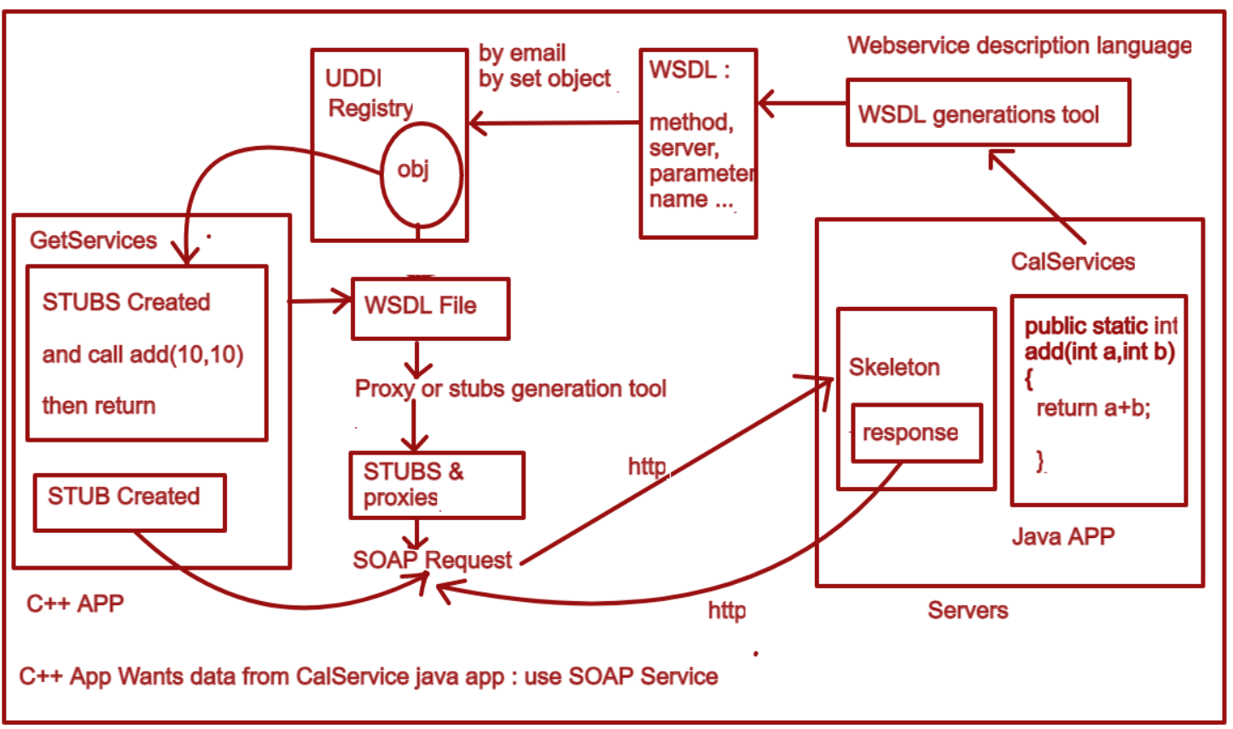

Need of webservice :

We have old technology that perform same task:

1. SP – Socket programming :

2. RMI- Remote method invocation

3. EJB – Enterprise javabeans

This three is used to share data but only if two application is a java application.

4. Dcom - Distributed Component Object Model

This is used to share data but only if two application is a dot net application.

5. Remote procedure call

This is used to share data but only if two application is a C and C++ application.

6. Corba - Common Object Request Broker Architecture

This is used to share data with two application in any language. There is no dependency between two application.

It is failed now days because if let’s one application is made in C++ and second is in java then corba will give specific implementations of each language. Then that application can used corba implementation. But it is not providing proper implementation in some of cases it is not able to share data so we need webservies.

Two Types of web service: SOAP and RESTFUL API

1. SOAP : Simple object access Protocol
2. It is a XML-based protocol for accessing web services.
3. It is platform independent and language independent
4. you will be able to interact with other programming language applications.

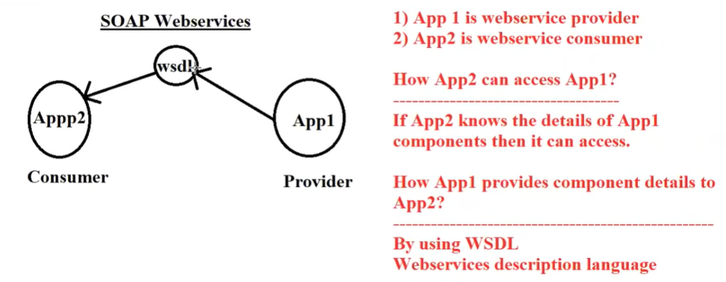

Disadvantage of soap :

1. SOAP uses XML format that must be parsed to be read
2. It is slow and consumes more bandwidth and resource.
3. SOAP uses WSDL and doesn't have any other mechanism to discover the service.

Representational state transfer



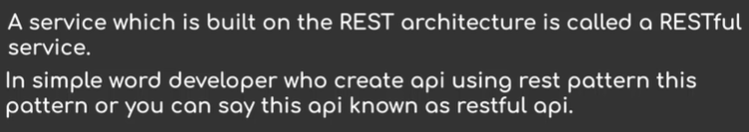

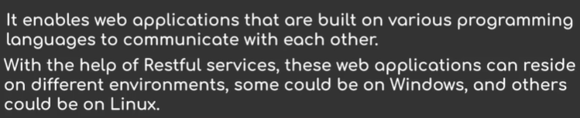

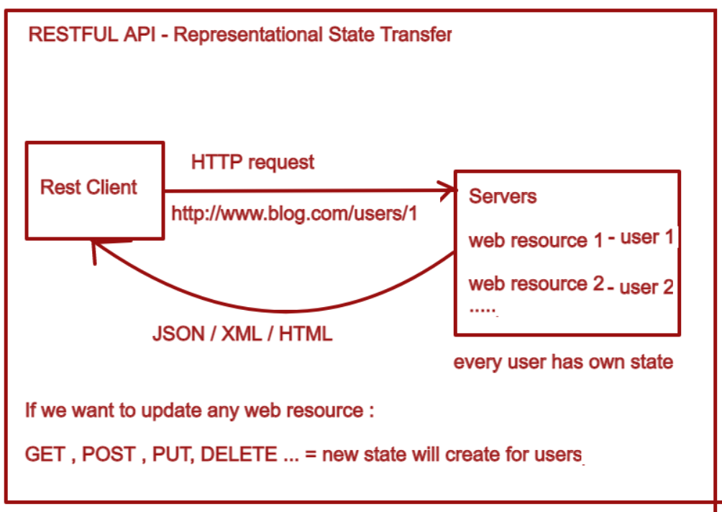

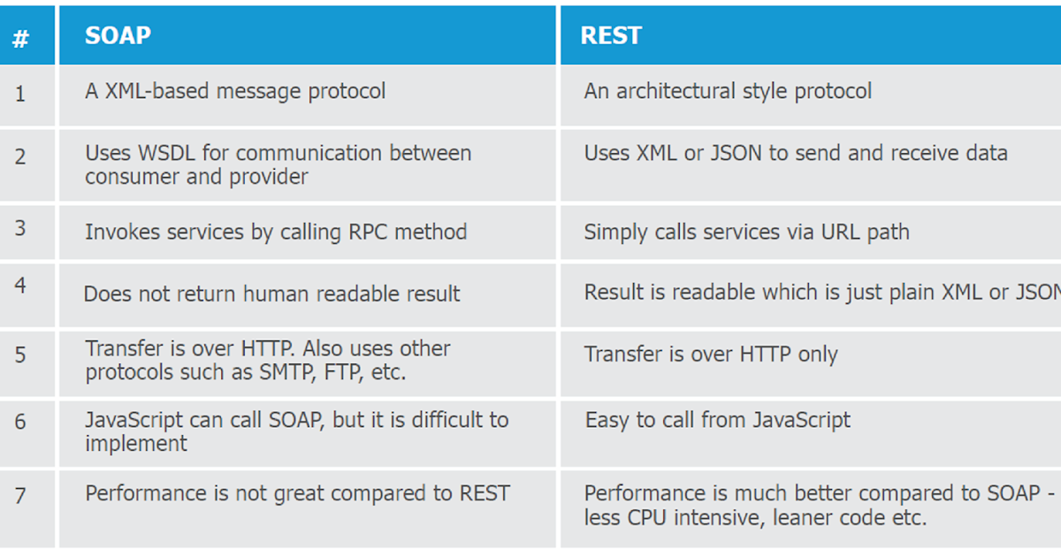

What are ways to make REST API :

1. Use Spring Boot OR Swagger framework
2. Use Jersery

JAX-RS: The Java API for RESTful Web Services. Jersey implements support for the annotations defined in JSR-311, making it easy for developers to build RESTful web services with Java and the Java JVM

* Add dependency –
* 1. org.glassfish.jersey.containers - jersey-container-servlet
* 2. org.glassfish.jersey.inject- jersey-hk2
* 3. org.glassfish.jersey.media - jersey-media-json-jackson
* 4. org.glassfish.jersey.core - jersey-client
* and setup web.xml and write code for api jersey
* For client – use client config and web resource , target many things for to get requires response.

Swagger Framework:

It is API documentation for rest client.

We can also test api using swagger

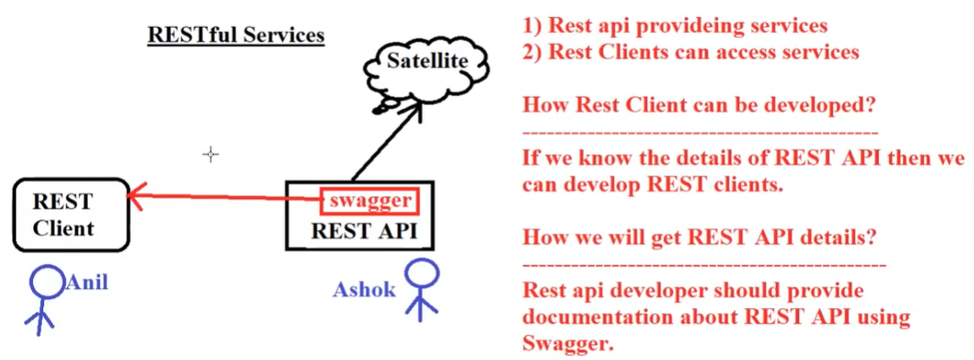

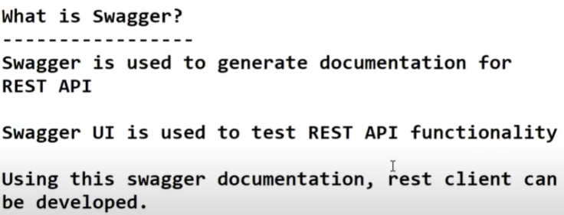

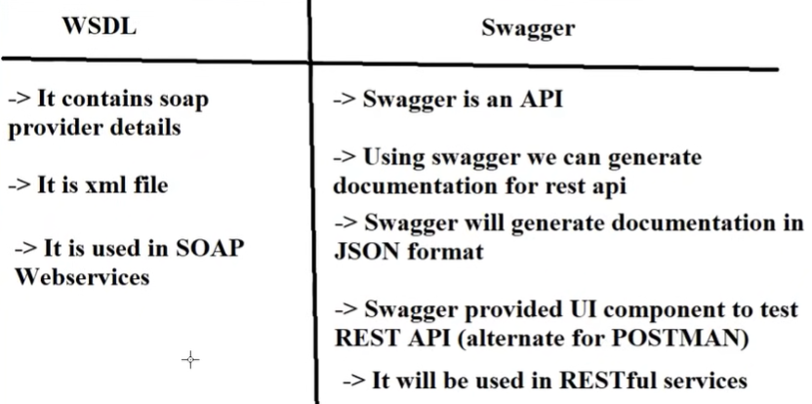

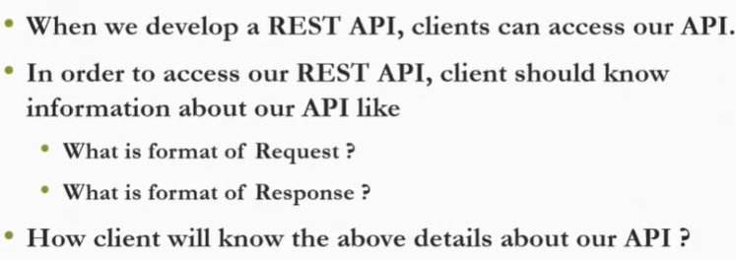­

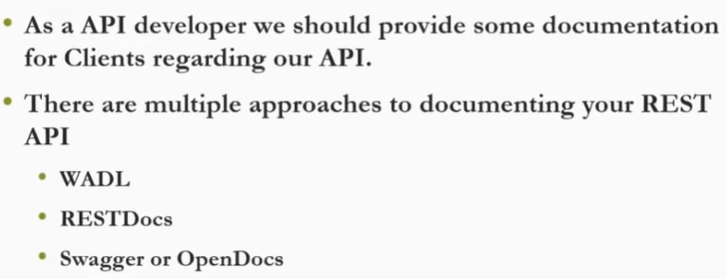

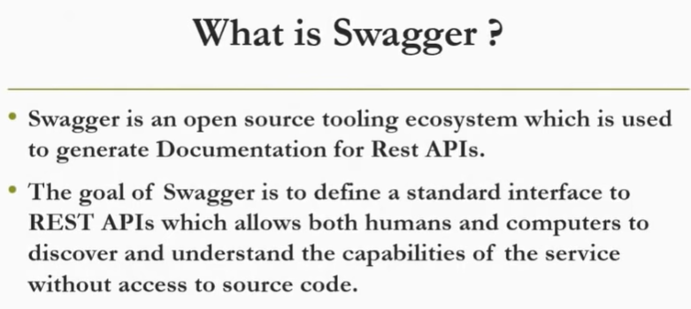

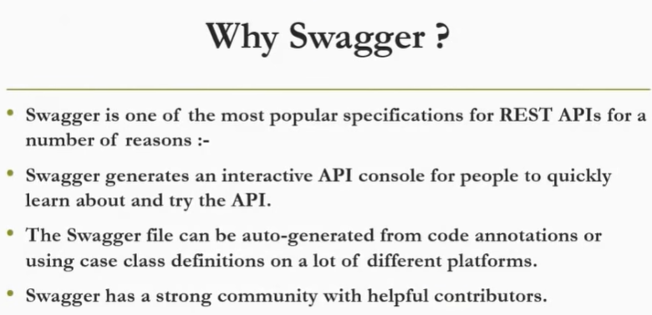

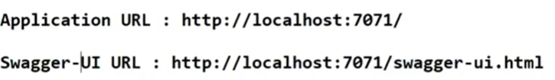

Swagger Api URL - <http://localhost:5000/v3/api-docs>

Dependency :

<dependency>

<groupId>org.springdoc</groupId>

<artifactId>springdoc-openapi-ui</artifactId>

<version>1.6.9</version> </dependency>

Spring boot app :

@OpenAPIDefinition(info = @Info(title = "Student ID - Test API", version = "1.0", description = "ID TEST DATA "))

Application properties : springdoc.swagger-ui.operationsSorter=method