INSERT INTO Teacher(Id, FirstName, LastName, BirthDate, HireDate, Email, Phone, Salary, [Address])

VALUES

(NEWID(), 'Elon Reeve', 'Musk', '1971-06-28', '2023-01-09', 'elon.musk@lifes.com', '+1 (213) 934-0001', 900000, '771 North Park Avenue'),

(NEWID(), 'Jeffrey Preston', 'Bezos', '1964-01-12', '2023-11-09', 'jeff.bezos@lifes.com', '+1 (213) 934-0002', 790000, '2721 Midvale Avenue'),

(NEWID(), 'Khalid Mahmud', 'Abbed', '1971-05-25', '2023-02-09', 'khalid.abbed@lifes.com', '+1 (213) 934-0003', 3000000, '23421 Palm Drive'),

(NEWID(), 'Taylor Alison', 'Swift', '1989-12-13', '2023-03-09', 'taylor.swift@lifes.com', '+1 (213) 934-0004', 700000, '2056 West 185th Street'),

(NEWID(), 'John Christopher', 'Depp', '1963-06-09', '2023-01-10', 'johnny.depp@lifes.com', '+1 (213) 934-0005', 670000, '2120 Bataan Road'),

(NEWID(), 'Barack Hussein', 'Obama', '1961-08-04', '2023-01-11', 'barack.obama@lifes.com', '+1 (213) 934-0006', 905000, 'Providence Little Company of Mary Medical Center Torrance, 4101 Torrance Boulevard'),

(NEWID(), 'Ingmar Hendrik', 'Rohusaar', '2005-05-23', '2023-01-08', 'ingmar.rohusaar@lifes.com', '+1 (213) 934-0007', 760000, '783 Aviation Boulevard'),

(NEWID(), 'James Stephen', 'Donaldson', '1998-05-07', '2023-11-09', 'jimmy.donaldson@lifes.com', '+1 (213) 934-0008', 870000, '4182 Woodgrove Avenue'),

(NEWID(), 'Witten', 'Edward', '1951-08-26', '2023-01-19', 'edward.witten@lifes.com', '+1 (213) 934-0009', 1190000, '3469 Tenaya Avenue'),

(NEWID(), 'Dwight', 'Alvey', '1978-05-25', '2023-01-09', 'dwight.alvey@lifes.com', '+1 (213) 934-1000', 902000, '4478 Santa Fe Avenue');

INSERT INTO Class(Id, ClassName, TeacherId)

VALUES

(NEWID(), 'TARpe22', (SELECT TOP 1 Id FROM Teacher WHERE Id NOT IN (SELECT TeacherId FROM Class) ORDER BY NEWID())),

(NEWID(), 'TARpe21', (SELECT TOP 1 Id FROM Teacher WHERE Id NOT IN (SELECT TeacherId FROM Class) ORDER BY NEWID())),

(NEWID(), 'TARpe23', (SELECT TOP 1 Id FROM Teacher WHERE Id NOT IN (SELECT TeacherId FROM Class) ORDER BY NEWID())),

(NEWID(), 'TITpe22', (SELECT TOP 1 Id FROM Teacher WHERE Id NOT IN (SELECT TeacherId FROM Class) ORDER BY NEWID())),

(NEWID(), 'TITpe21', (SELECT TOP 1 Id FROM Teacher WHERE Id NOT IN (SELECT TeacherId FROM Class) ORDER BY NEWID())),

(NEWID(), 'TITpe23', (SELECT TOP 1 Id FROM Teacher WHERE Id NOT IN (SELECT TeacherId FROM Class) ORDER BY NEWID())),

(NEWID(), 'METpe21', (SELECT TOP 1 Id FROM Teacher WHERE Id NOT IN (SELECT TeacherId FROM Class) ORDER BY NEWID())),

(NEWID(), 'METpe22', (SELECT TOP 1 Id FROM Teacher WHERE Id NOT IN (SELECT TeacherId FROM Class) ORDER BY NEWID())),

(NEWID(), 'METpe23', (SELECT TOP 1 Id FROM Teacher WHERE Id NOT IN (SELECT TeacherId FROM Class) ORDER BY NEWID())),

(NEWID(), 'MEHpe22', (SELECT TOP 1 Id FROM Teacher WHERE Id NOT IN (SELECT TeacherId FROM Class) ORDER BY NEWID()));

INSERT INTO Student(Id, FirstName, LastName, BirthDate, EnrollmentDate, HomeNumber, [Address], ClassId)

VALUES

(NEWID(), 'John', 'Doe', '2005-03-15', '2023-09-01', '+1 (123) 456-7890', '123 Main St', (SELECT TOP 1 Id FROM Class ORDER BY NEWID())),

(NEWID(), 'Jane', 'Smith', '2006-07-10', '2023-09-01', '+1 (234) 567-8901', '456 Elm St', (SELECT TOP 1 Id FROM Class ORDER BY NEWID())),

(NEWID(), 'Michael', 'Johnson', '2004-01-20', '2023-09-01', '+1 (345) 678-9012', '789 Oak St', (SELECT TOP 1 Id FROM Class ORDER BY NEWID())),

(NEWID(), 'Emily', 'Brown', '2005-11-05', '2023-09-01', '+1 (456) 789-0123', '101 Pine St', (SELECT TOP 1 Id FROM Class ORDER BY NEWID())),

(NEWID(), 'Daniel', 'Wilson', '2006-04-30', '2023-09-01', '+1 (567) 890-1234', '202 Maple St', (SELECT TOP 1 Id FROM Class ORDER BY NEWID())),

(NEWID(), 'Olivia', 'Davis', '2007-09-12', '2023-09-01', '+1 (678) 901-2345', '303 Cedar St', (SELECT TOP 1 Id FROM Class ORDER BY NEWID())),

(NEWID(), 'Matthew', 'Lee', '2004-12-03', '2023-09-01', '+1 (789) 012-3456', '404 Birch St', (SELECT TOP 1 Id FROM Class ORDER BY NEWID())),

(NEWID(), 'Ava', 'Martin', '2005-06-25', '2023-09-01', '+1 (890) 123-4567', '505 Oak St', (SELECT TOP 1 Id FROM Class ORDER BY NEWID())),

(NEWID(), 'William', 'Anderson', '2006-02-15', '2023-09-01', '+1 (901) 234-5678', '606 Pine St', (SELECT TOP 1 Id FROM Class ORDER BY NEWID())),

(NEWID(), 'Sophia', 'Garcia', '2005-10-08', '2023-09-01', '+1 (012) 345-6789', '707 Elm St', (SELECT TOP 1 Id FROM Class ORDER BY NEWID()));

INSERT INTO FoodCoupon(Id, Amount, StudentId)

VALUES

(NEWID(), 1.2, (SELECT TOP 1 Id FROM Student ORDER BY NEWID())),

(NEWID(), 1.2, (SELECT TOP 1 Id FROM Student ORDER BY NEWID())),

(NEWID(), 3, (SELECT TOP 1 Id FROM Student ORDER BY NEWID())),

(NEWID(), 1.2, (SELECT TOP 1 Id FROM Student ORDER BY NEWID())),

(NEWID(), 3, (SELECT TOP 1 Id FROM Student ORDER BY NEWID())),

(NEWID(), 1.2, (SELECT TOP 1 Id FROM Student ORDER BY NEWID())),

(NEWID(), 3, (SELECT TOP 1 Id FROM Student ORDER BY NEWID())),

(NEWID(), 3, (SELECT TOP 1 Id FROM Student ORDER BY NEWID())),

(NEWID(), 1.2, (SELECT TOP 1 Id FROM Student ORDER BY NEWID())),

(NEWID(), 1.2, (SELECT TOP 1 Id FROM Student ORDER BY NEWID()));

--- stored procedure

create procedure spGetStudentData

as begin

select FirstName, LastName, BirthDate, EnrollmentDate, HomeNumber, Address

from Student

end

execute spGetStudentData

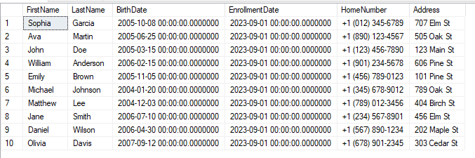

--- join päringud

-- inner join

select FirstName, LastName, ClassName

from Student

inner join Class

on Student.ClassId = Class.Id

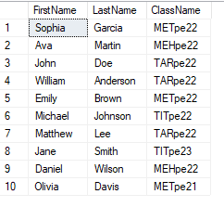

-- right join

select FirstName, LastName, ClassName

from Student

right join Class

on Student.ClassId = Class.Id

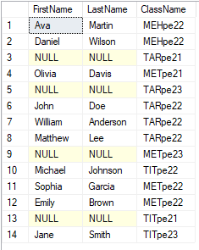

-- full outer join

select FirstName, LastName, ClassName

from Student

full outer join Class

on Student.ClassId = Class.Id

