IMAGEJ Multi_tracking (modified NanoTrackingBis)

By Ingrid Spielman

ImageJ is a tool that allows us to analyze images and image stacks (movies). Researchers interested in looking at cell movement have developed a program called Nano TrackingBis to track bacteria and objects. This software is written in Java and uses a cross-correlation method to track the movement of a kernel image over a ROI (region of interest) specified by the user.

We have modified this program to allow users to track multiple pillars in a single image stack. The program GUI (guided user interface) looks like the following.

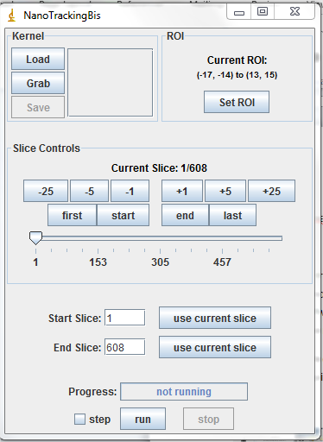

Figure 1 Original NanoTrackingBis

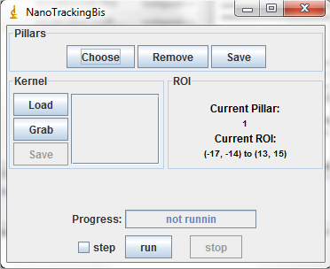Figure 2: New NanoTrackingBis for mutiple pillars

The new version allows you to pick multiple pillars and track them in a single attempt. We will explain exactly how to do that here.

1. Load the modified nanotrackingBis java and class file before starting your analysis. Do this by locating the imageJ plugins folder Program Files 🡪 ImageJ 🡪 plugins. Add those two files to the folder.
2. Load the image stack into imageJ. NanotrackingBis can only track 8-bit tiff stacks, so if your movie is not in this form, convert it and then save it.
3. To run the nanotrackingBis program if you have not already loaded it. Continue from step 1 by opening imageJ and click plugins 🡪 compile and run. The image stack must be open in order for the program to run. If no image stack is present, you will get an error “please open image stack before running nanotrackingbis”.
4. Use the rectangular selection tool from the imageJ toolbar to select a single pillar
5. 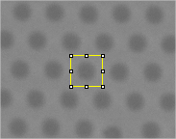 This is what the pillars look like when selected. Use as the kernel image as they are identical. Click “Grab” in the Kernel window of the GUI.
6. Next switch to the *Point* or multiselect tool. Select multiple pillars. To do that, hold the shift key down while selecting pillars that have been pulled. Your last selection should be a pillar not moved by the bacteria colony.
7. 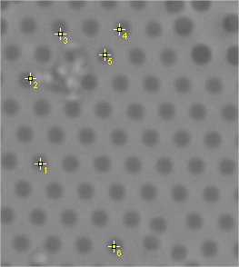This is what the selection should look like.
8. Click choose.
9. 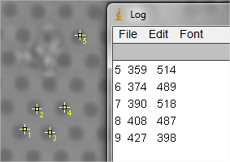Clicking choose will cause a log box to pop up with the coordinates of each point you selected. You can save the log to keep a list of where the pillars are located. Also consider print screening the pillar image so that you can refer to it later.
10. Exit out of the log and click run.
11. The program will run through all of the pillars you chose and then save a txt file with the name of the file and the pillar number in the folder that the tiff stack was opened from. These txt files can then be used for data analysis to answer questions like bacteria speed and force applied to the pillars

The files look like the following.

First column is the frame number, second is the X, third is the Y

