sweep_one_frame_3_hist_comparison.py

if ((intersection1 >= 0.6 and intersection2 >= 0.6) or
(intersection1 >= 0.6 and intersection3 >= 0.6) or
(intersection2 >= 0.6 and intersection3 >= 0.6)):

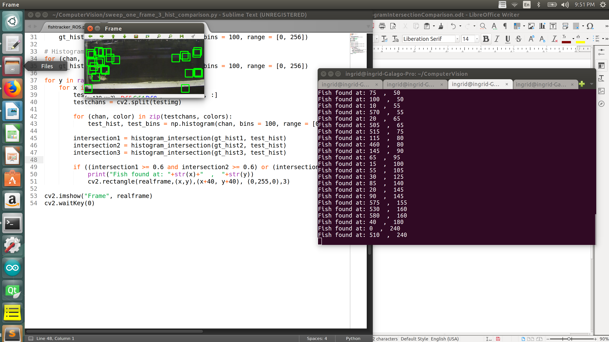
Intersection = 0.6

Intersection = 0.65
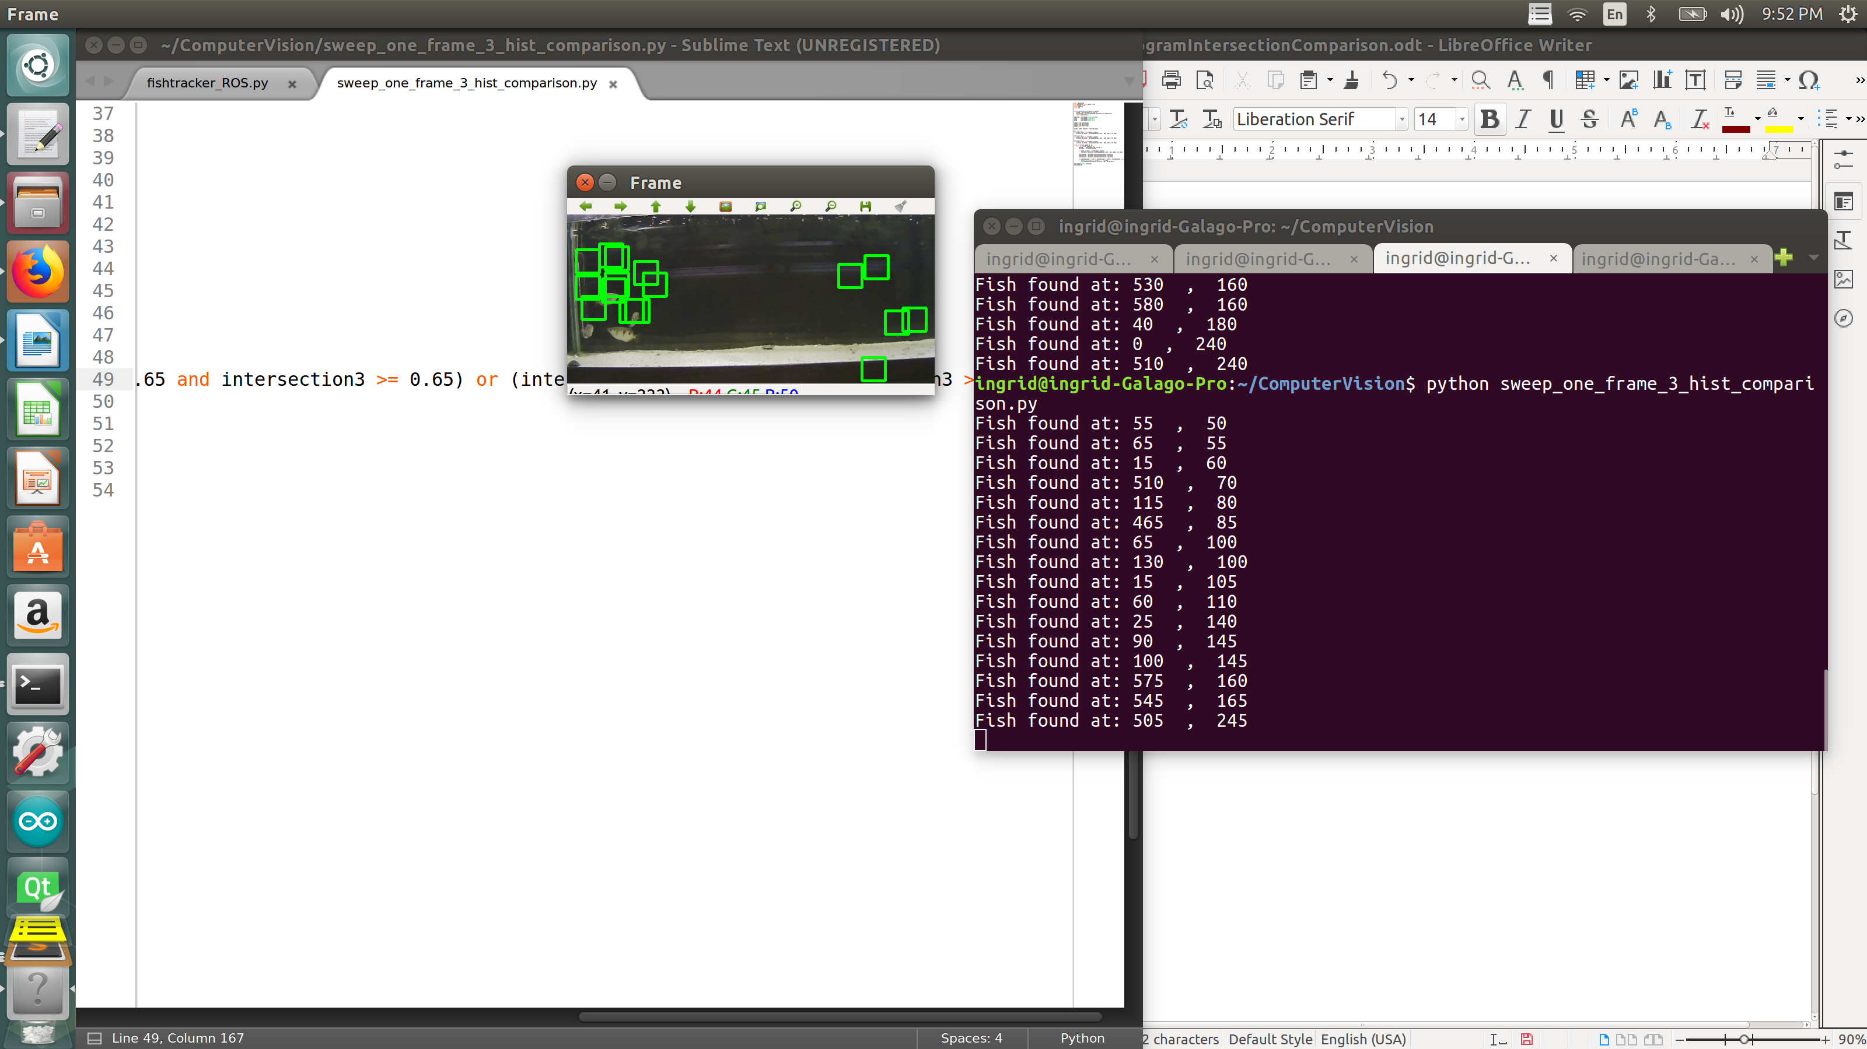

Intersection = 0.7
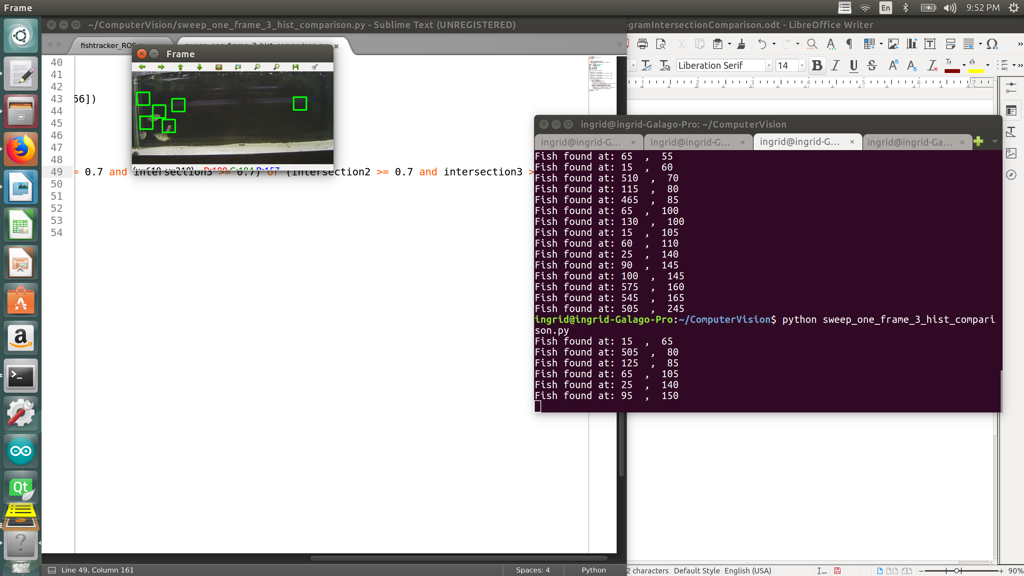

Intersection = 0.75
